Lab#11

Make boost (step up) DC-DC converter circuit using MOSFET
Objective:
In this lab, 5.0VDC to 12.0VDC step up converter will be studied, effects of switching frequency, duty cycle, varying load on output voltage in continuous conduction mode will be examined.

Equipment Required:
- MOSFET
- Diode 1N4007
- Inductor
- Resistors
- Capacitor
- Digital multimeters
- Oscilloscope
- Function Generator
- Power Supply

Circuit Diagram:
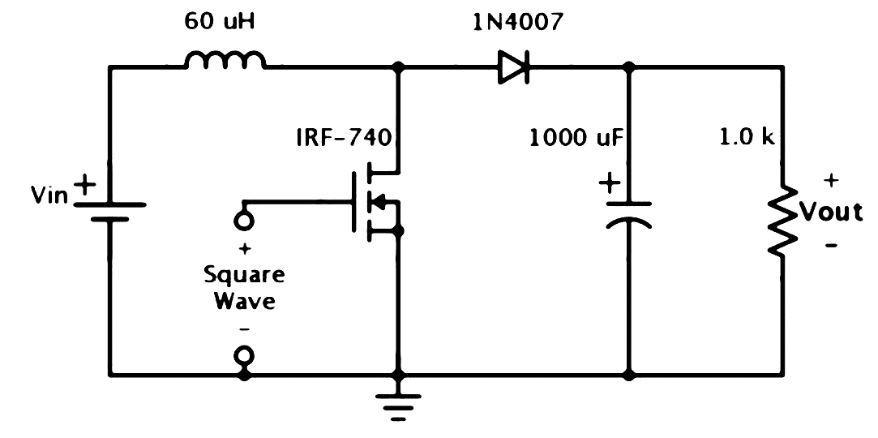
Figure 10.1: Circuit Diagram for Boost Converter

Conceptual Background:

Introduction:
A boost converter (step-up converter) is a DC-to-DC power converter with an output voltage (Vout) greater than its input voltage (Vin). It is a class of switched-mode power supply (SMPS) containing at least two semiconductor switches (a diode and a transistor) and at least one energy storage element, a capacitor, inductor, or the two in combination. Filters made of capacitors are normally added to the output of the converter to reduce output voltage ripple.

Working Principle:
The key principle that drives the boost converter is the tendency of an inductor to resist changes in current by creating and destroying a magnetic field. A schematic of a boost converter is shown in Figure 10.1. Overall working can be divide into two parts:
(a) When the MOSFET is in ON condition, current flows through the inductor in clockwise direction and the inductor stores some energy by generating a magnetic field. Polarity of the left side of the inductor is positive. (b) When the MOSFET is in OFF condition, current will be reduced as the impedance is higher. The magnetic field previously created will be destroyed to maintain the current flow towards the load. Thus, the polarity will be reversed (means left side of inductor will be negative now). As a result, two sources will be in series causing a higher voltage to charge the capacitor through the diode.

Equations for the design of a Boost Converter:
Average output voltage: $V_{out}= \frac{V_{in} }{1-k}$
Maximum Duty Cycle: $K=1- \frac{V_{in }η }{V_{out}}$
Inductor Ripple Current: ${ΔI}_{L}= \frac{V_{in} K}{f_{s} L}$
Maximum output current: $I_{max⁡(out)}=\left[ I_{sw(min)}-\frac{{ΔI}_{L}}{2}\right]\left(1-K\right)$
Inductor calculation: $L=$ $\frac{V_{in} \left(V_{out} {- V}_{in}\right)}{{ΔI}_{L}f_{s} V_{out}}$
Output capacitance $C_{out⁡(min)}= \frac{I_{out(max) }K}{f_{s} ΔV_{out}}$
Diode power dissipation: $P_{D}=I_{F}xV_{F}$
Input power: P_{in} = I_{in} xV_{in} x (1-D)
Output power: P_{out} = I_{out} xV_{out} x (1-D)²
Effeciency: $η= \frac{P_{out } }{P_{in }}$

Where
V_{in} = Input voltage (5vdc in our case)
Vout = Output Voltage
η = Effeciency of the converter
K = Duty cycle of square wave
ΔI_{L} = Inductor ripple current
f_{s} = Switching frequency
I_{sw(min)} = Minimum switch current (MOSFET drain to source current)
I_{out(max)} = Maximum output current
ΔV_{out} = Desired output voltage ripple
I_{F} = Average forward current of the rectifier diode
V_{F} = Forward voltage of the rectifier diode

Procedure:
- Set connections according to the figure 11.1 keeping Vin DC supply to 5.0Vdc
- Set the function generator to square wave mode, set the frequency fs=20kHz (T=50μs), duty cycle K=10%, amplitude Vin= 8.5V,
- Now fill the table 11.1 to 11.3 by doing appropriate steps to measure the required parameters
- Attach the waveforms of the ripple voltage of inductor and the voltage across load.4

Data &Calculations:
Set Rload = 1.0 kΩ, Vin = 12.0Vdc, fs = 20kHz,
Table 11.1 (to study the effect of change in duty cycle)
Sr. No. | Duty Cycle K (%) | V_{out} (V) | I_{in} (mA) | I_{in} (mA) | P_{out} (W) | P_{in} (W) | η (%)
1 | 5
2 | 10
3 | 20
4 | 30
5 | 40

Set K = 20%, Vin = 12.0Vdc, fs = 20kHz,
Table 11.2 (to study the effect of change in load)
Sr. No. | R_{Load} KΩ | V_{out} (V) | I_{in} (mA) | I_{in} (mA) | P_{out} (W) | P_{in} (W) | η (%)
1
2
3
4
5

Set K = 20%, Vin = 12.0Vdc, R_{L} = 1KΩ
Table 11.3 (to study the effect of change in switching frequency)
Sr. No. | f_{s} (KHz) | V_{out} (V) | I_{in} (mA) | I_{in} (mA) | P_{out} (W) | P_{in} (W) | η (%)
1
2
3
4
5

Review Questions:
- What is meant by dc step-up and step-down converter?
- What are the applications of dc boost converter?
- Write down the effect of varying the switching frequency on the load voltage or efficieny?
- Write down the effect of varying the duty cycle on the load voltage or efficieny?
- Explain Table 11.2.

The End

