Lab No # 08
Working and uses of Oscilloscope
Apparatus:

Theory:
Oscilloscope
An oscilloscope, previously called an oscillograph, and informally known as a scope, CRO (for cathode-ray oscilloscope), or DSO(for the more modern digital storage oscilloscope), is a type of electronic test instrument that allows observation of constantly varying signal voltages, usually as a two-dimensional plot of one or more signals as a function of time. Non-electrical signals (such as sound or vibration) can be converted to voltages and displayed.
Oscilloscopes are used to observe the change of an electrical signal over time, such that voltage and time describe a shape which is continuously graphed against a calibrated scale. The observed waveform can be analyzed for such properties as amplitude, frequency, rise, time interval, distortion and others. Modern digital instruments may calculate and display these properties directly. Originally, calculation of these values required manually measuring the waveform against the scales built into the screen of the instrument.
The oscilloscope can be adjusted so that repetitive signals can be observed as a continuous shape on the screen. A storage oscilloscope allows single events to be captured by the instrument and displayed for a relatively long time, allowing human observation of events too fast to be directly perceptible.
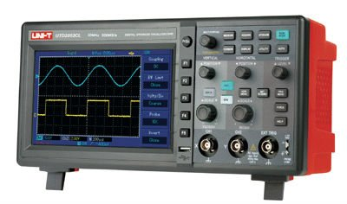

What Can You Do With an Oscilloscope?
Oscilloscopes are used by everyone from television repair technicians to physicists. They are indispensable for anyone designing or repairing electronic equipment. The usefulness of an oscilloscope is not limited to the world of electronics. With the proper transducer, an oscilloscope can measure all kinds of phenomena. A transducer is a device that creates an electrical signal in response to physical stimuli, such as sound, mechanical stress, pressure, light, or heat. For example, a microphone is a transducer that converts sound to an electrical signal. An automotive engineer uses an oscilloscope to measure engine vibrations. A medical researcher uses an oscilloscope to measure brain waves. The possibilities are endless.
Block Diagram of Digital Storage Oscilloscope:
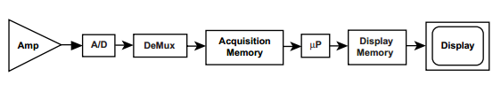
Measurement Terms:
The generic term for a pattern that repeats over time is a wave – sound waves, brain waves, ocean waves, and voltage waves are all repeating patterns. An oscilloscope measures voltage waves. One cycle of a wave is the portion of the wave that repeats. A waveform is a graphic representation of a wave. A voltage waveform shows time on the horizontal axis and voltage on the vertical axis. Waveform shapes tell you a great deal about a signal. Any time you see a change in the height of the waveform, you know the voltage has changed. Any time there’s a flat horizontal line, you know that there’s no change for that length of time. Straight diagonal lines mean a linear change – rise or fall of voltage at a steady rate. Sharp angles on a waveform mean sudden change.
\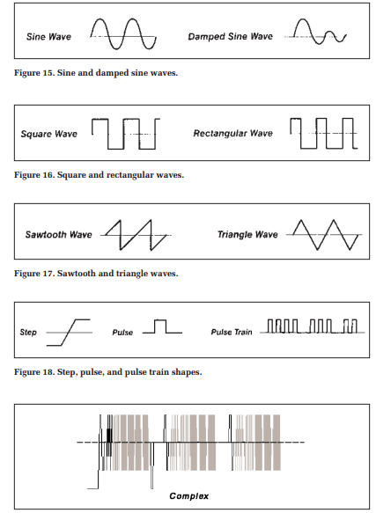

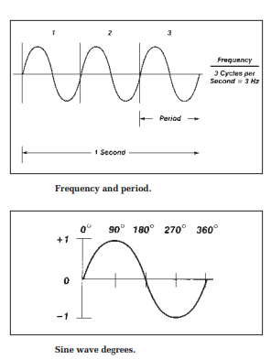
Probes
Now you are ready to connect a probe to your oscilloscope. It’s important to use a probe designed to work with your oscilloscope. A probe is more than a cable with a clip-on tip. It’s a high-quality connector, carefully designed not to pick up stray radio and power-line noise. Probes are designed not to influence the behavior of the circuit you are testing. However, no measurement device can act as a perfectly invisible observer. The unintentional interaction of the probe and oscilloscope with the circuit being tested is called circuit loading. To minimize circuit loading, you will probably use a 10X attenuator (passive) probe.

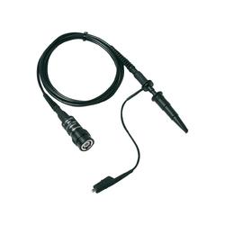

Observation / Calculation:

Voltage of CH1 | Maximum __________ | Minimum ___________
Voltage of CH2 | Maximum __________ | Minimum ___________
Frequency of CH1 | Maximum __________ | Minimum ___________
Frequency of CH2 | Maximum __________ | Minimum ___________

