Lab 2

Arithmetic Operations

Arithmetic Operators

C++ uses four basic arithmetic operators, +, -,*, / for addition, subtraction, multiplication and division. These operators work on all the data type.

Remainder Operator
The remainder operator only works on the integer variables. It is represented by the %, percent symbol also called modulus operator. It finds the remainder when one value is divided by another.

Program 1
#include <iostream>
using namespace std;

int main()
{
cout<< "6%8="<< 6%8 << endl;
cout<<"7%8=" << 7%8 << endl;
cout<<"8%8="<< 8%8 << endl;
cout<<"9%8="<< 9%8 << endl;
cout<<"10%8="<< 10%8 << endl;

}
Output of Program 1

Arithmetic Assignment Operator

C++ offers several ways to shorten your code. One of them is to use the assignment operator.
The following statement is common in most languages

total=total+item

The Arithmetic assignment operator combines the assignment and arithmetic operators such as;

total += item

Other operators are +=,-=,*=,/= and %=.

Program 2
#include <iostream>
using namespace std;

int main()
{
int ans=27;
ans += 10; // ans=ans+10
cout<< ans <<endl;
ans -= 7; // ans=ans-7
cout<< ans <<endl;
ans *= 2; // ans=ans*2
cout<< ans <<endl;
ans /= 3; // ans=ans/3
cout<< ans <<endl;
ans %= 3; // ans=ans%3
cout<< ans <<endl;

}

Output of Program 2

Increment Operator

Increment operator is used to add value 1 to the value of an existing variable.

count=count +1;

You can use arithmetic assignment operator

count+=1;

Or use the increment operator

++count;

Prefix and Postfix

The increment operator can be used in two ways;

Prefix means that the operator precedes the variable. Post fix means that the operator follows the variable.

Totalweight=avgweight* ++count

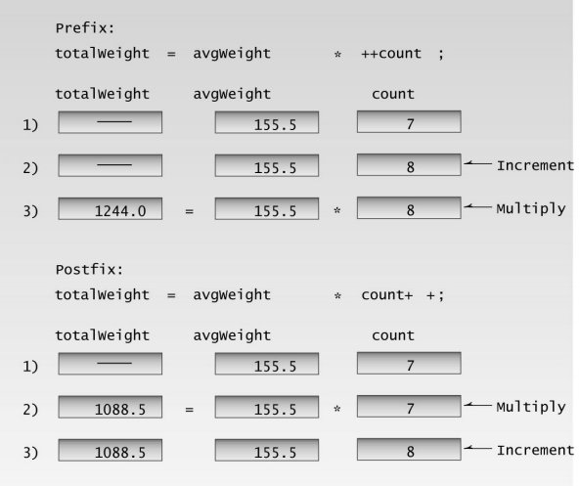

Decrement Operator

It is used in the same way as decreasing the value with 1 and uses prefix and postfix representation.

Library Function

Many activities in C++ are carried out using library functions. These functions perform file access, mathematical computation and data conversion.

Program 4

#include <iostream>

#include <cmath>

using namespace std;

int main()

{

double number, answer;

cout<< "Enter a number="<< endl;

cin>> number;

answer=sqrt(number);

cout<<"Square root =" << answer << endl;

return 0;

}

Out Put of Program 4

LAB TASKS

Program No 1

Write a program to declare two integers, assign them random values, and perform the arithmetic operations Addition, subtraction, multiplication, division and modulus. Display the results on the screen

Program No 2

Write a program which calculates the kinetic energy K.E=$\frac{1}{2}{mv}^{2}$. Take values of m and v from keyboard.

Program No 3

Temperature of a city in Fahrenheit degrees is input through the keyboard. Write a program to convert this temperature into Centigrade degrees.
C = (F-32) /1.8

Program No 4

If a five-digit number is input through the keyboard, write a program to calculate the sum of its digits.
(Hint: Use the modulus operator ‘%’)
Sample output:
Enter a 5 digit single number: 12423
Sum of all digits of the number is 12
NOTE: Your input is a single number not 5 different inputs

Explanation:
Inital value of a (input number): a = 567

Iteration 1:
b = a%10 → 567%10 = 7
sum = sum+b → 0+7 = 7
a = a/10 → 567/10 = 56

Iteration 2:
b = a%10 → 56%10 = 6
sum = sum+b → 7+6 = 13
a = a/10 → 56/10= 5

Iteration 3:
b = a%10 → 5%10 = 5
sum = sum+b → 13+5= 18
a = a/10 → 5/10 = 0

Now, the value of a is "0", condition will be fasle
Output will be 18

Date: __________________
Marks Obtained: ____________________
Instructor’s Signature: __________________

