INTERACTION WITH STRANGERS
LECTURE…09
CONFLICT
- Derived from Latin “com” and “fligere”
- Means “together” and “to strike” or simply “to strike together”
- Conflict connotes a state of dissonance or collision between two forces or systems.
- This state of dissonance can be expressed either overtly (OPENLY) or subtly.
- In the context of IC, conflict can be defined as, “the perceived and actual incapability of values, expectations, processes or outcomes between two or more parties from different cultures over substantive and relational issues.”
- Intercultural conflict typically starts off with miscommunication.
- Miscommunication often leads to misinterpretations and pseudo conflict.
- If the miscommunication goes unmanaged or unclarified, it can become actual interpersonal conflict.
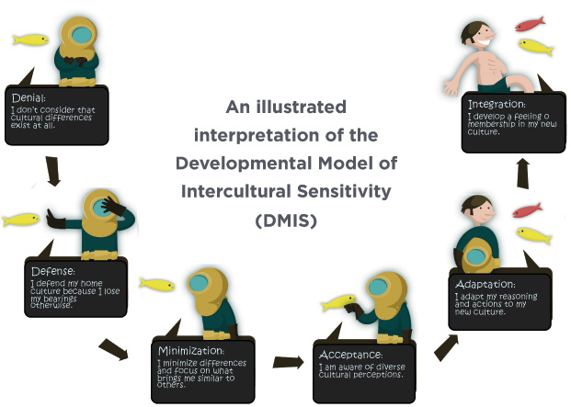

WHAT IS DMIS?
- The developmental model of intercultural sensitivity (DMIS) was created by Dr. Milton Bennett. This model was created as a basic outline to explain the reactions that people have to cultural differences.
- The DMIS consists of 6 different stages. These stages include denial, defense, minimization, acceptance, adaptation, and integration (Cushner, McClelland, & Safford, 2012). Each stage describes a cognitive structure that is communicated through attitudes and behaviors (Bennett, 2011).
STAGE 1…..DENIAL
- The first stage on the DMIS is denial. This stage is often created based on the belief that a person's culture is the only real culture. People in this stage often fail to see cultural differences and tend to isolate themselves from other groups.
- Often times, people that are in the stage of denial are not interested in cultural differences and could care less about people other then the ones that are in their direct culture .
STAGE 2…..DEFENCE
- Defense is the second stage of the DMIS. During this stage, learners often feel as though their own culture is the only good culture (Bennet, 2011). This stage often consists of negative stereotyping and us to them thinking. A person is in defense may feel threatened by other cultures and their differences. People tend to be very critical of other cultures and have a narrow focus on what appropriate behaviors and cultures are correct
STAGE 3…….MINIMIZATION
The third stage of the DMIS is minimization. During this stage, the learner begins to find commonalities between themselves and people of other cultures. Superficial cultures are mostly judged during this phase of the model. Some examples of superficial cultures would be eating, money, and many others. People in this stage begin to recognize that all people are people, whether they have different traditions and cultures or not
STAGE 4….ACCEPTANCE
- Acceptance is the fourth stage of the DMIS. During this stage, learners are able to recognize and appreciate cultural difference through both behaviors and values. This stage promotes the belief that one's own culture is just one of the many cultures that exists in the world (Bennett, 2011). An important aspect of this stage is that people do not necessarily have to agree on anything, they just need to recognize that there are other ways of going about certain situations (Cushner, McClelland, & Safford, 2012, p. 160). People in this stage are often curious about other cultures and have a desire to learn.
STAGE 5…..ADAPTATION
- During the fifth stage of DMIS, adaptation, learners begin to be more competent in how to communicate with people of other cultures. Learners are able in incorporate the world view of others into their own world view. A major aspect of this stage is that the learner will be able to see the world through another's "eyes." Because of this perspective, learners can change their behavior in order to communicate more effectively
STAGE 6….INTEGRATION
- Integration is the final stage of the DMIS, rarely do learners achieve this level of cultural sensitivity. During integration the learner is able to have other cultural experience move in and out of their own worldview. People in this view often maintain a marginal self-identity and view themselves as "in-process"
- People that reach integration are often culture mediators. They are able to help others understand different cultures and promote unity between these two cultures

