Color Study

Color Scheme
In general, the way the colors contrast with each other can be defined as either analogous or complementary....
- Complementary colors
- Double complementary colors
- Split- complementary colors
- Double split complementary colors

Complementary Colors
Complementary colors, on the other hand, are across from each other on the wheel.
Complementary colors are any two colors which are directly opposite each other, such as red and green and red-purple and yellow-green.
- Red + Green
- Red-orange + Blue-green
- Orange + Blue
- Yellow-orange + Blue-purple
- Yellow + Purple
- Red-purple + Yellow-green
Complementary color scheme
- Colors that are opposite each other on the color wheel are considered to be complementary colors (example: red and green). The high contrast of complementary colors creates a vibrant look especially when used at full saturation. This color scheme must be managed well so it is not jarring.

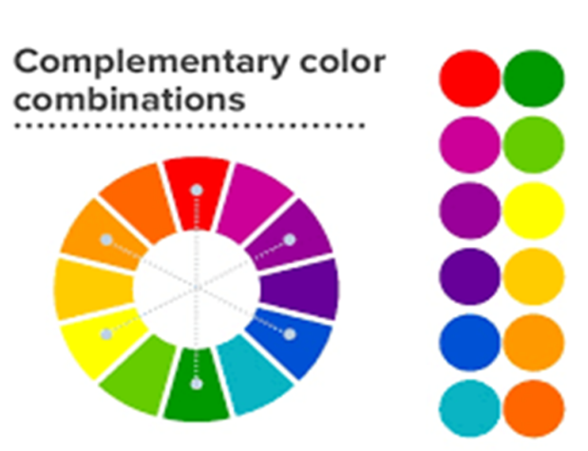

Double Complementary
- A double complementary scheme is when two hues (colors) are next to each other on the color wheel and are paired with two adjacent hues on the opposite side. This overall creates a color palette of four hues that are adjacent but opposite such as blue-green, blue, orange, and red-orange

Split- Complementary
Split-complementary is a color scheme using one base color and two secondary colors. Instead of using a complementary color, two colors placed symmetrically around it on the color wheel are used. The base color is main while the secondary colors should be used only for highlights and accents.
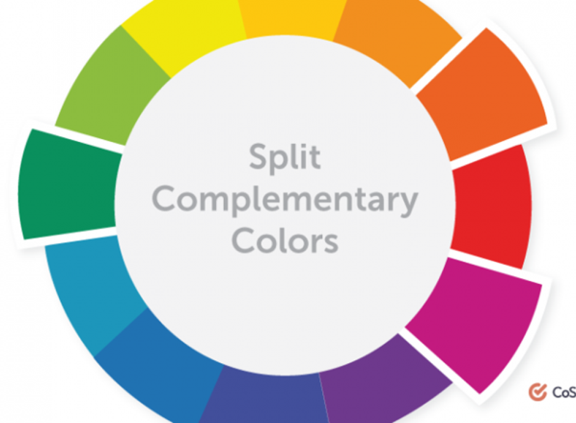

A split complementary scheme involves the use of three colors. Start with one color, find its complement and then use the two colors on either side of it. For example, the complement of blue-green is red-orange and the split complement of blue-green would be red and orange.

Double Split-Complementary
- Double-split complementary colors are the four colors on either side of a pair of complementary colors on the color wheel. Complementary colors are exactly opposite each other on the color wheel. Double-split complementary color schemes are commonly used in the fashion industry.

