Art History
Islamic Era
Most historians accept that Islam originated in Mecca and Medina at the start of the 7th century CE, approximately 600 years after the founding of Christianity, with the revelations received by the prophet Muhammad.

*622* after persecution in Mecca, Muhammad migrates to Medina. The migration — hijra — marks the beginning of the Islamic era. *623-631* after three battles, Muhammad conquers Mecca and forgives all his enemies. A written constitution is established as the basis of governance.

Islamic culture and Muslim culture refer to cultural practices common to historically Islamic people. The early forms of Muslim culture, from the Rashidun Caliphate to early Umayyad period, were predominantly Arab, Byzantine, Persian and Levantine.

The religion of Islam originated in Arabia. It was based on the teachings of Muhammad. Followers of Islam, called Muslims, built large empires and spread their faith through trade and conquest throughout parts of Asia, Africa, and the Mediterranean.

The Islamic Golden Age was a period of cultural, economic, and scientific flourishing in the history of Islam, traditionally dated from the 7th century to the 14th century
Much of the Arabic-speaking world was under rule of various Caliphates.
Caliphates: refers to a person or religious successor of the prophet Muhammad that was a leader of the Muslim community
Baghdad was centrally located between Europe and Asia and was an important area for trade and exchanges of ideas. Scholars living in Baghdad translated Greek texts and made scientific discoveries—which is why this era, from the seventh to thirteenth centuries CE, is named the Golden Age of Islam.

Islamic Golden Age is credited for a variety of advancements in:
- Artistry
- Engineering
- Architecture
- Poetry
- Philosophy
- Agriculture
- Economics
- Literature
- Navigation
- Sciences
- Sociology
- Technology

The First “Truly Universal Civilization”
Brought together, for the first time, a diverse population consisting of people
from China, India, people of the Middle-East and North Africa and the
Europeans
Islam began in the Arabian Peninsula in the early 7th century
- By the 13th century, Islam had spread across India and Southeast Asia
- Reasons for the success and expansion of Islam and its empire be attributed to:
- Strong Arab Army
- Use and development of common language
- Reasonable treatment of conquered peoples

Religion
- Emphasis on religion proved to be one of the biggest influences for the Islamic Golden Age
- Various Quranic injunctions and Hadith placed values on education and emphasize the importance of acquiring knowledge
- Islamic rulers welcomed conversion to the Islamic faith
- All Muslims must learn Arabic, so that they can read the Qur’an, the Islamic holy book

Cultural Influence
- Being that the Islamic empire had such strong trade routes, the cultural influence could be considered a melting pot
- Science, more specifically, medicine, was a central focus and one of the biggest influences left behind by the Islamic Golden Age built on the legacies left behind by Greek and Roman physicians and scholars

Government
- Very open minded
- Allowed Jews and Christians to Advance in society
- Heavily Financed Scholars and Innovators
- Established laws that favored scientific advancement
- Made it so that it was illegal to refuse to treat someone if they could not afford medical care

Technologies
- New Medical Technologies
- Vaccines
- New Farming Techniques
- Crop Rotation
- Incorporating foreign plants
- Hydropower/Wind power
- Used to power mills and factories

Advancements in Science
- Scientific Method
- Astronomy
- Chemistry
- Medicine
- Many other areas of science including Biology, earth sciences, psychology and social sciences.

Institutions
- Public hospital
- Psychiatric hospital
- Pubic library
- Degree-granting universities
- Astronomical observatory

Golden age of Islam. The Abbasid Caliphate becomes a center of learning from the 9th to the 13th centuries, collecting the knowledge of India, China and ancient Greece while also making significant new contributions to mathematics, astronomy, philosophy, medicine and geography.
Islamic art encompasses the visual arts produced in the Islamic world. Islamic art is difficult to characterize because it covers a wide range of lands, periods, and genres.
Islamic art is not art of a specific religion, time, place, or of a single medium. Instead it spans some 1400 years, covers many lands and populations, and includes a range of artistic fields including architecture, calligraphy, painting, glass, ceramics, and textiles, among others.

Islamic Art directly reflects its cultural values but also shows the unique Muslim view of life and all spiritual things. For Muslims, God is the center (Allah). ... Therefore Islamic art developed a unique character of geometric, arabesque, floral, and calligraphic patterns which reflect on their aspects of balance.

A predominant characteristic of Islamic art is that it is nonrepresentational. Rather than representing images and figures as Western art does, Islamic art is comprised of geometric shapes and patterns. One of these is called the arabesque, which is an interweaving of floral, leaf and geometric designs.

A common feature of Islamic art is the covering of surfaces covered with geometric patterns. This use of geometry is thought to reflect the language of the universe and help the believer to reflect on life and the greatness of creation.
General Characteristics:
- Islamic art is especially famous for its architecture.
- There are very few paintings and sculptures, because the Quran did not allow the representation of Muhammad, Allah, people or animals.
- However, Islamic art is very fine.

Umayyad dynasty (661-750)
Religious and civic art were developed under the Umayyad dynasty, when new concepts and new plans were put into practice. As with the arts, the Umayyad period was also critical in the development of Islamic architecture. While earlier architectural traditions continued, the requirements of the new religion and customs of the new Arab rulers necessitated a different usage of space. In the case of religious buildings, the Umayyad often constructed their monuments on sites of historical or symbolic significance. The Dome of the Rock in Jerusalem (691), the first major Umayyad architectural undertaking.

Abbasid dynasty (750 - 1258)
During this period, a distinctive style emerged and new techniques were developed that spread throughout the Muslim realm and greatly influenced Islamic art and architecture. Baghdad and Samarra became associated with the new artistic and architectural trend. As virtually nothing remains from Abbasid Baghdad today, the site of Samarra is particularly significant for understanding the art and architecture of the Abbasid period. In Samarra, a new way of carving surfaces, the so-called beveled style, as well as a repetition of abstract geometric forms, later to be known in the West as “arabesque,” were widely used as wall decoration and became popular in other media such as wood, metalwork, and pottery.

Medieval period (9th–15th centuries)
The Muslim world in the medieval period means the crusades. While this era was marked, in part, by military struggle, it is also overwhelmingly a period of peaceable exchanges of goods and ideas between West and East. Both the Christian and Islamic civilizations underwent great transformations and internal struggles during these years. In the Islamic world, dynasties fractured and began to develop distinctive styles of art. For the first time, disparate Islamic states existed at the same time. And although the Abbasid caliphate did not fully dissolve until 1258, other dynasties began to form, even before its end.

Ottoman Empire
The architecture of the Ottomans, especially after the early formative period, is primarily built of stone. Ottoman architecture in fact is known for the very high quality of its masonry. Still, combinations of brick and stone are very common, and brick is used for arches, domes and vaults. Lead is used to cover domes and minaret caps, especially from the 10th / 16th century onwards. Polychrome glazed ceramic tiles, such as the renowned Iznik tiles in which white and blue dominate, are used extensively as wall coverings, and by the 10th / 16th century often replace marble as a sheathing material. Wood is used both as a structural and as a decorative material, and it is the predominant material for the houses of the Ottoman capital, Istanbul.
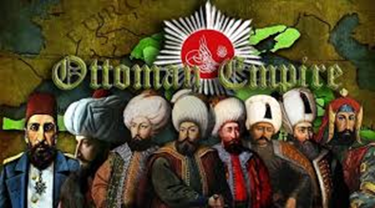
Mughal Empire
Mughal art and architecture, a characteristic Indo-Islamic-Persian style that flourished on the Indian subcontinent during the Mughal Empire. This new style combined elements of Islamic art and architecture, which had been introduced to India during the Delhi Sultanate and had produced great monuments such as the Qutub Minar, with features of Persian art and architecture. Mughal monuments are found chiefly in India, but there are also many remains in Pakistan. These distinctive forms of art and architecture as they developed under a succession of Mughal emperors.
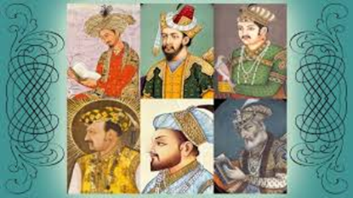

Islamic Art
Architecture
The most important buildings were:
- Palaces (for the caliphs)
- Mosques (for praying)
Palaces
- They usually had gardens and fountains. This courtyard is the Patio de los Leones of the Alhambra (Granada)
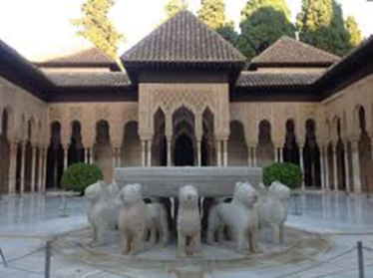

- And these gardens are the Genera life gardens, also in Granada

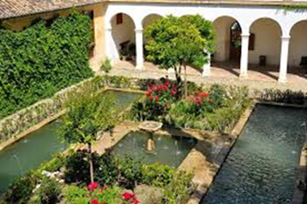

Palaces consisted of two areas:
- Public area (used for welcoming the ambassadors who went to visit the caliph)
- Private area (the residence area of the caliph and his family)

Mosques
Mosques were the buildings for praying in public, especially on Fridays.
This is the umayyad mosque of Damascus.
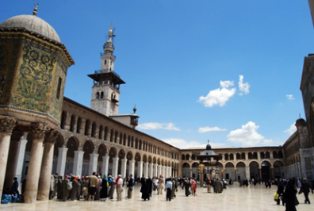
Parts of a Mosque
- The muezzin called to prayer from the minaret. The Giralda in Seville was the minaret of the old mosque. The mosque was destroyed and now the plant is occupied by the catholic gothic cathedral.

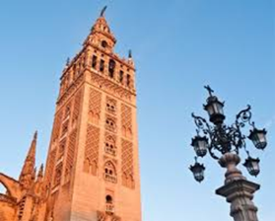
- This minerat is helicoidal, and it's in Samarra (Iraq)

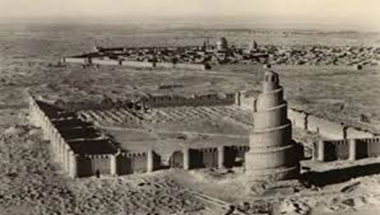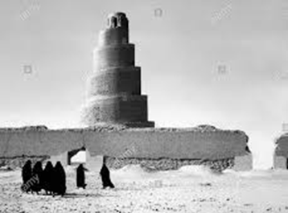

- After going through a door, we find a courtyard or patio. There is an ablution fountain which is used for ritual washing and spiritual purification before prayer.
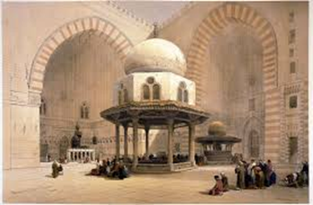

- The prayer hall is a covered area with columns. Muslims pray here. This is the interior of the Córdoba mosque.
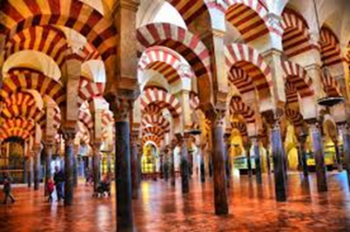

- The qibla is the wall muslims face when they pray. The qibla is orientated towards the holy city of Mecca.
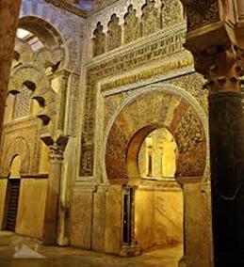

- The mihrab is a small niche in the qibla where the quran is kept. The wall in which a mihrab apperas is thus the “qibla wall’.
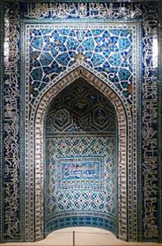

- The mimbar or pulpit. The imam (the muslim priest) leads prayers from here.
Famous Mosques:

Dome of the Rock, Jerusalem 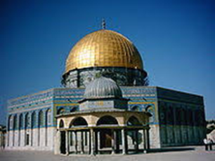

Blue Mosque of Cairo, Egypt 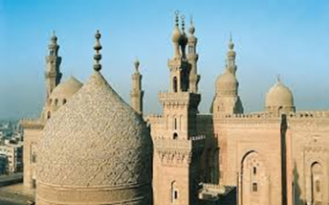

Cordoba mosque, Spain 