GENERAL DISCUSSION ABOUT ROADS/HIGHWAYS

General Discussion about pavements
Any ground surface that you can step on which carries a considerable amount of weight or load is called a pavement. Pavements are primarily constructed for use by vehicles and pedestrians, transferring the load from the upper surface to the natural soil. The earliest record of the first constructed pavements is from the 4000 BC. They consist of stone paved streets or timber roads, with roads of the earlier times dependent on stone, gravel and sand for construction. Road and pavement construction has evolved.
Difference between Flexible and rigid pavements

Layers

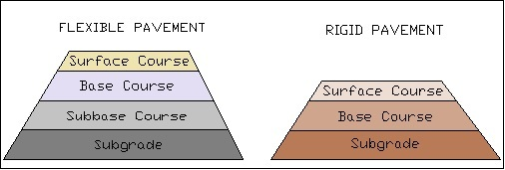

Materials

Flexible pavements are those consisting of a mixture of asphaltic or bituminous material and aggregates placed on a bed of compacted granular material of appropriate quality in layers over the subgrade. Its design is based on the principle that a load of any magnitude diminishes as the load is transmitted downwards from the surface. The load spreads over an increasingly larger area, which carries it deep enough into the ground through successive layers of granular material. This is why materials with high degree of strength are used at or near the surface without the need for steel reinforcement.
On the other hand, rigid pavements are associated with rigidity or flexural strength or slab action so the load is distributed over a wide area of subgrade soil. They are usually laid in slabs with steel reinforcement, with design based on providing a structural cement concrete slab of sufficient strength to resist the loads from traffic. Rigid pavements require high modulus of elasticity.

Loads

The main difference between the flexible and rigid pavements is based on the manner in which the loads are distributed to the subgrade. The pavement design is also one major factor, with flexible pavements reliant on subgrade strength and rigid pavement dependent on the flexural strength of concrete
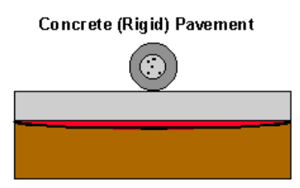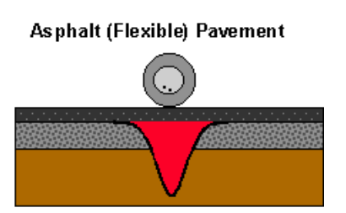
Much less pressure on material placed below the concrete pavement as compare to asphalt

Temperature

Temperature variations are sensitive in rigid pavements inducing heavy stresses; whereas such do not produce stress in flexible pavements.

Healing

Deformations in rigid pavements are permanent while in flexible pavements, they have self-healing properties that can recover from heavier wheel loads.

TYPES OF FAILURE IN RIGID PAVEMENT

SCALING OF CEMENT CONCRETE

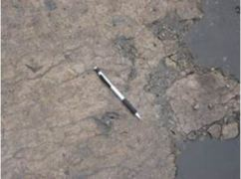
Scaling

Scaling of rigid pavement simply means, peeling off or flaking off of the top layer or skin of the concrete surface. This may be due to the following reasons
- Improper mix design
- Excessive vibration during compaction of concrete
- Laitance of concrete
- Performing finishing operation while bleed water is on surface

SHRINKAGE CRACKS
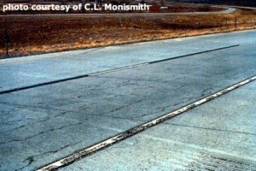
Shrinkage cracking
Formation of hairline shallow cracks on concrete slab is the indication of shrinkage cracks.
Shrinkage cracks develop on concrete surface during the setting & curing operation. These cracks may form in longitudinal as well as in transverse direction

JOINT SPALLING
Joint spalling is the breakdown of the slab near edge of the joint. Normally it occurs within 0.5 m of the joints. The common reasons for this defect are
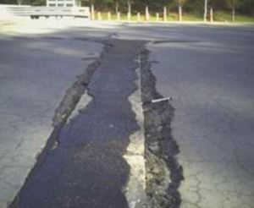
Joint spalling
- Faulty alignment of incompressible material below concrete slab
- Insufficient strength of concrete slab near joints
- Freeze-thaw cycle
- Excessive stress at joint due to wheel load

WARPING CRACKS
In hot weather, concrete slab tends to expand. Therefore the joints should be so designed to accommodate this expansion. When joints are not designed properly, it prevents expansion of concrete slab and therefore results in development of excessive stress. This stress cause formation of warping cracks of the concrete slab near the joint edge.
This type of crack can be prevented by providing proper reinforcement at the longitudinal and transverse joints. Hinge joints are generally used to relieve the stress due to warping.

PUMPING

When material present below the road slab ejects out through the joints or cracks, it is called pumping. When soil slurry comes out it is called mud pumping.
The common reasons for this defect are
- Infiltration of water through the joints, cracks or edge of the pavement forms soil slurry. Movement of heavy vehicles on pavement forces this soil slurry to come out causing mud pumping.
- When there is void space between slab and the underlying base of sub-grade layer
- Poor joint sealer allowing infiltration of water
- Repeated wheel loading causing erosion of underlying material
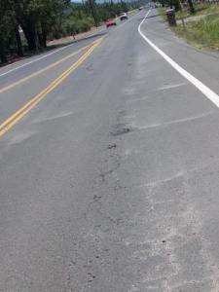
Pumping
Pumping can also lead to formation of cracks. This is because; ejection of sub-grade material below the slab causes loss of sub-grade support. When traffic movement occurs at these locations, it fails to resist the wheel load due to reduction of sub-grade support and develops cracks.
This type of defect can be identified when there is presence of base or sub-grade material on the pavement surface close to joints or cracks.

ESSENTIAL PROPERTIES OF ASPHALT CONCRETE
An asphalt concrete mixture must be designed, produced and placed in order to obtain the following desirable mix properties
1. STABILITY
Stability of an asphalt pavement is its ability to resist shoving and rutting under loads (traffic). A stable pavement maintains its shape and smoothness under repeated loading; an unstable pavement develops ruts (channels), ripples (wash boarding or corrugation) and other signs of shifting of the mixture.
Because stability specifications for a pavement depend on the traffic expected to use the pavement, the requirements can be established only after a thorough traffic analysis. Stability specifications should be high enough to handle traffic adequately, but not higher than traffic conditions require. Too high a stability value produces a pavement that is too stiff and therefore less durable than desired.
The stability of a mixture depends on internal friction and cohesion. Internal friction among the aggregate particles (inter-particle friction) is related to aggregate characteristics such as shape and surface texture. Cohesion results from the bonding ability of the binder.
A proper degree of both internal friction and cohesion in a mix prevents the aggregate particles from being moved past each other by the forces exerted by traffic. In general, the more angular the shape of the aggregate particles and the more rough their surface texture, the higher the stability of the mix will be. Where aggregates with high internal friction characteristics are not available, more economical mixtures using aggregate with lower friction values can be used where light traffic is expected.
The binding force of cohesion increases with increasing loading (traffic) rate. Cohesion also increases as the viscosity of the binder increases, or as the pavement temperature decreases. Additionally, cohesion will increase with increasing binder content, up to a certain point. Past that point, increasing binder content creates too thick a film on the aggregate particles, resulting in loss on inter-particle friction. Insufficient stability in a pavement has many causes and effects.
2. DURABILITY
The durability of an asphalt pavement is its ability to resist factors such as changes in the binder (polymerization and oxidation), disintegration of the aggregate, and stripping of the binder films from the aggregate. These factors can be the result of weather, traffic, or a combination of the two. Generally, durability of a mixture can be enhanced by three methods. They are:
- Using maximum binder content,
- Using a dense gradation of stripping-resistant aggregate, and
- Designing and compacting the mixture for maximum impermeability
Maximum binder content increases durability because thick binder films do not age and harden as rapidly as thin ones do. Consequently, the binder retains its original characteristics longer. Also, maximum binder content effectively seals off a greater percentage of interconnected air voids in the pavement, making it difficult for water and air to penetrate. Of course, a certain percentage of air voids must be left open in the pavement to allow for expansion of the binder in hot weather.
A dense gradation of sound, tough, stripping-resistant aggregate contributes to pavement durability in three ways. A dense gradation provides closer contact among aggregate particles. This enhances the impermeability of the mixture. A sound, tough aggregate resists disintegration under traffic loading; and stripping-resistant aggregate resists the action of water and traffic, which tend to strip the binder film off aggregate particles and lead to raveling of the pavement. Under some conditions, the resistance of a mixture to stripping can be increased by the use of anti-stripping additives, or mineral filler such as hydrated lime. Designing and compacting the mixture to give the pavement maximum impermeability minimizes the intrusion of air and water into the pavement. A lack of sufficient durability in a pavement can have several causes and effects.
3. IMPERMEABILITY
Impermeability is the resistance of an asphalt pavement to the passage of air and water into or through it. This characteristic is related to the void content of the compacted mixture, and much of the discussion on voids in the mix design sections relates to impermeability.
Even though void content is an indication of the potential for passage of air and water through a pavement, the character of these voids is more important than the number of voids. The size of voids, whether or not the voids are interconnected, and the access of the voids to the surface of the pavement all determine the degree of impermeability.
Although impermeability is important for durability of compacted paving mixtures, virtually all asphalt mixtures used in highway construction are permeable to some degree. This is acceptable as long as it is within specified limits.
4. WORKABILITY
Workability describes the ease with which a paving mixture can be placed and compacted. Mixtures with good workability are easy to place and compact; those with poor workability are difficult to place and compact. Workability can be improved by changing mix design parameters, aggregate source, and/or gradation.
Harsh mixtures (mixtures containing a high percentage of coarse aggregate) have a tendency to segregate during handling and also may be difficult to compact. Through the use of trial mixes in the laboratory, additional fine aggregate and perhaps binder, can be added to a harsh mix to make it more workable. Care should be taken to ensure that the altered mix meets all other design criteria, such as void content and stability. Too high a filler content can also affect workability. It can cause the mix to become gummy, making it difficult to compact. Workability is especially important where quite a bit of hand placement and raking (luting) around manhole covers, sharp curves, and other obstacles is required. It is important that mixtures used in such areas are highly workable.
Mixtures that can be too easily worked or shoved are referred to as tender mixes. Tender mixes are too unstable to place and compact properly. They are often caused by a shortage of mineral filler, too much medium-sized sand, and smooth, rounded aggregate particles, and/or too much moisture in the mix. Although not normally a major contributor to workability problems, the asphalt binder does have some effect on workability. Because the temperature of the mix affects the viscosity of the binder, too low a temperature will make a mix unworkable, too high a temperature may make it tender. Binder grade may also affect workability, as may the percentage of binder in the mix.
5. FLEXIBILITY
Flexibility is the ability of an asphalt pavement to adjust to gradual settlements and movements in the sub-grade without cracking. Since virtually all sub-grades either settle (under loading) or rise (from soil expansion), flexibility is a desirable characteristic for all asphalt pavements. An open-graded mix with high binder content is generally more flexible than a dense-graded, low binder content mix. Sometimes the need for flexibility conflicts with stability requirements, so that trade-offs have to be made.
6. FATIGUE RESISTANCE
Fatigue resistance is the pavement’s resistance to repeated bending under wheel loads (traffic). Research shows that air voids (related to binder content) and binder viscosity have a significant effect on fatigue resistance. As the percentage of air voids in the pavement increases, either by design or lack of compaction, pavement fatigue life (the length of time during which an in-service pavement is adequately fatigue-resistant) is drastically shortened. Likewise, a pavement containing binder that has aged and hardened significantly has reduced resistance to fatigue.
The thickness and strength characteristics of the pavement and the supporting power of the subgrade also have a great deal to do with determining pavement life and preventing load-associated cracking. Thick, well-supported pavements do not bend as much under loading as thin or poorly supported pavements do. Therefore, they have longer fatigue lives.
7. SKID RESISTANCE
Skid resistance is the ability of an asphalt surface to minimize skidding or slipping of vehicle tires, particularly when wet. For good skid resistance, tire tread must be able to maintain contact with the aggregate particles instead of riding on a film of water on the pavement surface (hydroplaning). Skid resistance is typically measured in the field at 40 mi/hr with a standard tread tire under controlled wetting of the pavement surface. A rough pavement surface with many little peaks and valleys will have greater skid resistance than a smooth surface. Best skid resistance is obtained with rough-textured aggregate in a relatively open-graded mixture with an aggregate of about 3/8 in.-1/2 in. (10-13 mm) maximum size. Besides having a rough surface, the aggregates must resist polishing (smoothing) under traffic. Calcareous aggregates polish more easily than siliceous aggregates. Unstable mixtures that tend to rut or bleed (flush asphalt to the surface) present serious skid resistance problems.

