EXPERIMENT
______________________________________________________________________________

1. Objective 2. Apparatus used 3. Theory 4. Procedure 5. Observations & Calculations 6. Graphs 7. Results & Discussions 8. Precautions.
______________________________________________________________________________
1. Objective
To measure the deflection of fixed end beam and compare Experimental and Theoretical results.
2. Apparatus Used

Beam deflection apparatus, beam, dial gauge, weights, hangers.
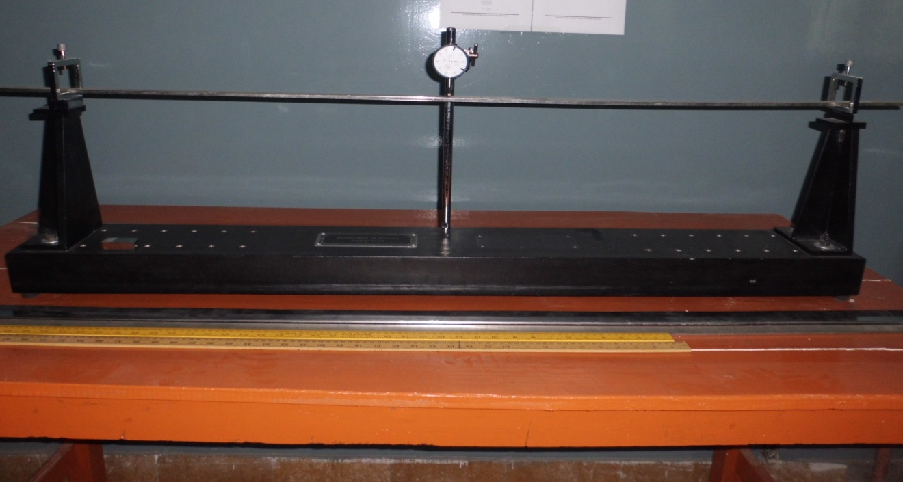
3. Theory
Beam:
A beam is a structural element that is capable of withstanding load primarily by resisting bending. The bending force induced into the material of the beam as a result of the external loads, own weight, span and external reactions to these loads is called a bending moment.

Fixed End Beam:
A beam that is supported at both free ends and is restrained against rotation and vertical movement is called a fixed end beam. It is also known as built-in beam or encase beam.
It can be shown that the deflection of a fixed end beam with a single concentrated load at the center can always be expressed in the form:
Z= (1/192) * (WL³)/ (EI)
Where:
Z: is the deflection
W: is the load acing on the beam
L: is the span length
E: Modulus of elasticity
I: moment of inertia

4. Procedure
- Measure the length of beam between two fixed ends.
- Measure width “b” and depth “h” and calculate moment of inertia as I=bh³/12
- Put load “W” at the center of beam.
- Read deflection at the center with dial gauge.
- Calculate deflection at the center using formula.
- Calculate the percentage error in measured and calculated deflections.
- Repeat the experiment by taking different values of load “W”.
5. Observations & Calculations
- Material --------------- Length = L =----------------
- Width = b = ------------------ Depth = h = ---------------
- Modulus of elasticity = E =---------------------

Sr # | Load on beam  W | Deflection measured  Z’ | Deflection calculated  Z | % Error
1
2
3
4
5
6

6. Graph
Draw the graph b/w Load Vs Deflection measured.
Draw the graph b/w Load Vs Deflection calculated.

7. Results & Discussion

The measured deflections should closely match with calculated deflections using formulae.

8. Precautions

- Apply load without any jerk.
- Perform the experiment away from vibrations and other disturbances.
- Dial gauge should be handled properly.

