Question # 1 (15)
Determine the equation of motion of the machine when synchronous machine is connected to an infinite bus through a transformer and double circuit transmission line. The infinite bus voltage is 1.0 pu, direct axis transient reactance of machine is 0.2 pu, transformer reactance is 0.1 pu, and the reactance of each of the transmission line is 0.4 pu, all to a base of the rating of the synchronous machine. Machine is delivering 0.9 pu power with terminal voltage of 1.1 pu and inertia constant is H = 6 MJ/MVA.
Figure 1

Question # 2 (10)
Consider the system provided in Question # 1 and now a three-phase fault with a balanced impedance of j 0.l to neutral is applied on one of the transmission line. The network during the fault is shown in Figure 2 where admittances are used for convenience. Develop the equation of motion during fault.
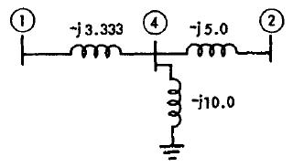
Figure 2
Question # 3 (10)
- Evaluate the synchronizing power and natural frequency of oscillations. Do they affect power system stability?
- Why it is assumed in the classical model of one machine system that mechanical power input remains constant during the transient period?
Question # 4 (5)
The power-angle curve of a synchronous machine connected to an infinite bus is provided in Figure 3, where the sine curve displaced from the origin vertically by an amount Pc and horizontally by the angle ɤ. Illustrate in few words, what Pc and ɤ represents?
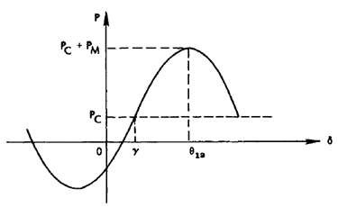
Figure 3
Question # 5 (10)
- Illustrate why three phase quantities (abc) are transformed two phase quantities dq0?
- Relate the concept of power system stability with power system security and power system reliability.

