Fashion Concepts
Flat Pattern Making

PATTERN MAKING
- Pattern making is an art. It is the art of manipulating and shaping a flat piece of fabric to conform to one or more curves of the human figure.
- Pattern making is a bridge function between design and production.

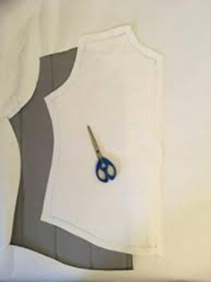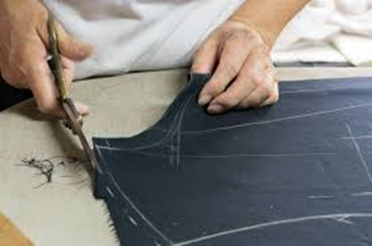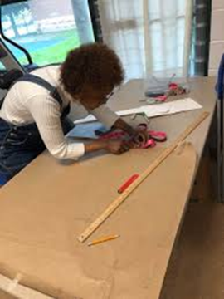
- A sketch can be turned into a garment via a pattern which interprets the design in the form of the garment components.
- Now a day’s sophisticated software programs are used for pattern making.

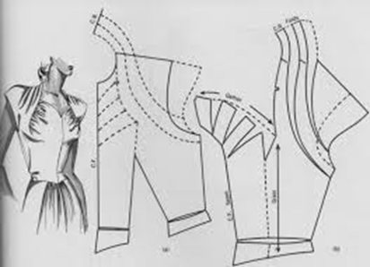
BASICS OF PATTERN MAKING
- A pattern is flat while the body is not. The body has height, width and depth.
- Darts are the basis of all pattern making. They convert the flat piece of cloth into a three dimensional form, which fits the bulges of the body.
- A patternmaker typically makes a pattern from a flat sketch with measurements or a two dimensional fashion illustration.

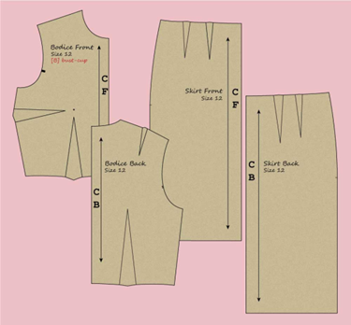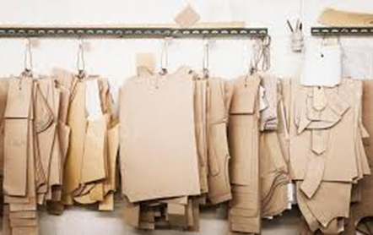
- The basic pattern is the very foundation upon which pattern making, fit and design are based.
- The basic pattern is the starting point for flat pattern designing.
- It is a simple pattern that fits the body with just enough ease for movement and comfort.
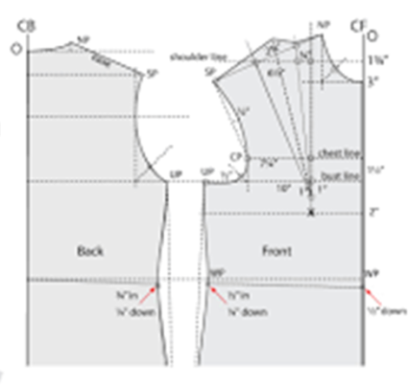
HISTORY OF PATTERN MAKING
- Prior to the Industrial Revolution the art of patternmaking was highly revered.
- Tailors meticulously worked with their client's personal measurements to customize patterns.
- Clothing made by tailors was elaborate and relegated only to the very rich.
- With the onset of the Industrial Revolution, standardized patterns were essential to the success of ready-to-wear clothing.
- Initial attempts to create standardized patterns resulted in poorly fitting garments with little detail.
- After lengthy experimentation and standardized sizing, patternmaking made a triumphant transformation from customization to standardization.

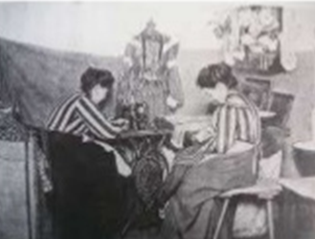

- Computers have been used by apparel companies since the early 1980's.
- Pattern Design Systems (PDS) have become invaluable tools to the patternmaker, assisting in much of the repetitive tasks associated with patternmaking.
- PDS systems are capable of storing an incredible amount of data that can be quickly retrieved, tweaked and re-filed.
- Using a mouse or stylus, patternmakers are able to swiftly add style details and make changes.
- There are many benefits to PDS - speed, accuracy and ease of data transmission being some of the most obvious.
- In today's competitive environment, software companies are zeroing in on the growing demands of the apparel manufacturer.

- Current research focuses on generating patterns that produce better fitting garments and 3D visualization tools to help fine tune style.
- With ongoing technological advances and diligent research, patternmaking software companies continue to successfully address the needs of their customers.
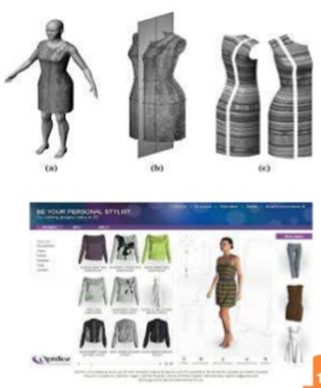
FLAT PATTERN MAKING
- In Flat Pattern Making, we take the accurate measurements from a dress form or a figure and then measurements are turned into a pattern using paper.
- In today's world flat pattern making has become necessary for a fashion designer to make garments of different body sizes. Flat pattern making is quite interesting and important, it helps the people of any age groups to interpret the designs and understand the design with technical ability.
- The right fit is a key to gaining consumer confidence and loyalty.
- Once a brand’s target fit has been defined, it must be wielded intelligently to maintain a competitive advantage.
- Flat pattern making, when done correctly, provides the code to this integral part of a brand’s DNA and helps ensure competitiveness in a challenging market place.
- Working pattern is derived from the flat method or modeling. Each and every pattern is laid on the board paper to copy the block pattern. Then sewing allowance, Trimming allowance, Button hole, button attaching, dart, pleat, Notch, shrinkage of the fabric, etc are added with the copied pattern.

- A sloper is a pattern that has no seam allowances or style lines.
- From a sloper a myriad of garment styles can be generated.
- The patternmaker creates a new style by adding design details such as a collar, pocket and pleats.
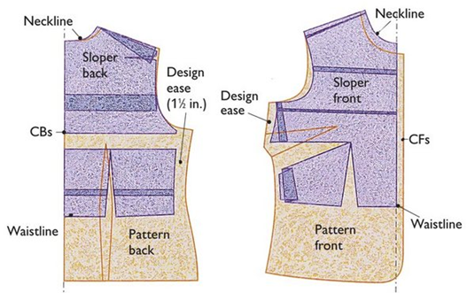
- The rapid output of new flat pattern designs, facilitated by slopers, is a useful skill for any fashion designer.
- Flat pattern can be used as a means of developing original ideas effectively and efficiently.
- Flat pattern is use of the three basic slopers:
- Waist
- Sleeve and skirt
- Some popular variations of these such as the kimono waist, raglan sleeves and pants.

- The flat pattern method uses twelve basic pattern slopers that are manipulated by the patternmaker to achieve a desired style or design.

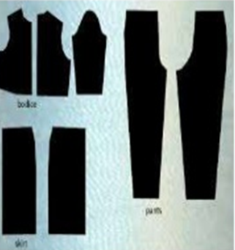
Steps of Flat pattern making:

- Block pattern: Block pattern or basic block indicates the original pattern. Block Pattern is made based on the specific and standard body measurement without any design or style.
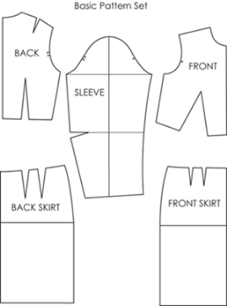

- Working pattern: Working pattern is derived from the flat method or modeling and it is further used for stylization in basic block pattern.
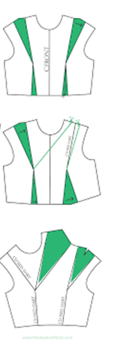
Five basic pattern pieces are used for women's clothing. They include:
- a snug-fitting bodice front
- bodice back with darts
- a basic neckline
- a sleeve
- a fitted skirt front and back with darts.
However, as fashion changes frequently women's styles fluctuate frequently. These basic slopers are then manipulated to create fashions.

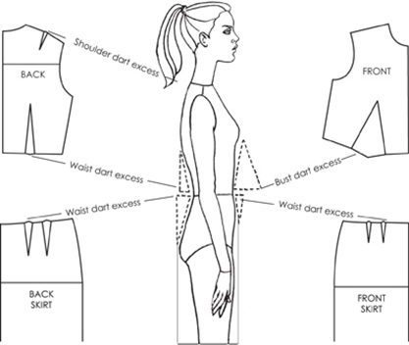

- "Patternmaking" is the process of creating all the correctly sized pieces needed to make a complete garment.
- For many smaller manufacturers, pattern making is still done on paper because the cost of computerized systems remains prohibitive.
- The flat patternmaking method is widely used in the ready-to-wear market because it is fast and accurate.
- Although pattern making is becoming increasingly computerized, patternmakers still must learn the manual method because making patterns manually develops an advanced understanding of garment construction, knowledge that cannot yet be replaced by a computer.

BASIC TOOLS FOR FLAT PATTERN MAKING
Having the right tools for making a pattern is a super important place to start. Most tools are not expensive and are easy to get.
1) Large scale paper
2) Clear Gridded Ruler
3) Flexible Design Rule
4) Hip/Arm Curve (Styling Design Ruler)
5) Pencil and a good Eraser
6) Large pins
7) Cork panels
8) Flexible Measuring Tape
9) Basic sewing book
10) Tracing Wheel
11) Tailor’s chalk
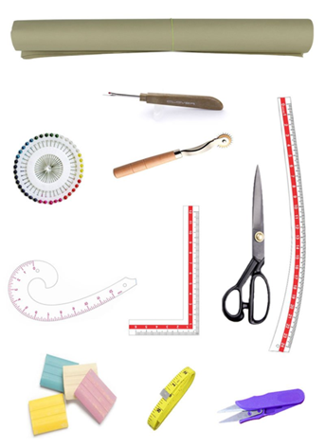
PATTERN MAKING IN TODAY’S WORLD
- Pattern making today has become an easy job with the use of the computers.
- Now-a-days different soft wares are available in the market to meet the needs of the manufacturers.
- The different soft wares used are Gerber, Lectra, Tukatech , OptiTex etc.
- These softwares have made the job of the Pattern master easier.
- They have made the process of pattern making more economical and less time consuming.
- Pattern-making software enables you to input your measurements and draft out a pattern. These soft wares draft patterns to fit your measurements specifically, eliminating much fitting trial and error in the sewing room.

