FINANCIAL ACCOUNTING
WEEK 1st/ Lecture 1st
What Is Accounting.
Accounting is the process of recording financial transactions pertaining to a business. The accounting process includes summarizing, analyzing, and reporting these transactions to oversight agencies, regulators, and tax collection entities. The financial statements used in accounting are a concise summary of financial transactions over an accounting period, summarizing a company's operations, financial position, and cash flows.

Accounting, definition and meaning
Accounting is an art to record the business transactions systematically.
Accounting is the work or process of keeping financial records. It is the systematic recording, reporting, and analysis of the financial activity (transactions) of a person, business, or organization. In business, it allows companies to analyze their financial performance.
Additionally, accounting allows businesses to examine their results regarding profits, losses, productivity, sales trends, costs, etc.
Accountancy is an information science we use to gather, classify, and manipulate financial information. Not only companies, but also individuals, charities, and many other entities are familiar with accountancy.
According to Business Dictionary, accounting is the “practice and body of knowledge concerned primarily with methods for recording transactions, keeping financial records, performing internal audits, reporting and analyzing financial information to the management, and advising on taxation matters.”
“It is a systematic process of identifying, recording, measuring, classifying, verifying, summarizing, interpreting and communicating financial information.”

Accounting Cycle
Under the traditional system of accounting, the accounting cycle will appear as follows:

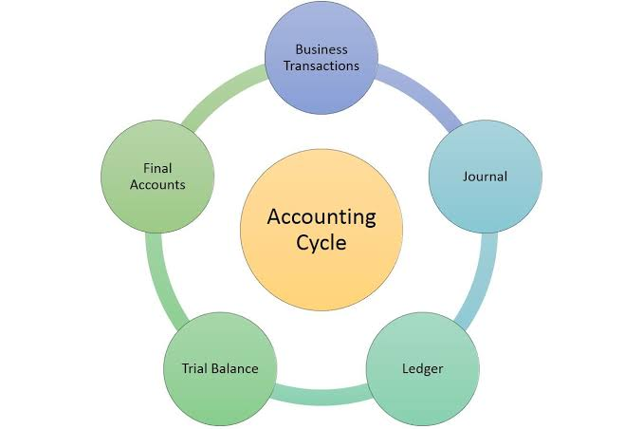
Accounting cycle is the complete sequence of accounting processes or procedures, which begin with the recording of business transactions in the book or books of original entry and end with the preparation of final accounts, and is repeated in the same order or sequence in each accounting period.

Accounting cycle involves certain sequential steps. The sequential steps involved in accounting cycle are:
Step 1 : Recording the business transactions in the book or books of original entry (i.e., either in a single book of original entry called the journal, or in a number of books of original entry called the special journals or subsidiary books) date-wise, as and when they occur.

Step 2 : Classifying the transactions (i.e., the entries found in the book or books of original entry) by posting or transferring those entries to the appropriate accounts in the ledger periodically.

Step 3 : Balancing the various ledger accounts to know the net effect of similar entries (i.e., to know the balances of various ledger accounts).

Step 4 : Preparation of a trial balance from the balances of various ledger accounts to verify or check the arithmetical accuracy of ledger accounts.

Step 5 : Preparing the final accounts or financial statements (i.e., trading and profit and loss account and balance sheet) from the trial balance and the adjustments, if any, at the end of the accounting period, to ascertain the profit or loss of the business for the accounting period and to ascertain the financial position of the business at the end of the accounting period.

Types of Accounting

Financial Accounting
Financial accounting refers to the processes used to generate interim and annual financial statements. The results of all financial transactions that occur during an accounting period are summarized into the balance sheet, income statement, and cash flow statement. The financial statements of most companies are audited annually by an external CPA firm. For some, such as publicly traded companies, audits are a legal requirement. However, lenders also typically require the results of an external audit annually as part of their debt covenants. Therefore, most companies will have annual audits for one reason or another.

Managerial Accounting
Managerial accounting uses much of the same data as financial accounting, but it organizes and utilizes information in different ways. Namely, in managerial accounting, an accountant generates monthly or quarterly reports that a business's management team can use to make decisions about how the business operates. Managerial accounting also encompasses many other facets of accounting, including budgeting, forecasting, and various financial analysis tools. Essentially, any information that may be useful to management falls underneath this umbrella.

Cost Accounting
Just as managerial accounting helps businesses make decisions about management, cost accounting helps businesses make decisions about costing. Essentially, cost accounting considers all of the costs related to producing a product. Analysts, managers, business owners and accountants use this information to determine what their products should cost. In cost accounting, money is cast as an economic factor in production, whereas in financial accounting, money is considered to be a measure of a company's economic performance.

