Experiment #04

Determination of Flash and Fire Point of bitumen

Flash and Fire point test is conducted on bitumen to know the safe mixing and application temperature values of particular bitumen grade.
Why it is Necessary?
At higher temperatures, bituminous materials leave out volatiles, these volatile vapors contains hydro-carbons which can catch fire easily and will cause flash at one point and if it is further prone to heat the material may ignite and burn.
Catching fire is very dangerous during mixing of bitumen especially during its application. So, it is necessary to recognize the safe temperature values of bitumen grades for mixing as well as for applying. The limited values of temperature can be determined by conducting Flash point and Fire point test on bitumen.

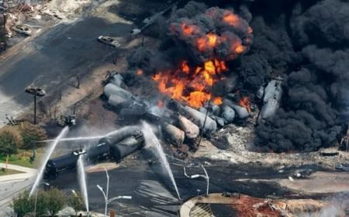
Explosion of Bitumen tanks Due to Excessive Temperature

What is a Flash Point?
The Flash point of a material is the lowest temperature at which vapor of substance quickly catches fire in the form of flash under definite conditions of the test. So, at this point fire will not last longer, just a flash will appear for a fraction of second.
The existence of highly volatile and inflammable materials in a particular grade of bitumen can be indicated by the Flash point.

What is a Fire Point?
The fire point of a material is the lowest temperature at which material catches fire and burns under definite conditions of test.
The presence of combustible materials in a bituminous material can be indicated by the Fire point.

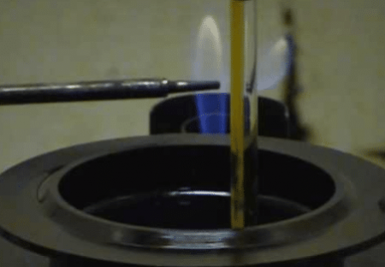
Flash Point Stage of Bitumen
Apparatus
- Pensky-Martens closed tester
- Thermometer
Pensky-Martens closed cup tester contains testing cup, lid, stirrer device, shutter, and flame exposure device. Thermometer of specified range generally 0ºC to 350ºC with sensitivity of 0.1ºC should be used.
Test Procedure
- Heat the bitumen to above its softening point generally 75ºC to 100ºC and stir this softened bitumen thoroughly to remove air bubbles.
- Fill the cup with softened bitumen up to the filling mark provided on the cup. Now place the lid and close the cup.
- Other accessories like thermometer and flame exposure are suitably fixed in their respective positions. Now lit up the flame and set the size of flame to 4mm in diameter.
- The bitumen getting heated and preferred rate of heating should be 5ºC to 6ºC per minute.
- Stirring of sample should be simultaneously done along with heating using stirrer device.
- The rate of stirring should be approximately 60 revolutions per minute.
- Observe the thermometer carefully and when the temperature is 17ºC below the actual flash point (175^{O}C) lit up the test flame.
- The test flame size should be of 4mm diameter and carry it close to the heating sample.
- Apply the test flame for every 1^{O}C rise from this point and remember during application of test flame the stirring should be stopped.
- When the sample catches the flame and forms Flash, note town the temperature at that point which is Flash point of the bitumen.
- Heat the sample further with the same previous rate and apply the test flame for every 2^{O}C rise when the material catches the fire and burns at least for 5 seconds, note the temperature at this point which is the fire point of the bitumen.
- Repeat the experiment for 2 more times and the average of the three readings should be taken as Flash point and Fire point of the given sample.
Results
- Flash point of the bitumen = _______ ^{O}C
- Fire point of the bitumen = _______ ^{O}C
Recommended Values
For any type of Bitumen grade
Minimum Flash point value should be = 175ºC
Minimum Fire point value should be = 175ºC + 5ºC.

