Experiment #03

Determination of Ductility of Bitumen

Ductility of bitumen is its property to elongate under traffic load without getting cracked in road construction works. Ductility test on bitumen measures the distance in centimeters to which it elongates before breaking.

DUCTILITY TEST ON BITUMEN:
The ductility test on bitumen will be used:
- To measure the ductility of a given sample of bitumen
- To determine the suitability of bitumen for its use in road construction.

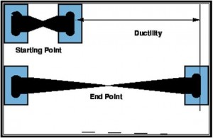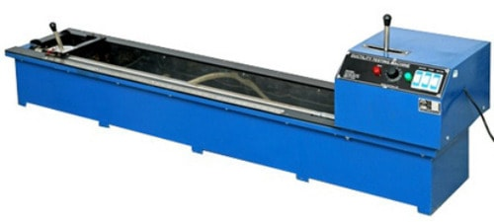

APPARATUS REQUIRED FOR DUCTILITY TEST ON BITUMEN:
The apparatus as per IS: 1208-1978 consists of:
(i) Briquette mould: It is made of brass. Circular holes are provided at ends called clips to grip the fixed and movable ends of the testing machine. The mould when properly assembled form a briquette specimen of following dimensions:
- Total length 75.0 ± 0.5 mm
- Distance between clips 30.0 ± 0.3mm
- Width at mount of slip 20.0 ± 0.2mm
- Width at minimum cross-section (half way between clips) 10.0 ± 0.1mm
- Thickness throughout 10.0 ± 0.1mm
(ii) Water bath: A bath maintained within 27.0° ±0.1 °C of the specified test temperature containing not less than 10 litres of water, the specimen being submerged to a depth of not less than 10 cms and supported on a perforated shell and less than 5 cms from the bottom of the bath.
(iii) Testing machine: For pulling the briquette of bituminous material apart, any apparatus may be used which is so constructed that the specimen will be continuously submerged in water while the two clips are being pulled apart horizontally at a uniform speed of 50 ± 2.5 mm per minute.
(iv) Thermometer: Range 0-44°C and readable up to 0.2°C
THEORY OF DUCTILITY TEST ON BITUMEN
The ductility test gives a measure of adhesive property of bitumen and its ability to stretch. In flexible pavement design, it is necessary that binder should form a thin ductile film around aggregates so that physical interlocking of the aggregates is improved.
Binder material having insufficient ductility gets cracked when subjected to repeated traffic loads and it provides pervious pavement surface.
Ductility of a bituminous material is measured by the distance in centimeters to which it will elongate before breaking when two ends of standard briquette specimen of material are pulled apart at a specified speed and specified temperature.
PROCEDURE OF DUCTILITY TEST ON BITUMEN
- Melt the bituminous test material completely at a temperature of 75°C to 100° C above the approximate softening point until it becomes thoroughly fluid.
- Strain the fluid through IS sieve 30.
- After stirring the fluid, pour it in the mould assembly and place it on a brass plate. In order to prevent the material under test from sticking, coat the surface of the plate and interior surfaces of the sides of the mould with mercury or by a mixture of equal parts of glycerine and dextrine.
- After about 30-40 minutes, keep the plate assembly along with the sample in a water bath. Maintain the temperature of the water bath at 27° C for half an hour.
- Remove the sample and mould assembly from the water bath and trim the specimen by levelling the surface using a hot knife.
- Replace the mould assembly in water bath for 80 to 90 minutes.
- Remove the sides of the mould.
- Hook the clips carefully on the machine without causing any initial strain.
- Adjust the pointer to read zero.
- Start the machine and pull clips horizontally at a speed of 50 mm per minute.
- Note the distance at which the bitumen thread of specimen breaks.
Mean of two observations rounded to nearest whole number is ductility value.
Note: Machine may have a provision to fix two or more moulds so as to test three specimens simultaneously.
PRECAUTIONS FOR THE TEST
- The plate assembly upon which the mould is placed shall be perfectly flat and level so that the bottom surface of the mould touches it throughout.
- In filling the mould, care should be taken not to distort the briquette and to see that no air pocket is within the molded sample.
OBSERVATIONS OF DUCTILITY TEST
- Bitumen Grade =
- Pouring Temperature =
- Test Temperature =
- Period of cooling in minutes
- In air =
- In water bath before trimming =
- In water bath after trimming =

Observations | 1 | 2 | 3
(a) Initial Reading
(b) Final Reading

RESULT OF DUCTILITY TEST ON BITUMEN
Ductility value =
RECOMMENDED VALUES OF BITUMEN DUCTILITY
Suitability of bitumen is judged depending on its type and proposed use. Bitumen with low ductility value may get cracked especially in cold weather. Minimum values of ductility specified by ISI for various grades are as follows.
Source of paving bitumen and penetration grade | Min ductility value (cms)
Assam Petroleum A25 | 5
A35 | 10
A45 | 12
A65, A90 and A200 | 15
Bitumen from sources other than Assam Petroleum S35 | 50
S45, S65 and S90 | 75

