Experiment 5
Examine the Amplitude Modulation/Demodulation using MATLAB R2007a.
Objective:

Simulink Model:

Theory:
Amplitude modulation (AM) as the type of modulation in which the amplitude of the carrier signal is varied according to the message signal.
The amplitude modulated signal is defined as:
AM = E (1 + m.cosµt) cosωt........ 1
= A (1 + m.cosµt). B cosωt........ 2
= [low frequency term a (t)] x [high frequency term c (t)]........ 3

Here: ‘E’ is the AM signal amplitude from eqn. (1). For modeling convenience eqn. (1) has been written into two parts in eqn. (2), where (A.B) = E.
‘m’ is a constant, which, as you will soon see, defines the ‘depth of modulation’. Typically m < 1. Depth of modulation, expressed as a percentage, is 100.m. There is no inherent restriction upon the size of ‘m’ in eqn. (1).
‘µ’ and ‘ω’ are angular frequencies in rad/s, where µ/(2.π) is a low, or message frequency, say in the range 300 Hz to 3000 Hz; and ω/(2.π) is a radio, or relatively high, ‘carrier’ frequency. In TIMS the carrier frequency is generally 100 kHz.
Notice that the term a(t) in eqn. (3) contains both a DC component and an AC component. As will be seen, it is the DC component which gives rise to the term at ω - the ‘carrier’ - in the AM signal. The AC term ‘m.cosµt’ is generally thought of as the message, and is sometimes written as m(t). But strictly speaking, to be compatible with other mathematical derivations, the whole of the low frequency term a(t) should be considered the message.
Thus:
a(t) = DC + m(t) ........ 4
Figure 2 below illustrates what the oscilloscope will show if displaying the AM signal.

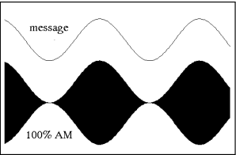

Figure: 1 AM with m=1

A block diagram representation of eqn. (2) is shown in Figure 2 below

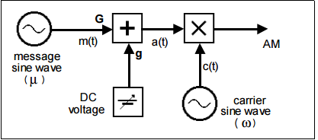
Figure: 2 generation of equation 2
Procedure:
- Open the Matlab and then open the Simulink.
- Draw the model of AM after that start the simulation.
- Note the different graph of modulation and demodulation which appears on window.
- Then check the results which obtained from the graph.
Conclusion:

Q1) What is standard amplitude modulation and multiplications of a signal?

Q2) Why is over modulation is undesirable?

Q3) Draw the output wave form of the AM modulation/De-modulation.

Output:

Name: ----------------------------------------------------

Registration No: --------------------------------------

Lab No: --------------------------------------------------

Date: -----------------------------------------------------

