Art History

Tomb of Hunting and Fishing, 520 BC
- Elaborate murals in the burial chambers, perhaps to keep the spirit happy
- Rhythmic quality similar to Minoan, but not weightless
- Could be influenced by Egyptian tomb paintings, but its more lifelike
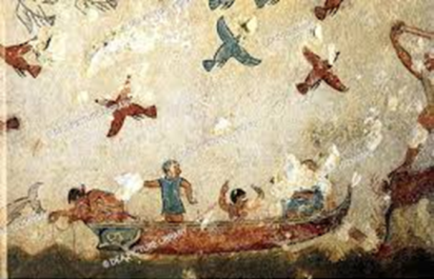
Tomb of the Augurs, Tarquinia
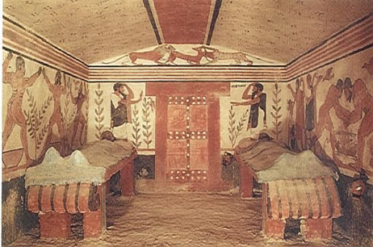

Diver tomb at Paestum (c. 475 BCE)

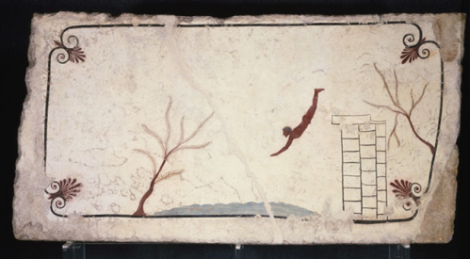
Etruscan Language:
- Etruscan does not belong to the indo- European language group and is completely unique in respect to the rest of Europe.
- Many believe that the Etruscan language is closely related to Basque, Hebrew and Turkish, but it has been concluded that the similarities are simply coincidental.
Etruscan sculpture

Characteristics of Etruscan Sculpture:
- Terra-cotta, stucco, and bronze (sometimes stone)
- Terra-cotta was modeled rather than carved
- Fired large works in kilns
- Shows some awareness of Greek Archaic art – but some differences:

GREEK sculpture:
- Kouros are stoic and proud
- Occasional light smile
- Broad shoulders of men
- Stylized hair
- Nudity

ETRUSCAN sculpture:
- Figures move dynamically in space
- Figures aware of the world around them
- Broad shoulders, stylized hair
- Avoided nudity

Reclining couple on a sarcophagus from Cerveteri
520 BCE. Tera cotta, length 6’7’’
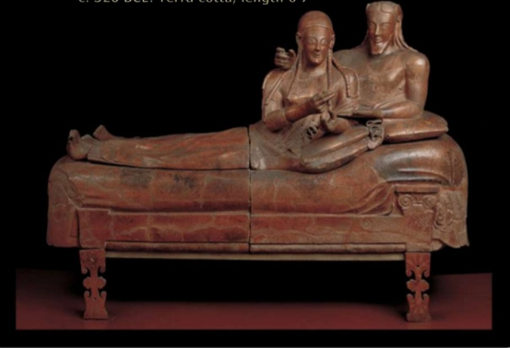
- Sarcophagus of married couple- ashes inside
- Full-length portraits.
- Both held objects in hands- egg (to symbolize life after death)
- Concentration on upper body (legs got little attention when sculpted)
- Bodies make unrealistic L-turn to the legs
- Tradition of reclining while eating- banquet couch
- Man has protective gesture around woman
- Woman is feeding the man (symbiosis)
- Reflects high standing of women in society (relative equality)
- Broad shoulders
- Little anatomical modeling
- Emaciated hands
- Made in separate pieces and joined together

Apollo from Veii, 510 BCE, terra-cotta, 5’ 10”
- Veii had sculptures lining the ridge of the roof (including this one)
- One of four large figures that once stood on the temple
- Stood on roof = meant to be seen from below
- Muscular, details, in motion- more expressive than archaic Greek sculptures of the time
- Has spirit, moves forward quickly
- Archaic smile
- Made of terra cotta
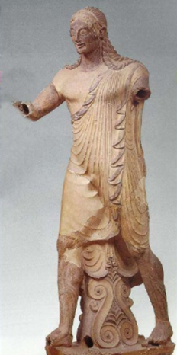
Portrait of a Boy, 3rd century BC
Portraiture showed up only after the influence of the Greeks
Worked in Bronze- sensitive and gentle expression
- Uncovered in Chiuis, Italy
- Bronze sculpture
- The boy appears to be looking away perhaps toward a faraway land
- The Etruscan were famous for their bronze work, created using the lost wax method
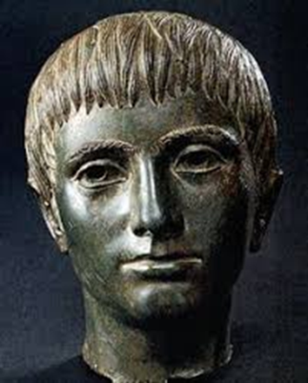
Capitoline Brutus, 300 BCE
- Unearthed in Rome, Italy
- Bronze sculpture
- Considered to be cast by Etruscan artists who were skilled in bronze work, although it represents a famous Roman politician
- Brutus was an early hero of the Roman Republic, not the same person who killed Julius Caesar
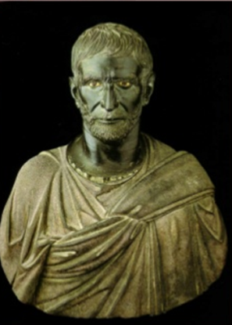

Chimera of Arezzo, 400-350 BCE, bronze
- Composite: lion head and body, goat’s neck springing from spine, snake for a tail
- Angry, snarling, wounded, posed for attack
- Richly articulated anatomy- spike like mane, hurt defensive posture

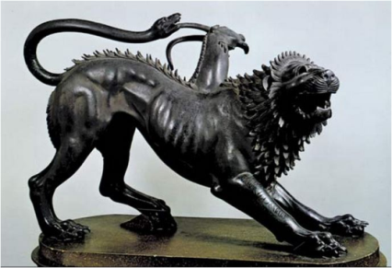

Engraved mirror back, 400 BC
- Became master craftsmen in metal
- Produced small mirrors and statues for domestic use and export
- Probably inspired by Greeks but not Greek subject- winged person looking at a liver of a sacrificial animal
- Etruscans strongly believed in omens- will of the gods manifest itself through natural occurrences (thunderstorms, flights of birds)
- Priests who could interpret omens were revered
- Priests “read” the liver of sacrificed animals to make predictions

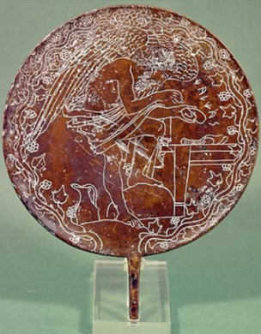
Etruscan pottery:
Bucchero ware, Etruscan earthenware pottery common in pre-Roman Italy chiefly between about the 7th and early 5th century BC. Characteristically, the ware is black, sometimes gray, and often shiny from polishing. Heavy use of bronze and terracotta in pottery.

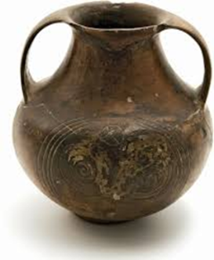
- NECROPOLIS: “city of the dead”- large burial area
- STUCCO: a fine plaster used for wall decorations and moldings
- TERRA-COTTA: hard ceramic clay used for buildings, pottery, sculpture, etc.
- TUMULUS: an artificial mound of earth and stones placed over a grave.

