Iqra National University
Department of Civil Engineering
Mid-Term Examination- 2020
Course Title: Engineering Mechanics Course Code: CE-122
Instructor: M.Majid Naeem Total Marks: 30
_______________________________________________________________________________________________
Note: Attempt all questions.
Q1: Part-(a) two high strength flexible steel cables AB and AC are fastened to the ceiling of a building through high carbon steel hooks at point B & C. These cables are knotted together to a 3rd cable at point A which is holding a thick wall water tank weighting 1200 pounds and is full of 3500 liters of water volume. What percentage of the whole weight is being held by cable BC alone? What amount of tensions must be there in both the cables to maintain the static equilibrium of the system? (7)
Part-(b) if the water tank weight and volume of water are decreased 15% and 35% respectively what effects will occur on results of Part-a. (3)
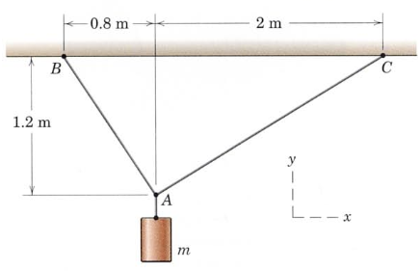
Q2: Find the resultant force and its direction with respect to x-axis and y-axis (Marks=10)
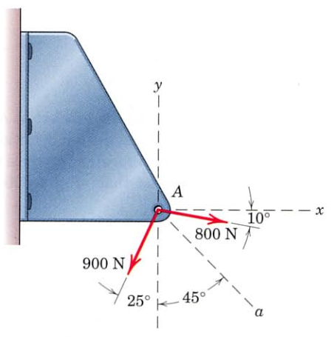

Q3: Calculate the reactions at supports (Marks=10)
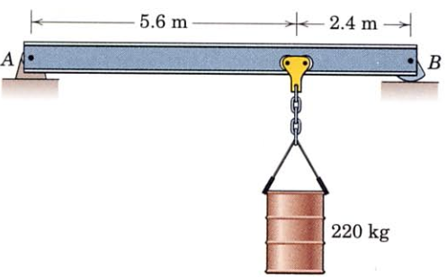
500-lbs
18000-Kg
12-ft
6-ft
4.54-ft
7.5-ft

Reference Material:
- Class Lectures & Videos
- Engineering Mechanics-Statics by Meriam and Kraige (5th Edition)
- Engineering Mechanics – Statics by R.C. Hibbeler, 12th Edition

