Final Term Examination
Subject Name: Electric Circuits
Instructor: M Khalid Hamid
Total Marks: 50
Note: Attempt all Questions
Q1:
- Show with the help of diagram that the current is the same at all points in a series circuit?
- Calculate the voltage across each resistor in the following diagram and find the value of V_{S}. To what maximum value can V_{S} be raised if the current is to be limited to 5 mA?
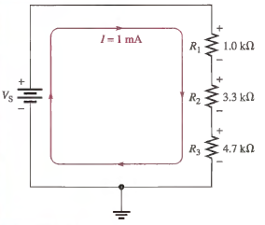

Q2:
- If we connect multiple voltage sources in a parallel circuit, then how to determine the voltage across each parallel branch?
- Determine the voltage across each resistor in the following circuit?
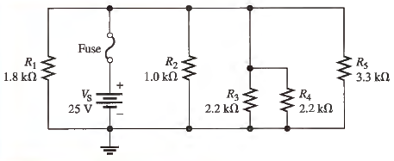

Q3:
- Determine R_{T} of the following circuit between A and B?
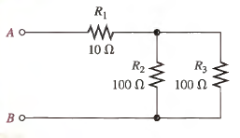

Q4:
- Calculate the load current (I_{L}) in the following circuit for the following values of R_{L}: 100Ω, 560 Ω and 1.0 k Ω.
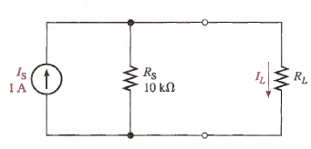

Q5:
Write short note on the following.
- Thevenin Therorem
- Superposition

