Art History
Early Christian Era

Early Christian Art Forms/Motifs
- Frescoes
- Mosaics
- Sculptures
- Illuminated manuscripts

Adaptation of Roman pagan motifs
- Peacock
- Grapevine
- Good Shepherd
- Fish (ikhtus)

Mosaics
- Simple beginnings
- Invented to provide simple and inexpensive flooring
- Pebble mosaics of geometric shapes

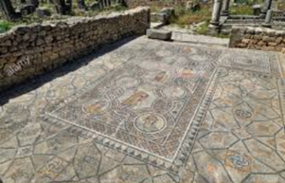 (Gordium floor mosaics, the oldest extant tile mosaic Western Turkey
8th century BC)

- 3rd BC
- Invention of a new kind of mosaic
- Used “tesserae” (Latin for cubes or dice)
- Used to decorate walls and vaults

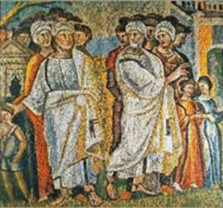 (The parting of Lot and Abraham Mosaic in nave of Santa Maria Magiorre
Rome, Italy)
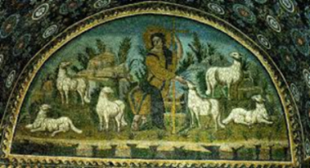 (Christ as the Good Shepherd, mosaic Mausoleum of Galla
Placidia, Ravenna, Italy, 423 AD)

- Tesserae were made of glass so as to reflect light and make the surface sparkle

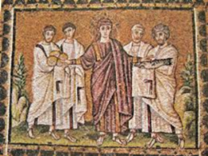 (Miracle of the loaves and fishes Sant’ Apollinare Nuovo Ravenna,
Italy, ca 504)

Illuminated Manuscripts
- Manuscript in which the text is supplemented by the addition of decorations
- Time consuming and costly to produce
- Borders
- Marginalia
- Miniature illustrations
- From Latin, “illuminare” –to light up

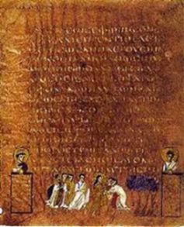 (Sinope Gospels Illuminated Greek Gospel book)

- Gold or silver
- Illuminators were humble craftsmen
- Painter’s guild or book trade guild
- Earliest preserved illuminated book that contains illustrations of the New Testament Christ

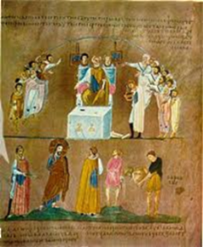 (Christ before Pilate Rossano Gospels, folio 8 6th century)

- Oldest, well-preserved , surviving, illustrated biblical codex
- Probable origin, Syria
- First half of the 6th century
- Written on purple dyed vellum

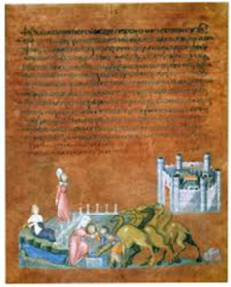 (Vienna Genesis, folio 7 6th century)
Sculptures
(Ivory Carvings)
- Ivory carving – luxury art much admired in the Early Christian period
- Book covers, boxes, chests

(Suicide of Judas and Crucifixion of Christ Plaque
from a box Unknown Roman sculptor 420 AD)
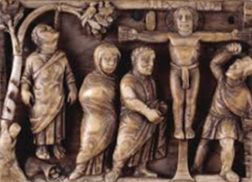

- Early Christian sculptors followed the Greco-Roman example of their time in their works just as the Romans imitated the Greek sculptors. Rather than imitate Greek myths, the Christians sculptors took as their inspiration the Bible.

(Christ as Good Shepherd, 300’s AD, Rome)
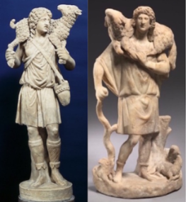 (Christ as Good Shepherd,
200’s AD, Asia Minor)

- The Sarcophagus of Junius Bassus is very famous in art circles and has been described as “probably the single most famous piece of early Christian relief sculpture.”
- This ancient sarcophagus is in the manner of the Greco-Roman art of its time with an individual twist by the sculptor. The themes are Biblical rather than mythic.
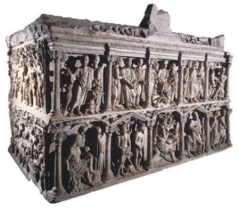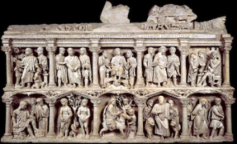

Fresco Paintings
- Artists worked with more expensive media as the wealthy converted to Christianity. More space allowed for artists to complete narratives in both fresco and relief. Some of these were very extensive in scale and detail.

- The apses of the basilicas used their large space to house figures of Christ or the Virgin Mary, or sometimes iconic frescos.
- An early representation of Christ found in the Catacomb of Domitilla shows the figure of Christ flanked by a group of his disciples or students. It conveys rather the idea that Christ is the true teacher.
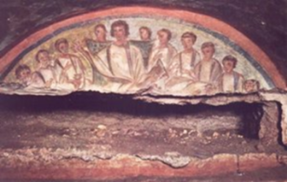
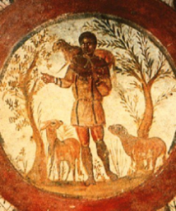 (The Good Shepherd, Catacombs of Rome, 3rd C)

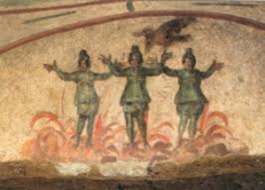 (Three Youths in the Fiery Furnace – Catacomb of Priscilla)
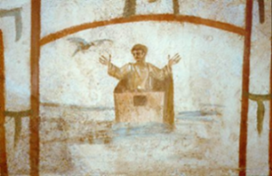 (Noah Praying in the Ark – Roman Catacombs)

Pottery
- Early Christian also created some metallic pieces, with a focus on silver chalices and other vessels, and also reliquary.

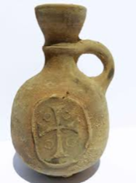 (Biblical Ancient Terracotta Holy Land pottery)

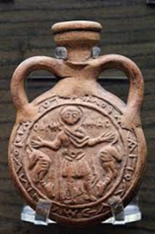 (Clay jar (AMPULLAE) representing Saint Mena flanked by two camels)

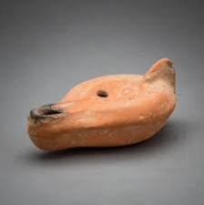 (Early Christian Terracotta Oil Lamp)

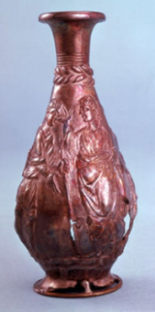 (Early Christian Silver Vase)

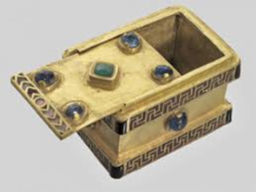 (Early Christian reliquary)

Early Christian Art Top Works

- Sarcophagus of Junius Bassus 359 AD
- Dome mosaic at the Church of Sant’Apollinare in Classe
- Ravenna Mosaics
- Moses Striking the Rock
- Three Youths in the Fiery Furnace – Catacomb of Priscilla
- Adoration of the Magi on third-century catacomb cover
- Noah Praying in the Ark – Roman Catacombs

