Art History
Early Christian Era

- Christianity had its birth in Judaea, an eastern province of the Roman Empire, spread and carried by St. Peter, St. Paul and other missionaries to Rome, as the center of the World – Empire.

- Around 331 AD the Christ was called a Nazorean from the name Nazareth, and that in earlier centuries "Christians" were once called "Nazarenes.’’

- The Early Christian period is generally taken as lasting from Constantine to the death of Gregory the Great (A.D. 604), although in Rome and many Italian cities it continued up to the tenth century.

- Early Christianity is generally reckoned by church historians to begin with the ministry of Jesus ( c. 27-30) and end with the First Council of Nicaea (325). It is typically divided into two periods: the Apostolic Age ( c. 30–100, when the first apostles were still alive) and the Ante-Nicene Period ( c. 100–325).

Christianity Beliefs:

- Christians are monotheistic, i.e., they believe there's only one God, and he created the heavens and the earth. This divine Godhead consists of three parts: the father (God himself), the son (Jesus Christ) and the Holy Spirit.

- The religion had schisms and theological disputes that had as result four main branches: the Roman Catholic Church, the Eastern Orthodox churches, Oriental Orthodoxy and Protestant churches. Most of the first Christians were ethnically Jewish or Jewish proselytes. An early difficulty came from non-Jewish converts.

- Christianity suffered disabilities upon the division of the Roman Empire, which first took place in A.D. 365 when Valentinian became Emperor of the West and his brother Valens of the East.
- 286 A.D. Emperor Diocletian reorganizes the Roman Empire splitting it into two; the Eastern and Western part.
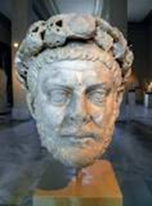 (Diocletian (284- 305)

- The number of Christian communities established by the Apostle Paul in his missionary journeys round the Eastern Mediterranean, in Syria, Africa, Greece, and Italy.

- First emperor, Constantine changed the capital of the Empire from Rome to Byzantium in A.D. 324, when the old Roman political system came to an end, and reigned as an absolute monarch till his death in A.D. 337.
- In A.D. 313 Constantine issued his celebrated decree from Milan, giving Christianity equal rights with other religions.
- In A.D. 323 he himself professed Christianity, which became the official religion of the Roman Empire, and the Christians then began to build churches of a type suit-able to their needs and ritual.

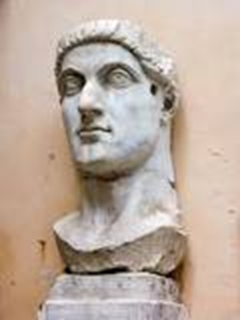 (Colossal marble head of Emperor Constantine the Great, Roman, 4th century)

- Supported the church financially.
- Had a large number of basilicas built
- Granted privileges (tax exemptions) to clergy.
- Promoted Christians to high-ranking offices.
- Returned properties confiscated during the Great Persecution of Diocletian.
- Endowed the Church with land and other wealth.
Other Legacies:
- Abolished Crucifixion for reasons of Christian piety
- Declared Sunday as the official rest day.
- Publicly displayed gladiatorial games were ordered to be eliminated in 325 AD.

House Church
The first house church is where the disciples of Jesus met together in the "Upper Room" of a house. For the first three centuries of the church, known as Early Christianity, Christians typically met in homes, if only because intermittent persecution (before the Edict of Milan in 313) did not allow the erection of public church buildings. Clement of Alexandria, an early church father, wrote of worshipping in a house. The Dura-Europos church was found to be used as a Christian meeting place in AD 232, with one small room serving as a baptistery. At many points in subsequent history, various Christian groups worshipped in homes, often due to persecution by the state church or the civil government.

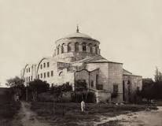 (Hagia Eirene, the first church commissioned by Constantine in
Constantinople)

Early Christian Art and architecture or Paleochristian art is the art produced by Christians or under Christian patronage from the earliest period of Christianity to, depending on the definition used, sometime between 260 and 525. ... Early Christianity used the same artistic media as the surrounding pagan culture.

- They provide an important record of some aspects of the development of Christian subject matter. The earliest Christian iconography tended to be symbolic. The single most important social phenomenon of the Early Christian period was the spread and acceptance of the Christian Religion.

- The Early Christian style was a rejection of the classical style in sculpture and painting. It sought to replace the classical style with a non-naturalistic, hieratic aesthetic that featured wafer-thin, frontal figures on gold backgrounds.

- Christianity has extended its influence to many works of Western art. Artists use their artworks to express their own faith or to describe Biblical events and views on Christianity. ... Some works are dramatic and emotional, used to make the viewer feel a sense of love, fear, or respect for Christianity.

- The term “Early Christian Architecture” refers to the architecture of the early Christian Churches of the Roman Era. When Christianity widely accepted as a state religion in Rome, it was necessary for Architecture to respond to the demands of the religion for worship space.

Architecture
- Early Christian architecture at Rome was influenced by, and was the logical outcome of, existing Roman architecture, modified in other parts of the empire according to the type already recognized as suitable for the geographical situation of those countries, such as Syria, Asia minor , north Africa, and Egypt
- Geological influences may be said to have acted indirectly on Early Christian architecture for the ruins of roman building often provided the quarry where obtained. This influenced the style, both as regards construction and decoration
- The Early Christian Architecture started in two (2) prominent locations at ROME and CONSTANTINOPLE
- Purpose of the Christian church was to shelter worshippers who met for prayer and praise to an unseen Deity, and, during the unsettled conditions at the beginning of Christianity, various places were adapted for this worship
- Building of pagan temples ceased before any attempt was made to build Christian churches.
- Columns and other architectural features, as well as fine sculptures and mosaics from older building, were incorporated into basilican churches of the new faith.
- Early Christian architecture may be taken to have lasted from about 300 to 600 AD.
- The Early Christians, as Roman craftsmen, continued old Roman traditions
- Utilized as far as possible the materials from Roman temples which had become useless for their original purpose for their new buildings.
- Their churches, modeled on Roman basilicas, used old columns which by various devices were brought to a uniform height.
- Early Christian buildings hardly have the architectural value of a style produced by the solution of constructive problems.

The requirements include:
- A path for processional entry and exit clergy.
- An altar area, where the clergy celebrate mass
- A space for the segregation of the clergy from the congregation during procession and communion.
- Burial space

Early Christian Churches were further divided into two:
- Basilica Church
- Alternative Church Plans

Basilica Church
- The early churches were generally simple and functional in their design.
- The emphasis was centered on the act of Christian worship.
- The form chosen for the early church was the Roman Basilica.
- The architecture of the church that developed was not a completely new style, but the use of available Roman forms to satisfy a new program need.
- It was suitable for use as a church with no serious modification and it could be easily and rapidly built at low cost.
- The Basilica was also preferred because of the emphasis on participation in mass.
- The most common form of the early churches had a rectangular hall with a timber trussed roof.
- It also had one or two isles on each side of a central nave and an apse at one end facing the principal entrance located at the other end.

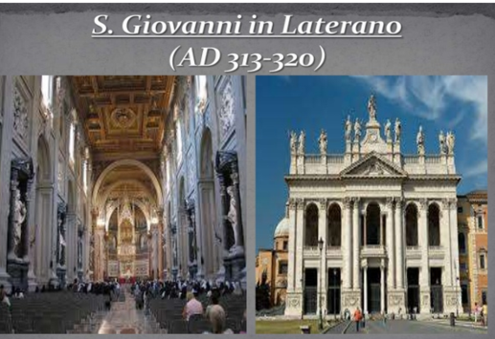 (S. Giovanni in Laterano or known as St. John Lateran Basilica
A.D. 313-320)

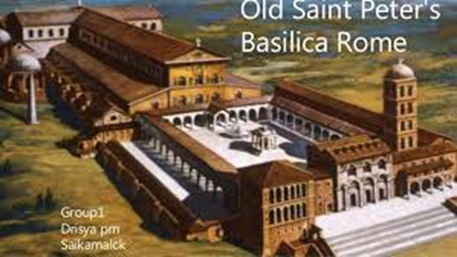 (S. Peter’s, Rome also known as St. Peter’s Basilica A.D. 333)

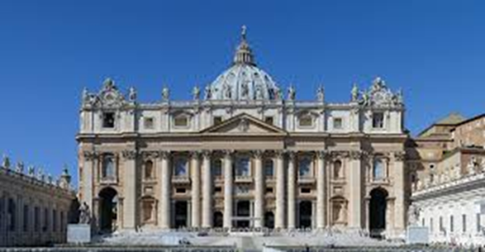
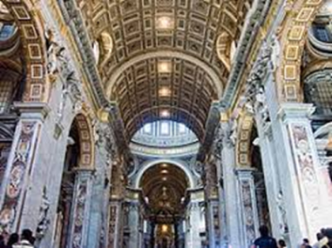

Alternative Church Form
- Alternative more centralized plans, with a focus on a central vertical axis rather than longitudinal horizontal one were also adopted occasionally
Baptistery Church Form
- The Baptistery of Constantine, Rome (A.D. 430-440) built near the Lateran church of Sixtux III, and not by Constantine to whom it is generally attributed is among the oldest of Italian baptisteries, of which it was probably the model
- In Christian architecture the baptistery, is the separate centrally-planned structure surrounding the baptismal font. The baptistery may be incorporated within the body of a church or cathedral and be provided with an altar as a chapel.

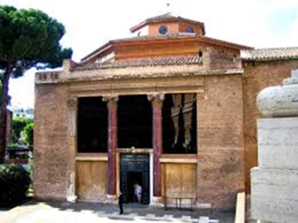 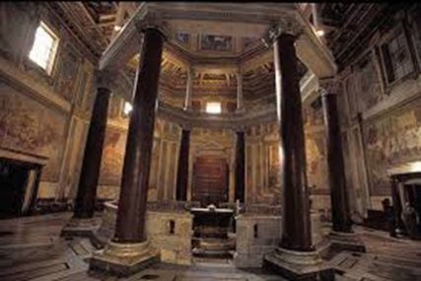 (Lateran Baptistery, the first structure
expressly built as a baptistery)
Mausoleum
- Monumental form of tomb.
- A mausoleum is a house of the dead, although ii is often as much a symbol as a sepulcher.
- This term has been employed for large, monumental, and stately tombs, usually erected for distinguished or prominent individuals

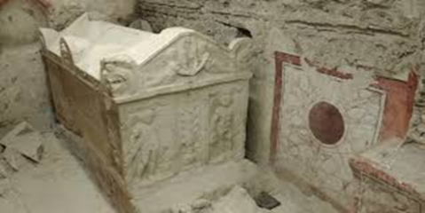

Catacombs
- Hundreds of miles of Catacombs found under city of Rome…..some five stories deep….millions of bodies
- Christians, Jews and pagans used these burial grounds because they were a cheaper alternative to above-ground burial.
- Christians didn’t like cremation- preferred burial because it symbolized Jesus’s rising from the dead, body and soul.
- Wealthy people buried in mortuary chapels called CUBICULA.
- Poor people placed in LOCULI.

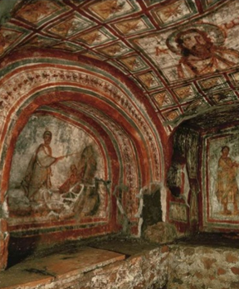 (Cubiculum of Leonis, catacomb of Commodilla, Near Rome. Late 4th Century)

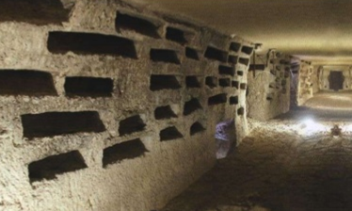 (Loculi, catacomb)

