EXPERIMENT: Performing Charpy Impact Test on Steel Sample

Scope:
- This experiment covers the determination of energy absorbed by a steel sample before breakage.

Significance:
- The ability of a material to absorb energy due to impact load is of concern when a structure is expected to experience impact loads in its life. Loads due to traffic movement on bridges and those resulting from blast in a building are common examples of impact loads on a structure. The structures are thus required to absorb the energy imparted by such impact loads. This experiment is aimed at studying the ability of a steel sample to absorb energy when subjected to impact load.

Related terminology:

Impact load:
- Impact load is a very large load applied in a very short time.

Apparatus:
- Charpy Impact testing machine
- Steel sample
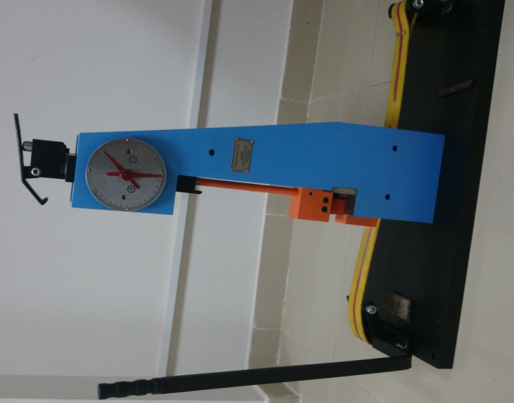 | 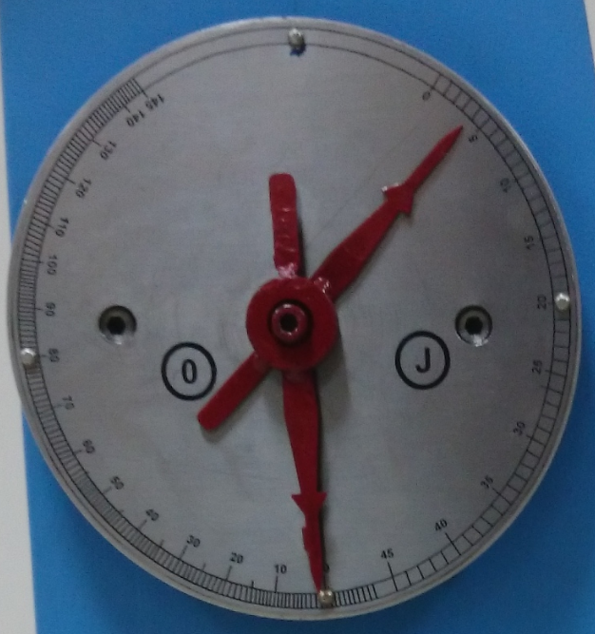
Fig. Charpy impact testing machine

Procedure:
- Lock the hammer of charpy impact testing machine.
- Set the energy needle at exactly vertically downward position and angle needle at zero.
- Unlock the hammer to let it swing freely. Apply brakes to the hammer to stop it and lock the hammer.
- Note down the reading marked by energy needle on energy scale. This is free swing energy.
- Place the steel sample on the sample platform.
- Unlock the hammer to let it swing breaking the steel sample.
- Apply brakes to stop the hammer.
- Note the reading marked by energy needle on energy scale.
- Find the difference between the free swing energy and energy reading obtained in the above step for the steel sample. This is the energy absorbed by the sample.

Observation and calculation:

Free swing energy  (Joule) | Energy with sample breakage  (joule) | difference  (joule)

Report:
- Energy absorbed by the steel sample = Joule

Keywords
- Impact, Charpy, Energy absorbed, steel

Safety instruction and additional precautions:
- Do not stand in the swing path of the hammer.
- Do not in expected direction of motion of piece of steel sample.
- Do not try to stop the hammer by holding the swinging hammer in hands. Always use brakes to stop the hammer.
Let hammer rest in vertically downwards position when done with the experiment. A locked hammer if unlocked unintentionally can cause injury to person in the swinging path of the

