Computer Communication & Networks
Lecture 10, 11
Dynamic Routing

Advantages of Dynamic over static:
• There is no need to know the destination networks.
• Need to advertise the directly connected networks.
• Updates the topology changes dynamically.
• Administrative work is reduced
• Used for large organizations.
• Neighbor routers exchange routing information and build the routing table
automatically.

Types of Dynamic Routing Protocols
• Distance Vector Protocol
• Link State Protocol
• Hybrid Protocol

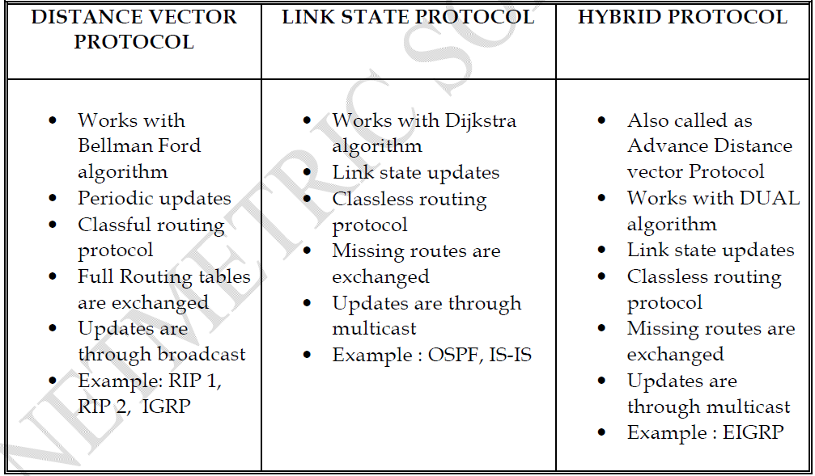

Routing Information Protocol v1
Open Standard Protocol
• Classful routing protocol
• Updates are broadcasted via 255.255.255.255
• Administrative distance is 120
• Metric : Hop count
Max Hop counts: 15 Max routers: 16(which is unreachable)
• Load Balancing up to 4 equal paths
• Used for small organizations
• Exchange entire routing table for every 30 seconds

Rip Timers
Update timer : 30 sec
– Time between consecutive updates
Invalid timer : 180 sec
– Time a router waits to hear updates
– The route is marked unreachable if there is no update during this interval.
Flush timer : 240 sec
– Time before the invalid route is purged from the routing table

RIP Version 2
• Classless routing protocol
• Supports VLSM
• Auto summary can be done on every router
• Supports authentication
• Trigger updates
• Uses multicast address 224.0.0.9.

Advantages of RIP
– Easy to configure
– No design constraints
– No complexity
– Less overhead

Disadvantage of RIP
– Bandwidth utilization is very high as broadcast for every 30 second
– Works only on hop count
– Not scalable as hop count is only 15
– Slow convergence

Configuring RIP 1
Router(config)# router rip
Router(config-router)# network <Network ID>

Configuring RIP 2
Router(config)# router rip
Router(config-router)# network <Network ID>
Router(config-router)# version 2

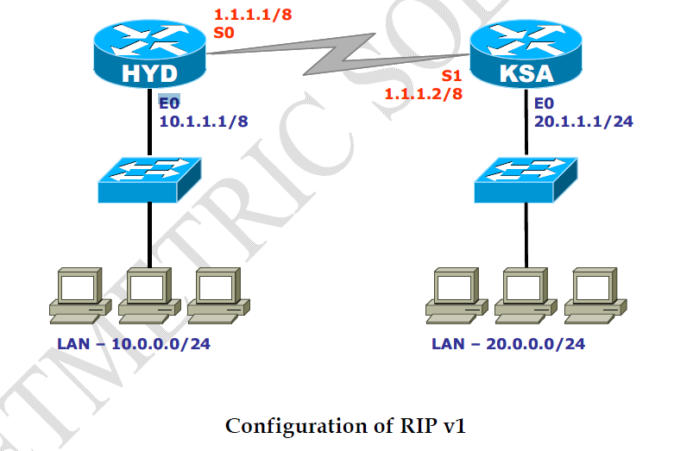

On Hyderabad Router

HYDERABAD # config t
HYDERABAD(config) # router rip
HYDERABAD(config-router) # network 10.0.0.0
HYDERABAD(config-router) # network 1.0.0.0
HYDERABAD(config-router) # exit
HYDERABAD(config) # exit

On KSA Router
KSA # config t
KSA(config) # router rip
KSA(config-router) # network 20.0.0.0
KSA(config-router) # network 1.0.0.0
KSA(config-router) # exit
KSA(config) # exit

CONFIGURATION OF RIP V2
On Hyderabad Router
HYDERABAD # config t
HYDERABAD(config) # router rip
HYDERABAD(config-router) # network 10.0.0.0
HYDERABAD(config-router) # network 1.0.0.0
HYDERABAD(config-router) # Version 2
HYDERABAD(config-router) # exit
HYDERABAD(config) # exit

On KSA Router
KSA # config t
KSA(config) # router rip
KSA(config-router) # network 20.0.0.0
KSA(config-router) # network 1.0.0.0
KSA(config-router) # Version 2
KSA(config-router) # exit
KSA(config) # exit

Administrative Distance:
It is the trustworthiness of the information received by the router.
The number is between 0 and 255.
Least value is more preferred.
Default administrative distances are as follows:

Directly connected=0
Static Route=1
IGRP=100
OSPF=110
RIP=120
EIGRP=90/170
IS-IS=115

ACCESS CONTROL LIST

• ACL is a set of rules which will allow or deny the specific traffic moving through the router
• It is a Layer 3 security which controls the flow of traffic from one router to another.
• It is also called as Packet Filtering Firewall.

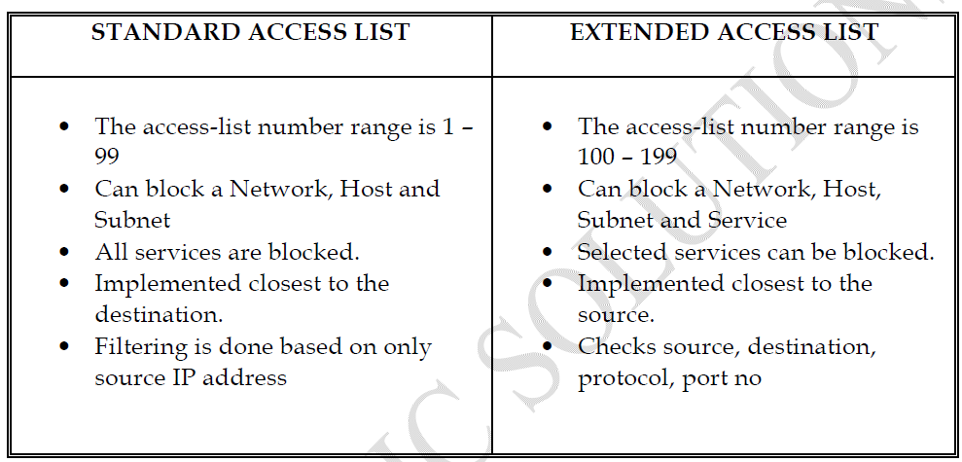

Rules of Access List
•All deny statements have to be given First
• There should be at least one Permit statement
• An implicit deny blocks all traffic by default when there is no match (an invisible statement).
• Can have one access-list per interface per direction. (i.e.) Two access-lists per interface, one in inbound direction and one in outbound direction.
• Works in Sequential order
• Editing of access-lists is not possible (i.e) selectively adding or removing access list statements is not possible.

Wild Card Mask
Tells the router which addressing bits must match in the address of the ACL statement.
• It’s the inverse of the subnet mask, hence is also called as Inverse mask.
• A bit value of 0 indicates MUST MATCH (Check Bits)
• A bit value of 1 indicates IGNORE (Ignore Bits)
Wild Card Mask for a Host will be always 0.0.0.0
• A wild card mask can be calculated using the formula :
Global Subnet Mask
– Customized Subnet Mask
-------------------------------
Wild Card Mask
E.g.
255.255.255.255
– 255.255.255.240
---------------------
0. 0. 0. 15
Creation of Standard Access List
Router(config)# access-list <acl no> <permit/deny> <source address>
<source WCM>

Implementation of Standard Access List
Router(config)# interface <interface type> <interface no>
Router(config-if)# ip access-group <number> <out/in>

To Verify :
Router# show access-list
Router# show access-list <no>

Creation of Extended Access List
Router(config)# access-list <acl no> <permit/deny> <protocol>
<source address> <source wildcard mask>
<destination address> < destination wildcard mask> <operator>
<service>

Implementation of Extended Access List
Router(config)#interface <interface type> <interface no>
Router(config-if)#ip access-group <number> <out/in>

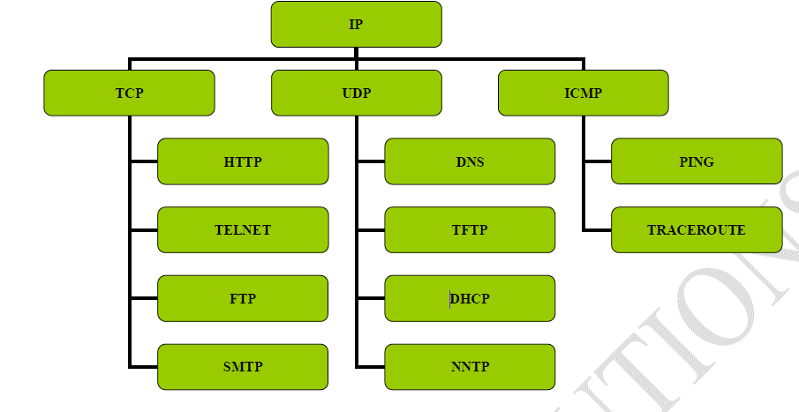
Operators :
eq (equal to)
neq (not equal to)
lt (less than)
gt (greater than)

Named Access List
• Access-lists are identified using Names rather than Numbers.
• Names are Case-Sensitive
• No limitation of Numbers here.
• One Main Advantage is Editing of ACL is Possible (i.e) Removing a specific statement
from the ACL is possible.
(IOS version 11.2 or later allows Named ACL)

Creation of Standard Named Access List
Router(config)# ip access-list standard <name>
Router(config-std-nacl)# <permit/deny> <source address> <source wildcard mask>

Implementation of Standard Named Access List
Router(config)#interface <interface type><interface no>
Router(config-if)#ip access-group <name> <out/in>

Creation of Extended Named Access List
Router(config)# ip access-list extended <name>
Router(config-ext-nacl)# <permit/deny> <protocol> <source address>
<source wildcard mask> <destination address>
< destination wildcard mask> <operator> <service>

Implementation of Extended Named Access List
Router(config)#interface <interface type><interface no>
Router(config-if)#ip access-group <name> <out/in>
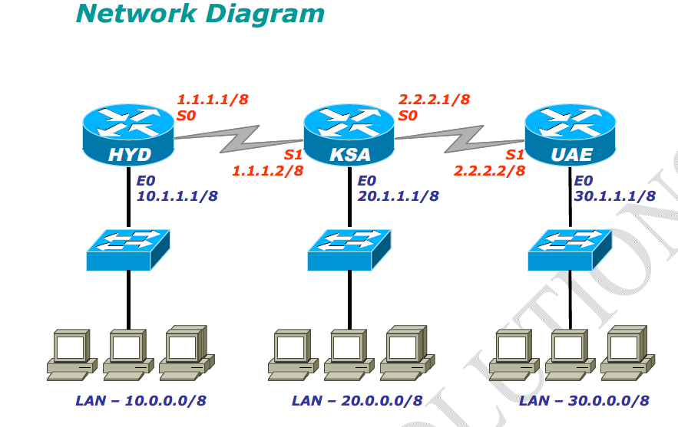

STANDARD ACCESS-LIST

Lab-1 Requirement
1. Entire 20.0.0.0 network should be denied
2. Host 30.1.1.2 and 30.1.1.3 from UAE lan should be denied

Creation of ACL :
HYD (config) # access-list 5 deny 20.0.0.0 0.255.255.255
HYD (config) # access-list 5 deny 30.1.1.2 0.0.0.0
HYD (config) # access-list 5 deny host 30.1.1.3
HYD (config) # access-list 5 permit any

Implementation
HYD (config) # interface fa0/0
HYD (config-if ) # ip access-group 5 out

Lab 2 :

Restricting telnet access to the router to specified networks or hosts
Creation of ACL :
HYD (config) # access-list 10 pemit host 10.1.1.2
HYD (config) # access-list 10 pemit host 10.1.1.3

Implementation
CHE (config) # line vty 0 4
CHE (config-line) # access-class 1 in
CHE (config-line) # exit
CHE (config) # exit

Extended ACL

Lab Requirment
1. 10.1.1.2 should not ping 20.1.1.2
2. 30.0.0.0 NETWORK should not access 10.1.1.2 web service

On HYD:
HYD # config terminal
HYD (config) # access-list 100 deny icmp 10.1.1.2. 0.0.0.0 20.1.1.2 0.0.0.0 echo
HYD (config) # access-list 100 deny tcp host 10.1.1.2 30.0.0.0 0.255.255.255 eq 80
HYD (config) # access-list 100 permit ip any any

Implementation
HYD (config) #interface fa0/0
HYD (config-if) # ip access- group 100 in
HYD (config-if) #exit
HYD (config) # exit
HYD # sh ip access-list

LAB Restricting Telnet Access

