Fall 2020 Mid-Term Assignment
Course Name | Max. Marks | Max. Time | Date | Instructor
Business Process Engineering | 30 | 6 Days | 20/4/2020 | Aasma Khan

- Attempt all questions.
- Marks will be given as per the DEPTH of the answer, not LENGTH.
Question No: 01 (5)
Briefly explain different process types and illustrate it using figure and explain the difference among value added, non-value added and control activities with example.

Question No: 02 (10)
Below is the example of Claim Handling in a Large Insurance Company, Figure 1 is for the existing design and Figure 2 is for new recommended design, identify the procedural and structural changes with the new recommended design.

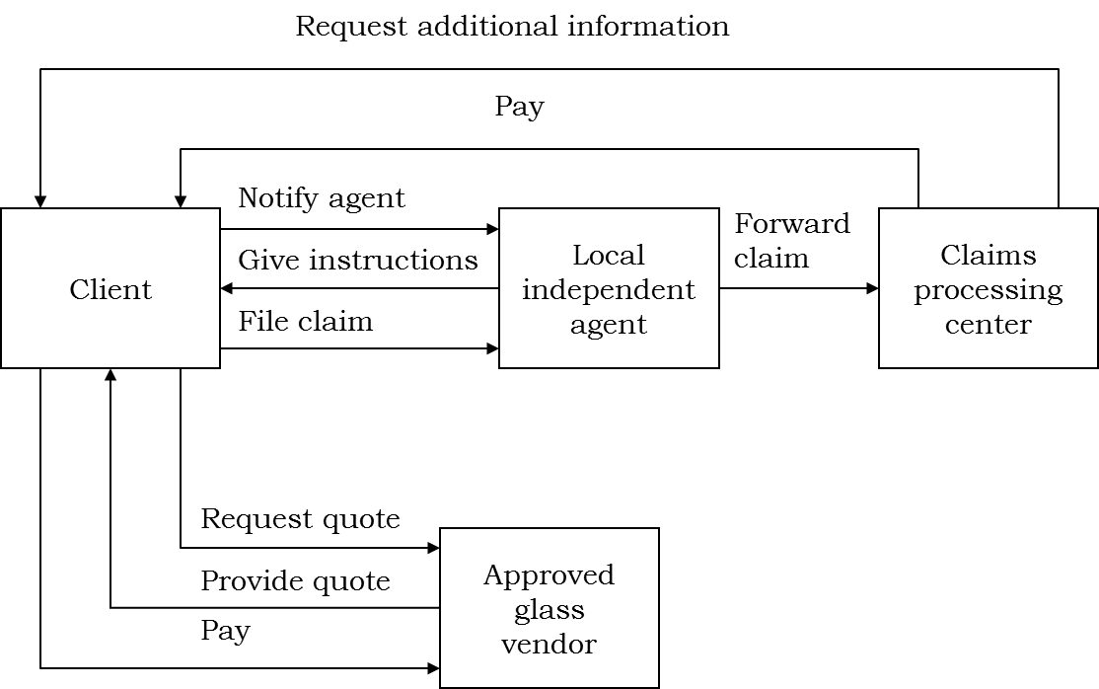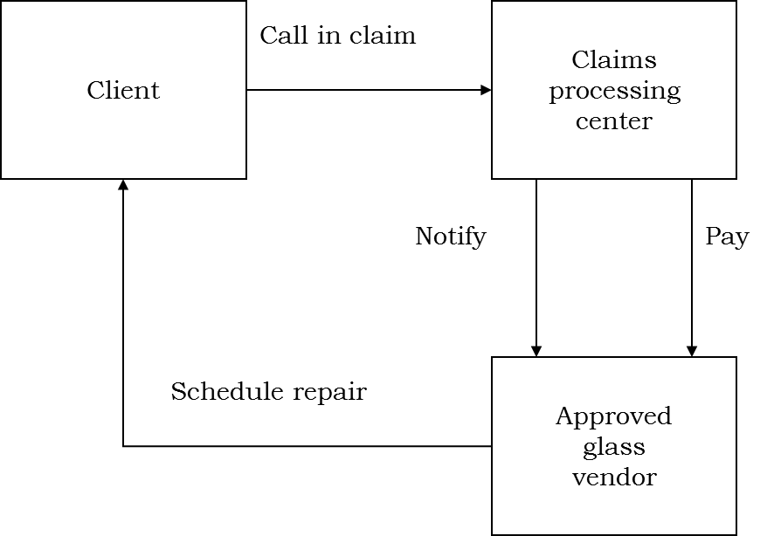
Figure 1 Figure 2

Question No: 03 (5+5+5)
a) Explain CPS model with figure and why we use it?
b) When it is needed to re-engineer Business Process Re-engineering?
c) List down any 5 conceptual process design principles and give their basic theme.

Good Luck

