Assignment/Quiz

Q.1 a): There are two well-known formulae for calculating the total resistance of parallel-
connected resistances. One of these works only for two resistances while the other works
for any number of parallel resistances. Write these two formulae.

b): A quantity often useful in electric circuit analysis is conductance, defined as the
reciprocal of resistance;
G$=\frac{1}{R}$
In a series circuit, resistance increases and conductance decreases with the addition of
more resistors;
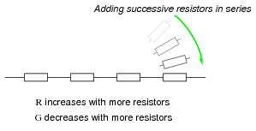
Describe what happens to total resistance and total conductance with the addition
of parallel resistors;
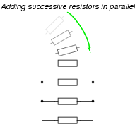

Q.2: In the given circuit, three resistors receive the same amount of voltage (24 volts) from
single source. Calculate the amount of current “drawn” by each resistor, as well as the
amount of power dissipated by each resistor;

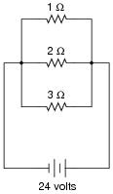

Q.3: Differentiate between the following;

- Current & Voltage.
- Resistance & Conductance.
- Power & Energy
- Inductance & Capacitance
- Synchronous motor & Asynchronous motor.

Good Luck……….

