IQRA NATIONAL UNIVERSITY, PESHAWAR

Compiler Construction

Program: BSCS Major Assignment Semester: Fall-2020

Maximum Marks: 30 ODD ROLL NUMBERS Time Allowed: 3 hrs

  - Construct regular expression defining each of the following language over the alphabet Σ={a, b} .
    - All words having odd length
    - All words having at least two as and two bs
    - All words having at least triple a or double b
    - All words starts with double a or triple b. (10)

  - For figure 3 if q0 is the initial state, the draw a transition table for it. (5)
  - Define what is Finite Automaton. What can be the regular expression of the diagram given in figure 1. (5)

  - Draw a transition table for the diagram given in figure 2. (0) is the starting state and (dotted lines) are the dead transition states which can be ignored. (10)

Figure 1:

y
a

x –
b

Z+
a,b
a,b

Figure 2:

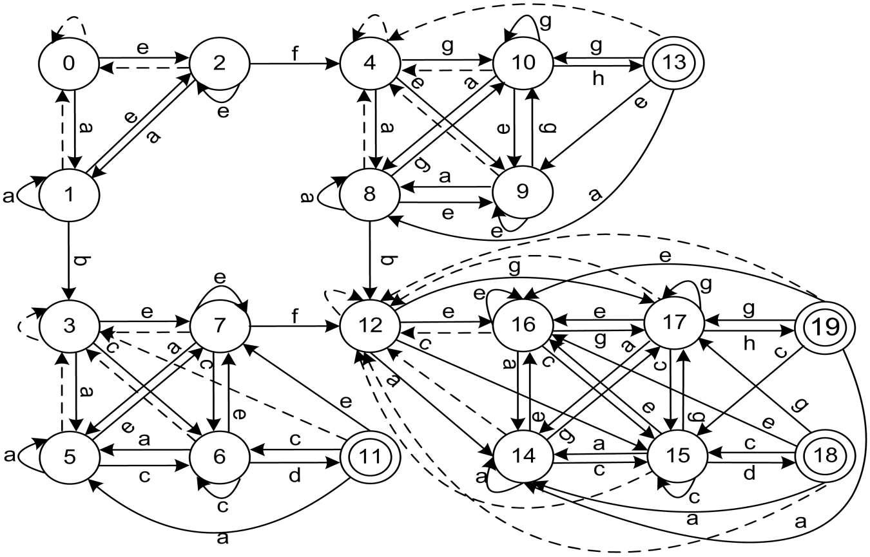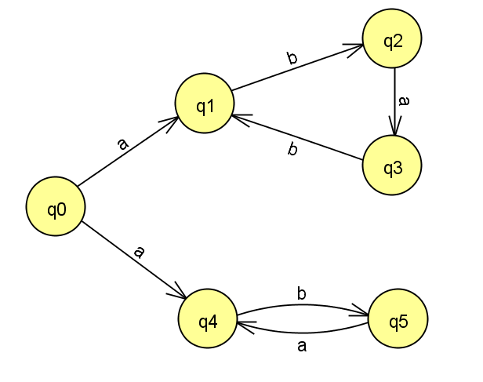
Figure 3

