Iqra National University
Computer Science Department

Course Title: Database Systems
Assignment # 2

Q1: Simply Re-draw and take screenshot of below ERD using Lucidchart.com (https://www.lucidchart.com/pages/er-diagrams) Crow’s foot notation and based on following business rules.

A salesperson may manage many other salespeople. A salesperson is managed by only one salespeople. A salesperson can be an agent for many customers. A customer is managed by one salespeople. A customer can place many orders. An order can be placed by one customer. An order lists many inventory items. An inventory item may be listed on many orders. An inventory item is assembled from many parts. A part may be assembled into many inventory items. Many employees assemble an inventory item from many parts. A supplier supplies many parts. A part may be supplied by many suppliers.

Q2: Following is an Example of ERD which has attributes.
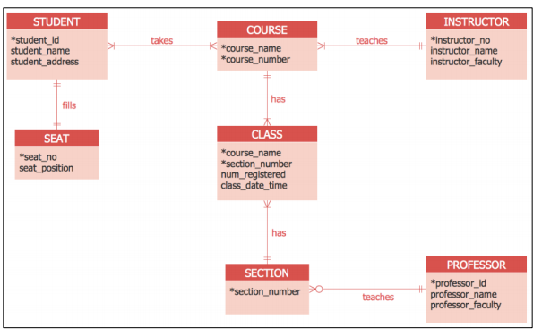

Now using the following business rules create your own ERD diagram on paper and take a picture of it. Or create on Lucid chart or on draw.io.

Following requirements for a simple database for the National Hockey League (NHL):
- the NHL has many teams,
- these teams only belong to NHL
- each team has a name, a city, a coach, a captain, and a set of players,
- each player belongs to only one team,
- each player has a name, a position (such as left wing or goalie), a skill level, and a set of injury records
- NHL has an official website.
- The website has a unique URL and title.

