ATM Forum Interface

The ATM Forum interface reference architecture identifies a series of management interfaces numbered Ml through M5.
ii. M1 and M2 are the interfaces between a private NMS and either an end user or a private network, respectively. The end user can be a workstation, ATM switch, or any ATM device. A private ATM network is an enterprise network.
iii. A private network management system can access its own network-related information in a public network via an M3 interface to the public network management system.
iv. The public NMS responds to the private NMS via the M3 interface with the relevant information or takes the action requested.
v. The M4 interface is between the public NMS and the public network. The final interface, M5, is between the NMSs of two service providers. The ATM Forum has not yet specified this interface.
vi. The ATM framework defines five different M-interfaces for management see Figure 1.
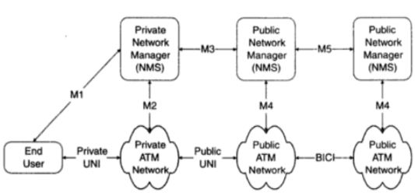
The ATM Forum Management Interface Reference Architecture
- The ATM Forum Management Model:
i. The Network Management Working Group of the ATM Forum has developed an end-to-end generic management model that encompasses private and public networks and lays out standards for interworking between them.
ii. The model defines gateways between SNMP and CMIP systems, and between standards-based and proprietary systems.
iii. Five key management interfaces are defined in this model, labelled M1-M5.
iv. M1 is concerned with the management of the end-user equipment connecting to either private or public switches.
v. M2 undertakes management of private ATM switches and networks. Private ATM network management is addressed through M1 combined with M2. M4 deals with their public ATM switches and networks. M3 is the link between private and public networks, used for exchanging fault, performance and configuration information.
vii. Finally, M5 supports interactions between any two public networks. The definition of these interfaces allows a complete management service, ranging from a global view of the network (M5 management interface) to the management of individual elements (M1 management interface).
viii. In some cases, several management interfaces use the same information from a management information base (MIB) tree, see Table1.
Types | Interaction | Purpose | Services | Protocol
M1 | CPE / NMS | Management of user terminal equipment | - | SNMP
M2 | P-Switch / NMS | Management of the ATM private network | Similar to M4 | SNMP
M3 | NMS / NML | Management interaction between private and public domains | i.,Public network configuration and status gathering., ii.,Add & deletion of pre-authorized VCs., iii.new connection request | SNMP
M4 | NML / EML or,EML / NE | Management of NE's and EMLs | i.,Fault and performance management, ii.,Configuration and circuit provisioning, iii.,accounting | CMIP,(Q3),or SNMP
M5 | NML / NML | Management interaction between different owned public domains | Cross public network management | No standard yet
ILMI | Private/public | Service control | Service activation, service assurance (maintenance), usage metering (performance, billing) | ILMI - SNMP
Table1: Management Interface
- M1 Interface: Management of ATM Network Element
i. The M1 interface is between an SNMP management system and an SNMP agent in an ATM device, as shown in Figure2.
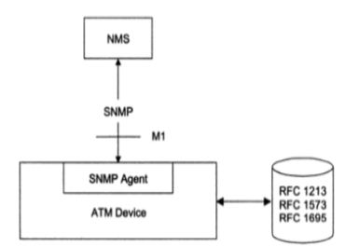
SNMP ATM Management (M1 Interface)
ii. Four entities, ifInNUcastPkts, ifOutNUcastPkts, ifOutQLen, and ifspecific have been deprecated. The interfaces (interfaces) and ifMIB (IF MIB) groups under the mgmt. node.
- M1/M2 Interfaces and the ILMI Implementation:
i. Interim Local Management Interface (ILMI), which is an implementation of the M I /M2 interfaces, enables the exchange of status, configuration, accounting and control information between any two ATM devices - such as two ATM switches - across a user-to-network interface (UNI).
ii. For ILMI to function, every ATM switch or network terminator and every ATM network that deploys a public or private network UNI must be equipped with a UNI Management Entity (UME) which supports an ILMI MIB.
iii. Two adjacent (or peer) UMEs can communicate using the common attributes provided by the ILMI.
iv. By sending SNMP commands, a UME may obtain or modify (if the object is indeed modifiable) information contained in its ILMI MIB.
v. The ILMI has been deployed by some vendors to perform management tasks across the UNI for some devices. However, since the ILMI provides a solution that is applicable only at the UNI, it cannot support the management tasks that are involved in a network comprising a range of ATM devices.
- M4 Interface: Public Network Management
i. The management of public ATM network is primarily the responsibility of network service providers, carriers and Postal Telephone and Telegraph (PTT) companies.
ii. They have the challenge of not only managing the public network, but also keeping up with new technology.

