Assignment
Program: BBA/MBA Assignment (Spring-2020)
Dated: 16th May, 2020 Time allowed: 30th May, 2020
Course Title: Project Management Instructor: Zaighum Abbas
Note: Attempt All Questions Total marks: 20
________________________________________________________________________________
Note: This Assignment should be attempted by word or PDF file. After making a word or PDF file upload this file through SIC portal in an assignment section. You have a limited time till 05 June which will automatically closed after the completion of timeline. No file will be accepted after the given time line.

Q1.
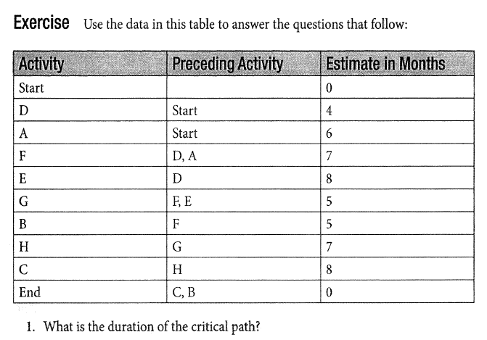.
(Plagiarism from one source should not be more than 5% and overall should not be more than 19%) (20 Marks)

