Mid Semester Assignment
Spring 2020
Subject: Telecom Networks and Protocols
Note: Attempt all questions.
Q1: We measure the performance of a telephone line (4kHz of bandwidth). When the signal is 10V, the noise is 5mV. What is the maximum data rate supported by this telephone line?
Q2: What is the difference between direct dialing-in in which there are multiple ISDN numbers, one for each of multiple S reference points and the use of multiple ISDN numbers at a single T reference point?
Q3: Write your comments on the following figure.

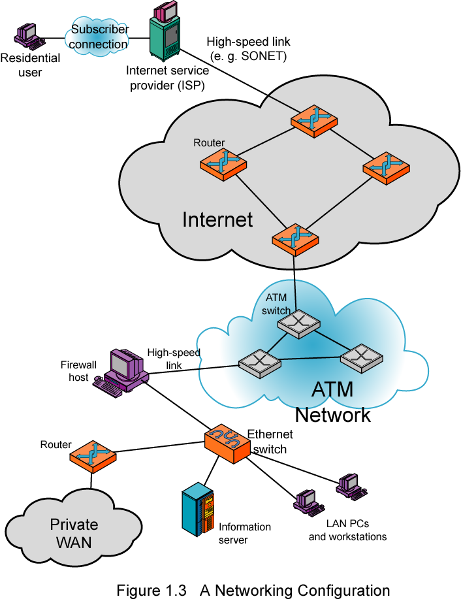
Q4: Discuss
- Conceptual view of ISDN connection features.
- Name principles for ISDN; also suggest its key objectives
- Show the configuration of primary access for ISDN channel group

Q5: Briefly explain the following with respect to data over a link?
- frame synchronization
- flow control
- error control
- addressing

