Sessional Assignment
Transmission, Switching & Signaling
Submission Date: 04th June, 2020

- Design a multistage switch (3 stage) for N=200, n=20 & k=10 usinig;
- Multi-stage switch
- Clos Criteria
- What is Access Network? Give examples of some of the technologies used in Access Network?
- What is Digital Telephony? With an example explain the digitization of the PSTN.
- What is PDH? Name some of its limitations and advantages of SDH/SONET. Show the path section designation for SDH. Also show the SDH Frame and calculate its basic capacity for a byte and frame.
- Explain the figure given below
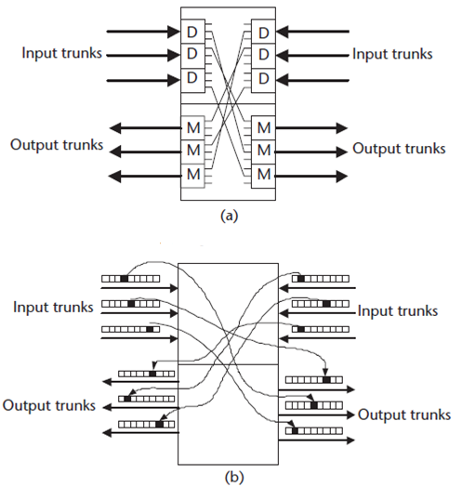
- Explain LATA, SS7, RBOC, and IXC
- (a) A microwave transmitter has an output of 500 mW. What is its output in dBW?
(b) A combining network has two inputs: +29 dBm and +6 dBm. It has an insertion loss of 3 dB. What is the combined output in dBm?
- VOIP. Explain w.r.t basic functions, VOIP components. Also explain how to overcome the challenges. What is the role of FXO and FXC in VOIP?
- What is PSTN? How does PSTN work? Describe present day PSTN terminals, services?
- What is PBX? Explain its interface standards, functions, features. What are the functional features offered by a CO switch?
- Difference between in-band and channel associated signaling.
- Draw the SS7 protocol stack. Show and brief the signaling unit structure of MSU
- What is SIGTRAN? How does it provide reliable datagram service?
- ADSL? Describe and show the Modulation Technique used in DSL. Also show and calculate the upstream and downstream data rate for ADSL.
- Explain Multiplexing hierarchy of T3?
- Explain SIGTRAN?
- Explain SS7oip?
- Explain SCTP?
- Explain IP Telephony?
- Explain VOIP?
- What is parity, even parity, odd parity?
- Explain FTTx (FTTH, FTTC, FTTB, FTTCab etc).

