Subject : Anatomy-IV
Submitted by: Dr. Arooba.
DPT 4th Semester
MidTerm Assignment, Spring 2020.

Total marks: 30.
Select the best possible answer.
1. Sub arachnoid hemorrhage is caused by the rupture of which vessel?
a. Middle meningeal artery
b. middle menigeal vein
c. cerebral artery
d. cerebral vein

2. The superior sagittal sinus is located between the?
a. inner table of the skull and the endosteal (parietal) layer of the dura
b. endosteal (parietal) and the meningeal (visceral) layers of the dura
c. meningeal (visceral) layer of the dura and the arachnoid layer
d. arachnoid layer and the pia mater

3. How many poles does a cerebrum has?
a. 3 lobes
b. 4 lobes
c. 3 poles
d. 4 poles

4. What type of cells is present in the fifth layer of cerebral cortex?
a. large pyramidal cells
b. giant pyramidal cells
c. Betz cells
d. Both b & c

5. A fetal origin posterior communicating artery arises from the?
a. basilar artery
b. middle cerebral artery
c. internal carotid artery
d. vertebral artery

6. Regarding sympathetic and parasympathetic nervous system, which of the following is true?
a. Long preganglionic fibers and short postganglionic fibers in SNS.
b. Long preganglionic fibers and short postganglionic fibers in PSNS.
c. Short preganglionic fibers and short postganglionic fibers in SNS.
d. Short preganglionic fibers and long postganglionic fibers in PSNS
e. both b & c.
f. both a & d.

7. Sensory information enters the CNS via the dorsal portion, Motor commands exit the CNS via the ventral portion.
a. True
b. False

8. Which of the following regarding taste area is true?
a. Brodmann's area 43
b. situated in lower end of post central gyrus in superior wall of lateral sulcus near the insula.
c. both a & b.
d. none of them are true.

Questions 9-11 are related to the figure 1, given below. Question number 9, 10 carries 1 mark each. Question number 11 carries 5 marks.

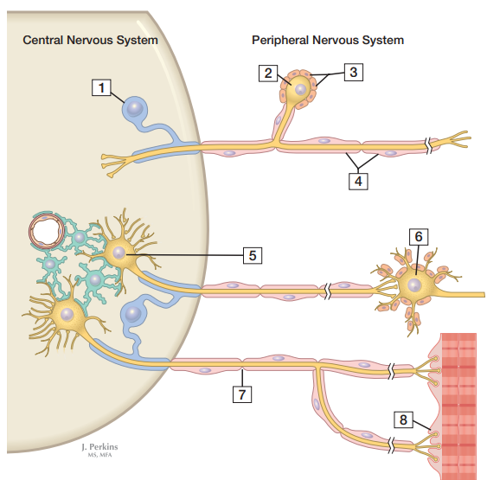
Figure 1

9. Given in the figure below, area labeled as 5 is?
a. Postganglionic autonomic neuron
b. Preganglionic autonomic neuron
c. Motor end plate (neuromuscular junction)
d. Primary sensory (ganglion) cell body

10. Given in the figure below, area labeled as 6 is?
a. Postganglionic autonomic neuron
b. Preganglionic autonomic neuron
c. Motor end plate (neuromuscular junction)
d. Primary sensory (ganglion) cell body

11. In the figure 1 shown above, label the following numbers;

2 __________
3 __________
4 __________
7 __________
8 __________

Answer the following questions. Add diagrams/ pictures if needed.
Each question carries 5 marks.

1. Osman, a 23 years old boy suffered a traumatic brain injury on the right sided orbital lobe. Which side and which half of the retinal field's sensory input would be lost? Reason why?

2. What are the differences between spinal nerves and cranial nerves?

3. What do you know about the reticular formation of spinal cord?

