Quiz/Assignment
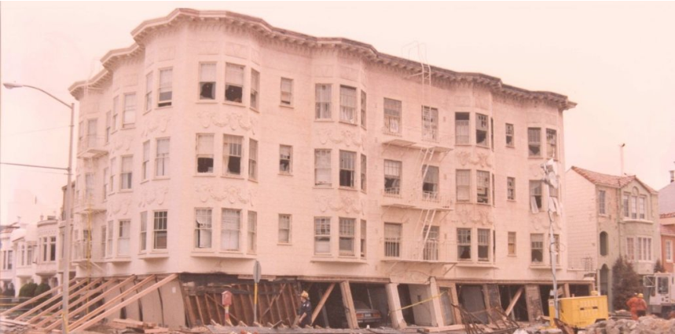
Describe the types of the configurations depicted in Figure 1, 2 & 3. How they can effect seismic performance of a structure and what are their possible solutions.
Figure 2
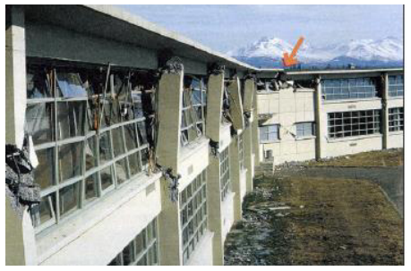
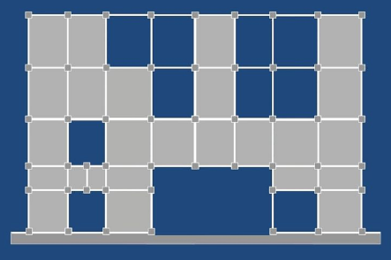
Figure 1

Figure 3

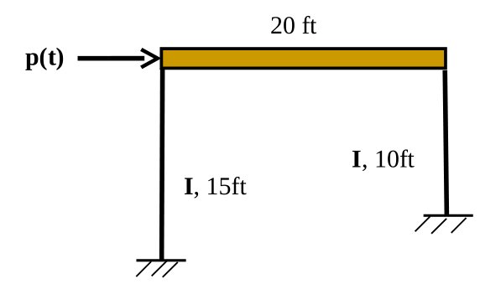
Develop the equation of motion of the frame shown in figure 4 under the action of a lateral dynamic force p(t). Consider a uniformly Distributed gravity load of (registration number) lb/ft acting on the beam. Neglect damping effect
Figure 4

