IQRA NATIONAL UNIVERSITY
NAME NADIA
CLASS ID 6927
DEPARTMENT DPT
PAPER EBP
TEACHER DR.ATTA UL ALLAH
Date 11/7/2020

Q 1: WHAT ARE CLINACL GUIDELINES?
ANSWER : CILINICAL GUIDELINES:
- “systematically developed statement to assist practitioners and patient decision about appropriate health care for specific circumstances”
- Guidelines are designed to support the decision –making processes in patient care
- The content of guidelines is based on a systematic review of clinical evidence –the main source for evidence-based care.
- Information about diagnosis ,prognosis ,effects of therapy
- Clinical guidelines provide an efficient alternative
- They provide single sources of information about the management of clinical conditions.
- Evidence –based clinical guidelines integrate high quality clinical research with contributions from clinical experts and patients, in order to formula reliable recommendations for practice.
PURPOSE OF CPGs

- The purpose of a clinical guideline is to provide a ready-made resources of high quality information for both practitioner and patient so that can discuss together
-the different options for treatment and
-the different degrees of benefit or risk that interventions may have for that patient

- A shared and informed decision can then be made about how to proceed with treatment.

- To describe appropriate care based on the best available scientific evidence and broad consensus
- To reduce inappropriate variation in practice
- To provide a more relational basis for referral
- To provide a focus for continuing education
- To promote efficient use of resources
- To act as focus for quality control ,including audit
- To highlight shortcoming of existing literature and suggest appropriate future research.
Systematic review CLINICAL GUIDLINE
- Focus is likely to be on a single clinical 1:usually covers the whole process of disease
Question, or a limited aspect of patient management, with many clinical questions, so
Care likely to be developed by a small may require a number of systematic reviews
Group of researchers. Developed by a wide range of stakeholders: patients,
Clinical experts, researchers, professional groups

- Conclusions of the review are based on 2: conclusions (recommendations)are on a complex
Results from high quality clinical synthesis of high quality clinical research, but also
Research alone export opinion, patient experience and
Consensus views
- Patients have a limited role or no 3: patients have key role in production of the
Role in production of the review guidelines. They may participate in framing of
Rarely, patients may be involved questions, interpretation of evidence and ,with the
In framing review question (s) rest of guideline development group, making
And helping with the assessment judgments about information from patients and
And interpretation of evidence health care practitioners
- Validity of conclusion depends 4: validity of conclusions (recommendations)depends
On methodological rigor methodological rigor and judgments made by
Guideline development group

5. Can be developed relatively quickly 5: take a longer time to develop (risk of evidence being out
(evidence can be very current) of date at time of publication)
Typically published as a technical patient version often produced, in addition to a publication
Report for health professionals for health professionals

THE BENEFITS OF CLINICAL PRACTICE GUIDELINES INCLUDE
- Improve clinical outcomes
- Reduce variability in clinical practice
- Increase use of known effective interventions
- Provide greater cost effectiveness
- Increase transparency of evidence to justify interventions
- Legitimize profession in of external stakeholders

CLINICAL GUIDELINES ARE IMPORTANT TO PHYSIOTHEROPISTS BECAUSE THEY
- Provide quick access to synthesis of evidence
- Give the clinical direct access to the knowledge –based of the export
- Allow one to self –assess their current practice
- Assist with developing direction of future clinical research

QUESTION NO 2:
WHY DO WE NEED CLINICAL GUIDELINES?
ANSWRES:
Why do we need clinical guidelines?
- With the increase volume of high quality clinical research available to physical therapists,
-it can be a challenge to determine which study outcomes are sufficiently reliable to be applied in practice.
-but high quality clinical guidelines do the work

- The implementation of clinical guidelines should provide more consistent, as more effective care for patients.
- They also provide an important resources for patients, helping them understand their condition and treatment options.

WHERE CAN I FIND CLINICAL GUIDELINESS?

- Only a minority of clinical guidelines are published in journals, so the major databases such as MEDIINE, EMBASES and CINAHAL provide a poor way of locating practice guidelines.
- The most complete database of evidence-based practice guideline relevant to physiotherapy is Pedro

EVIDENCE-BASED PRECTIC GUIDELINES
- The clinical practice guidelines must contain systematically developed statements
-that include recommendations, strategies, or information
-that assist physiotherapists or patients to make decisions about
Appropriate health care for specific clinical circumstances.

- Some countries have national clinical guideline programmers ,which produce multiprosessional clinical guidelines
- Sties of national clinical guideline programs and information include :
-(in the USA )www .guidelines.gov
-(in new Zealand )www.nzgg.org.nz

STEPES FOR DEVELOPING CLINICAL PRACTICE GUIDELINES
- Defining the question
- Collecting the evidences
- Synthesizing the results
- Making a recommendation based on results
- Grading the strength of recommendation

MUITIDISCIPLINARY EBCPGs
- Guidelines of the Quebec task force on spinal disorders
- The American healthcare and policy research guidelines for acute low back pain
- The British medical journal evidence

HOW DO I KNOW IF I CAN TRUST THE RECOMMENDATIONS IN A CLINICAL GUIDELINESS
- Two studies (shaneyfelt )et al 1999,grilli et al 200)examined published medical guidelines ton dermarmine their quality .both concluded there were widespread quality problems
- Gillis’s study looked specifically at clinical guidelines published by specialist societies, while ahanefelt looked at guidelines published by specialist societies and by other organization s.

APPRAISAL OF GUIDELINESS, Research and E VALUATION (AGREE)
- Scope and purpose
- Stakeholder involvement
- Rigor of developed
- Clarity and presentation
- Applicability
- Editorial independence

SCOPE AND PURPOSE
- The overall objectives of the guidelines are specifically described
- Clinical questions covered by the guideline are specifically described
- The patients to whom the guideline is meant to apply are specifically described

RELLIABILTY AND VALIDITY OF THE AGREE INSTRUMENT USED BY PHYSICAL THERAPISTS IN ASSEMENT OF CLINICAL PRACTICE GUIDELINES
- A total of 69 physical participated and were classified as generalist ,specialist or researchers,paires of appraisers within each category evacuated independently ,a set of 6 CPG selected at random from a pool of 55 CPGs
- They concluded that the AGREE instrument is reliable and valid when used by physiotherapists to assess the quality of CPG pertaining to physical therapy health service.

COLLABORATION IN GUIDELINES DEVELOPMENT
- Between guideline developers and systematic reviewers
- International collaboration
- Between guidelines developers and researchers

CLINICAL PATHWAYS
- A care pathway is a mufti-disciplinary plan of care that blends patient needs, quality outcomes, and controlled costs, with predetermined standard of care using a replicable prosaic
- Clinical pathways are structured, muit-disciplinery plans of care designed to support the implementation of clinical guidelines and protocols

- Many synonyms exist for the term clinical pathways including:
-integrated care pathways
-multidisciplinary pathways of care
-pathways of care
-Care maps
-collaborative care pathways
HISTORY AND AIMS
- Clinical pathways were introduced in the early 1990s n the UK and the USA ,and are being increasingly sued throughout the developed worid
- They are designed to support clinical management, clinical and non –clinical resource management ,clinical audit and also financial management

BENEFITS
Pathways have several benefits to an organization
- Improve clinical and financial outcomes
- Improve quality and coordination of care
- Help reduce variations in patient care (by promoting standardization)
- Reduce practice variation ,increase usage of best practices

ALGORITHMS
- Algorithms are “written guidelines to stepwise evaluation and management strategies that require
-observation to be made
-Decision to be considered ,and
-actions to be taken’

- A list of well –defined instructions for completing a task.

EXAMPLE
- This is an algorithm that tries to figure out why the lamp donts’tturn on and tries to fix using the steps.
- Flowcharts are often used to represent algorithm graphically.

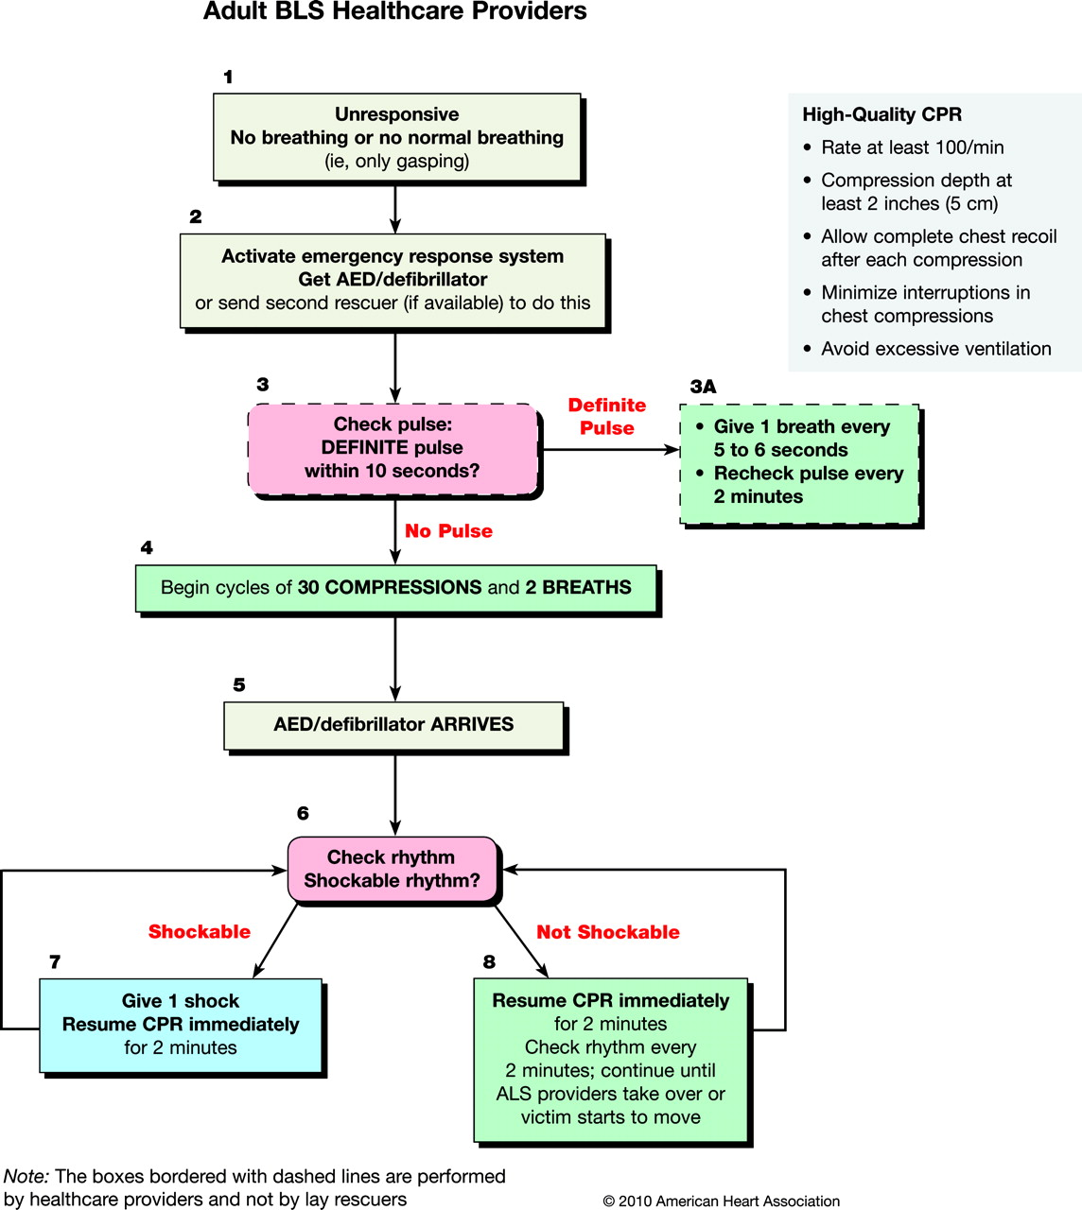

Question no 3
What is clinical audit? Explain in detail?

Answers:
CLINICAL AUDIT:
DEFINITION:
  - a quality improvement process that seeks to improve patient care and outcomes through systematic review of care against explicit criteria and the implementation of change“
Evaluation of data, documents and resources to check performance of systems meets specified standards.
MEDICAL AUDIT:
- “An evaluation system in which established standards are used to measure performance.
- Once corrective action has been taken about problems identified through a review process,
Performance is re-measured after an appropriate time period.

WHAT IS AUDIT?
- Audit in the wider sense is simply a tool used
To find out what you do now
- to be compared with what you have done in the past, or
What you think you may wish to do in the future

WHY CLINICAL AUDIT:
- The key component of clinical audit is that
  - performance is reviewed (or audited) to ensure that what should be done is being done, and
  - if not it provides a framework to enable improvements to be made.
- For improving the standard of clinical practice

- Maintain participant and staff safety.
- Maintain data quality .
- Protect reputation of staff, host and sponsorer
- Protect current and future funding
- Improve quality.
- It does not involve experiments
- It uses data that already exists

CLINICAL AUDIT CYCLE:

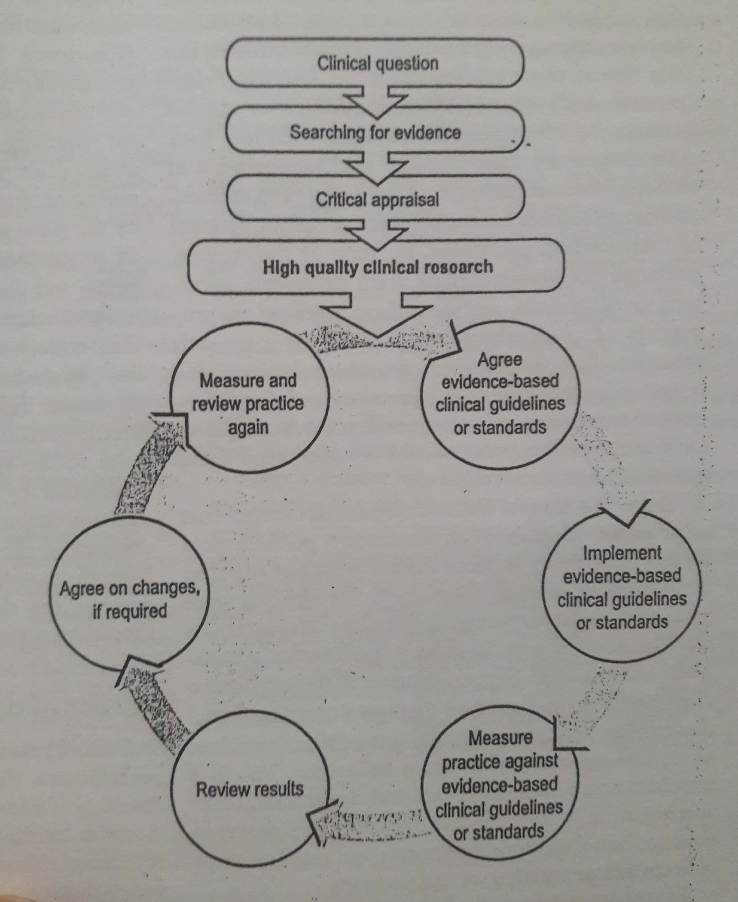

FIVE STAGES OF CLINICAL AUDIT:
1: PREPARING FOR AUDIT

2; SELECTING CRITERIA

3: MEASURING PERFORMANCE

4: MAKING IMPROVEMENTS

5: SUSTAINING IMPROVEMENTS.

FIRST STAGE:
PREPARING FOR AUDIT
SELECTING A TOPIC.

DEFINING THE PURPOSE.

PLANING.

SECOND STAGE:
SELECTING CRITERIA:

DEFINING CRITERIA

SOURCE OF EVIDENCE
APPRAISING THE EVIDENCE

THIRD STAGE:
MEASURE LEVEL OF PERFORMANCE;
PLANNING DATA COLLECTION

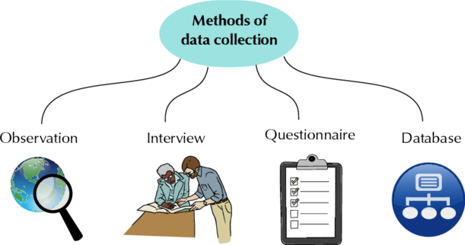

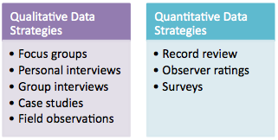METHODS OF DATA COLLECTION
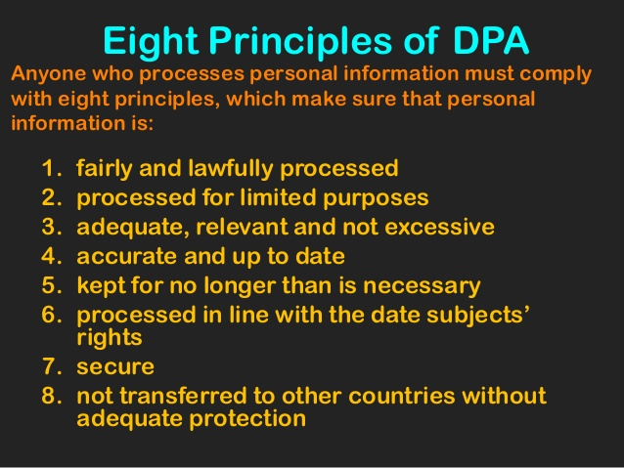HANDLING THE DATA

STAGEING 4;
MAKING IMPROVEMENT
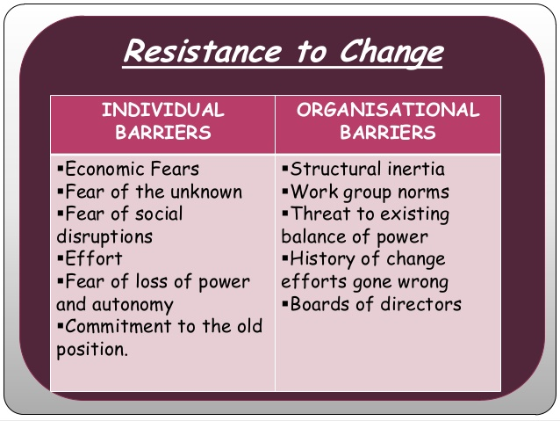IDENTYFYING BARRIER TO CHANGE.

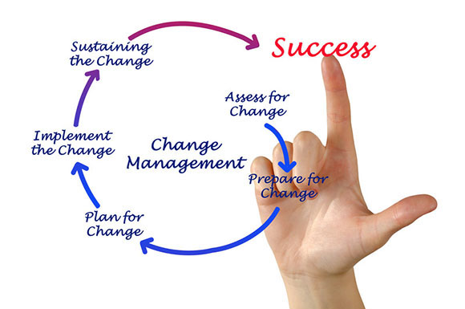IMPLEMENTING CHANGE
STAGE: 5
SUSTAINING IMPROVEMENT:
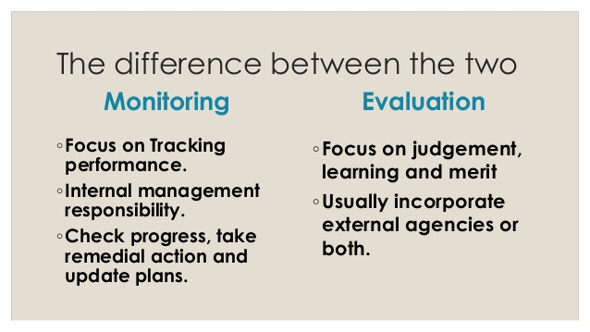
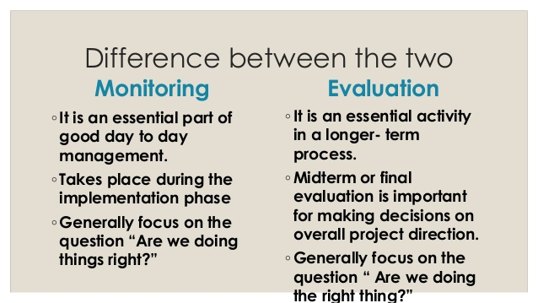MONITIRING AND EVALUATION

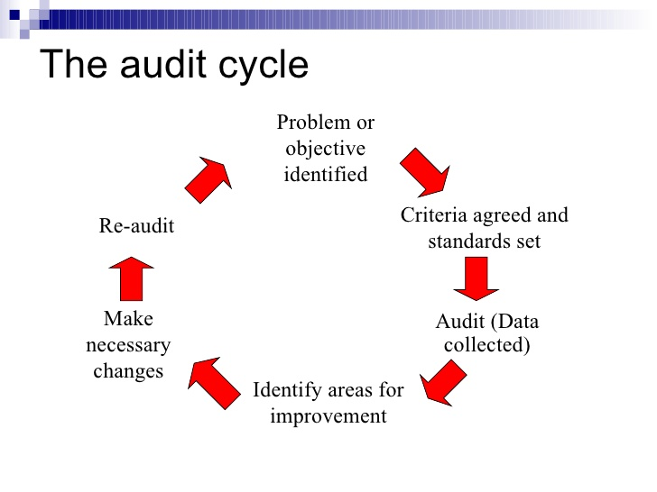RE-AUDIT

MAINTAINING AND REIENFORCMENT IMPROVEMENT.

THANK YOU!

