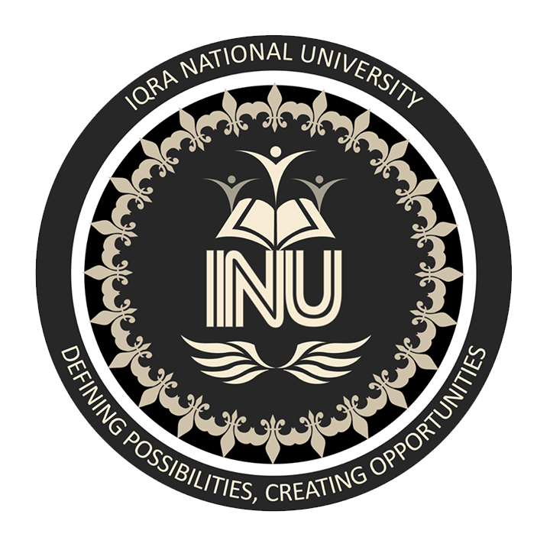

IQRA NATIONAL UNIVERSITY
INSTRACTOR mam benish
Name zain ullah khan
STUDENT ID 16547
DEPARTMENT BS(CS) II
ASSIGNMENT mid term
Subject pak study

QNO 1= What is Ideology and what were the Aims And objective of the creation of Pakistan?

ANS= Ideology=>
Such a social or political aims for which the people of society work together to get those aims, is called ‘Ideology’.

The aims and objectives of the creation of Pakistan
The Muslims of sub-continent got their separate land so, that they could worship Allah without feeling any fear and they could apply the rules of Allah and his Prophet (S.A.W).
Islam is not just a name of prayers and customs moreover it is a complete code of life.
Here are some big objectives of the creation of Pakistan which are following

Communal disturbance
Many people were killed due to Hindu and Muslims Communal disturbance.
Hindus killed the Muslims orderly with communal organizations. The Hindus were in majority than Muslims so, they might convert the lives of Muslims in difficulties after English people went on.
Hindus wanted that after English Rurals they will keep up their own rules on Muslims.

Social circumstances
Muslims were fear of lineage and generation differences in Hindus custom. Hindus were making cruelty on Muslims.
Muslims thought that they would made them footmen after War of independent. So, the Muslims worked hard to get their separate land (Pakistan).

Muslims’s language and Customs/Culture
Hindus were struggling hard to make the “Hindi” as a national language in the presence of English Rurals. They were trying to eradicate the “Urdu” and “Muslims culture. Muslims demanded for separate land to save their culture and language (Urdu).

Two Nation ideology
Muslims claimed that they were a separate nation. They have their own culture, language, customs, way of life and Religion (Islam). They are different from other nations so, they are a complete nation. They had right of to raise voice for separate land. As a nation, Muslims wanted to maintain a separate country for them.

Congress’s polity

Congress’s polity was in the Sub-Continent from 1937 to 1939. At that time Hindus used their power to destroy the Muslims, their culture and much more but the Government did not pay any attention to the Muslims circumstances. Hindus did not give the rights to the Muslims.
Muslims were aware that the Hindus are in majority and after English Rurals they would continue their rules and Muslims would become their victim forever.
At last Muslims raised their voices against cruelty of Hindus and for separate Homeland.

Abide of Islamic Rules

We all know that Islam is a complete code of life. In the Sub-Continent Muslims wished to abide the Islamic rules as practically. It was not easy in South Asia because of Hindus majority.
Therefore, the Muslims of North-East and North-West demanded for the creation of separate Homeland (Pakistan).so, that they might get Pakistan as an Islamic laboratory.
Muslims wished to see the Pakistan as a power for whole Islamic World. Pakistan was a starting point of Islamic movement near to the Muslims on worldwide.
So, these were some objectives and aims of the Sub-continent Muslims for the creation of Pakistan. And after the efforts of Muslims Pakistan came into being on August 14, 1947.
May Allah bless the people of Pakistan and keep Pakistan safe and strong till the last day of this World. Ameen!

END OF QUESTION NO 1

Q NO 2=What were the efforts of Sir Syed Ahmad Khan for Education?

ANS= Little about Sir Sayyad Ahmad Khan

- Sir Sayyad Ahmad Khan was born on 17th october,1817 in Delhi. He belonged to a noble and Muslim family. His father name was Mir Muttaqi and mother name were Aziz-un-Nisa. He got his early education in Delhi. After that became Master in History, Mathematics. He passed his LLB exam.
- From the time of education Sir Sayyad Ahmad khan was worried about Muslims. Muslims of the Sub-Continent were living in very difficult time. But at that time ALLAH sent a great leader toward the Muslims in form of Sir Sayyad Ahmad khan.
- He was unhappy about the position of Muslims in India as their social and economic status was declining. He worked hard for the Muslims in every field such as Educational and Political etc.
- He started a great Movement for the Muslims Rights. Sir Sayyad Ahmad khan was a great Leader at that time. Sir Sayyad Ahmad khan was a starting point of the Muslims Movement for Pakistan.

Educational Services
Sir Sayyad Ahmad Khan was of the view that the path of development of the Muslims nation could only be paved with the help of education.
He advised Muslims to get modern education and move forward alongside other nations. He not only gave advice also tried his best to facilitate the acquisition of modern knowledge for Muslims.
He attracted Muslims to science, modern literature and the social sciences. He termed the teaching of English as a stepping stone for the success of Muslims so that they could attain the same social status as Hindus.
Here are some steps whose taken by Sir Sayyad Ahmad Khan for the Education of Muslims of the Sub-Continent.
- In 1859, Sir Sayyad Ahmad khan established madrassas in Murad Abad and in 1862 in Ghazipur. Apart from Persian, English language and modern sciences were also taught in these madrassas.
- In 1875, he founded the MAO high school in Aligarh. And he became a college and university after his death in 1920. In these institutions he hired English teachers such as Archbold Arnold and Morrison.
- In 1863, Sir Sayyad established an institution in Ghazipur called the Scientific Society. The purpose of this institute was to translate books written in Western languages into Urdu. Later in 1876 the offices of the Society were shifted to Aligarh. Sir Sayyad encouraged the new generation to learn English so that they could benefit from modern western sciences.
Seeing this a lot of capital of Western literature, sciences and other sciences was transferred to Urdu language. Thanks to the services of the society, the Urdu language got a lot of development.
- In 1886, Sir Sayyad Ahmad khan founded an institution called the Muhammadan Educational Conference. The organization has been instrumental in providing people with the educational needs of the Muslim nation, and inspired by the conference’s performance, various personalities have launched educational activities in their respective areas.
- Islamia College in Lahore founded Sindh Madrasa-ul-Islam in Karachi, Islamia college in Peshawar and Haleem College in Kanpur. The Muhammadan Educational conference also sought to protect the political, cultural, economic and social rights of Muslims.

END OF QNO 2

Q NO 3=Write down any form of government and also describe what are the advantages and disadvantages of that form of government for Pakistan which you have written?

ANS= Government
Such a system of social control under which the Rurals make laws, rights and enforce the people, is called “Government”. Government can be held by anyone such as, by one person or majority. Government is an important part of any state because without Government a State can never be work.
In other words, Government is the working agency and a political organization for any State.
Government is responsible of people’s needs, justice, health, education, treat, food, security, safety and economical system.
Here we will talk about “Democratic Government” that what type of Government is this?

Democratic Government
Such a form of Government in which people have their own rights to select the Rurals for the future of their country, is called a “Democratic Government”. Democratic countries give free rights to the people to cast their votes.
In this type of Government people choose the Rurals through election. First of All, some parties become, these parties work for the people to convince them that they would be prove themselves as a great Rurals.
Elections are held after some specific time, different participate in the election and people support them and cast their votes to their favorite party but those party is considered as a Rurals who have more votes than others parties. I’m talking about Pakistan where a government is chosen for five years but the others countries have their own rules for the duration of government.
“Democratic Government” is good than other forms of Governments but every form of Government has its own characteristics. In “Democratic Government” people are responsible for their Government because they chose their Rurals according to their choice. There are many countries having ““Democratic Government” such as Pakistan, china, India, USA etc.

Advantages of Democracy in Pakistan

- People have their own right to select the government in Pakistan.
- People have right of vote.
- We chose our Leaders through voting in Pakistan.
- Our rights are protected by law in Pakistan.
- Leaders are grateful to us and they work for us.
- All are equal according to law of Pakistan.
- We have same and equal rights.
- We are completely free in Pakistan.
- Every one can start his business in Pakistan.
- We can travel from one place to another.
- We can apply for any type of job according to our skills.
- We are free to fight for our rights.
- There are individual MNAs an MPAs for every district.
- People have right to reject their Rurals.
- People can raise their voices in Pakistan.

Disadvantages of Democracy in Pakistan
- Sometime people select a bad leader.
- Our Leaders are involved in corruption in Pakistan.
- They only interested in vote bank policies.
- Our Leaders in Pakistan think they have come in government for enjoyment.
- And they also use the power and the privileges that come along.
- In Pakistan Leaders use the money and muscle power to earn votes.
- In Pakistan our Leaders think only about their families, but not about common people.
- They misuse of their power against people.
- In Pakistan sometimes our Rurals do not give our rights properly because they say people themselves elected us by election.
- When a bad Rural comes in the government of Pakistan, he has to pass his full duration in government so, our country goes on the verge of Destruction.
- Mostly in Pakistan our Leaders are involved in corruption and Money laundering because of Democracy.
- The people of Pakistan are pours, sometime because of bad circumstances they sell their votes and the Rich Leaders get their votes on money.
- Mostly People of Pakistan are unaware of their rights, therefore Rurals doesn’t give their rights to them.

These are some Advantages and Disadvantages of Democracy in Pakistan.

END OF QNO 3 AND PAPER AS WELL.

