Course Title: Teaching methodology &community medicine Instructor: Dr. M. Shahzeb khan PT
Semester: DPT 6TH
Student Name: Dawood Zaman Khan ID# 13914
__________________________________________________________________
Q3: what are genetic abnormalities? Write down different types genetic abnormalities

ANS: DEFINITION
A genetic disorder is a disease that is caused by a change, or mutation, in an individual's DNA sequence. A genetic disorder is an illness caused by changes in a person's DNA Or
A genetic disease is any disease caused by an abnormality in the genetic makeup of an individual. The genetic abnormality can range from minuscule to major from a discrete mutation in a single base in the DNA of a single gene to a gross chromosomal abnormality involving the addition or subtraction of an entire chromosome or set of chromosomes. Some people inherit genetic disorders from the parents, while acquired changes or mutations in a preexisting gene or group of genes cause other genetic diseases. Genetic mutations can occur either randomly or due to some environmental exposure.

What are the four types of genetic disorders (inherited?)

- Single gene inheritance
- Multifactorial inheritance
- Chromosome abnormalities
- Mitochondrial inheritance

Six Symptoms and Signs of Down syndrome

The baby with Down syndrome has a hallmark appearance. However, every aspect of the appearance does not need to be present as the phenotype, the way the genes make the child look, can be markedly different for each patient. Common Down syndrome symptoms are:

- a small head and short neck,
- flat face, and
- upward slanting eyes, ears are flat and positioned lower than "normal,"
- the tongue protrudes and seems to be too large for the mouth,
- hands tend to be wide,
- short fingers and there is just a single flexion crease in the palm, and
- Joints tend to be more flexible and muscles may lack tone.

7 single gene inheritance disorders

Single gene inheritance is also called Mend Elian or monogenetic inheritance. Changes or mutations that occur in the DNA sequence of a single gene cause this type of inheritance. There are thousands of known single-gene disorders. These disorders are known as monogenetic disorders (disorders of a single gene).
Single-gene disorders have different patterns of genetic inheritance, including
- autosomal dominant inheritance, in which only one copy of a defective gene (from either parent) is necessary to cause the condition;
- autosomal recessive inheritance, in which two copies of a defective gene (one from each parent) are necessary to cause the condition; and
- X-linked inheritance, in which the defective gene is present on the female, or X-chromosome. X-linked inheritance may be dominant or recessive.

Some examples of single-gene disorders include
- cystic fibrosis,
- alpha- and beta-thalassemia,
- sickle cell anemia (sickle cell disease),
- Marfan syndrome,
- fragile X syndrome,
- Huntington's disease, and
- Hemochromatosis.

7 common multifactorial genetic inheritance disorders

Multifactorial inheritance is also called complex or polygenic inheritance. Multifactorial inheritance disorders are caused by a combination of environmental factors and mutations in multiple genes. For example, different genes that influence breast cancer susceptibility have been found on chromosomes 6, 11, 13, 14, 15, 17, and 22. Some common chronic diseases are multifactorial disorders.

Examples of multifactorial inheritance include
- heart disease,
- high blood pressure,
- Alzheimer's disease,
- arthritis,
- diabetes,
- cancer, and
- Obesity.

4 chromosomal abnormalities

Chromosomes, distinct structures made up of DNA and protein, are located in the nucleus of each cell. Because chromosomes are the carriers of the genetic material, abnormalities in chromosome number or structure can result in disease. Chromosomal abnormalities typically occur due to a problem with cell division.
For example, Down syndrome (sometimes referred to as "Down's syndrome") or trisomy 21 is a common genetic disorder that occurs when a person has three copies of chromosome 21. There are many other chromosomal abnormalities including:

- Turner syndrome (45,X0),
- Klinefelter syndrome (47, XXY), and
- Cri du chat syndrome, or the "cry of the cat" syndrome (46, XX or XY, 5p-).
Diseases may also occur because of chromosomal translocation in which portions of two chromosomes are exchanged.

3 mitochondrial genetic inheritance disorders

This type of genetic disorder is caused by mutations in the non-nuclear DNA of mitochondria. Mitochondria are small round or rod-like organelles that are involved in cellular respiration and found in the cytoplasm of plant and animal cells. Each mitochondrion may contain 5 to 10 circular pieces of DNA. Since egg cells, but not sperm cells, keep their mitochondria during fertilization, mitochondrial DNA is always inherited from the female parent.
Examples of mitochondrial disease include
- Leber's hereditary optic atrophy (LHON), an eye disease;
- myoclonic epilepsy with ragged red fibers (MERRF); and
- Mitochondrial encephalopathy, lactic acidosis, and stroke-like episodes (MELAS), a rare form of dementia.

__________________________________________________________________________________________________________________________________________________________________________________________________________________________________________

Q No 4(A): what is diabetes? Write down different types of diabetes mellitus.

Ans: DIABETES MELLITUS:
- Diabetes mellitus is a metabolic disease characterized by high blood sugar (glucose) levels that result from defects in insulin secretion or the body’s ability to use insulin.
- Diabetes mellitus is a syndrome of impaired carbohydrate, fat, & protein metabolism caused by either lack of insulin secretion or decreased sensitivity of the tissues to insulin.
- Two forms of diabetes mellitus:

Type I Diabetes Mellitus,
- Is also called insulin-dependent diabetes mellitus (IDDM), is caused by impaired secretion of insulin.
- Type 1 diabetes is an autoimmune disease. The immune system attacks and destroys cells in the pancreas, where insulin is made. It’s unclear what causes this attack. About 10 percent of people with diabetes have this type.
Type II Diabetes Mellitus,
- Is also called non-dependent diabetes mellitus (NIDDM), is caused by resistance to the metabolic effects of insulin in target tissues.
- Type 2 diabetes occurs when your body becomes resistant to insulin, and sugar builds up in your blood.

Symptoms in men:

In addition to the general symptoms of diabetes, men with diabetes may have a decreased sex drive, erectile dysfunction (ED), and poor muscle strength.

Symptoms in women:

Women with diabetes can also have symptoms such as urinary tract infections, yeast infections, and dry, itchy skin.

Signs & Symptoms of Type I- Diabetes Mellitus:
- Polyuria (Urination)
- Polydipsia (Thirst)
- Polyphagia (Hunger)
- Weight loss
- Fatigue
- Frequency of infection
- Rapid onset
- Early onset
- Blurry vision

Signs & Symptoms of Type II- Diabetes Mellitus:
- Sedentary Lifestyle
- Familial tendency
- Headache
- Fatigue
- Decrease energy
- Recurrent infections
- Itchy skin
- Slow healing of cuts

Diabetes risk factors:

Certain factors increase your risk for diabetes.

Type 1 diabetes:

You’re more likely to get type 1 diabetes if you’re a child or teenager, you have a parent or sibling with the condition, or you carry certain genes that are linked to the disease.

Type 2 diabetes:

Your risk for type 2 diabetes increases if you:
- are overweight
- are age 45 or older
- have a parent or sibling with the condition
- aren’t physically active
- have had gestational diabetes
- have prediabetes
- have high blood pressure, high cholesterol, or high triglycerides
Diabetes complications:
- heart disease, heart attack, and stroke
- neuropathy
- nephropathy
- retinopathy and vision loss
- hearing loss
- foot damage such as infections and sores that don’t heal
- skin conditions such as bacterial and fungal infections
- depression
- dementia sugar

Treatment of diabetes:
Doctors treat diabetes with a few different medications. Some of these drugs are taken by mouth, while others are available as injections.
Type 1 diabetes is treated with:
- insulin,
- exercise, and a
- Type 1 diabetes diet.
Type 2 diabetes is treated:
- First with weight reduction, a type 2 diabetes diet, and exercise
- Diabetes medications (oral or injected) are prescribed when these measures fail to control the elevated blood sugars of type 2 diabetes.
- If other medications become ineffective treatment with insulin may be initiated.
- Diet and exercise can help some people manage type 2 diabetes. If lifestyle changes aren’t enough to lower your blood sugar, you’ll need to take medication.
- These drugs lower your blood sugar in a variety of ways:
----------------------------------------------------------------------------------------------------------------
Q No 4(B): what is different b/w diabetes mellitus and diabetes insipidus?

ANS: the different b/w diabetes mellitus and diabetes insipidus as under below

Diabetes mellitus | Diabetes insipidus
It is the most common form of diabetes caused by a deficiency of the pancreatic hormone insulin which result in a failure to metabolize  There are two types of Diabetes mellitus  Type 1  Type 2.  Both types of diabetes are chronic diseases that affect the way your body regulates blood sugar, or glucose. Glucose is the fuel that feeds your body's cells, but to enter your cells it needs a key. Insulin is that key  Difference  Diabetes mellitus causes high blood glucose, or blood sugar, resulting from the body's inability to use blood glucose for energy. | It is a rare form of diabetes caused by a deficiency of the pituitary hormone that caused frequent urination  There are four types of diabetes insipidus;  1) central diabetes insipidus,  2) nephrogenic diabetes insipidus,  3) dipsogenic diabetes insipidus,  4) Gestational diabetes insipidus.  The most common symptom of diabetes insipidus is frequent urination.  Difference  People with diabetes insipidus have normal blood glucose levels; however, their kidneys cannot balance fluid in the body.

Q No 4(C): How you well prevent yourself from diabetes mellitus?
ANS:
You can help reduce your risk of type 2 diabetes by understanding your risk and making changes to your lifestyle.
There are some tips to help you reduce your risk of type 2 diabetes.
- Check your risk of diabetes. Take the Life!
- Manage your weight. Excess body fat,
- Exercise regularly.
- Eat a balanced, healthy diet.
- Limit takeaway and processed foods. ‘
- Limit your alcohol intake.
- Quit smoking.
- Control your blood pressure.
- Reduce your risk of cardiovascular disease.
- See your doctor for regular check-ups.
__________________________________________________________________________________________________________________________________________________________________________________________________________________________________________

Q5 (A): What is mental disorder? Write different types of mental disorder.
Ans: A mental disorder or psychiatric disorder is a mental or behavioral pattern or anomaly that causes distress or disability & which is not developmentally or socially normative.
Types of Mental Disorder:
- Anxiety disorder: People with anxiety disorders respond to certain objects or situations with fear & as well as with physical signs of anxiety or nervousness, such as a rapid heartbeat & sweating.

- Eating disorder:
- Eating disorders involve extreme emotions, attitudes, & behaviors about weight & food.
- Eating disorders are actually serious & often fatal illnesses that cause severe disturbances to a person’s eating behaviors. Obsessions with food, body weight, & shape may also signal an eating disorder. Common eating disorders include anorexia nervosa, bulimia nervosa.

- Mood disorder:
- These disorder involve persistent feelings of sadness or periods of feeling overly happy, or fluctuations from extreme happiness to extreme sadness.

- Psychotic disorder:
- Psychotic disorders involve distorted thinking.
- Two of the most common symptoms of psychotic disorder are hallucinations & delusions.
- Hallucination: the sensory perception of something that doesn’t exist.
- Delusion: False belief.

- Impulse control & addition disorder:
- People with impulse control disorder are unable to resist or perform acts that could be harmful to themselves or others e.g. Pyromania, kleptomania.
- Alcohol & drugs are common objects of addictions.
- Pyromania: uncontrollable urges to start fire.
- Kleptomania: obsession with stealing without economic or material need.
- Personality disorder:
- People with personality disorders have extreme & inflexible personality traits that are distressing to the person & or cause problems in work, school, or social relationships.
- Adjustment Disorder:
Adjustment disorder occurs when a person develops emotional or behavioral symptoms in response to a stressful event or situation.

- Dissociative disorder:
People with these disorders suffer severe disturbances or changes in memory, consciousness, and general awareness of themselves and their surroundings.

-----------------------------------------------------------------------------------------------
Q 5(B): why we need health information system? Explain it
Ans: Commonly known as HIS, it is a centralized healthcare system to manage all kinds of data in one place. It includes the collection, storage, processing, transmission, and management of a patient’s records and other kinds of data. It plays a crucial role in the operational management of a hospital. Some of its major components are materials management, immunization database, clinical system, retail pharmacy, provider repository, and so much more
BENEFITS OF HEALTH INFORMATION SYSTEMS
Health information systems tend to target efficiency and data management. The main drivers of health information systems are:
- Data analytics: The healthcare industry constantly produces data. Health information systems help gather, compile and analyze health data to help manage population health and reduce healthcare costs. Then the healthcare data analysis can improve patient care.

- Collaborative care: Patients often need to treatments from different healthcare providers. Health information systems — such as health information exchanges (HIEs) — allow healthcare facilities to access common health records.

- Cost control: Using digital networks to exchange healthcare data creates efficiencies and cost savings. When regional markets use health information exchanges to share data, healthcare providers see reduced costs. On a smaller scale, hospitals aim for the same efficiencies with electronic health records.

- Population health management: Health information systems can aggregate patient data, analyze it and identify trends in populations. The technology also works in reverse. Clinical decision support systems can use big data to help diagnose individual patients and treat them.

______________________________________________________________________________
_________________________________________________________________________________________________________________________________________________________-
Question no 1 and two read from pages and also pages will be attached with end in from of ascending order 1 to11 because the time was short I will apologize sir
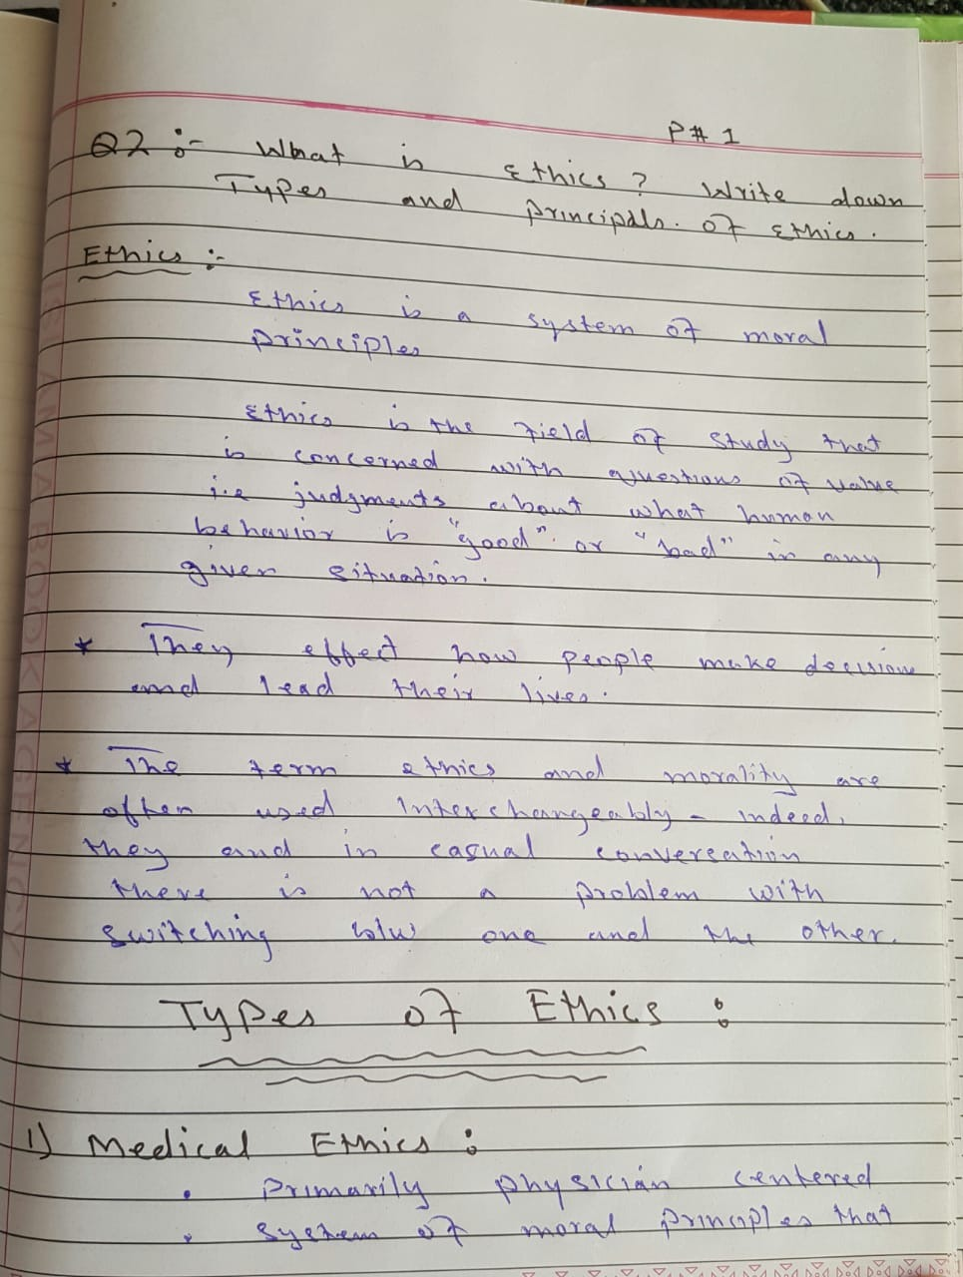
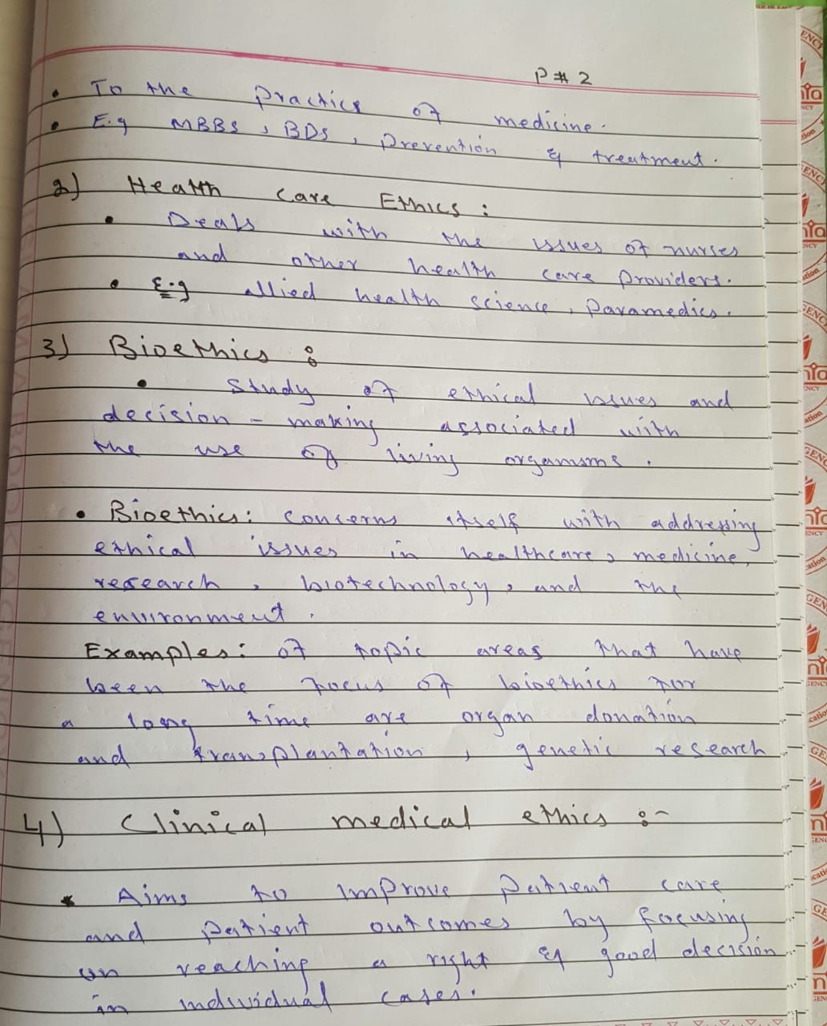
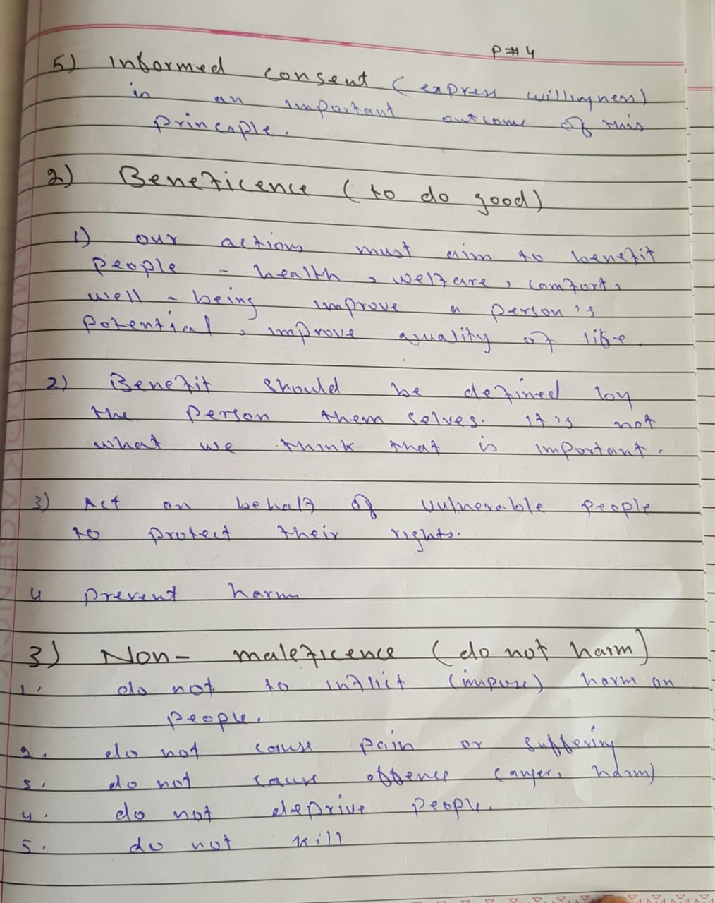
Q NO 1: Read from page no 6
