Assignment
Program: BBA Assignment Final Term
Dated: 26th June,2020 Time allowed: 06 hrs
Course Title: Principles of
Management Instructor: Shoala Rasheed Khan
Note: Attempt All Questions Total Marks: 50

Note: Attempt all questions in a word file and upload through SIC portal in an assignment section. You have a limited time of 06 hours which will be automatically closed after the completion of timeline. No file will be accepted after the given time line.
Q1.How would you define decision making? Write its types in detail?
Answer:
Decision making can refer either to a specific act or to a general process. Decision making is the act of choosing one alternative from among set of alternatives. The decision-making process, however, is much more than this. One step of the process, for example, is that the person making the decision must recognize that a decision is necessary and identify the set of feasible alternatives before selecting one. Hence, the decision making process includes recognizing and defining the nature of a decision situation, identifying alternatives, choosing the "best' alternative and putting it into practice.
Effective decision making requires that the decision-maker understand the situation deriving the decision Most people would consider an effective decision to be one that optimizes some set of factors such as profits, sales, employee welfare and market share. In some Situations, though, an effective decision may be one that minimizes may even mean selecting the best method for going out of business, laying off employees, or terminating the contract. We should also note that managers make decisions about both problems and opportunities. for example making decisions about how to cut costs by 10 percent reflects a problem-an undesired Situation that requires a solution But decisions are also necessary for a situation of opportunity.
Learning that the firm is earning higher-than-projected profits, for example, requires a decision. Should the extra funds be used to increase shareholder dividends, reinvested in current operations, or use to expand into new markets? Of course, it may take a long time before a manager can know if the right decision was made.
Types of Decisions:
Managers must make many different types of decisions. In general, however, most decisions fall into one of two categories.
1. Programmed decision and
2. Non-programmed decision.
A Programmed Decision:
A programmed decision is one that is fairly structured or recurs with some frequency (or both). Example:
Suppose a manager of the distribution centre knows from experience that she needs to keep a thirty-day Supply of a particular item on hand. She can then establish a system whereby the appropriate quantity is automatically reordered whenever the inventory drops below the thirty-day requirement. Likewise, the Bryan BMW dealer has made a decision that he will sponsor a youth soccer team each year. Thus when thee soccer club president calls, the dealer already knows what he will do. Many decisions rearming basic operating systems and procedures and standard organizational transactions are of this variety and therefore can be programmed.
Non-Programmed Decision.
Non-programmed decisions, on the other hand, are relatively unstructured and occur much less often Example: Consider GES decision to exchange businesses with Thomson and BMW's decision to build a new plant: no business makes decisions like those on a regular basis. Mangers faced with such decisions must treat each one as unique, investing enormous amounts of time, energy, and resources into exploring the situation from all perspectives Intuition and experience are major factors In non-programmed decisions. Most of the decisions made by top managers involving strategy (including mergers, acquisitions, and takeovers) and organization design are non-programmed. So are decisions about new facilities, new products, labour contracts, and legal issues.
Programmed Decisions
- Recurring problems
- Apply rule
Nonprogrammer Decisions
Unique situations
- Poorly defined
- Unstructured

b. Explain different conditions of decision making?
Answer:
Decision Making Conditions are as the following:
Everyday a manager has to make hundreds of decisions in the organization. There are different conditions in which decisions are made. Managers sometimes have an almost perfect understanding of conditions surrounding a decision, but in other situations they may have little information about those conditions. At the same time, the decision taken by the managers at present will also have an effect on future. For this purpose, the decision-making process involves the visualization of the conditions that may be present in future. So, the decision maker must know the conditions under which decisions are to be made. Generally, the decision maker makes decision under the condition of certainty, risk and uncertainty. There are three conditions that managers may face as they make decisions.
They are (1) Certainty, (2) Risk, and (3) Uncertainty.

Certainty
When the certainty conditions are present, it can be reasonably expected by the managers what is going to happen when a particular decision has been taken by them. Certainty is a condition under which the manager is well informed about possible alternatives and their outcomes. There is only one outcome for each choice. When the outcomes are known and their consequences are certain, the problem of decision is to compute the optimum outcome. Similarly, if there are more than one alternative they are evaluated by conducting cost studies of each alternative and then choosing the one which optimizes the utility of the resources. The condition of certainty exists in case of routine decisions such as allocation of resources for production, payment of wages and salary etc. There is a little ambiguity and relatively low chance of making and impractical decision. In these situations, the managers use a deterministic model, and it is assumed that all the factors are exact and there is no role for chance.
Risk
In a risk situation, although the factual information may be present but it can be insufficient. Mostly the managers have to take business decisions under risk situations. A more decision making condition is a state of risk. In such a condition, managers have knowledge about alternative course of actions but outcomes are associated with probability estimates. It is more difficult to predict future conditions without full information, so the outcome of an alternative cannot be accurately determined. Therefore, managers can guess the probable outcome on the basis of their experience, research and other available information. They can choose an alternative with highest expected outcome. However, such decisions are largely subjective as no decision criteria are fully reliable. Decision making under conditions of risk is accompanied by moderate ambiguity and chances of an impractical decision. On the other hand, the managers may also use subjective probability that is based on their experience and judgment. For this purpose, several tools are available to the managers that can help in taking decisions under risk conditions.

Uncertainty
In case of uncertainty conditions, very little information is available to the managers and the managers are not sure regarding the reliability of such information. A state of uncertainty occurs when managers are unaware of the problem they face. They do not know all the alternatives, the risk associated with them or the likely consequences of each alternative. This uncertainty arises from the complexity and dynamism of contemporary organization and their environments. Managers have limited information to calculate the degree of risk, so statistical analysis is not possible. The condition of uncertainty arises when the organization introduces a new or innovative product or service, adopts new technology, selects new advertising program etc. To make effective decision in uncertain conditions, managers must acquire as much relevant information as possible and approach the situation from a logical and rational perspective. Intuition, judgment and experience always play major roles in the decision making process. However, decision under uncertainty is the most ambiguous for managers and there is more possibility of error. However, there are certain techniques that can be used by the managers for making a better decision under uncertainty conditions. For example, they may use decision trees, risk analysis and preference theory for making the right decisions in uncertainty conditions. Hence, In conclusion, we can say that greater the amount of reliable information, the more likely the manager will make a good decision. Hence, manager should make sure that the right information is available at the right time.

Q2. What are the foundations of strategic competitiveness?
Answer:
Foundations of Strategic Competitiveness
Foundations of Strategic competitiveness are accomplished when a firm successfully integrates a value-creating strategy. The key to having a complete value-creating strategy is to adopt a holistic approach that includes business strategy, financial strategy, technology strategy, marketing strategy and investor strategy. The objective of the firm has to be based on creating value in an efficient way because it is the starting point for all businesses and it will generate profit after cost. Eric Beinhocker, the Executive Director of the Institute for New Economic Thinking at the Oxford Martin School, University of Oxford, says in his book The Origin of Wealth that the origin of wealth is knowledge. Knowledge does not have to be perceived as an assumption, or as an external factor. It has to be in the heart of the business. For this reason, the value-creating strategy must include a thorough knowledge of each area of the company in order to develop a competitive advantage.

Business strategy
In business strategy, it is important to distinguish strategic decisions which imply long-lasting commitments, from tactical decisions, which are short-term responses to the current environment. The strategic decisions define the evolution of state variables that provide a scenario in which current tactics are played out. For instance, investment in physical capital has a strategic role as the basis to determine the success of the enterprise in the future. A firm can gain an advantage by investing and creating a more dynamic behavior that in the future will lead its rivals to respond by competing less dynamically or by completely staying out of the market.

Financial strategy
For both new and established businesses, it is essential to establish a strong and clear financial strategy that determines the guiding principles in all financial decisions. Financial decisions are of three types: the investment decision, the financing decision, and the dividend decision. Investment decisions cover capital investment and current investment. Financing decisions include targets for the ratios of debt to total capital and of total debt to total assets. Dividend decisions are concerned with dividend growth and dividend payout.

Technology strategy

Technology implementation is often an important way to drive relative advantage over competitors, even among small businesses.

Social media
Social networks such as Facebook, Twitter, Instagram, and LinkedIn are effective tools. Adopting an effective social media strategy can rapidly improve a company’s branding and visibility by facilitating the interaction with its customers. Social media sends direct messages and can attract many people to the company's website as long as its design and content are compatible with the quality of the strategy; otherwise, it will be difficult to retain the new public.

New technologies
Nowadays, most private enterprises have adopted modern technology. They have created user-friendly websites, online catalogs, and call centers, and they have restructured inventory management. Nevertheless, there are still other important aspects of technology, mentioned by Forbes, that large business are adopting and that small businesses may also be able to adopt:
- Real-time, for marketing and product promotion.
- Online customer relationship management.
- Tablet-based systems for employees to provide instant, one-to-one responses to customers' needs.
- Subscription-based Software as a service (SaaS).

Marketing strategy
An effective marketing strategy covers the "4 P's" of the marketing mix: Product, price, place, and promotion.
- Product: variety, design, quality, features, brand name, packaging, services
- Price: list price, discounts, allowance, payment period, credit terms
- Place: channels, coverage, assortments, locations, inventory, transportation, logistics
- Promotion: advertising, personal selling, sales promotion, public relations.
Nevertheless, these "4 P's" may be challenged by the "4 C's": Customer solution, customer cost, convenience, and communication.
- The customer looks for solutions to their problems when buying, not for products.
- The customer wants to know the total cost of acquiring, using and disposing of a product, not price.
- Customers want to purchase the products and services as soon as possible, not place.

b. How strategies are formulated? Explain in your own words?
Answer:
There are several ways strategy formulation can be done for a company. However some methods are better than the others. Here are 10 steps which guide you in deciding the strategy of your company. Steps 1 to 5 mainly involve internal or external research as well as very long term strategy making (Strategies made in the first 5 steps affect the whole life cycle of the company)
1) Vision Statement
A vision statement (crisp and to the point) is a must for developing a strategy. Exploring and deciding on the vision of the company gives you clarity on the main objectives of the company.
2) Mission Statement
Decide a Mission statement for the company. This mission statement would actually determine the methodology of the company in reaching its vision, its purposes and its philosophy behind its goals.
3) Define the company profile
The company profile needs to be comprehensive which further clears the goals of the organization. What would be the strengths of the company, capabilities, management. In essence mention everything you can about the company. This helps in transparency while deciding the strategy.
4) Study the External environment
No strategy can be complete without taking into consideration the effect that external environment has on businesses. Thus an in depth study on external environment is necessary and the same should be mentioned in the strategy report.
5) The 5th step involves matching all three – Mission statement, Company profile and the external environment such that they are in sync to achieve the vision of the company.
From here on, Step 6 to 10 involve decision making based on the research as well as the decisions taken for the company in the previous steps. The last steps are more inclined towards implementation.
6) Deciding the actions for accomplishing the mission of the organization
7) Selecting long term strategies which will be most effective
8) Deciding on short term strategies arising from the long term ones such that these short term strategies too are in sync with the mission and vision statement
9) Deciding the budget and resource allocation according to the short term strategy
10) Implementation of the strategies along with pre decided review system along with measures to maintain control and a fallback short term plan.
Following these 10 steps of deciding on a strategy, you get – A vision statement, a mission statement, long term strategies, short term strategies, budget and resource allocation and finally implementation along with review plans.

Q3. What is Job Designing? Write about Job specialization with examples.
Answer:
The Job Design means outlining the task, duties, responsibilities, qualifications, methods and relationships required to perform the given set of a job. In other words, job design encompasses the components of the task and the interaction pattern among the employees, with the intent to satisfy both the organizational needs and the social needs of the jobholder. The objective of a job design is to arrange the work in such a manner so as to reduce the boredom and dissatisfaction among the employees, arising due to the repetitive nature of the task. There are several important methods and techniques that the management uses while designing the jobs. These are:
Job Design
- Job Simplification
- Job Rotation
- Job Enrichment
- Job Enlargement
While designing the job, the following aspects are to be taken into the consideration:
1. The foremost requirement for a job design is to define clearly the task an individual is supposed to perform. A task is the piece of work assigned to the individual and who has to perform it within the given time limits.
2. The management must decide on the level of motivation that is required to be enforced on an individual to get the work completed successfully. Thus, the managers must design the jobs that motivate his employees.
3. The managers must decide critically on the amount of resources that needs to be allocated to perform a particular type of a job. Thus, the efforts should be made to make an optimum utilization of organizational resources while designing the job so that the organization does not suffer any dilemma due to the shortage of its resources.
4. When the jobs are assigned to the individual, he agrees to do it because of the rewards attached to it. Thus, the manager must include in the job design the compensation, bonuses, incentives, benefits and other remuneration method for the employees.
Thus, the job should be designed with the intent to find a fit between the job and its performer, such that the job is performed efficiently, and the performer experiences satisfaction while performing it and give his best efforts towards its completion.
Job specialization and examples:
Job specialization often requires training and education but it provides you with a developed skill set that will make you more employable, efficient and successful in your role. When entering the workforce or looking for career advancement opportunities, it can be helpful to expand your knowledge and expertise in a specific area. This article explains what job specialization is, details some of the benefits and challenges associated with job specialization and provides a few examples.
Job specialization, sometimes referred to as the division of labor, is a process in which employees develop specific skills, experience and knowledge in a particular area in order to gain the expertise required to perform certain aspects of a job. This process often involves extensive training and creates skilled employees who are able to complete tasks within their realm of expertise with minimum supervision.

Important aspects of job specialization
Here are a few of the concepts that are important to keep in mind when considering job specialization:
Feedback
In order for job specialization to be effective, there needs to be open communication between the employees and the manager. Feedback allows a supervisor to remain aware of which tasks have been completed, if they met the organization’s standards and if there are opportunities for improvement.
Autonomy
Autonomy refers to the level of control that an employee has when completing a task. Those with more specialized skill sets typically find it much easier to retain control over a task’s processes and outcomes.

Task significance
In order for you to become a successful specialist, it’s important that you understand the priority level that accompanies each responsibility, allowing you to more effectively multi-task and appreciate the relationship between your different job functions. For example, there may be some prerequisite tasks that should be completed in order to carry out others.
Task identity
Generally speaking, you can only be as effective as the job description that you have been given. With any position, but especially with specialized roles, it’s important to be aware of the responsibilities that fall within your purview as well as the tools and strategies that should be used for measuring and organizing them.
Skill variety
Before you can choose a job specialization that makes you more employable and effective in the workplace, you will need to gain an understanding of which skills are necessary to satisfy each job requirement. This will allow you to identify which areas to specialize in as well as the training that will be necessary to become a specialist in that area.
Advantages of job specialization
Here are some of the advantages of contributing to a streamlined workplace with job specialization:
Less transition time
There is a faster transition between each task.
Reduced risks

Q4. Explain how organizational cultures are created and how they can help companies be successful ?
An organization’s culture is shaped and created as the organization faces external and internal challenges and learns how to deal with them. When the organization’s way of doing business provides a successful adaptation to environmental challenges and ensures success, those values are retained. These values and ways of doing business are taught to new members as the way to do business.
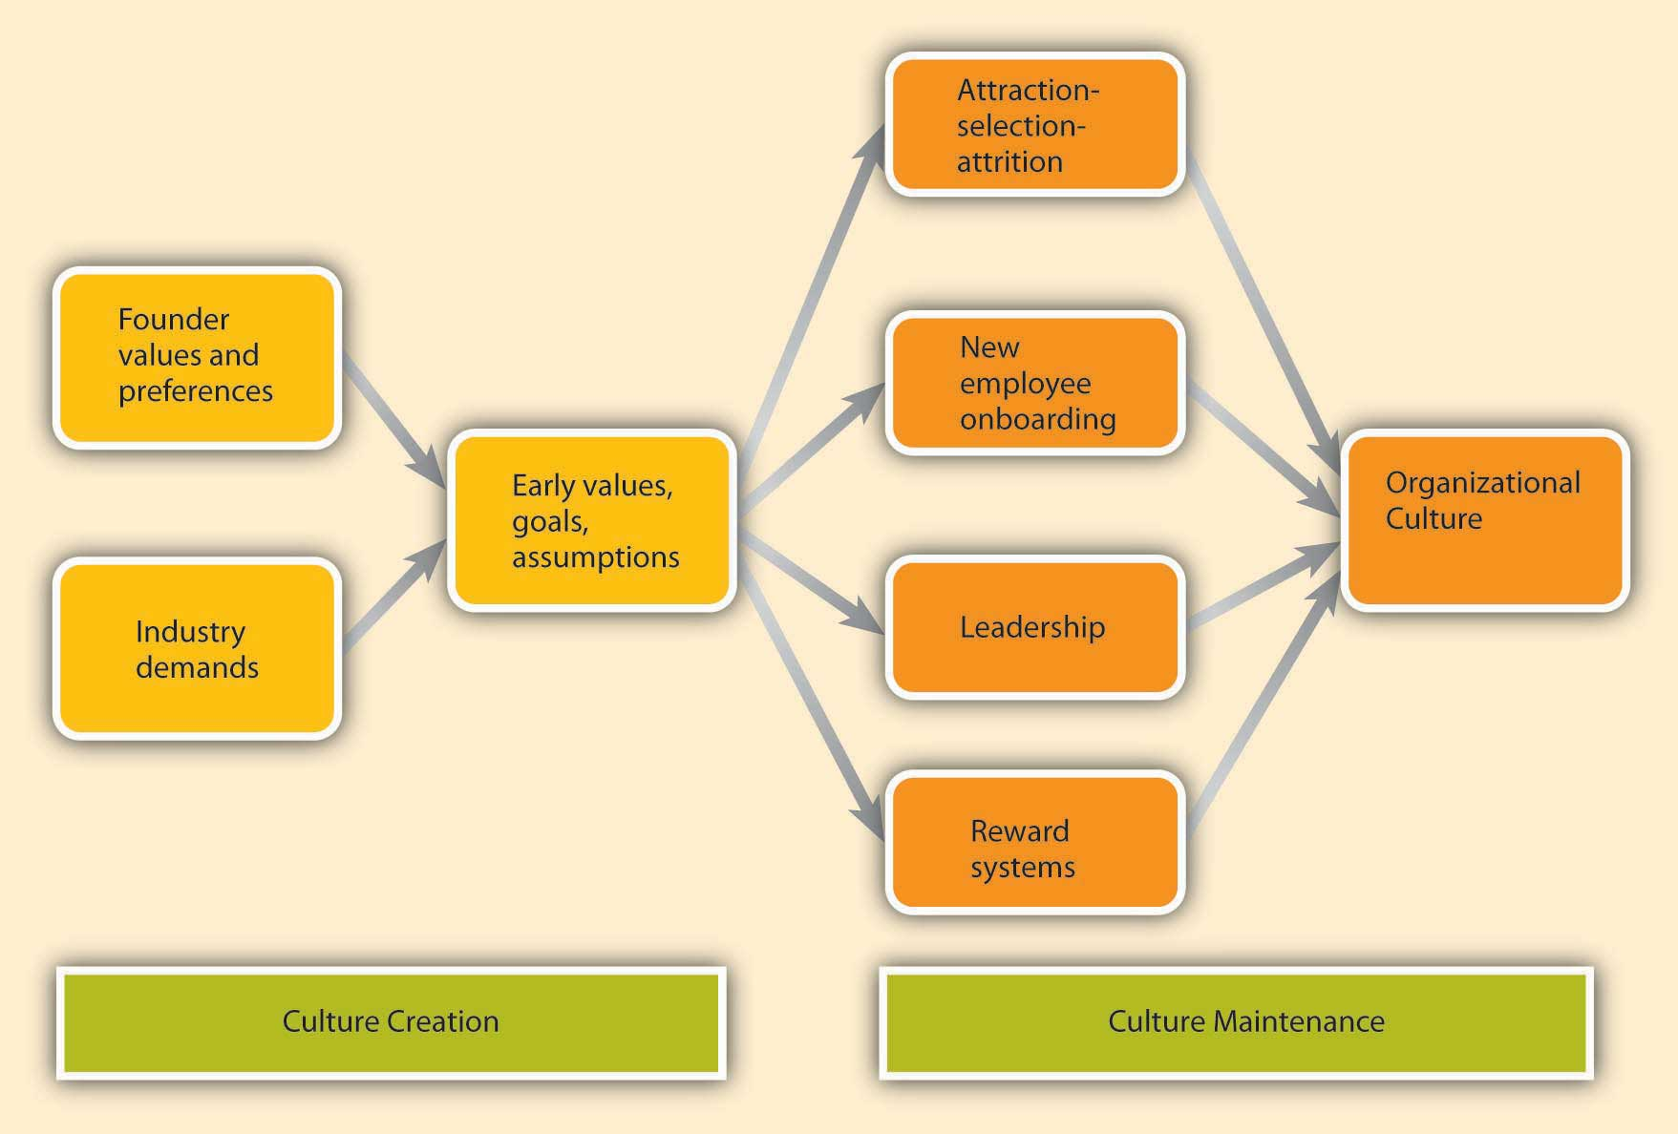

The factors that are most important in the creation of an organization’s culture include founders’ values, preferences, and industry demands.

Founder’s Values
A company’s culture, particularly during its early years, is inevitably tied to the personality, background, and values of its founder or founders, as well as their vision for the future of the organization. This explains one reason why culture is so hard to change: It is shaped in the early days of a company’s history. When entrepreneurs establish their own businesses, the way they want to do business determines the organization’s rules, the structure set-up in the company, and the people they hire to work with them.

Industry Demands
While founders undoubtedly exert a powerful influence over corporate cultures, the industry characteristics also play a role. Industry characteristics and demands act as a force to create similarities among organizational cultures. For example, despite some differences, many companies in the insurance and banking industries are stable and rule oriented, many companies in the high-tech industry have innovative cultures, and companies in the nonprofit industry tend to be people oriented. If the industry is one with a large number of regulatory requirements—for example, banking, health care, and nuclear power plant industries—then we might expect the presence of a large number of rules and regulations, a bureaucratic company structure, and a stable culture.

Cultures Maintenance
As a company matures, its cultural values are refined and strengthened. The early values of a company’s culture exert influence over its future values. It is possible to think of organizational culture as an organism that protects itself from external forces. Organizational culture determines what types of people are hired by an organization and what types are left out. Moreover, once new employees are hired, the company assimilates new employees and teaches them the way things are done in the organization. We call these processes attraction-selection-attrition and onboarding processes. We will also examine the role of leaders and reward systems in shaping and maintaining an organization’s culture. It is important to remember two points: The process of culture creation is in fact more complex and less clean than the name implies. Additionally, the influence of each factor on culture creation is reciprocal. For example, just as leaders may influence what type of values the company has, the culture may also determine what types of behaviors leaders demonstrate.

Attraction-Selection-Attrition (ASA)
Organizational culture is maintained through a process known as attraction-selection-attrition. First, employees are attracted to organizations where they will fit in. In other words, different job applicants will find different cultures to be attractive. Someone who has a competitive nature may feel comfortable and prefer to work in a company where interpersonal competition is the norm. Others may prefer to work in a team-oriented workplace. Research shows that employees with different personality traits find different cultures attractive. For example, out of the Big Five personality traits, employees who demonstrate neurotic personalities were less likely to be attracted to innovative cultures, whereas those who had openness to experience were more likely to be attracted to innovative cultures (Judge & Cable, 1997). As a result, individuals will self-select the companies they work for and may stay away from companies that have core values that are radically different from their own.

New Employee Onboarding
Another way in which an organization’s values, norms, and behavioral patterns are transmitted to employees is through onboarding (also referred to as the organizational socialization process). Onboarding refers to the process through which new employees learn the attitudes, knowledge, skills, and behaviors required to function effectively within an organization. If an organization can successfully socialize new employees into becoming organizational insiders, new employees feel confident regarding their ability to perform, sense that they will feel accepted by their peers, and understand and share the assumptions, norms, and values that are part of the organization’s culture. This understanding and confidence in turn translate into more effective new employees who perform better and have higher job satisfaction, stronger organizational commitment, and longer tenure within the company

Leadership
Leaders are instrumental in creating and changing an organization’s culture. There is a direct correspondence between a leader’s style and an organization’s culture. For example, when leaders motivate employees through inspiration, corporate culture tends to be more supportive and people oriented. When leaders motivate by making rewards contingent on performance, the corporate culture tends to be more performance oriented and competitive. In these and many other ways, what leaders do directly influences the cultures their organizations have.

Reward Systems
Finally, the company culture is shaped by the type of reward systems used in the organization, and the kinds of behaviors and outcomes it chooses to reward and punish. One relevant element of the reward system is whether the organization rewards behaviors or results. Some companies have reward systems that emphasize intangible elements of performance as well as more easily observable metrics. In these companies, supervisors and peers may evaluate an employee’s performance by assessing the person’s behaviors as well as the results. In such companies, we may expect a culture that is relatively people or team oriented, and employees act as part of a family.

Reward Systems
Finally, the company culture is shaped by the type of reward systems used in the organization, and the kinds of behaviors and outcomes it chooses to reward and punish. One relevant element of the reward system is whether the organization rewards behaviors or results. Some companies have reward systems that emphasize intangible elements of performance as well as more easily observable metrics. In these companies, supervisors and peers may evaluate an employee’s performance by assessing the person’s behaviors as well as the results. In such companies, we may expect a culture that is relatively people or team oriented, and employees act as part of a family. And these will help the organization to be successful in doing business.

