NAME ABID KHAN
ID 13763
Course Title: Orthodontic Instructor: Ms. Salma Ishaq
Max Marks: 30
NOTE:
Midterm assignment

Q1: For missing upper central incisor due to trauma at young age, which is more preferable implant or esthetic bridge?
Ans1: That is actually age dependent. We cannot do implant therapy at a young age. What I prefer in younger individuals is resin bonded bridges. They are technique sensitive but offer retrievability and thus can be removed and implant can be placed at a later stage when the individual has reached the age of maturity.
Replacing a central incisor by implant always reach a problem due to the lengthening of facial bones throughout life. This entail a gap on incisive edges which could be compensated by the change of the prosthesis but also on the gingival festoon much difficult to correct. Also the bridge glued cantilever seems far preferable to the extent that it does not lock the inter maxillary suture. Finally if, on a young person, is envisaged an orthodontic treatment with premolar extraction, the auto graft is the solution that seems to me.
Q2: Explain the condition of upper and lower teeth? And how it effects on the jaw and shape of face?
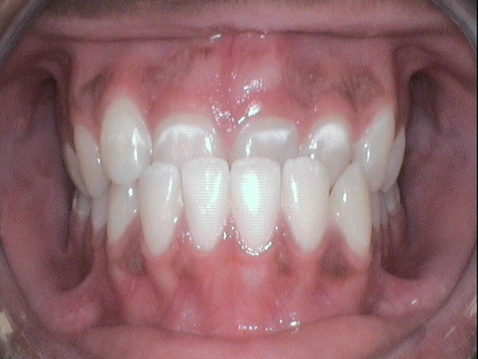
Ans 2. condition is class 3 malocclusion .
It is a skeletal facial deformity characterized by a forward mandibular position with respect to the cranial base and/or maxilla. Class III malocclusion represents patients with anterior cross bite and a skeletal Class III jaw disharmony.
Effects on jaw and shape of face .
The patient exhibits a concave facial profile , a retrusive naso maxillary area and a prominent lower third of the face
The lower lip is often protruded relative to the upper lip.
Q3: Illustrate the periods of occlusal development?
Ans. Periods of occlusal development.
- Pre dental period.
- The deciduous dentition
- The mixed period.
- The permanent dentition period.
- PRE DENTAL PERIOD ( gum pads )
The alveolar process at the time of birth.
- Dental grooves : separates the libiobuccal and lingual portion.
- Transverse groove: divide the gum pads into 10 segments representing each deciduous tooth
- Gingival groove: separates the gum pads from the plate and floor of the mouth.
- Lateral sulci: present between the canine and 1st molar
INFINTILE OPEN BITE
When the upper and lower gum pad are approximated there is a complete over jet all around. The infantile open bite is considered to be normal. It helps in sucking
- THE DECIDUOUS DENTITION:
( eruption age and sequence )
The mandibular central incisors are the first to erupt around 6-8 months of age.
A variation of three months from the mean age is accepted to normal.
The sequence of eruption is ( A-B-D-C-E)
The primary dentition is usually established in the age of 3 years
- THE MIXED DENTITION :
(eruption age and sequence )
The mixed dentition periods begin at around six years of age with the eruption of the 1st permanent molar
This period can be divided into three following phases;
A.1st transitional period.
- Inter transitional period
- 2nd transitional period
A. 1ST TRSNSITIONAL PERIOD:
( emergence of 1st permanent molar )
The mandibular 1st molar is the first permanent tooth to erupt at around six year of age.
The location and relation of 1st permanent molar is depends on the distal relationship between the upper and lower 2nd deciduous molars.

B.INTER TRANSITIONAL PERIOD:
This ohase is relatively stable and no changes occur.
In this period between then permanent incisors and the 1st permanent molar are the deciduous molar and canine.

C . 2nd TRANSITIONAL PERIOD :
(LEEWAY SPACE OF NANCE)
The 2nd transitional period is characterized by the eplacment of of deciduous molar and canine by the permanent premolars and cuspids respectively.
The combined mesio distal width of the permanent canines and premolars are less then that of the deciduous canine and molar. This excess space is called (LEEWAY SPACE OF NANCE )
1.8mm - maxillary arch.
3.4mm- mandibular arch.
- THE PERMANENT DENTITION:
The permanent dentition formed within a jaw soon after birth except for the formation of 1st permanent molar which form before birth
The permanent incisors lingual or palatel to the deciduous incisor and move labial as the erupt.

( ERUPTION SEQUENCE )
In MAXILLARY arch:
6-1-2-4-3-5-7/ 6-1-2-3-4-5-7
In MANDIBULAR Arch:
6-1-2-3-4-5-7/6-1-2-4-3-5-7

End of paper

