Iqra National University
Class BS Software Engineering Section B
Name: IJAZ KHAN
ID# 16764
Subject discrete structure
Semester (2)
Submitted to M.abrar khan
Date:8/june/2020

Q1: what is venn diagram? Explain in detail the application of venn diagram ?

Venn Diagrams
A Venn diagram is a diagrammatic representation of ALL the possible relationships between different sets of a finite number of elements. Venn diagrams were conceived around 1880 by John Venn, an English logician, and philosopher. They are extensively used to teach Set Theory. A Venn diagram is also known as a Primary diagram, Set diagram or Logic diagram.
Example:
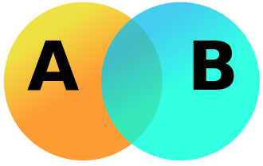
This example involves two sets, A and B, represented here as coloured circles. The orange circle, set A, represents all living creatures that are two-legged. The blue circle, set B, represents the living creatures that can fly. Each separate type of creature can be imagined as a point somewhere in the diagram. Living creatures that both can fly and have two legs—for example, parrots—are then in both sets, so they correspond to points in the region where the blue and orange circles overlap. It is important to note that this overlapping region would only contain those elements (in this example creatures) that are members of both set A (two-legged creatures) and are also members of set B (flying creatures.)

Q2: what is union? Draw member ship table for union using different examples?
UNION:
The union of two sets A and B is the set of elements which are in A, in B, or in both A and B. In symbols, . For example, if A = {1, 3, 5, 7} and B = {1, 2, 4, 6, 7} then A ∪ B = {1, 2, 3, 4, 5, 6, 7}

EXAMPLE:

if A1={a,b,c},A2={c,h},A3={a,d}A1={a,b,c},A2={c,h},A3={a,d}, then ⋃iAi=A1∪A2∪A3={a,b,c,h,d}⋃iAi=A1∪A2∪A3={a,b,c,h,d}. We can similarly define the union of infinitely many sets A1∪A2∪A3∪⋯A1∪A2∪A3∪⋯.

Membership Table For Union:
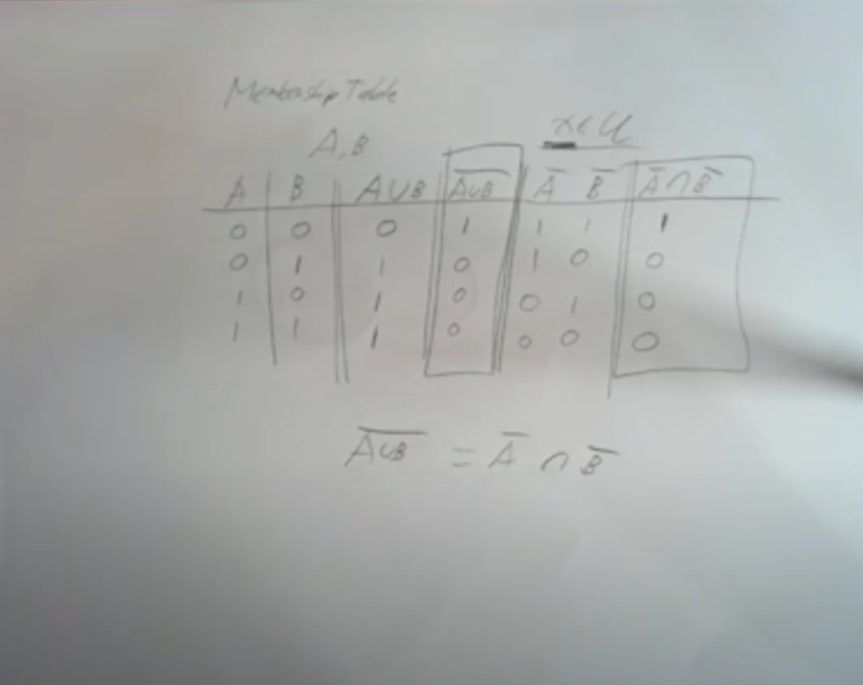

Q3:what is intersection ? draw membership table for intersection using different examples?
INTERSECTION:
Intersection of two given sets is the largest set which contains all the elements that are common to both the sets.
To find the intersection of two given sets A and B is a set which consists of all the elements which are common to both A and B.
The symbol for denoting intersection of sets is ‘∩‘.

EXAMPLE:
Let set A = {2, 3, 4, 5, 6}
and set B = {3, 5, 7, 9}
In this two sets, the elements 3 and 5 are common. The set containing these common elements i.e., {3, 5} is the intersection of set A and B.
Q4: what is difference ? draw member ship table for set difference using different examples?

ANS: Membership Tables
We combine sets in much the same way that we combined propositions. Asking if an element xx is in the resulting set is like asking if a proposition is true. Note that xx could be in any of the original sets.
What does the set A∪(B∩C)A∪(B∩C) look like? We use 11 to denote the presence of some element xx and 00 to denote its absence.
A11110000B11001100C10101010B∩C10001000A∪(B∩C)11111000ABCB∩CA∪(B∩C)1111111001101011000101111010000010000000
This is a membership table. It can be used to draw the Venn diagram by shading in all regions that have a 11 in the final column. The regions are defined by the left-most columns.
---------------------------------------------------------------------------
end

