final Term ASSIGMENT

**MS Construction Engineering Management IQRA NATIONAL UNIVERSITY PESHAWAR**

SUBMITTED BY:Salaman Jilani Khan Roll# :14880 Submitted to: Engr.Shabir Ahmad

**Q 1 : (i):**

**Why do we carry out Granular (Physical) Stabilization?**

**Ans:**  Granular Stabilization involves preparation of mixture of soil aggregate consisting of Stone, Gravel, and Sand and containing Silt-Clay and Compacted to maximum density to obtain high strength, stability, and durability in all weather conditions. Granular stabilization is used in construction of Base, Sub-base, and Surface Courses of paved facilities.

The purpose of Granular Stabilization is to obtain a well-proportioned mixture of particles with continuous gradation (well graded) and the desired plasticity. The requirements for the composition of mixtures intended for use as bases generally differ from those for use as wearing surfaces.

**Ans (II):**

**How do we carry out Granular (Physical) Stabilization considering Granulometry and Colametry, Fabric, Soil Binder, Collamereitics, and specification of gradation and selection of soil elements.**

**Ans: Granulometry:**

The pore volume and the size of the pores formed by the granular skeleton determine the transition of a particular soil to one with or without a bearing skeleton. Fundamentals of Granulometry are applied to establish quantitative definitions of granular skeleton with effective compactness. Grain-size distributions that yield minimal porosity values with small densification effort are best presented by the Talbot formula:

s=(d/dmax)m

where

s = weight percent of the particles with diameter less than d.

d max = maximum particle diameter in the mixture

m = exponent determined empirically

The factor m varies between 0.11 and 0.66.

U.S. Bureau of Public Roads recommends 0.45 as the best overall value for m.

The grain size distribution of materials necessitate design of a mix which could be best suited for intended stabilization.

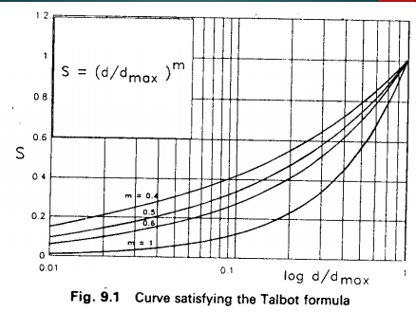

**Callomatetry:**

Soils with granular bearing skeleton in the densified state possesses volume stability and frictional resistance. They may require bonding or cementation, increase in cohesion, decrease in permeability or water storage capacity (if deficient in fines), Such stabilized granular soils belong to the class of Collameritic. In the terminology of materials science, such bonded soils belong to the class of:

Concrete if the maximum particle size is larger than the openings of No. 4 sieve (4.76 mm), Mortars if the largest particles are of fine sand size or the size of the openings of No. 40 sieve (0.425 mm)

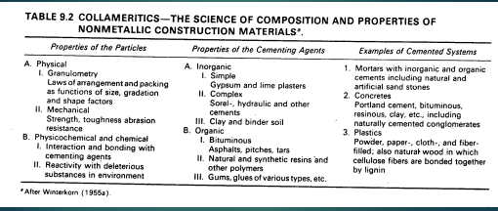**Soil Binder:**

The latter type of materials are also called "soil binder."

Complete replacement of natural soil binder in a clay-bonded stabilized

gravel (clay concrete) by Portland cement produces Portland Cement Concrete. Partial replacement leads to systems that possess properties intermediate between those of Clay Concrete and a Portland Cement Concrete. Similarly, partial replacement of the soil binder by asphalt leads to waterproofed granular soil stabilization, and complete replacement by bitumen and filler leads to Bituminous Concrete. The soil binder or the cementing materials tend to surround the coarse-grain particles and/or form bonding bridges between particles such that the granular system attains rigidity and stability. The strength of such a system is dependent on the strength of the cement and on the shear resistance at the cement-particle interface, as well as on the strength of the granular network.

**Specification of Grading and selection of Soil Elements:**

To get the desire mixture the addition of proper proportions of the aggregates or fines

and treated with waterproofing of cementing material.

The properties of the final mixture are generally controlled and judged by

gradation, the liquid limit, and the plasticity index. A granular bearing skeleton may be established by several different methods. The choice depends on:

* The soil and other materials available
* Intended use and special properties desired in the stabilized system
* Time constraints for planning and construction.

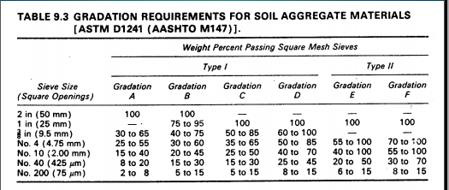

**Soil Binder and Water** are the two elements that create the adhesion and bonding between the coarse grains and provide the continuity of the structure by filling in the voids of the bearing skeleton. The continuous granular skeleton is strengthened and stabilized by the added cohesion.

**During dry weather** Shrinkage of soil binder develops tensile forces on the surfaces of the coarse grains, which has the desirable effect of increased compression on the granular skeleton.

**During wet weather** Swelling of the soil binder might be desirable, as it would reduce the permeability and retard penetration of water. However, introduction of excessive volume

change to the system might be detrimental to functioning of the bearing skeleton. Therefore, the amount and the properties of the soil binder should be controlled for

optimum results.

ASTM and AASHTO Specifications

Formulae for Mixing of Aggregates

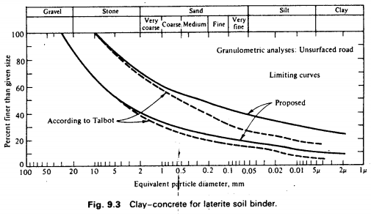

**Exceptions to Gradation Requirements:**

Cases may occur in which certain natural materials that do not meet gradation requirements may develop satisfactory CBR values in the prototype. Exceptions to the gradation requirements are permissible when supported by adequate in-place CBR tests on similar construction that has been in service for several years.

**Fabric:**

The geosynthetics that are routinely used in the transportation industry are geotextiles, geogrids, geomembranes, erosion control blankets and materials, geosynthetic clay liners, geocomposite drainage materials and geonets. The major functions of geosynthetic materials in relation with transportation engineering are separation, reinforcement, filtration, drainage and acting as a liquid barrier. Geotextiles are planar polymeric materials that have been extensively used in roads for separation and reinforcement in flexible pavement systems and for many years, the principal use of geotextiles has been as a separator during the construction of roadworks and in the area of stabilization. In providing filtration and drainage, it aids in improving subsurface drainage and allows the rapid dissipation of excess subgrade pore pressures caused by traffic loading. However, the geosynthetic must minimize the possibility of erosion of the drainage layer and resist clogging of the filter over the design life of the pavement.

# Q2 (i)

**(1): Aggregate Idenfication:**

Aggregates can be identified on the basis of

(1) Origin (Composition)

(2) Mode of Formation & Deposition

(3) Density (Intra-particle voids)

(4) Shape

(5) Surface Texture

**1. Origin:**

**Naturally Occurring Materials**

The majority of aggregates used in road construction are obtained from naturally occurring deposits. Natural aggregates for road-making are obtained from rock of the following geological groups:

Igneous Rocks (95% of Earth’s Crust) which are formed by the cooling of molten material.

Sedimentary Rocks (5% of Earth’s Crust & 75% of Earth’s Surface) which are formed by deposition of granular material.

Metamorphic Rocks which are igneous or sedimentary rocks that have undergone transformations due to heat and pressure

The weathering product may be of two general types:

Residual Materials which may be either weathered or un weathered, generally occur in large deposits and are obtained by quarrying.

Transported Deposits are found, for example, in stream beds, sand and gravel bars, and alluvial fans.

**2.Mode of Formation and Deposition:**

**Colluvium Deposits (Talus)**

a. formed by gravity and weathering action of a steeply sloping rock face

b. crushing usually necessary

c. large angular chunks

**Glacial Deposits**

a. true glacial deposits - transported by glacial ice and have not been

subjected to river transportation

b. fluvial-glacial - glacial deposits subjected to stream action

glacial deposits may be unsuitable as aggregate sources since they are heterogeneous and require a great deal of processing before they can be used.

c. fluvial-glacial deposits - are more suitable.

**Fluvial Deposits**

materials which have been transported and deposited by running water:

a. stream-bed - from beds and banks of existing rivers

b. terrace deposits - older stream bed deposits laid down as a stream bed, earlier age

c. alluvial deposits - fans or cones deposited at the mouth of ravines, gullies, or canyons, arid and semiarid regions.

d. Flood-plain - deposited outside normal stream channels during flood

periods

**Eolian Deposits**

a. deposits laid down by the wind

b. finer sands of narrow size range

c. well rounded and hard and durable

**Marine Deposits**

a. usually contains hard, durable particles as a result of weathering

b. particles are normally very well rounded

c. usually narrow size range

d. wash to remove salts

**3.Density:**

Poros

Non Poros

**4.Surface Texture:**

1. **Glassy Smooth:** Conchoidal feature, Water worn or smooth due to fracture of laminated or fine grained rock.
2. **Granular Rough:** Fracture showing more or less uniform rounded grains , rough fracture of fine or medium grained rock containing no easily crystalline constituents.
3. **Crystalline Honeycombed:** Containing easily visible crystalline constituents with visible pores and cavities.

**5.Shape:**

1. **Rounded Irregular:** Fully water worn or completely shaped by attrition, naturally irregular or partly shaped by attrition and having round edges.
2. **Angular:** Possessing well defined edges formed at the intersection of roughly planar faces.
3. **Flaky:** Material in which the thickness is small than the other two dimensions.
4. **Elongated:** Material usually angular in which length is considerably larger than the other two dimensions.
5. **Flaky and Elongated:** Materials having length considerably larger than width and width is considerably larger than thickness.

**Ans (II):** In field investigation for concrete material prior to construction are chiefly confined to

**Material Sourcing:**

There are two main types ofmaterial sourcing.

1. Natural Aggregate
2. Rock quaries

**Natural Aggregates:**

Natural aggregates are the most important constituents in concrete. They give body to the concrete, reduce shrinkage and affect economy. Natural aggregates are inert granullar material such as sand,gravels stone or crushed stone that are used with a binding medium i.e water, bitumen, Portland cement, lime etc to form compound materials i.e asphalt and Portland cement concrete.

**a)Natural Deposits**

* Stream/ river deposits
* Glacier Deposits
* Fluvial deposits
* Talus deposits
* Wind bloom deposits

**Prospect Sources:**

**Existing Sources**

Information is obtained from

* Geological maps
* Soil survey maps
* Aerial photographs
* Satellite imageries

**b) Rocks quaries:**

**Shallow Deposits**

* Grid of test pits/ trenches

**Representing Samplings**

From different depths.

From bottom and sides.

**Q 3:**

**Macadam Base Material:**

[The term macadam is usually applied to construction where acoarse, crushed aggregate is placed in a relatively thin layer and rolled into place; then fine aggregate orscreenings are placedon the surface of the coarse aggregate layer and rolled and broomed into thecoarse rock until itis thoroughly keyed in place.Water may be used in the compacting and keyingprocess. When water isused, the base is termed a water bound macadam. The crushed rock used for macadam base courses should consist of clean, angular, durable particles free of clay, organic matter,](https://archive.tpub-products.com/content/p/id/46/)

[and other objectionable material or coating. Because of the method of construction, it is necessary to](https://archive.tpub-products.com/content/p/id/46/)

[maintain the coarse and fine aggregates separately. Aggregates for macadam type construction should](https://archive.tpub-products.com/content/p/id/46/)

[meet the](https://archive.tpub-products.com/content/p/id/46/)[gradation](http://engineeringtraining.tpub.com/14069/css/Gradation-518.htm) requirements given in Table 5. Any hard, durable crushed aggregate can be used,

provided the coarse aggregate is primarily one size and the fine aggregate will key into the coarse aggregate.

**Types of Macadam Bases:**

**Water Bound Macadam(WBM):** if the stone materials are held together by the addition of water and filler

**Dry Bound Macadam:** if the aggregates are held together by mechanical interlock only

**Wet Mix Macadam:** if graded stones are mixed with water and compacted

**Penetration Macadam:** if a bituminous material is sprayed over the stones and allowed to penetrate into the course and by "premix" macadam if the bituminous material is mixed with the aggregates prior to laying.

**Water Bound Macadam (WBM): (**In Detail**)**

The roads having its wearing surface consisting of clean, crushed aggregates, mechanically interlocked by rolling and bound together with a filler material and water, laid on a prepared base course is called Water Bound Macadam(W.B.M) road. This is constructed as village road serves as a base for bituminous roads. In most of the roads projects, in the first phase, W.B.M roads are constructed and when the funds are available, the surfacing is done with the premix carpet bituminous macadam or cement concrete. So a water-bound macadam road is considered as the mother of all types of road construction.  
  
**CONSTRUCTION OF W.B.M. ROADS**  
WBM road is known after John Macadam, Surveyor General of Road in England in 1827, who was the first to introduce this particular road. In the present day, the term macadam means the pavement base course constructed by broken aggregates that are interlocked mechanically by rolling and voids filled with screening and binding materials with the help of water. The WBM is used as a sub-base, base course or surface course. The thickness of each layer ranges from 7.5 cm to 10 cm depending on the size of aggregates used. To prolong the life of WBM road, a bituminous surfacing is provided. Construction procedure involves preparation of foundation, provision of literal confinement, spreading of coarse aggregates, rolling, application of screening, sprinkling and grouting, application of binding material, and setting and drying.

**The construction of W.B.M roads is done in the following stages:**  
  
**Preparation of Sub-grade:**  
  
After completing the earthwork in embankment and cutting, the formation level is prepared. The sub-grade is generally in the form of a trench a thickness equal to the thickness of finished pavement. The sub-grade is prepared according to the chamber and grade of the road. It is then thoroughly compacted with road roller of weight not less than 8 tones. Before rolling, water is sprinkled on the sub-grade. Any low pot, if developed during rolling should be rectified and the surface brought to the required grade. If the soil is clayey, a layer of granular material like natural sand, mourn, gravel, literate or Kantar should be spread with 10 to 15 cm thickness. Earthen Krebs along the road edge of 15 cm depth are constructed to hold the road materials in the proper pos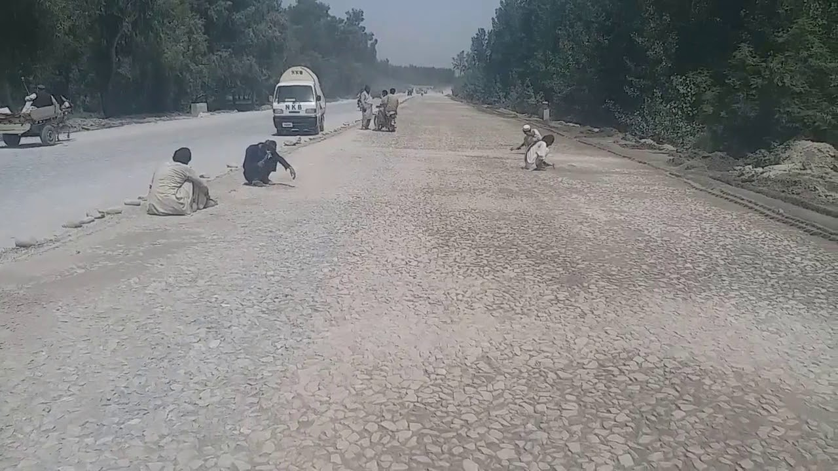  
**Preparation of the Base Course of Foundation:**  
  
This consists of 12 to 18 cm size boulders or broken pieces of stones, over burnt bricks, or brick soling. Care should be taken to keep minimum possible voids in hand packing of boulders. Voids are filled with small pieces of stones. The width of this course is kept 60 cm wider than the pavement width of the road. The surface is then compacted with 10 tones roller as the base course is laid with boulders.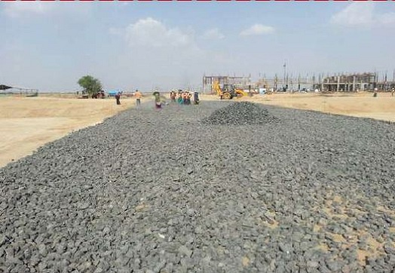

**Advantage of W.B.M:**

-WBM is superior in quality because the materials are carefully graded and the resulting mass is almost void less compacted mass.  
-The interlocking of aggregate particles imparts adequate strength of the materials selected for filling the voids. These ensure non-entry of the plastic materials of the sub-grade into the voids.  
-Water bound macadam is less costly as compared to bituminous base course.

**Disadvantage:**

-The stone pieces used in WBM road are keyed together utilizing sand and clay and no other cementing material is used. The binding effects of sand and clay depend upon the pressure and moisture.  
-When a fast-moving vehicle passes over a W.B.M road, the slurry of sand and clay is sucked out by pneumatic wheel tires, the stone pieces get disturbed and finally, the road surface is disintegrated. Due to this, the W.B.M roads are not suitable for fast-moving vehicles with pneumatic wheels.  
-These roads are only suitable for moving iron wheeled traffic such as ton gas, bullock carts, etc.  
-Constant use of the road by iron wheels, the road mental gets crushed. Considering these factors, it may be inferred that a W.B.M road survives only for a short time.

**Wet Mixing Macadam: (**In Detail**)**

Wet-Mix macadam is a specification in which a well-graded aggregate is mixed with water in a mechanical mixer and the resultant mixture is laid by pavers and compacted.

The aggregate is generally crusher-run, and includes fines also. Because of the close grading, the course will have good interlock with excellent density.

For WBM construction we use three materials:

1. Aggregates
2. Screeners
3. Binders.

**Aggregates:**

We use the aggregates of different grades. IRC(Indian Roads Congress) has classified the coarse aggregates into 9 grades, according to their size.

For the construction of the WBM roads aggregates are used in the sub-base, base and surface course and so the aggregates are divided into 3 grades according to their size.

Grade 1 - particles of size 90 mm to 40 mm.

Grade 2 - particles of size 63 to 40 mm.

Grade 3 - particles of size 50 to 20 mm.

The grade 1 aggregates having size of 90 mm to 40 mm are preferred for the sub-base material and grade 2 for the base and grade 1 for the surface course. However, if we only use the WBM as the surface course, it gets deteriorated fast due to abrasion with the traffic so, bituminous surfacing over the WBM is general practice.

**Screeners** are the aggregates of the smaller sizes, generally 12.5 mm or 10 mm, for grade A and grade B.  They are of the same chemical composition as of the coarse aggregates.   
  
For economic considerations IRC has suggested non plastic materials such as, crushed over burnt bricks, moorum, gravels,  etc. provided the liquid limit of the material is less than 20%, plasticity index is less than 6.0% and the portion of fines passing 0.075 mm sieve is less than 10%.   
However if crush-able type of aggregates are used, use of the screeners may be disposed off.

**Binders:**  
  
Binders, are the layers of materials which are laid after the compaction of the aggregates and the screening materials one after the another. Kankar dust or lime stone dust may be utilized if locally available.   
  
The binding material with plasticity index value of 4% to 9% is used in surface course construction; the plasticity index of binding course material should be less than 6% in the case of the WBM layers used as base course or sub-base course, with bituminous surfacing.   
  
However if the screening used are of crushable material like moorum or soft gravel, there is no need to apply binding material, unless the plasticity index value is low.

Construction WMM Roads:

Aggregates used are of the smaller sizes, varies between the 4.75 mm to 20 mm sizes and the binders(*stone dust or quarry dust having PI(Plasticity Index) not less than 6%*) are premixed in a batching plant or in a mixing machine. Then they are brought to the site for overlaying and compaction.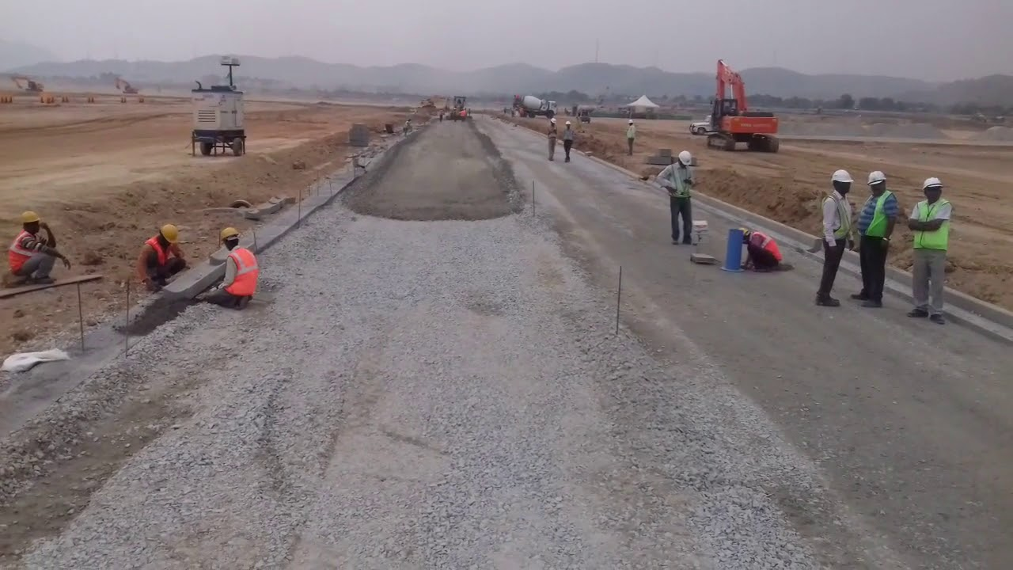

The PI(plasticity Index) of the binding material is kept low because it should be a sound and non plastic material. If the plasticity index is more then there are the chances of the swelling and more water retention properties. So this value should be kept in mind.

While constructing a road, there needs to lay down the base course material right before hot mix asphalt is laid, and that process done through the Wet Mix Macadam. The materials used for the sub-base, base or existing pavement are prepared in a plant as per the specifications provided. Once it is prepared, it is brought to the site for overlaying and rolling under the guidelines of engineers.

The WMM process is a newly developed concept. Earlier it was done through the WBM (water bound macadam) process. Though WBM process is cheaper than the WMM, the later gives plenty of benefits. In short, the outputs of WMM pay you of the debt.

Following are the benefits of WMM Road Construction,

* The roads constructed through WMM process are durable
* The WMM roads get dry sooner as compared to that of WBM
* The WMM process allows constructing road faster than other processes
* Roads can be ready in no time and can be applied or topped with Bituminous layers soon after the laying process done
* WMM process saves plenty of water.

**Comparison of WMM and WBM:**

Following are the Differences

* The main advantage of wet-mix macadam over water-bound macadam is that it is composed of a well-graded mixture. This ensures good interlock and high stability.
* Addition of water while mixing facilitates the handling of the mixture. The operation of laying is much simpler than that of water-bound macadam, where the screenings and binding material have to be added in stages and forced into voids. If a crusher-run material is used, there is no possibility of plastic fines entering into the mixture.
* The compaction is greatly facilitated by the moisture added which lubricates the individual particles.
* One disadvantage of the wet-mix macadam is that it is slightly costlier than water-bound macadam. This is because the specification involves the use of mixing plant and paver. On the other hand, water-bound macadam has been traditionally a labour-oriented specification.
* The aggregates for wet mix macadam will have to be crusher-run, whereas the aggregates for water-bound macadam are generally hand-broken.
* The WMM roads are said to be more durable.

# Q 4 (i): Bitumen:

# Bitumen, also known as asphalt in the United States, is a substance that forms through the distillation of [crude oil](https://www.investopedia.com/terms/c/crude-oil.asp). It has waterproofing and adhesive properties. Bitumen production through distillation removes lighter crude oil components, such as gasoline and diesel, leaving the “heavier” bitumen behind. The producer often refines it several times to improve its grade. Bitumen can also occur in nature: Deposits of naturally occurring bitumen form at the bottom of ancient lakes, where prehistoric organisms have since decayed and have been subjected to heat and pressure.

**Bituminous Materials-Manufacturing :**

Bitumen is the residue or by-product when the crude petrolium is refined. A wide variety of refinery processes, such as the straight distillation process, solvent extraction process etc. may be used to produce bitumen of different consistency and other desirable properties. Depending on the sources and characteristics of the crude oils and on the properties of bitumen required, more than one processing method may be employed.

##### **Distillation:**

Bitumen is produced by fractional distillation of crude oil. Usually, distillation is done in two steps. First the crude oil is heated up to 300-350°C and introduced into an atmospheric distillation column. Lighter fractions like naphtha, kerosene and gas oil are separated from the crude oil at different heights in the column. The heaviest fractions left at the bottom of the column are called heavy residue.

The long residue is heated up to 350-400°C and introduced into a vacuum distillation column. By using reduced pressure it is possible to further distillate lighter products from the residue because the equivalent temperature (temperature under atmospheric conditions) is much higher. If second distillation were carried out under atmospheric conditions and by increasing the temperature above 400°C, thermal decomposition/cracking of the heavy residue would occur. The residue at the bottom of the column is called short residue and is the feedstock for the manufacture of bitumen.

The viscosity of the short residue depends on the origin of the crude oil, the temperature of the long residue, the temperature and pressure in the vacuum column and the residence time. Usually, the conditions are such that short residue is produced with a Penetration between 100 and 300 dmm. The amount of short residue decreases and the relative amount of asphaltenes increases with increasing viscosity of the short residue.

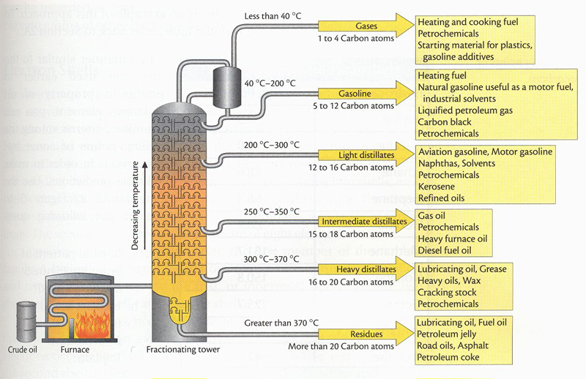

##### **Propane Deasphalting:**

Bitumen is also produced by propane deasphalting and there are differences in the properties of bitumen prepared by propane deasphalting and those prepared by vacuum distillation from the same feed stock. Propane deasphalting also has the ability to reduce a residuum even further and to produce a bituminous product with lower viscosity, higher ductility, and higher temperature susceptibility than other bitumen, although such properties might be anticipated to be very much crude oil dependent. Propane deasphalting is conventionally applied to low-bitumen-content crude oils, which are generally different in type and source from those processed by distillation of higher-yield crude oils.

##### **Air Blowing:**

 The properties of bitumen can be modified by air blowing in batch and continuous processes. On the other hand, the preparation of bitumen in liquid form by blending (cutting back) bitumen with a petroleum distillate fraction is customary and is generally accomplished in tanks equipped with coils for air agitation or with a mechanical stirrer or a vortex mixer. Air is heated up to 150–250°C and introduced at the bottom of a blowing column. It then migrates through the bitumen to the top of the column. The chemical reactions result in bitumen with a different mixture of molecular structures. Catalysts can influence this process.

Blown bitumen has more and stronger molecular interactions than the original bitumen and is therefore more cohesive. Blowing causes the softening point to increase and the penetration to decrease. However, the increase in softening point is usually more than the decrease in penetration. This means that blowing reduces the temperature susceptibility of bitumen. The effectiveness of blowing depends largely on the original bitumen (i.e. the original mixture of molecular structures). With respect to the composition, generally the amount of saturates do not change, the amount of aromates decreases because some oxidized aromates behave like resins, the amount of asphaltenes increases due to trans-formation of some resins and the total amount of resins stays the same.

When bitumen is strongly blown it becomes so cohesive that the adhesive properties become so poor that it is not suited for asphalt applications anymore. Therefore, only semi-blown bitumen is suited for asphalt applications. Semi-blown bitumen can have both improved cohesion and improved adhesion.

**Visbreaking**

Light products have a higher selling value than heavy products like bitumen. Visbreaking is a way to break heavy products (e.g. the residue from crude oil distillation or even very heavy crude oils) into lighter products. Hereto, the crude oil or residue is heated up to 450 °C and kept at that temperature for 1 to 20 minutes. During this period a large amount of molecular structures are broken into smaller structures. The product from the visbreaking process (VB product) is further normally distilled.

* The WMM roads gets dry sooner and can be opened for traffic withing less time as compare to the WBM roads which take about one month for getting dry.
* WMM roads are soon ready to be black topped with the Bituminous layers.
* WMM roads are constructed at the faster rate.
* The consumption of the water is less in case of the WMM roads.
* Stone aggregates used in WBM is larger in size which varies from 90 mm to 20 mm depending upon the grade but in case of the WMM size varies from 4.75 mm to 20 mm.
* In case of WBM, stone aggregates, screenings and binders are laid one after another in layers while in WMM, aggregates and binders are premixed in the batching plants and then brought to the site for overlaying and compacting.
* Materials used in the WBM are the stone aggregates, screenings and binder material(Stone dust with water) while in WMM material used are only stone aggregates and binders.
* Quantity of the WBM is generally measured in cubic meters while that of the WMM in square meters.

**Q 4: (ii): Bituminous Materials-Chemistry:**

**Composition of Bitumen**

Materials in bituminous family are:

### 1) Tar:

Coal tar is a brown or dark black liquid of high viscosity, which smells of naphthalene and aromatic hydrocarbons. Being flammable, coal tar is sometime used for heating or to fire boilers. It can be used in coal tar soap, and is used in medicated shampoo to kill and repel head lice, and as a treatment for dandruff.

Depending upon its source of origin, **TAR** is classified as:

### 2) Coal Tar:

It is the liquid by-product of the distillation of coal to make coke. The gaseous by-product of this process is commonly known as town gas. It is used for coating of wooden poles and sleepers, iron poles.

### 3) Wood Tar:

It is obtained by the distillation of resinous wood. Wood tar contains creosote and as such has strong preservative properties. Search for "**resin**" in the above search box.

### 4) Mineral Tar:

It is obtained by the distillation of bituminous shale.

### ) Coal Tar Pitch:

It is the residue of the direct distillation of crude tar produced by the high temperature carbonization of coal. It is used as a water proofing compound in masonry, steel and timber structure. It is also used for water proofing [concrete](https://www.aboutcivil.org/concrete-technology.html) structures.

## Chemical Composition of Bitumen:

Molecular weight wise, bitumen is a mixture of about 300 - 2000 chemical components, with an average of around 500 - 700. Elementally, it is around 95% carbon and hydrogen (± 87% carbon and ± 8% hydrogen), and up to 5% sulfur, 1% nitrogen, 1% oxygen and 2000ppm metals. Bitumens are composed mainly of highly condensed polycyclic aromatic hydrocarbons. They also contain several elements, a number of which are toxic.

### Chemical Components in bitumen are:

1. Asphaltenes
2. Resinous components (polar aromatics)
3. Non-polar aromatics (naphtene aromatics) and
4. Saturates

**In other words the bitumenios material chemistry** is discussed as under….

**Asphalts are Complex Mixtures of Hydrocarbons**

Hydrocarbons are compounds that contain carbon and hydrogen.

**Organic Chemistry**

In organic chemistry, hydrocarbons are classified on the basis of chemical behavior as saturated or unsaturated. Essentially, saturated hydrocarbons have no multiple linkages between carbon atoms. Unsaturated hydrocarbonscontain one or more double or triple bonds between carbon atoms and, as a consequence, have a great reactivity with other elements.

**Asphalt Composition:** Asphalts are a complex mixture of hydrocarbons, varying, in the case of semi-solid asphalt cements, from low molecular weight (approximately 300) materials to very high molecular weight materials (larger than 5000). Although these materials have the same consistency at a specific temperature, 77 F (25C), it can be seen that the size distribution is different. It is quite probable that these materials will react differently to changes in temperature and behave differently under load. Moreover, the chemical composition of the materials will, in all probability, vary in the different molecular weight ranges, depending upon the crude oil source.Hence, suffice it to say that each material is quite complex unto itself and the materials vary considerably among each other chemically.

**Asphalt Composition** Some generalizations can be made, however, with regard to the chemical composition of the semi-solid materials. According to Simpson they generally consist of Carbon (70-85%)Hydrogen (7-12%)Nitrogen (0-1%) Sulfur (1-7%)Oxygen (0-5%) and small amounts of metals either dispersed in the form of oxides and salts or in metal containing organic compounds.

**Asphalt Composition** The lighter molecular weight materialscontain a considerable amount of carbon and hydrogen in the form of chain-type or aliphatic organic compounds. As the molecular weight increasesthe tendency toward ring type (naphthenic or aromatic) organic compounds is more apparent with the side chains attached to the ring sections.The very high molecular weight compoundsconsist primarily of the ring type materials with very few side chains of the aliphatic variety present. It is in the higher molecular weight ranges where the other elements mentioned above, i.e., nitrogen, oxygen, sulfur. **Asphalt Composition** For convenience, the wide spectrum of organic compounds contained in an asphalt are separated into a number of components, one commonly used classifications states that asphalts can be separated into: ASPHALTENES RESINS OILS MALTENES **Asphalt Composition ASPHALTENES** are the high molecular weight materialsand are primarily of an aromatic nature with very few side chains attached. The hypothetical asphaltene molecule shown in Figure illustrates qualitatively, at least, this composition. It will be noted that sulfur and nitrogen are incorporated in the ring structure in this type of material. Asphaltenes have been defined by ASTM as: the components of the bitumen in petroleum, petroleum products, malthas, asphalt cements, and solid native bitumens, which are soluble in carbon disulfide but insoluble in paraffin naphthas. **RESINS** are the intermediate molecular weight materialsand contain more side chains than the asphaltenes. Some sulfur and nitrogen is also included in these materials, but to a lesser extent than in the asphaltenes. The resins are polar molecules resulting from their aromaticity and the inclusion of sulfur. This polar nature gives resins the ability to be adsorbed by and to dissolve the asphaltenes.

**OILS** are the lightest molecular weight materialsin the asphalt and generally have a large number of chains in proportion to the number of rings. A number of the materials in this range are naphthenic-type closed chains.

It should be emphasized at this point that the asphaltenes, resins, and oils are not three distinct compounds. Rather, there exists a range in molecular weights in the oil fraction, the resin fraction, and the asphaltene fraction. Moreover, the composition of the materials in each fraction and in each asphalt will vary, depending upon the crude source and method of manufacture.

In addition to the classification listed above, other terminology has also been used to describe the various components of asphalt. For example, the oils plus resins are at times referred to as maltenes.

*Actually, there are many methods used to separate asphalts into components for study. Some separation techniques are based on chemical reactivity while others are based on molecular weight or a combination or both.*

The solution and precipitation method developed by Rostler-Sternberg

The chromatic method advance by Corbett

have been the most widely used. **

**Corbett Method** Studies have indicated that SATURATES are better plasticizers than NAPHTHENE AROMATICS ASPHALTENES are solution thickenersSATURATES and ASPHLATENES produce low temperature sensitivityPOLAR AROMATICS control the ductility of the asphalt

**END**