Name: Waleed Raham I.D.No: 14984
Examination: Final Term Paper: Pathology and Microbiology
Teacher: DR. Imran Iqra National University

Ans:1) Healing and Repair:
The body’s attempt, after injury, at restoring normal structure and function. It usually consists of two processes – tissue regeneration and fibrous organization (scar formation), in varying combinations.
Whenever tissue is injured, the body reacts, usually in the form of inflammation and heamostasis. With time, the body attempts to restore normal structure and function. This process is known as healing/repair.
Sometimes, healing occurs primarily by regeneration (i.e: same tissue type grows back), whereas in others, it occurs by scarring.
The process of healing and repair starts right from the time of injury. Often, there is ongoing inflammation as well. Tissue injuries associated with inflammation are eventually followed by some form of healing.
Healing:
Healing starts before the end of inflammation. Healing is usually a tissue response.
- To a wound (common in the skin).
- To inflammatory processes in internal organs.
- To cell necrosis in organs incapable of regeneration.
Healing by first intention:
A common example of wound repair is healing of a clean, uninfected surgical wound approximated by sutures. Such healing is called healing by first intention.
Incision causes;
Death of limited number of epithelial cells and connective tissue.

Healing by Second intention:
Extensive loss of cells and tissues.
Large defects.
Abundant granulation tissue grows in from the margin to complete the repair.
Healing Process:
Within 24 hrs:
Neutrophils enter.
24-28 hrs:
Epithelial cells move and fuse in the midline.
Day 3:
Macrophages move in
Granulation tissue forms
Collagen laid down
Epithelial cell layer forms
Day 5:
Granulation tissue fills the gap
Maximal neovascularization
Collagen fibrils increases
Epithelial cells thickness
2nd Week:
Accumulation of collagen and fibroblast proliferation
Regression of vascular channels, inflammation of edema
4th Week:
Scar
Covered by epidermis
Dermal appendages are absent
Wound strength - over several months.
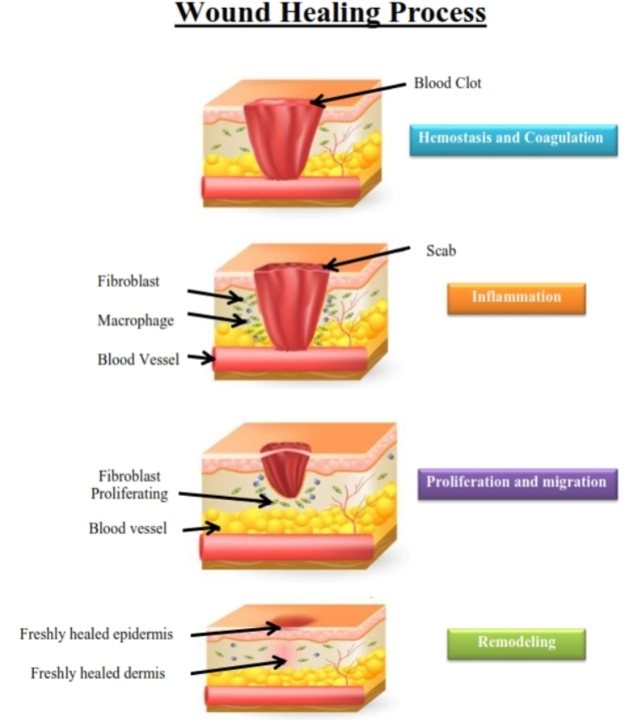

Repair:
Repair is the process by which lost or destroyed cells are replaced by viable cells.
Repair is done by two processes;
Regeneration.
Replacement by connective tissues.
Regeneration:
Growth of cells and tissues to replace lost structures.
The replacement of the destroyed tissue by the parenchymal cells of the same type is called regeneration.
Regeneration refers to the proliferation of cells and tissues to replace lost structures, such as the growth of an amputated limb in amphibians.
In order for an injury to be healed by regeneration, the cell type that was destroyed must be able to replicate. Cells also need a collagen framework along which to grow.

Example:
Acute tubular necrosis (ATN) in the kidney is a case in which cells heal completely by regeneration.
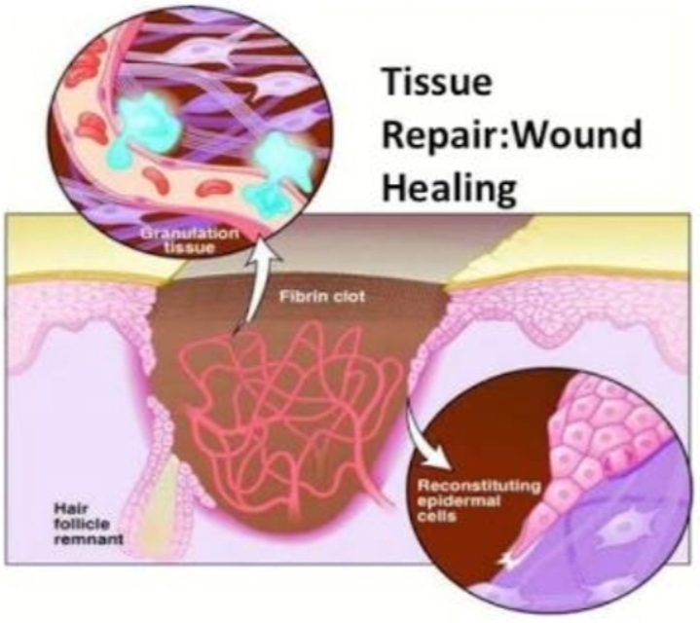

Ans:2) Hemodynamic Disorders:
Meaning:
Heme means blood,
Dynamic means movement
Definition:
The study of the blood flow is called hemodynamics.
The disorders caused by the movement of blood are called hemodynamic disorders.

Hemodynamic Disorders:
- Edema:
Increased fluid in the interstitial tissue spaces.

Pathophysiologic Causes of Edema:
Increased hydrostatic pressure
Reduced plasma osmotic pressure
Lymphatic obstruction
Sodium retention
Inflammation

Types of Edema:
Anasarca
Dependent edema
Renal edema
Peri-orbital edema
Pitting edema
Pulmonary edema
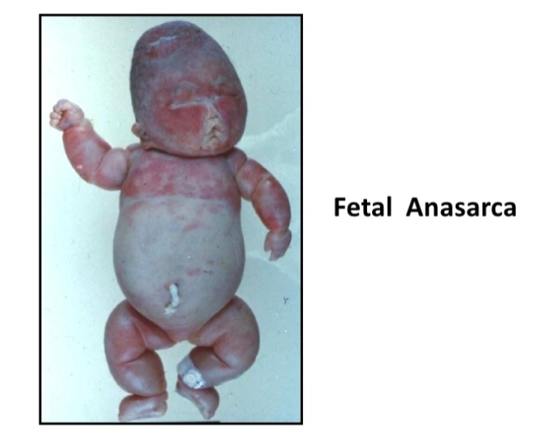

- Hemorrhage:
Extravasation of blood due to vessel rupture.
Types of Hemmorhage:
Hematoma:
Accumulation of blood within tissue.
Petechiae:
Minute 1 to 2mm hemorrhages into skin, mucous membranes, or serosal surfaces.
Purpura:
Slightly larger (greater than 3mm) hemorrhages.
Ecchymoses:
Larger (greater than 1 to 2 cm) subcutaneous hematomas.
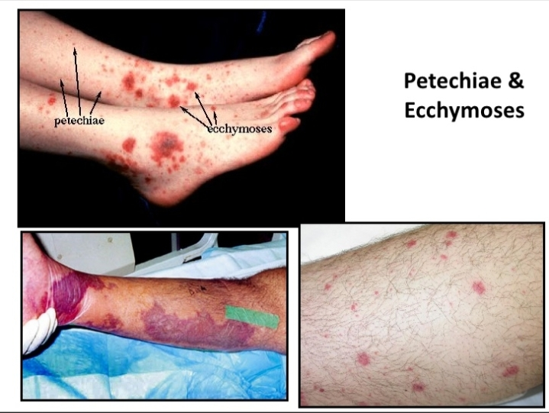

Hemothorax, hemopericardium, hemoperitoneum, or hemarthrosis (in joints):
Large accumulations of blood in one of the body cavities.

- Congestion:
It indicates a local increased volume of blood in a particular tissue.
There is an increased volume and pressure of blood in a given tissue with associated capillary dilation and a potential for fluid extravasation.
In congestion, diminished outflow leads to a capillary bed swollen with deoxygenated venous blood and resulting in cyanosis.
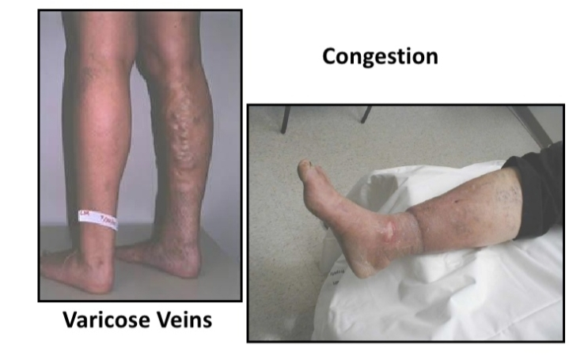

Ans:3) Renewal and Regeneration:
Tissue Renewal:
Tissue renewal determines the rate of cell division. In many tissues, renewal derives from rare stem cells. Many tissues that renew frequently have a clear hierarchy of cell division and differentiation.
Renewing Tissues and Epithelial Risk:
The epithelium of the human colon turns over at least once per week throughout life. As cells die at the surface, they are replaced by new cell divisions.
Hematopoietic Renewal:
The numerous distinct blood types derive from hematopoietic stem cells via a complex transit hierarchy.
Gastrointestinal Renewal:
Renewal occurs by a flow of cells from numerous invaginations – crypts – throughout the intestinal surface. Cells flow from the base of each long, narrow crypt to the surface.
Epidermal Renewal:
The epidermal layer of the skin turns over about every 7 days in mice and approximately every 60 days in humans.
Regeneration:
Some tissues are able to replace the damaged components and essentially return to a normal state; this process is called regeneration.
Regeneration occurs by proliferation of cells.
Retain the capacity to proliferate.
Regeneration In humans is the regrowth of lost tissues or organs in response to injury. This is in contrast to wound healing, or partial regeneration, which involves closing up the injury site with some gradation of scar tissue.
Liver Regeneration:
Regeneration of the liver occurs by two major mechanisms:
Proliferation of remaining hepatocytes.
Repopulation from progenitor cells.
Cell and Tissue Regeneration:
The regeneration of injured cells and tissues involves cell proliferation, which is driven by growth factors and is dependent on the integrity of the extracellular matrix, and by the development of mature cells from stem cells.

Ans:4) Staphylococcus and Streptococcus:
Staphylococcus:
Bacteria in the genus Staphylococcus are the pathogens of man and other mammals. Traditionally, they were divided into two groups on the basis of their ability to clot blood plasma.
The coagulase-positive staphylococci.
The coagulase-negative staphylococci.
S aureus expresses a variety of extracellular proteins and polysaccharides, some of which are correlated with virulence. Virulence results from the combined effect of many factors expressed during infection.
Structure:
Staphylococcus aureus is a gram-positive, round-shaped bacterium which is about 0.5 – 1.0 micrometer in diameter. They grow in clusters, pairs and occasionally in short chains. The clusters arise because staphylococci divide in two planes.
Natural Habit:
S aureus colonizes the nasal passage and axillae. S epidermis is a common human skin commensal. Other species of staphylococci are in frequent human commensals.
Pathogenesis:
Surface proteins that promote colonization of host tissues.
Factors that probably inhibit phagocytosis.
Toxins that damage host tissues and cause disease symptoms.
Host Defenses:
Phagocytosis is the major mechanismfor combating staphylococcal infection. Antibodies are produced which neutralize toxins and promote opsonization. The capsule and protein A may interfere with phagocytosis.
Epidemiology:
Epidemiological tracing of S aureus is traditionally performed by phage typing but has limitations.
Diagnosis:
Diagnosis is based on performing tests with colonies. Tests for clumping factor, coagulase, hemolysins are used to identify S aureus.
Treatment:
Penicillinase-resistant B-lactams.
Vancomycin.

Streptococcus:
Streptococcus is a genus of gram-positive or spherical bacteria that belongs to the family Streptococcaceae, that cause many disorders, including pharyngitis,pneumonia, wound and skin infections, sepsis, and endocarditis. Symptoms vary with the organ infected.
Classification:
Beta-hemolytic streptococci
Alpha-hemolytic streptococci
Gamma-hemolytic streptococci
Virulence factors:
Many streptococci elaborate virulence factors; including streptolysins, DNAases, and hyaluronidase which contribute to tissue destruction and spread of infection.

Diseases caused by Streptococci:
S. pyogenes
Pharyngitis
Skin infections
Rheumatic fever
Acute glomerulonephritis

Streptococcal skin infections:
Impetigo
Erysipelas
Cellulitis

Diagnosis:
Culture
Sometimes rapid antigen tests or antibody titers.
Streptococci are readily identified by culture on a sheep blood agar plate.

Treatment:
Pencillin is the drug of choice for pharyngeal GABHS infections. No isolate of GABHS has shown penicillin resistance clinically. However, some streptococcal strains appear to have in vitro tolerance to penicillin.
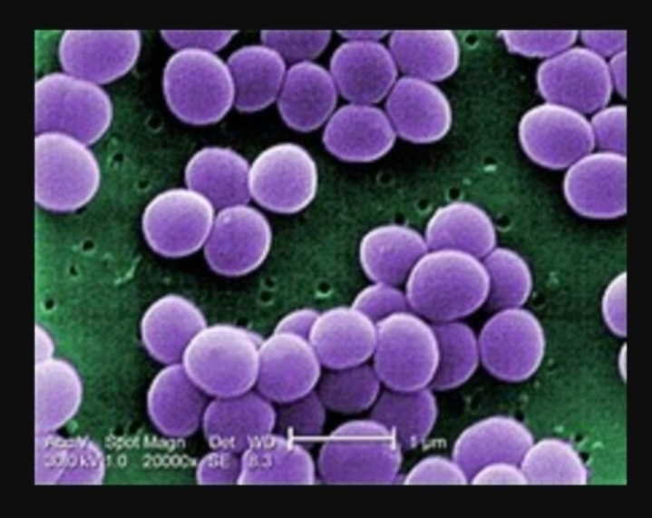

Thank You!

