Name :NASEER U DDIN
Id : 14465
Date 11 / 7 /2020
4th semester
Bs Dt
Assignment: General pharmacology
Drugs used for hypertension
DIURETICS :
MOA:
Act on V-2 receptor in kidneys (vasopressin receptor) having an antediuretic function---- leads to diuresis----increased secretion of Na & H2O decrease in blood volume ----decreased CO--- decreased BP

Specific agents
Thiazides diuretics: chlorthalidone
Loop diuretics :Furosemide
K+ sparing diuretics :Spironolactone

Adverse effects
dizziness,
electrolyte
imbalance/depletion,
hypokalemia,

hyperlipidemia,
hyperglycemia

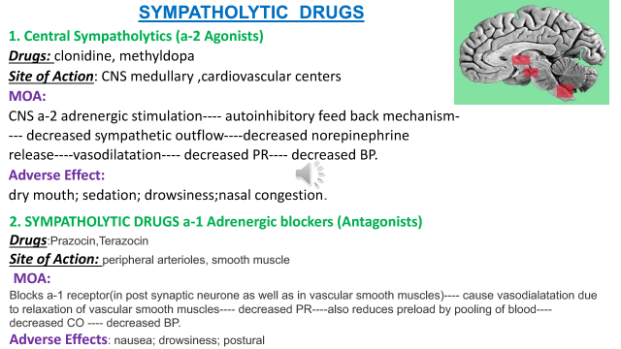
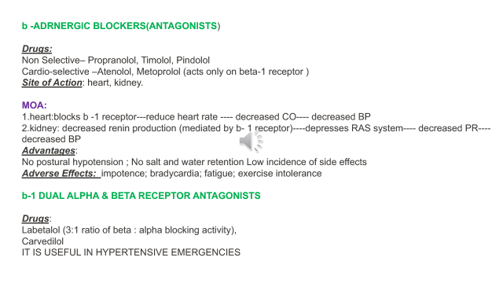
Drugs used for cardiac heart failure

Is the ability of heart failure to pump blood to meet the demands needs of the body
Types
- RHF
- LHF
- CCF
Drug used for heart failure
- Diuretics e.g frusemide , spironolactone , amiloride (lasix , lesoride , spiromide)
- ACE inhibitors e.g captoril ,enalapril , lisinopril .
- Losartin potassium eg ezady , antagonist of angiotensin 2 receptor
- Vasodilators eg nitrates ,nitroglycerin , isosorbide , mononitrates
- Digoxin or dopamine in severe caseeg lanoxin 0.25

