Name: Ghazala
Class Id: 14023
Subject: pathology and microbiology
Exam: final term
Semester: 6th
Dep: AHS (Dpt)
Teacher: Ma'am Maria

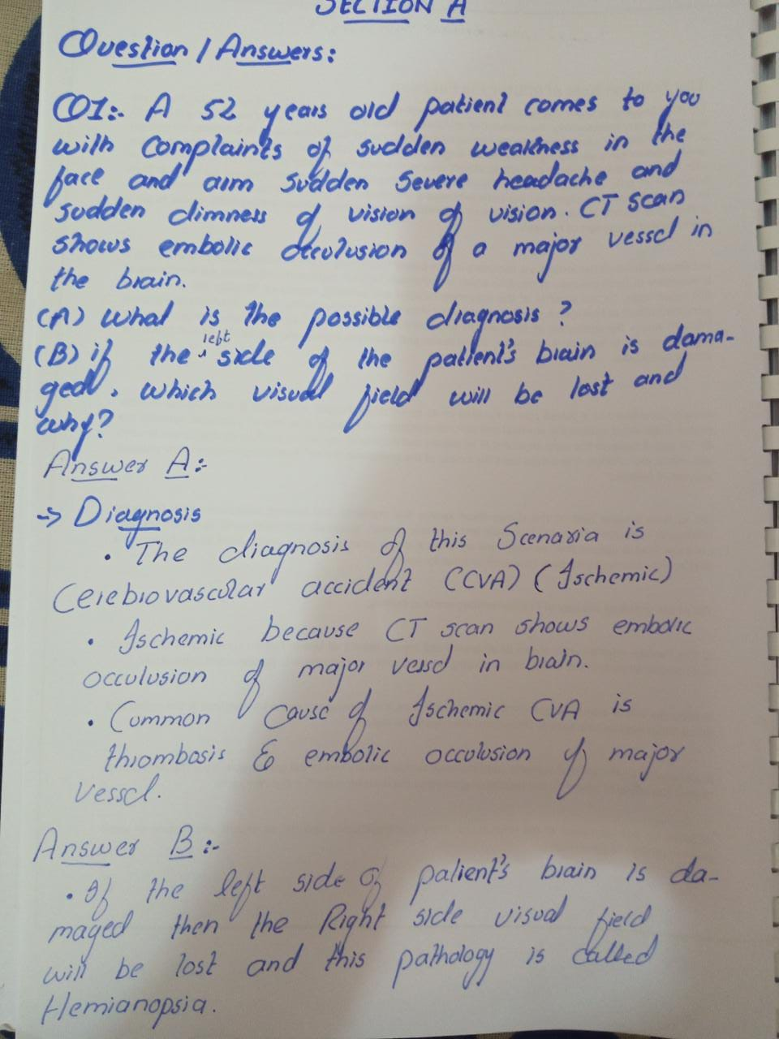

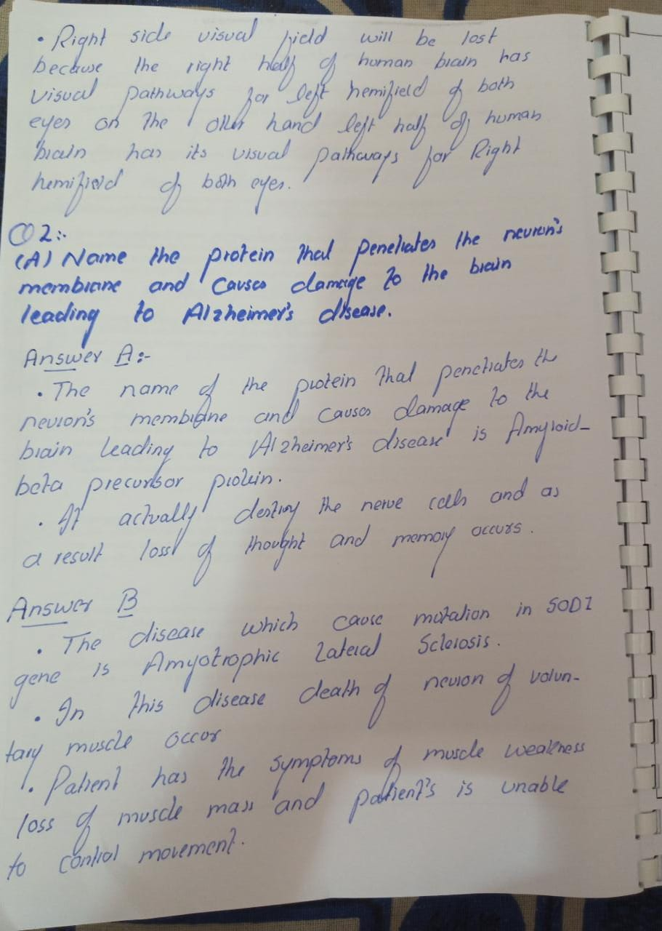

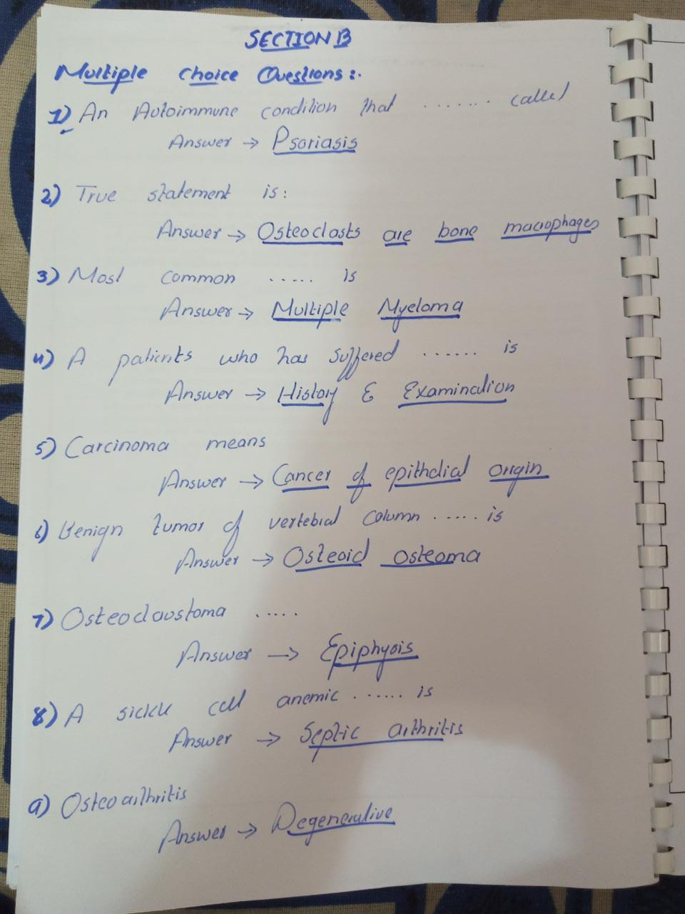

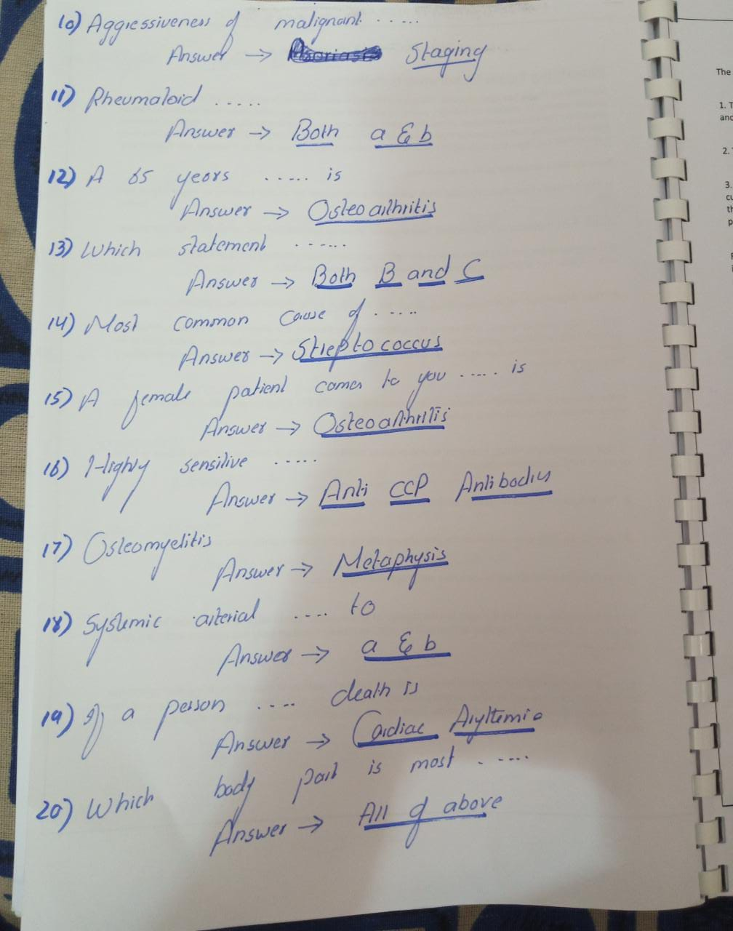

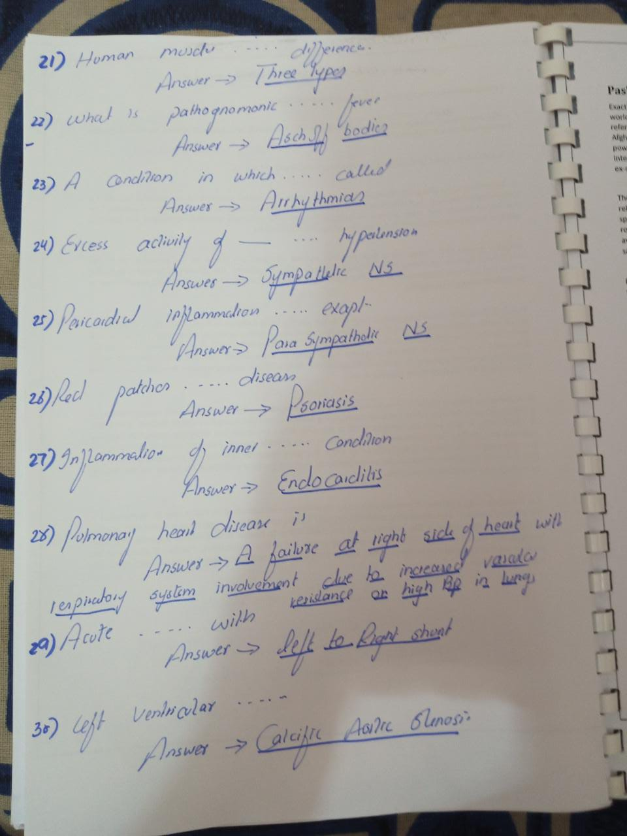

The end!

