Name:
Maryam Noor
ID: 16638
Paper:
Managerial Economics
Department:
MBA (3.5) Weekend
Instructor:
Sir Prof.Dr Mohammad Jalal Uddin

IQRA NATIONAL UNIVERSITY PESHAWAR
Department of Business Administration
Final Exam Spring 2020
Subject: Managerial Economics
Total Marks: 50 Time allowed: 6 hours
Note: Attempt all questions

Question No :1
It is said that firms are generally organized for profit earning. In the managerial economics, profit management is a challenging issue. Explain?

Answer:
Managerial economics is a discipline which deals with the application of economic theory to business management. It deals with the use of economic concepts and principles of business decision making. Formerly it was known as “Business Economics” but the term has now been discarded in favour of Managerial Economics.
Definitiom:
Managerial Economics may be defined as the study of economic theories, logic and methodology which are generally applied to seek solution to the practical problems of business. Managerial Economics is thus constituted of that part of economic knowledge or economic theories which is used as a tool of analysing business problems for rational business decisions. Managerial Economics is often called as Business Economics or Economic for Firms.
Profit management:
Business firms are generally organized for earning profit and in the long period, it is profit which provides the chief measure of success of a firm. Economics tells us that profits are the reward for uncertainty bearing and risk taking. A successful business manager is one who can form more or less correct estimates of costs and revenues likely to accrue to the firm at different levels of output. The more successful a manager is in reducing uncertainty, the higher are the profits earned by him. In fact, profit-planning and profit measurement constitute the most challenging area of Managerial Economics.
Capital management:
The problems relating to firm’s capital investments are perhaps the most complex and troublesome. Capital management implies planning and control of capital expenditure because it involves a large sum and moreover the problems in disposing the capital assets off are so complex that they require considerable time and labour. The main topics dealt with under capital management are cost of capital, rate of return and selection of projects.

Conclusion:
The various aspects outlined above represent the major uncertainties which a business firm has to reckon with, viz., demand uncertainty, cost uncertainty, price uncertainty, profit uncertainty, and capital uncertainty. We can, therefore, conclude that the subject-matter of Managerial Economics consists of applying economic principles and concepts towards adjusting with various uncertainties faced by a business firm.

Question No 2
Under the umbrella of Business Management demand analysis and forecasting play key role for a successful business. Discuss?

Answer
Managerial economics is a discipline which deals with the application of economic theory to business management. It deals with the use of economic concepts and principles of business decision making. Formerly it was known as“Business Economics” but the term has now been discarded in favour of Managerial Economics.
Managerial Economics may be defined as the study of economic theories, logic and methodology which are generally applied to seek solution to the practical problems of business. Managerial Economics is thus constituted of that part of economic knowledge or economic theories which is used as a tool of analysing business problems for rational business decisions. Managerial Economics is often called as Business Economics or Economic for Firms.

Definition of Managerial Economics:
“Managerial Economics is economics applied in decision making. It is a special branch of economics bridging the gap between abstract theory and managerial practice.” – Haynes, Mote and Paul.
“Business Economics consists of the use of economic modes of thought to analyse business situations.” - McNair and Merriam
“Business Economics (Managerial Economics) is the integration of economic theory with business practice for the purpose of facilitating decision making and forward planning by management.” - Spencer and Seegelman.
“Managerial economics is concerned with application of economic concepts and economic analysis to the problems of formulating rational managerial decision.”
Demand Analysis and Forecasting:
Demand forecasting reduces risk related to business activities and helps it to take efficient decisions. For firms having production at the mass level, the importance of forecasting had increased more. A good forecasting helps a firm in better planning related to business goals
Business firm:
A business firm is an economic organisation which is engaged in transforming productive resources into goods that are to be sold in the market. A major part of managerial decision making depends on accurate estimates of demand. A forecast of future sales serves as a guide to management for preparing production schedules and employing resources. It will help management to maintain or strengthen its market position and profit base. Demand analysis also identifies a number of other factors influencing the demand for a product. Demand analysis and forecasting occupies a strategic place in Managerial Economics.

Question No 3

Define Supply? Discuss determinants of Supply.

Answer

Supply
Definition:
In economics, “Supply” implies the quantity (how much) of a commodity that the producers, manufacturers or sellers are willing and able to offer to the market at different prices during a particular period of time.Basically, supply is something that the firm offers for sale, to the target audience in the market, which may not be something that the firm succeeds in selling, because everything that is offered is for sale, may not get sold.
Individual Supply:
Individual Supply connotes the quantity of a good or service which an individual organization is willing and able to produce and offer for sale.
Individual supply schedule:
An individual supply schedule is an indicator of various quantities of a product offered for sale by a producer at different prices.
Market Supply:
Market Supply implies how much of a commodity, all the producers in the market are willing and able to produce and offer for sale is called market supply.
Market supply schedule reflects the different quantities of a product that all the firms in the market are ready to supply at set market price, during a particular period of time.

Determinants of Supply:
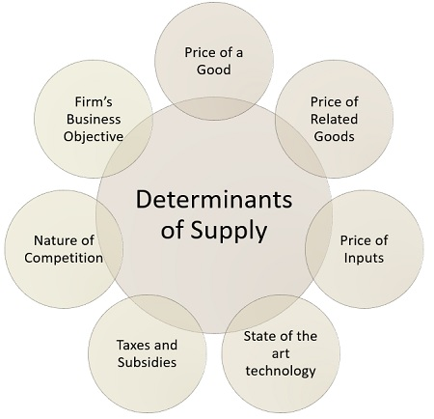
Price of a good:
Other things remain constant when the relative price of a commodity is high, it is supplied in great quantity, as firm produces the commodity to earn profit and the profit of the firm increases with an increase in its price.
Price of related goods:
When the price of other goods, i.e. competing or complementary goods rise, it becomes comparatively profitable to the firm to produce and offer the other good than the good in question.
For instance:
A farmer produces two crops tea and coffee and if the price of tea increases, then in such a situation, it will be more profitable for the farmer to produce more tea. Therefore, the farmer may shift his resources from the coffee production to that of tea. In this way, the supply of tea may increase and coffee will fall.
Price of inputs:
The price of factors of production (inputs), i.e. land, labor, capital, entrepreneur also affects the supply of the commodity, in a way that if there is an increase in the price of a factor of production, then the cost of producing a commodity which uses that particular factor in excess will be more in comparison to the commodity, which uses the same factor in less quantity.
State of the art technology:
Innovations in the product, usually make the product better than before, and also better than its competitors, with the limited resources which the company possess. Thus the company will increase the supply of the products with state of the art technology and reduce the supply of the product which is displaced.
Taxes and subsidies:
Goods and services tax is levied on goods, which increases the overall cost of production and so the supply of the commodity will increase only when the price of the commodity rises. Conversely, government subsidies usually decrease the cost of production and hence it is beneficial to the firm to increase the supply of goods.
Nature of competition:
When there is a cut-throat competition between firms in the market, the firm wants to increase their share to the maximum, for which they supply more of the commodity. Further, when there is a new entry to the industry, it also increases the supply of the existing goods in the market.
Firm’s business objective:
The primary objective of the firm, i.e. profit maximization or sales maximization or the combination of the two, also influence the market supply of the commodity. So, when the firm wants to increase the profit, it will decrease the supply of the commodity, which can help the firm in increasing the price when there is a high demand for it. In contrast, when the firm wants to increase its sales, it will simply raise the supply.
Apart from the given factors, there are other factors like natural factors especially in the case of agricultural products, which influences the supply. Further, the future expectation of the products about the price rise/fall may also influence the supply of the commodity in the market.

Question No 4
Discuss Monopoly Equilibrium in the Firm?

Answer
Monopoly is that market form in which a single producer controls the whole supply of a single commodity which has no close substitute.
From this definition there are two points that must be noted:
Single Producer:
There must be only one producer who may be an individual, a partnership firm or a joint stock company. Thus single firm constitutes the industry. The distinction between firm and industry disappears under conditions of monopoly.
No Close Substitute:
The commodity produced by the producer must have no closely competing substitutes, if he is to be called a monopolist. This ensures that there is no rival of the monopolist. Therefore, the cross elasticity of demand between the product of the monopolist and the product of any other producer must be very low.
Price-output determination under monopoly:
A firm under monopoly faces a downward sloping demand curve or average revenue curve. Further, in monopoly, since average revenue falls as more units of output are sold, the marginal revenue is less than the average revenue. In other words, under monopoly the MR curve lies below the AR curve. The Equilibrium level in monopoly is that level of output in which marginal revenue equals marginal cost. The producer will continue producer as long as marginal revenue exceeds the marginal cost. At the point where MR is equal to MC the profit will be maximum and beyond this point the producer will stop producing.
Equilibrium in Monopoly:
The conditions for Equilibrium in Monopoly are the same as those under perfect competition. The marginal cost (MC) is equal to the marginal revenue (MR) and the MC curve cuts the MR curve from below.

A Firm’s Short-Run Equilibrium in Monopoly:
Like in perfect competition, there are three possibilities for a firm’s Equilibrium in Monopoly. These are:
The firm earns normal profits – If the average cost = the average revenue
It earns super-normal profits – If the average cost < the average revenue
It incurs losses – If the average cost > the average revenue

Normal Profits:
A firm earns normal profits when the average cost of production is equal to the average revenue for the corresponding output.
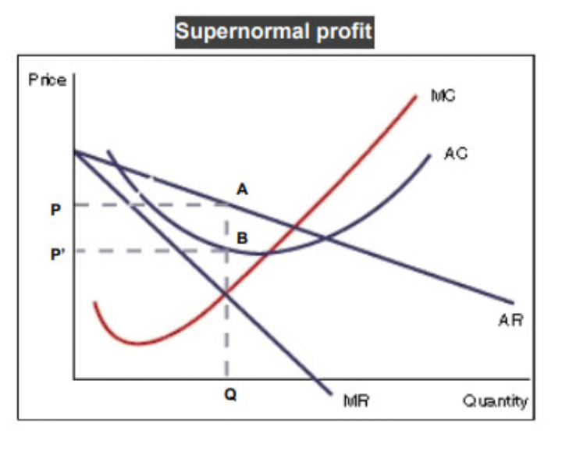
In the figure above, you can see that the MC curve cuts the MR curve at the equilibrium point E. Also, the AC curve touches the AR curve at a point corresponding to the same point. Therefore, the firm earns normal profits.

Super-normal Profits
A firm earns super-normal profits when the average cost of production is less than the average revenue for the corresponding output.

In the figure above, you can see that the price per unit = OP = QA. Also, the cost per unit = OP’. Therefore, the firm is earning more and incurring a lesser cost. In this case, the per unit profit is
OP – OP’ = PP’
Also, the total profit earned by the monopolist is PP’BA.

Losses:
A firm earns losses when the average cost of production is higher than the average revenue for the corresponding output.
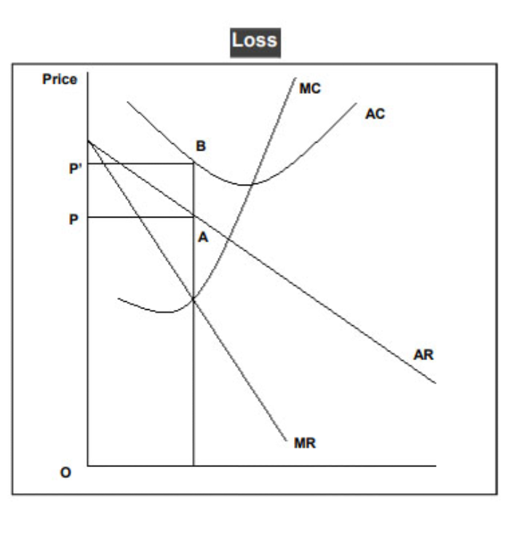
In the figure above, you can see that the average cost curve lies above the average revenue curve for the same quantity. The average revenue = OP and the average cost = OP’. Therefore, the firm is incurring an average loss of PP’ and the total loss is PP’BA. In the short-run, a monopolist sometimes sets a lower price and incurs losses to keep new firms away.

Short-run Equilibrium in Monopoly:
In the short-run, a monopolist firm cannot vary all its factors of production as its cost curves are similar to a firm operating in perfect competition. Also, in the short-run, a monopolist might incur losses but will shut down only if the losses exceed its fixed costs. Further, if the demand for his product is high, then the monopolist can also make super-normal profits.
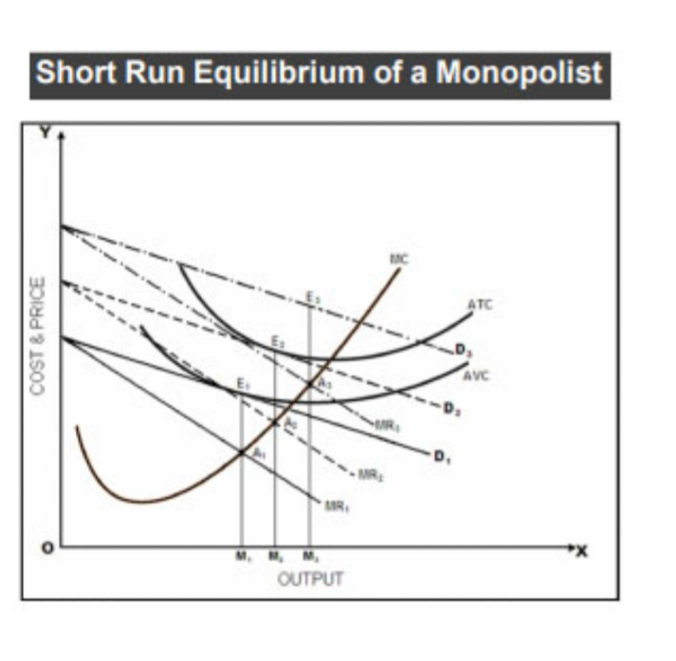
The figure shown above depicts a firm’s short-run Equilibrium in Monopoly. The quantity is along the X-axis and price and cost of production along the Y-axis.
There are three curves the average variable cost (AVC) curve, the average total cost (ATC) curve, and the marginal cost (MC) curve. Further, there are three demand curves to explain the possible positions of the equilibrium:

Demand Curve D₁ is tangent to the AVC curve at point E₁
Its corresponding MC curve intersects the MR₁ curve from below at point A₁. Therefore, while the monopolist satisfies the first condition of equilibrium, he is unable to recover his complete cost of production. However, even if he closes the plant down, he cannot reduce the losses since they are fixed costs. Therefore, he decides to produce OM₁ quantity of output and sells it at a price E₁M₁. This ensures that he suffers a loss which is equal to his fixed costs.It is important to note that if the demand curve lies left to the position of D₁, then there is no production since the monopolist would simply add to his losses by operating the plant. In such cases, a monopolist would close down the plan and restrict his losses to the fixed costs.

Demand curve D₂
If the demand curve lies to the right of D₁, then the monopolist can recover a part of his fixed costs. Further, if this demand curve is tangent to the ATC curve (demand curve D₂), then the monopolist can also recover his complete cost of production.
If D₂ is the demand curve, then the equilibrium position of the monopolist is at the intersection of the MC curve and the MR₂ curve at point A₂. This corresponds with the point of tangency between D₂ and the ATC curve (point E₂).
Therefore, the MC curve cuts the MR₂ curve from below and AR = ATC. Hence, the monopolist earns normal profits by producing a quantity OM₂ and selling it at a price E₂M₂.

Demand Curve D₃
If the demand curve lies further to the right of D₂ (like D₃), the monopolist can earn super-normal profits. The equilibrium position is the point of intersection between the MC curve and the MR₃ curve at point A₃. Therefore, the monopolist produces a quantity OM₃ and sells it at a price E₃M₃.

A Firm’s Long-run Equilibrium in Monopoly
In the long-run, a monopolist can vary all the inputs. Therefore, to determine the equilibrium of the firm, we need only two cost curves – the AC and the MC. Further, since the monopolist exits the market if he is operating at a loss, the demand curve must be tangent to the AC curve or lie to the right and intersect it twice.
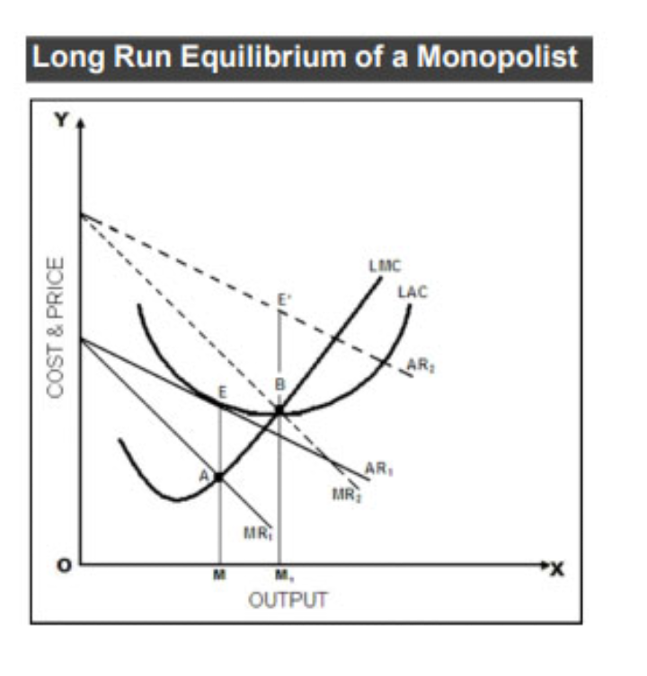

As you can see above, there are two alternative cases for the determination of Equilibrium in Monopoly:
With normal profits
With super-normal profits
We have not taken the loss scenario here because if the monopolist incurs losses in the long-run, he will stop operating.

Case 1
The demand curve AR₁ is tangent to AC or LAC at point E. Remember, if the demand curve lies to the left of the AC curve, then the monopolist is unable to recover his costs and closes down.However, if the AR curve is tangent to the AC curve, then the monopolist can recover his costs and stay in the market. Further, note that the perpendicular drawn from point E to the X-axis, the MC curve, and the MR curve are concurrent at point A. Therefore, all the conditions of equilibrium are satisfied. The monopolist produces OM quantity and sells it at a price of EM per unit which covers its average costs + normal profits.

Case 2
The marginal revenue curve MR₂ cuts the MC curve from below at point B. The corresponding height of the AR2 curve is E’M₁. Hence, the monopolist produces OM₁ quantity and sells it at E’M₁ per unit to earn an extra profit of E’B per unit. Being a monopoly, this extra profit is not lost to competition or newer firms entering the industry.

