Name Mazhar Alam
ID 16444
Department BS Rad Sec A
Subject physiology

Q No 1 answer
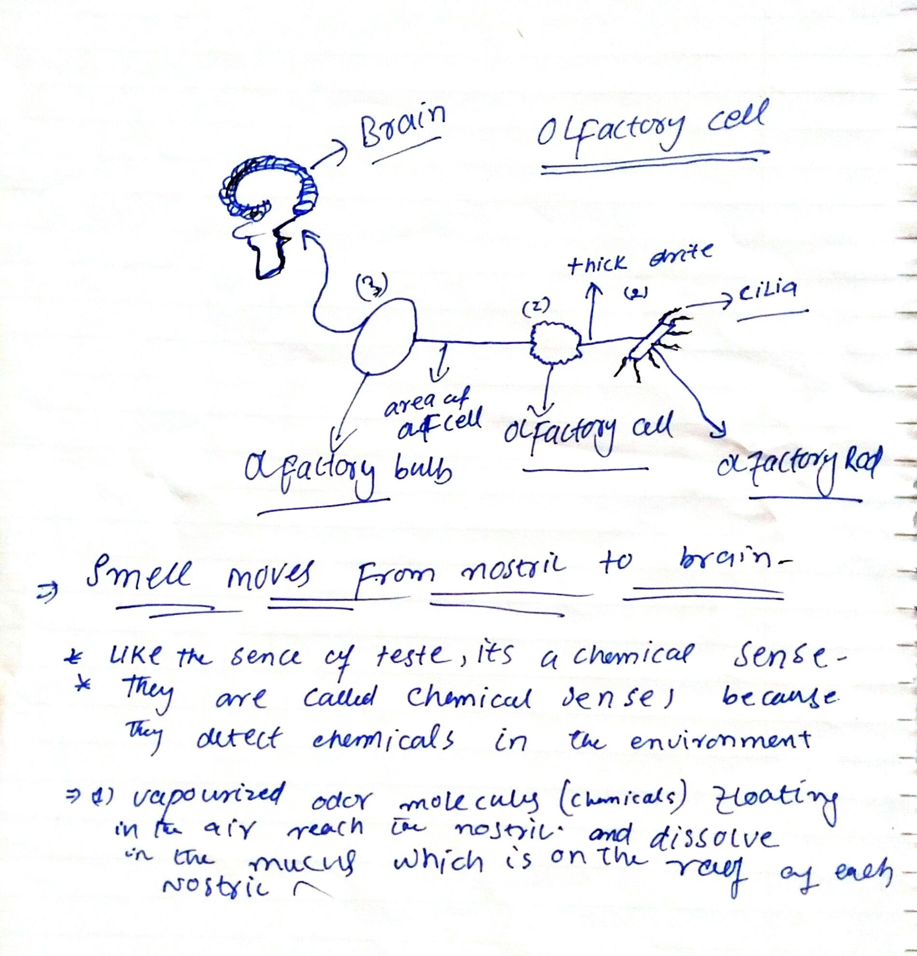

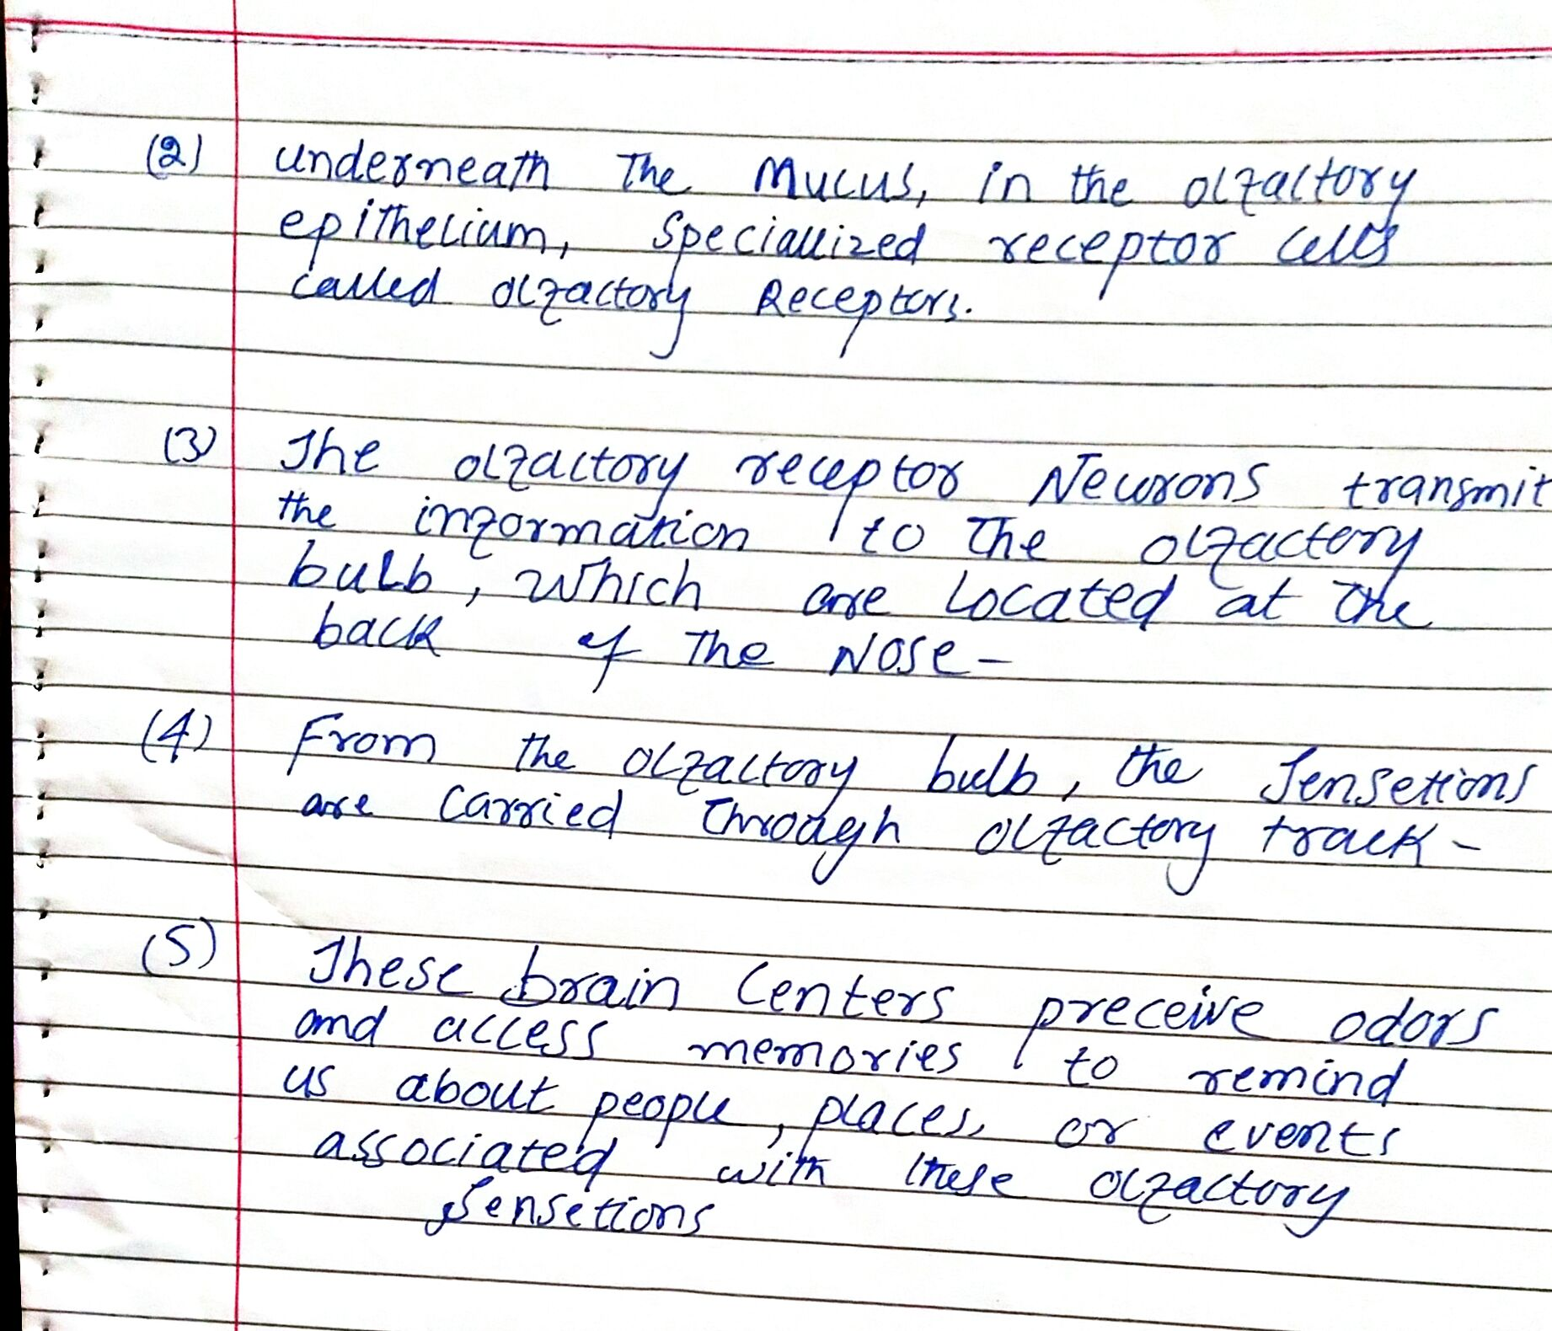

Q No 2 Answer
Difference between Haemostasis and Haematopoiesis and Homeostasis :*

Haematopoiesis is the formation of blood cellular components. All cellular blood components are derived from haematopoietic stem cells. In a healthy adult person, approximately 10¹¹–10¹² new blood cells are produced daily in order to maintain steady state levels in the peripheral circulation.
difference between homoeostasis and haemostasis

Haemostasis: is the of wound healing. This involves blood clotting. Haemostasis has three major steps: 1) vasoconstriction, 2) temporary blockage of a break by a platelet plug, and 3) blood coagulation, or formation of a fibrin clot. These processes seal the hole until tissues are repaired.

Homoestasis: is the proccess by which variables are regulated so that internal conditions remain stable and relatively constant. Examples of homeostasis include the regulation of temperature and the balance between acidity and alkalinity (pH). It is a process that maintains the stability of the human body's internal environment in response to changes in external conditions.

( B ) Erythroblastosis fetalis:*

a hemolytic disease of the fetus and newborn that occurs when the immune system of an Rh-negative mother produces antibodies to an antigen in the blood of an Rh-positive fetus which cross the placenta and destroy fetal erythrocytes and that is characterized by an increase in circulating erythroblasts and by jaundice

( Q No 3 Answer )

( A ) immunity..*

: the quality or state of being immune
especially : a condition of being able to resist a particular disease especially through preventing development of a pathogenic microorganism or by counteracting the effects of its products

Two types of immunity...

active and passive:
Active immunity occurs when our own immune system is responsible for protecting us from a pathogen.

( Passive immunity ) occurs when we are protected from a pathogen by immunity gained from someone else.
( B )Difference between antigen and antibody
The humoral immune system consist of B.cell which irignate in the bone marrow and stay there to develop .B .cells can produce anti bodies
The antigens presenting macrophages active those helper T cells with matching receptors the constant region determine the mechanism used to destroy antigen. Antibodies are produced by the immune system in response to antigens (material perceived as foreign). The antibody response to a particular antigen is highly specific and often involves a physical association between the two molecules. This association is governed by biochemical and molecular forces. The reaction between antigens (Ags) and antibodies (Abs) involves complementary binding sites on the Ab and on the Ag molecules. Some of the differences between antigen and antibody

( Q No 4 Answer )

Function Of Antibody *
The antibodies act sort of like the immune system's scouts. They find antigens, stick to them, and identify for the immune system the exact type of antigen so that it can be destroyed.
Each antibody is made for one and only one antigen, and it's fitted with special receptors that will only bind to that antigen. For instance, a specific antibody is created to help destroy the chickenpox virus. Only that particular antibody will attack a chickenpox virus.

** Main Functions of the antibody...

Neutralization of infectivity,
Phagocytosis,
Antibody-dependent cellular cytotoxicity (ADCC),
Complement-mediated lysis of pathogens or of infected cells: Antibodies activate the complement system to destroy bacterial cells by lysis.
Antibodies have three main functions
: 1) Antibodies are secreted into the blood and mucosa, where they bind to and inactivate foreign substances such as pathogens and toxins (neutralization). 2) Antibodies activate the complement system to destroy bacterial cells by lysis (punching holes in the cell wall).

( B )The primary immune responce occurs when an antigen comes in contact to the immune system for the first time. ... The secondary immune responce occurs when the second time (3rd, 4th, etc.) the person is exposed to the same antigen
In a primary immune response, naive B cells are stimulated by antigen, become activated, and differentiate into antibody-secreting cells that produce antibodies specific for the eliciting antigen. A secondary immune response is elicited when the same antigen stimulates memory B cells, leading to the production of greater quantities of specific 88antibodies that are produced in the primary response. Some of the differences between Primary and Secondary Immune Response are as follows:

Q No 5 Answer

Cell mediate **

The cell mediate immune system consist of T cell which orginate in the bone marrow but moves to the thymus where their thymus their devalopment is completed t cell are highly speciallised cells in the blood and lymph they fight bacteria viruses fungi protozoan cancer etc .within host cells and react against foreign mater such as organ trasplant there are three kind of t cell cytoxic t cells directly kill invaders helper t cell aid b cell and other t cell to do their jobs suppresor t cell suppress the activites of b cell and other t cell so they dont overrating the celluar immunne responses cells of the immune system kill cell of the body.
That have been infected with a virus or that are cancerous .this responce relies on cytocxic t tc cell tc cells contain molecule called perforins

The antibody Mediated Immunity

The humoral immune system consist Of B cells which orginate in the bone marrow and stay there to devlop .b.cells can produce antibodies but need exposure to foreign antigens to do so these antigens are cell surface oligosaccharides and proteins which the cell uses as if tags
Antibodies are chemically proteins present in blood plasma and lymph they help in fighting bacteria and viruses in body fluids
All daughter cells of a b.cell will be able to produce the same antibodies as the mother cell antibodies bind to certain parts of an antigen to mark it for destruction by the T cells

The body humoral or antibody mediatefc immune responce begins in the same manner as the cell mediated responce but there the macrophage are joined by b cells.
The to enter the battle .mean while the antigen presenting macrophages activate those helper t cell with receptors thise t cell in turn lead the battle front with activated b cells
Antigen presenting cell
Anti fragement
Clone of plasma cells
Clone of memory b cells ....

The End
Thanks Sir !

