|  |  |  |  |
| --- | --- | --- | --- |
| **Department of Electrical Engineering**  **Assignment**  **Date: 24/06/2020**  **Course Details** | | | |
| **Course Title:** | Electronic Circuit Design | **Module:** | 04 |
| **Instructor:** | Engr. Mujtaba Ihsan | **Total Marks:** | 50 |
|  |  |  |  |

**Student Details**

|  |  |  |  |
| --- | --- | --- | --- |
| **Name:** | Adnan Shahzada | **Student ID:** | 14780 |

|  |  |  |  |
| --- | --- | --- | --- |
| Q1. | (a)  (b) | **Discuss** the darlington connection for multistage amplifiers.  The input of a certain regulator increases by 4.5 V. As a result, the output voltage increases by 0.062 V. The nominal output is 40 V. **Evaluate** the line regulation in both % and in %/V | Marks 05+10 |
| CLO 2 |
| Q2. |  | **Explain** Colpitts and Hartley oscillators. | Marks 10 |
| CLO 2 |
| Q3. | (a)  (b) | **Describe** the idea behind class B amplifiers.  **Explain the** types of voltage regulators and their purposes. | Marks 06+06 |
| CLO 2 |
| Q4. |  | **Explain** the working of Flash ADC. | Marks 05 |
| CLO 2 |
| Q5. | (a)  (b) | **Differentiate** between the following:  Low pass & high pass filters  Active and passive filters | Marks 04+04 |
| CLO 2 |

Q1: a

Ans**: Darlington connection for multisage amplifiers**:

Two or more amplifiers can be connected to increase the gain of an ac signal. The overall gain can be calculated by simply multiplying each gain together is multistage amplifiers.

Transformer coupling is often used in high frequency amplifier. Other configuration is shown below: Darlington pair. The main feature of the Darlington connection is that the composite transistor acts as a single unit with a current gain that is the product of the current gains of the individual transistors.

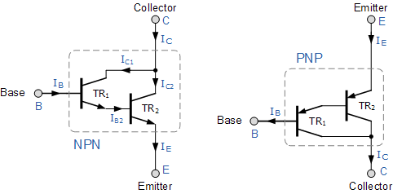

Using the NPN Darlington pair as the example, the collectors of two transistors are connected together, and the emitter of TR1 drives the base of TR2. This configuration achieves β multiplication because for a Base current ib, the collector current is β*ib where the current gain is greater than one, or unity and this is defined as:

This means that the overall current gain, β is given by the gain of the first transistor multiplied by the gain of the second transistor as the current gains of the two transistors multiply. In other words, a pair of bipolar transistors combined together to make a single Darlington transistor pair can be regarded as a single transistor with a very high value of β and consequently a high input resistance.

the base to emitter voltage of Darlington equal the double of base

to emitter voltage of single transistor.

The resistance of the base for Darlington 𝑅𝐵 must be high enough to

protect it from high current that pass through base pin of Darlington

𝐼𝐵𝐷.

The voltage gain of Darlington emitter follower amplifier approximately

equal one.

A very popular connection of two bipolar junction transistors for operation as one “superbeta” transistor is the

Darlington connection . The main feature of the Darlington connection is that the composite

transistor acts as a single unit with a current gain that is the product of the current gains of the individual transistors. If

the connection is made using two separate transistors having current gains of β1 and β2, the Darlington connection

provides a current gain of βD = β1β.

Q1: b

Ans: b

Solution

Line reg=0.062/4.5*100%= 1.377%

Line reg = 0.062/40 * 100/4.5 =0.034%/V

Q2:

Ans:

The Colpitts Oscillator design uses two centre-tapped capacitors in series with a parallel inductor to form its resonance tank circuit producing sinusoidal oscillation.

In many ways, the Colpitts oscillator is the exact opposite of the Hartley Oscillator we looked at in the previous tutorial. Just like the Hartley oscillator, the tuned tank circuit consists of an LC resonance sub-circuit connected between the collector and the base of a single stage transistor amplifier producing a sinusoidal output waveform.

The basic configuration of the Colpitts Oscillator resembles that of the Hartley Oscillator but the difference this time is that the centre tapping of the tank sub-circuit is now made at the junction of a “capacitive voltage divider” network instead of a tapped autotransformer type inductor as in the Hartley oscillator.

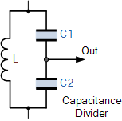

The Colpitts oscillator is a type of oscillator that uses LC circuit in the feed-back loop. The feedback network is made up of a pair of tapped capacitors C1 and C2 and an inductor L to produce a feedback necessary for oscillations.The output voltage is developed across C1. The feedback voltage is developed across C2. The Hartley oscillator is almost identical to the Colpitts oscillator. The primary difference is that the feedback network of the Hartley oscillator uses tapped inductors L and a single capacitor C.

The analysis of Hartley oscillator is identical to that Colpitts oscillator. the frequency of oscillation



Q3:

Ans: the class B amplifier has a big advantage over the class A that no current flow through the transister when they are in their quiescent state i.e with no input signal therefore no poer dessipated in the output transister or transformer when there is no present .

Class B amplifier is a power amplifier where the active device “transister” conducts only for one half cycle .theoratically maximum efficiency of class B amplifier is 78.5% . the schematic of a single ended class B amplifier and input, output waveforms shows

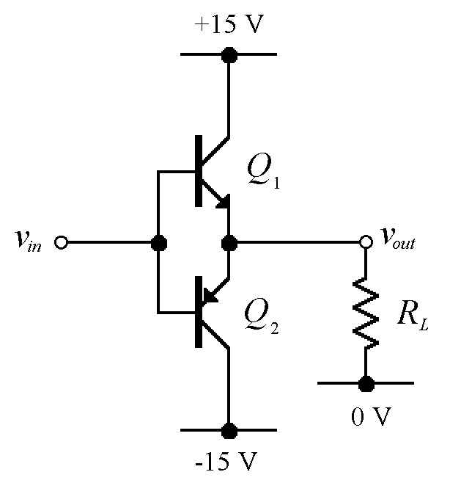

Q1 and Q2 form two unbiased emitter followers

Q1 only conducts when the input is positive

Q2 only conducts when the input is negative

Conduction angle is, therefore, 180°

When the input is zero, neither conducts

i.e. the quiescent power dissipation is zero

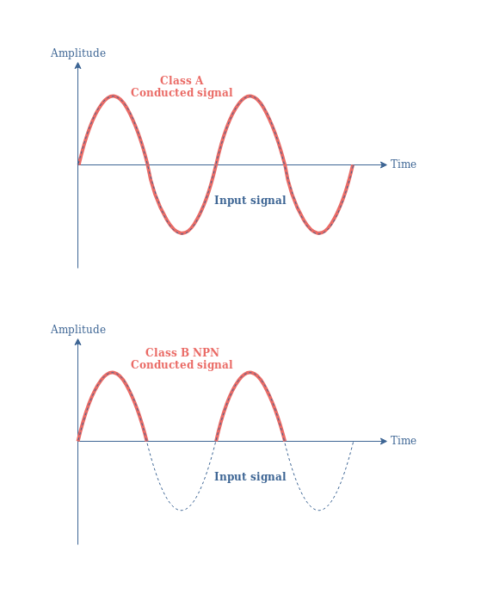

The downside for this increased efficiency is that the transistor only amplifies half the waveform, therefore producing severe distortion. However, if the other half of the waveform can be obtained in some other way without too much distortion, then class B amplifiers can be used to drive most types of output device. The aim is to obtain a good power gain with as much of the energy consumed from the power supply going into the load as possible. This should be as consistent with reasonable linearity (lack of distortion), as possible. Power output stages do however produce more distortion than do voltage or current amplifiers.

Q3: b

Ans: A voltage regulator is used to regulate voltage levels. When a steady, reliable voltage is needed, then the voltage regulator is the preferred device. ... It is available in two types, which are compact and used in low power, low voltage systems. Let us discuss different types of voltage regulators.

Types of Voltage Regulators and Their Working Principle

Basically, there are two types of Voltage regulators: Linear voltage regulator or line regulator and Switching voltage regulator or load regulator.

The purpose of line regulation is to maintain a nearly constant output voltage when the input voltage varies.

Linear regulator or line regulator acts as a voltage divider. In the Ohmic region, it uses FET. The resistance of the voltage regulator varies with load resulting in constant output voltage.

Advantages of a linear voltage regulator:

Gives a low output ripple voltage

Fast response time to load or line changes

Low electromagnetic interference and less noise

Disadvantages of the linear voltage regulator:

Efficiency is very low

Requires large space – heat sink is needed

Voltage above the input cannot be increased



Load regulation:

A change in load current (due to a varying RL) has practically no effect on the output voltage of a regulator (within certain limits) 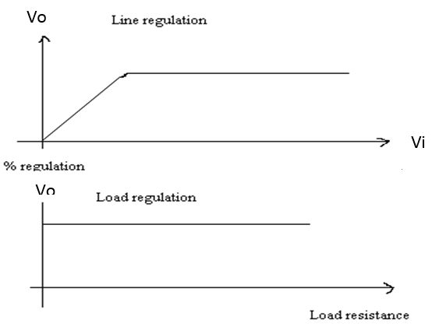

Load regulation refers to the ability to maintain a constant voltage output from a power supply despite changes or variability in the input load. Typically, we express load regulation as a percentage of the max load condition, indicating how much output will vary.

Fundamental classes of voltage regulators are linear regulators and switching regulators.

Two basic types of linear regulator are the series regulator and the shunt regulator.

The series regulator is connected in series with the load and the shunt regulator is connected in parallel with the load.

Fundamental classes of voltage regulators are linear regulators and switching regulators.

Two basic types of linear regulator are the series regulator and the shunt regulator.

The series regulator is connected in series with the load and the shunt regulator is connected in parallel with the load.

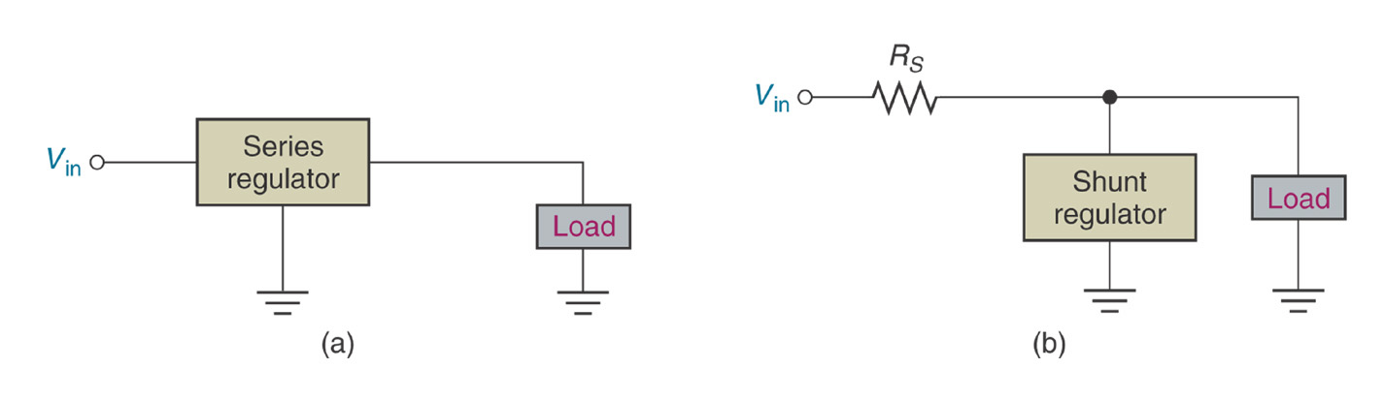

Control element in series with load between input and output.

Output sample circuit senses a change in output voltage.

Error detector compares sample voltage with reference voltage → causes control element to compensate in order to maintain a constant output voltage.

Applications of Shunt Regulators

Shunt regulators are used in:

Low Output Voltage Switching Power Supplies

Current Source and Sink Circuits

Error Amplifiers

Adjustable Voltage or Current Linear and Switching Power Supplies

Voltage Monitoring

Analog and Digital Circuits that require precision references

Precision current limiters

Q4:

* Ans: A flash ADC (also known as a direct-conversion ADC) is a type of analog-to-digital converter that uses a linear voltage ladder with a comparator at each "rung" of the ladder to compare the input voltage to successive reference voltages.
* series of comparators, each one compares input to a unique reference voltage.
* comparator outputs connect to a priority encoder circuit produces binary output
* 2N-1 comparators for N-bits
* Each reference voltage equivalent to a quantization level
* Encoding logic produces word.

ANALOG DIGITAL

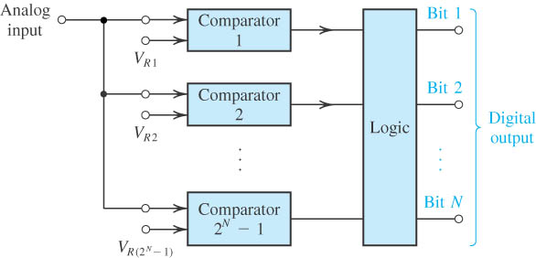

For explanations, consider the analog signal found in Figure 1. Let’s assume that it is an audio signal, since this the most popular applications for analog-to-digital and digital-to-analog conversions. The “y” axis represents voltage while the “x” axis represents time.

The analog input voltage exceeds the reference voltage at each comparator, the comparator outputs will sequentially saturate to a high state.

The priority encoder generates a binary number based on the highest-order active input, ignoring all other active inputs.

the ADC circuit does is to take samples from the analog signal from time to time. Each sample will be converted into a number, based on its voltage level. In Figure 2 you see an example of some sampling points on our analog signal.

The frequency on which the sampling will occur is called sampling rate. If a sampling rate of 22,050 Hz is used, for example, this means that in one second 22,050 points will be sampled. Thus, the distance of each sampling point will be of 1 / 22,050 second 45.35 µs, in this case. If a sampling rate of 44,100 Hz is used, it means that 44,100 points will be captured per second. In this case the distance of each point will be of 1 / 44,100 second or 22.675 µs. And so on.

Advantage :

Very high speed Low latency.

Most efficient in terms of speed, very fast

limited only in terms of comparator and gate propagation delays

Disadvantages:

Lower resolution

Expensive

For each additional output bit, the number of comparators is doubled

i.e. for 8 bits, 256 comparators needed

Q5:a

Ans: low pass and high pass filter:

Within applied of input voltage having different frequency component the low pass filter action result in maximum low frequency voltage across RL. While of the high frequency voltage is developed across the resister

High pass filter:

The high pass passes to load all frequencies are higher then the cut off frequency while lower frequencies cannot develop appreciable voltage across the load.

Active and passive filters:

The major difference between active and passive filter is that an active filter uses active components like transistor and op-amp for the filtering of electronic signals. As against a passive filter uses passive components like resistor inductor and capacitor to generate a signal of a particular band.

Passive filters consume the energy of the signal, but no power gain is available; while active filters have a power gain.

Active filters require an external power supply, while passive filters operate only on the signal input.

Only passive filters use inductors.

Only active filters use elements kike op-amps and transistors, which are active elements.

Theoretically, passive filters have no frequency limitations while, active filters have limitations due to active elements.

Passive filters have a better stability and can withstand large currents.

Passive filters are relatively cheaper than active filters.

Passive filters include only passive components—resistors, capacitors, and inductors. In contrast, active filters use active components, such as op-amps, in addition to resistors and capacitors, but not inductors

Thank you

______________________________________________________