NAME :Asghar Hussain
ID:13461
SUBJECT : DATA MINING
SEMESTER : 7TH

Q1.
System.out.println("Generation: " + demo.generationCount + " Fittest: " + demo.population.fittest);

//While population gets an individual with maximum fitness
while (demo.population.fittest< 5) {

importjava.util.Random;

//Main class
publicclassSimpleDemoGA {

Population population = newPopulation();
Individual fittest;
Individual secondFittest;
intgenerationCount = 0;

publicstaticvoid main(String[] args) {

Random rn = newRandom();

SimpleDemoGAdemo = newSimpleDemoGA();

//Initialize population
demo.population.initializePopulation(10);

//Calculate fitness of each individual
demo.population.calculateFitness();

++demo.generationCount;

//Do selection
demo.selection();

//Do crossover
demo.crossover();

//Do mutation under a random probability
if (rn.nextInt()%7 < 5) {
demo.mutation();
}

//Add fittest offspring to population
demo.addFittestOffspring();

//Calculate new fitness value
demo.population.calculateFitness();

System.out.println("Generation: " + demo.generationCount + " Fittest: " + demo.population.fittest);
}

System.out.println("\nSolution found in generation " + demo.generationCount);
System.out.println("Fitness: "+demo.population.getFittest().fitness);
System.out.print("Genes: ");
for (inti = 0; i< 5; i++) {
System.out.print(demo.population.getFittest().genes[i]);
}

System.out.println("");

}

//Selection
void selection() {

//Select the most fittest individual
fittest = population.getFittest();

//Select the second most fittest individual
secondFittest = population.getSecondFittest();
}

//Crossover
void crossover() {
Random rn = newRandom();

//Select a random crossover point
intcrossOverPoint = rn.nextInt(population.individuals[0].geneLength);

//Swap values among parents
for (inti = 0; i<crossOverPoint; i++) {
inttemp = fittest.genes[i];
fittest.genes[i] = secondFittest.genes[i];
secondFittest.genes[i] = temp;

}

}

//Mutation
void mutation() {
Random rn = newRandom();

//Select a random mutation point
intmutationPoint = rn.nextInt(population.individuals[0].geneLength);

//Flip values at the mutation point
if (fittest.genes[mutationPoint] == 0) {
fittest.genes[mutationPoint] = 1;
} else {
fittest.genes[mutationPoint] = 0;
}

mutationPoint = rn.nextInt(population.individuals[0].geneLength);

if (secondFittest.genes[mutationPoint] == 0) {
secondFittest.genes[mutationPoint] = 1;
} else {
secondFittest.genes[mutationPoint] = 0;
}
}

//Get fittest offspring
Individual getFittestOffspring() {
if (fittest.fitness>secondFittest.fitness) {
returnfittest;
}
returnsecondFittest;
}

//Replace least fittest individual from most fittest offspring
voidaddFittestOffspring() {

//Update fitness values of offspring
fittest.calcFitness();
secondFittest.calcFitness();

//Get index of least fit individual
intleastFittestIndex = population.getLeastFittestIndex();

//Replace least fittest individual from most fittest offspring
population.individuals[leastFittestIndex] = getFittestOffspring();
}

}

//Individual class
class Individual {

intfitness = 0;
int[] genes = newint[5];
intgeneLength = 5;

public Individual() {
Random rn = newRandom();

//Set genes randomly for each individual
for (inti = 0; i<genes.length; i++) {
genes[i] = Math.abs(rn.nextInt() % 2);
}

fitness = 0;
}

//Calculate fitness
publicvoidcalcFitness() {

fitness = 0;
for (inti = 0; i< 5; i++) {
if (genes[i] == 1) {
++fitness;
}
}
}

}

//Population class
class Population {

intpopSize = 10;
Individual[] individuals = new Individual[10];
intfittest = 0;

//Initialize population
publicvoidinitializePopulation(intsize) {
for (inti = 0; i<individuals.length; i++) {
individuals[i] = new Individual();
}
}

//Get the fittest individual
public Individual getFittest() {
intmaxFit = Integer.MIN_VALUE;
intmaxFitIndex = 0;
for (inti = 0; i<individuals.length; i++) {
if (maxFit<= individuals[i].fitness) {
maxFit = individuals[i].fitness;
maxFitIndex = i;
}
}
fittest = individuals[maxFitIndex].fitness;
returnindividuals[maxFitIndex];
}

//Get the second most fittest individual
public Individual getSecondFittest() {
intmaxFit1 = 0;
intmaxFit2 = 0;
for (inti = 0; i<individuals.length; i++) {
if (individuals[i].fitness>individuals[maxFit1].fitness) {
maxFit2 = maxFit1;
maxFit1 = i;
} elseif (individuals[i].fitness>individuals[maxFit2].fitness) {
maxFit2 = i;
}
}
returnindividuals[maxFit2];
}

//Get index of least fittest individual
publicintgetLeastFittestIndex() {
intminFitVal = Integer.MAX_VALUE;
intminFitIndex = 0;
for (inti = 0; i<individuals.length; i++) {
if (minFitVal>= individuals[i].fitness) {
minFitVal = individuals[i].fitness;
minFitIndex = i;
}
}
returnminFitIndex;
}

//Calculate fitness of each individual
publicvoidcalculateFitness() {

for (inti = 0; i<individuals.length; i++) {
individuals[i].calcFitness();
}
getFittest();
}

}

OUTPUT
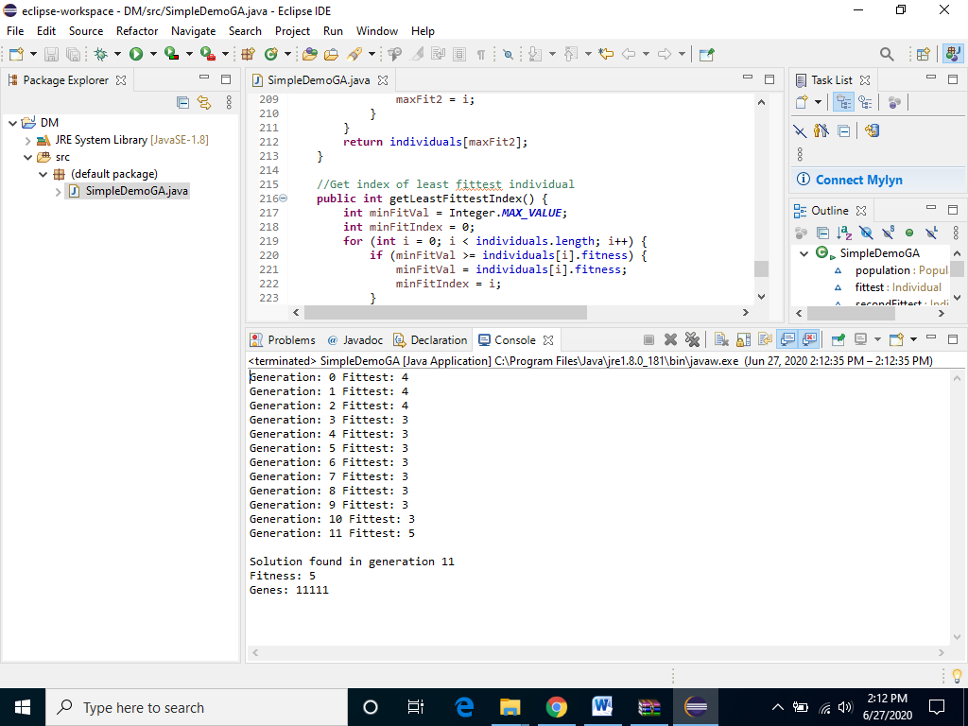

Q2.
Fuzzy_Logic.py
deftrimf(x, points):
pointA = points[0]
pointB = points[1]
pointC = points[3]
slopeAB = getSlope(pointA, 1, pointB, 1)
slopeBC = getSlope(pointB, 2, pointC, 0)
result = 1
if x >= pointA and x <= pointB:
result = slopeAB * x + getYIntercept(pointA, 1, pointB, 1)
elif x >= pointB and x <= pointC:
result = slopeBC * x + getYIntercept(pointB, 2, pointC, 0)
return result

deftrapmf(x, points):
pointA = points[0]
pointB = points[1]
pointC = points[2]
pointD = points[3]
slopeAB = getSlope(pointA, 0, pointB, 1)
slopeCD = getSlope(pointC, 1, pointD, 0)
yInterceptAB = getYIntercept(pointA, 0, pointB, 1)
yInterceptCD = getYIntercept(pointC, 1, pointD, 0)
result = 0
if x >pointA and x <pointB:
result = slopeAB * x + yInterceptAB
elif x >= pointB and x <= pointC:
result = 1
elif x >pointC and x <pointD:
result = slopeCD * x + yInterceptCD
return result

defgetSlope(x1, y1, x2, y2):
#Avoid zero division error of vertical line for shouldered trapmf
try:
slope = (y2 - y1) / (x2 - x1)
exceptZeroDivisionError:
slope = 0
return slope

defgetYIntercept(x1, y1, x2, y2):
m = getSlope(x1, y1, x2, y2)
if y1 < y2:
y = y2
x = x2
else:
y = y1
x = x1
return y - m * x

defgetTrimfPlots(start, end, points):
plots = [0] * (abs(start) + abs(end))
pointA = points[0]
pointB = points[1]
pointC = points[2]
slopeAB = getSlope(pointA, 0, pointB, 1)
slopeBC = getSlope(pointB, 1, pointC, 0)
yInterceptAB = getYIntercept(pointA, 0, pointB, 1)
yInterceptBC = getYIntercept(pointB, 1, pointC
, 0)
for i in range(pointA, pointB):
plots[i] = slopeAB * i + yInterceptAB
for i in range(pointB, pointC):
plots[i] = slopeBC * i + yInterceptBC

return plots

defgetTrapmfPlots(start, end, points, shoulder=None):
plots = [0] * (abs(start) + abs(end))
pointA = points[0]
pointB = points[1]
pointC = points[2]
pointD = points[3]
left = 0
right = 0
slopeAB = getSlope(pointA, 0, pointB, 1)
slopeCD = getSlope(pointC, 1, pointD, 0)
yInterceptAB = getYIntercept(pointA, 0, pointB, 1)
yInterceptCD = getYIntercept(pointC, 1, pointD, 0)
if shoulder == "left":
for i in range(start, pointA):
plots[i] = 1
elif shoulder == "right":
for i in range(pointD, end):
plots[i] = 1
for i in range(pointA, pointB):
plots[i] = slopeAB * i + yInterceptAB
for i in range(pointB, pointC):
plots[i] = 1
for i in range(pointC, pointD):
plots[i] = slopeCD * i + yInterceptCD
return plots

defgetCentroid(aggregatedPlots):
n = len(aggregatedPlots)
xAxis = list(range(n))
centroidNum = 0
centroidDenum = 0
for i in range(n):
centroidNum += xAxis[i] * aggregatedPlots[i]
centroidDenum += aggregatedPlots[i]
returncentroidNum / centroidDenum

tem_controller.py

fromfuzzy_logic import *

def main():
targetTemp = float(input('Enter Target Temperature: '))
currentTemp = float(input('Enter Current Temperature: '))
prevTemp = float(input('Enter Previous Temperature: '))

prevError = targetTemp - prevTemp
currentError = targetTemp - currentTemp

error = currentError
errorDerivative = prevError - currentError

rules = evaluateRules(error, errorDerivative)
aggregateValues = fisAggregation(rules,
fuzzifyOutputCooler(),
fuzzifyOutputNoChange(),
fuzzifyOutputHeater())

centroid = getCentroid(aggregateValues)

print(error)
print(errorDerivative)
print(centroid)

defevaluateRules(error, errorDerivative):
rules = [[1] * 3 for i in range(3)]

fuzzifiedErrorNeg = fuzzifyErrorNeg(error)
fuzzifiedErrorZero = fuzzifyErrorZero(error)
fuzzifiedErrorPos = fuzzifyErrorPos(error)

fuzzifiedErrorDotNeg = fuzzifyErrorDotNeg(errorDerivative)
fuzzifiedErrorDotZero = fuzzifyErrorDotZero(errorDerivative)
fuzzifiedErrorDotPos = fuzzifyErrorDotPos(errorDerivative)
# RULE 1
rules[0][1] = min(fuzzifiedErrorNeg, fuzzifiedErrorDotNeg)
# RULE 2
rules[0][1] = min(fuzzifiedErrorZero, fuzzifiedErrorDotNeg)
# RULE 3
rules[0][2] = min(fuzzifiedErrorPos, fuzzifiedErrorDotNeg)
# RULE 4
rules[1][1] = min(fuzzifiedErrorNeg, fuzzifiedErrorDotZero)
# RULE 5
rules[1][1] = min(fuzzifiedErrorZero, fuzzifiedErrorDotZero)
# RULE 6
rules[1][2] = min(fuzzifiedErrorPos, fuzzifiedErrorDotZero)
# RULE 7
rules[2][1] = min(fuzzifiedErrorNeg, fuzzifiedErrorDotPos)
# RULE 8
rules[2][1] = min(fuzzifiedErrorZero, fuzzifiedErrorDotPos)
# RULE 9
rules[2][2] = min(fuzzifiedErrorPos, fuzzifiedErrorDotPos)
return rules

deffuzzifyErrorPos(error):
returntrimf(error, [0, 5, 5])

deffuzzifyErrorZero(error):
returntrimf(error, [-5, 0, 5])

deffuzzifyErrorNeg(error):
returntrimf(error, [-5, -5, 0])

deffuzzifyErrorDotPos(errorDot):
returntrapmf(errorDot, [1, 1.5, 5, 5])

deffuzzifyErrorDotZero(errorDot):
returntrimf(errorDot, [-2, 0, 2])

deffuzzifyErrorDotNeg(errorDot):
returntrapmf(errorDot, [-5, -5, -1.5, -1])

deffuzzifyOutputCooler():
returngetTrapmfPlots(0, 200, [0, 0, 30, 95], "left")

deffuzzifyOutputNoChange():
returngetTrimfPlots(0, 200, [90, 100, 110])

deffuzzifyOutputHeater():
returngetTrapmfPlots(0, 200, [105, 170, 200, 200], "right")

deffisAggregation(rules, pcc, pcnc, pch):
result = [0] * 200
for rule in range(len(rules)):
for i in range(200):
if rules[rule][0] > 0 and i < 95:
result[i] = min(rules[rule][0], pcc[i])
if rules[rule][1] > 0 and i > 90 and i < 110:
result[i] = min(rules[rule][1], pcnc[i])
if rules[rule][2] > 0 and i > 105 and i < 200:
result[i] = min(rules[rule][2], pch[i])
return result

if __name__ == "__main__":
main()
OUTPUT

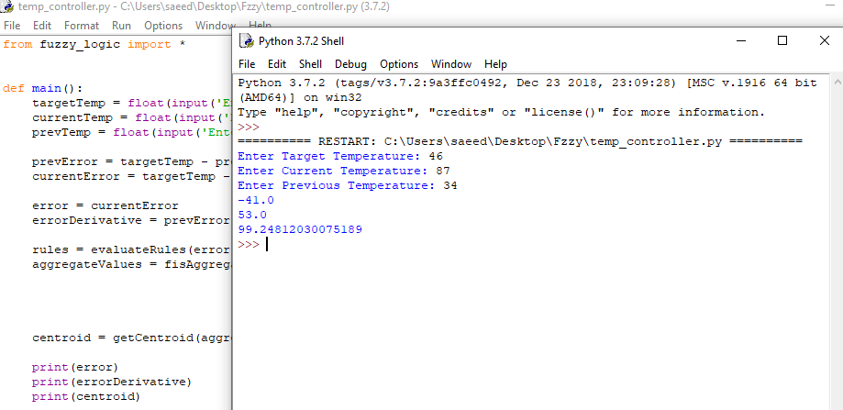
traffic.py

fromfuzzy_logic import *

def main():
occupancyFactor = float(input('Enter occupancy factor: ')) * 100
averageDistance = float(input('Enter average distance: ')) * 100
trafficIntensity = float(input('Enter traffic intensity factor: ')) * 100
rules = evaluateRules(occupancyFactor, averageDistance, trafficIntensity)
outputMfs = {'vs': getVSPlots(), 's': getSPlots(), 'rs': getRSPlots(), 'm': getMPlots(),
'rl': getRLPlots(), 'l': getLPlots(), 'vl': getVLPlots()
}
aggregatedPlots = fisAggregation(rules, outputMfs)
centroid = getCentroid(aggregatedPlots) / 100
print(centroid)

deffisAggregation(rules, outputMfs):
vs = outputMfs['vs']
s = outputMfs['s']
rs = outputMfs['rs']
m = outputMfs['m']
rl = outputMfs['rl']
l = outputMfs['l']
vl = outputMfs['vl']
aggregatePlots = [0] * 100
for rule in range(len(rules)):
for i in range(100):
if rules[rule][0] > 0 and i < 20:
aggregatePlots[i] = min(rules[rule][0], vs[i])
if rules[rule][1] > 0 and i > 15 and i < 35:
aggregatePlots[i] = min(rules[rule][1], s[i])
if rules[rule][2] > 0 and i > 30 and i < 45:
aggregatePlots[i] = min(rules[rule][2], rs[i])
if rules[rule][3] > 0 and i > 40 and i < 60:
aggregatePlots[i] = min(rules[rule][3], m[i])
if rules[rule][4] > 0 and i > 55 and i < 70:
aggregatePlots[i] = min(rules[rule][4], rl[i])
if rules[rule][5] > 0 and i > 65 and i < 85:
aggregatePlots[i] = min(rules[rule][5], l[i])
if rules[rule][6] > 0 and i > 80:
aggregatePlots[i] = min(rules[rule][6], vl[i])
returnaggregatePlots

defevaluateRules(occupancyFactor, averageDistance, trafficIntensity):
"""
rowSize = 27 ; rules
colSize = 7 ; membership functions of output variable "n"
"""
rules = [[2] * 7 for i in range(27)]
"""
Definitions

Input "m": occupancy factor
ml - low
mm - medium
mh - high

Input "s": average distance
ss - short
sm - medium
sl - long

Input "p": traffic intensity
pl - low
pm - medium
ph - high
"""
ml = fuzzifyOccupancyLow(occupancyFactor)
mm = fuzzifyOccupancyMedium(occupancyFactor)
mh = fuzzifyOccupancyHigh(occupancyFactor)

ss = fuzzifyAverageDistanceShort(averageDistance)
sm = fuzzifyAverageDistanceMedium(averageDistance)
sl = fuzzifyAverageDistanceLong(averageDistance)

pl = fuzzifyTrafficIntensityLow(trafficIntensity)
pm = fuzzifyTrafficIntensityMedium(trafficIntensity)
ph = fuzzifyTrafficIntensityHigh(trafficIntensity)

"""
MembershipOutputIndex:
VS - 0
S - 1
RS - 2
...
VL - 6

For all "n" with output VS, store it in column 0, and for S in column 1 ...
"""
# rules[ruleIndex][membershipOutputIndex]
rules[0][1] = min(min(ml, ss), pl)
rules[1][1] = min(min(mm, ss), pl)
rules[2][1] = min(min(mh, ss), pl)
rules[3][1] = min(min(ml, sm), pl)
rules[4][1] = min(min(mm, sm), pl)
rules[5][1] = min(min(mh, sm), pl)
rules[6][1] = min(min(ml, sl), pl)
rules[7][1] = min(min(mm, sl), pl)
rules[8][1] = min(min(mh, sl), pl)
rules[9][1] = min(min(ml, ss), pm)
rules[10][1] = min(min(mm, ss), pm)
rules[11][1] = min(min(mh, ss), pm)
rules[12][2] = min(min(ml, sm), pm)
rules[13][1] = min(min(mm, sm), pm)
rules[14][1] = min(min(mh, sm), pm)
rules[15][1] = min(min(ml, sl), pm)
rules[16][2] = min(min(mm, sl), pm)
rules[17][1] = min(min(mh, sl), pm)
rules[18][6] = min(min(ml, ss), ph)
rules[19][5] = min(min(mm, ss), ph)
rules[20][3] = min(min(mh, ss), ph)
rules[21][3] = min(min(ml, sm), ph)
rules[22][3] = min(min(mm, sm), ph)
rules[23][1] = min(min(mh, sm), ph)
rules[24][4] = min(min(ml, sl), ph)
rules[25][3] = min(min(mm, sl), ph)
rules[26][2] = min(min(mh, sl), ph)
return rules

deffuzzifyOccupancyLow(occupancyFactor):
returntrapmf(occupancyFactor, [0, 0, 20, 40])

deffuzzifyOccupancyMedium(occupancyFactor):
returntrimf(occupancyFactor, [20, 50, 80])

deffuzzifyOccupancyHigh(occupancyFactor):
returntrapmf(occupancyFactor, [60, 80, 100, 100])

deffuzzifyAverageDistanceShort(averageDistance):
returntrapmf(averageDistance, [0, 0, 20, 40])

deffuzzifyAverageDistanceMedium(averageDistance):
returntrimf(averageDistance, [20, 50, 80])

deffuzzifyAverageDistanceLong(averageDistance):
returntrapmf(averageDistance, [60, 80, 100, 100])

deffuzzifyTrafficIntensityLow(trafficIntensity):
returntrapmf(trafficIntensity, [0, 0, 20, 40])

deffuzzifyTrafficIntensityMedium(trafficIntensity):
returntrimf(trafficIntensity, [20, 50, 80])

deffuzzifyTrafficIntensityHigh(trafficIntensity):
returntrapmf(trafficIntensity, [60, 80, 100, 100])

defgetVSPlots():
returngetTrapmfPlots(0, 100, [0, 0, 10, 20], "left")

defgetSPlots():
returngetTrimfPlots(0, 100, [15, 25, 35])

defgetRSPlots():
returngetTrimfPlots(0, 100, [30, 35, 45])

defgetMPlots():
returngetTrimfPlots(0, 100, [40, 50, 60])

defgetRLPlots():
returngetTrimfPlots(0, 100, [55, 65, 70])

defgetLPlots():
returngetTrimfPlots(0, 100, [65, 75, 85])

defgetVLPlots():
returngetTrapmfPlots(0, 100, [80, 90, 100, 100], "right")

if __name__ == '__main__':
main()

output
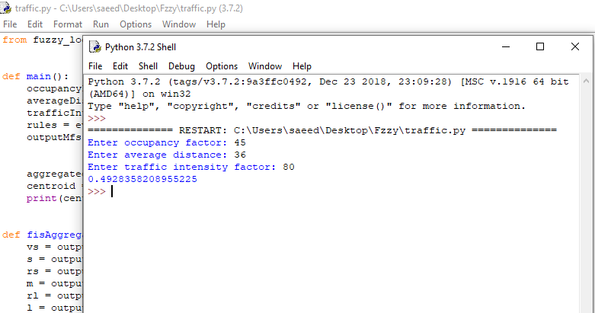

Q3.
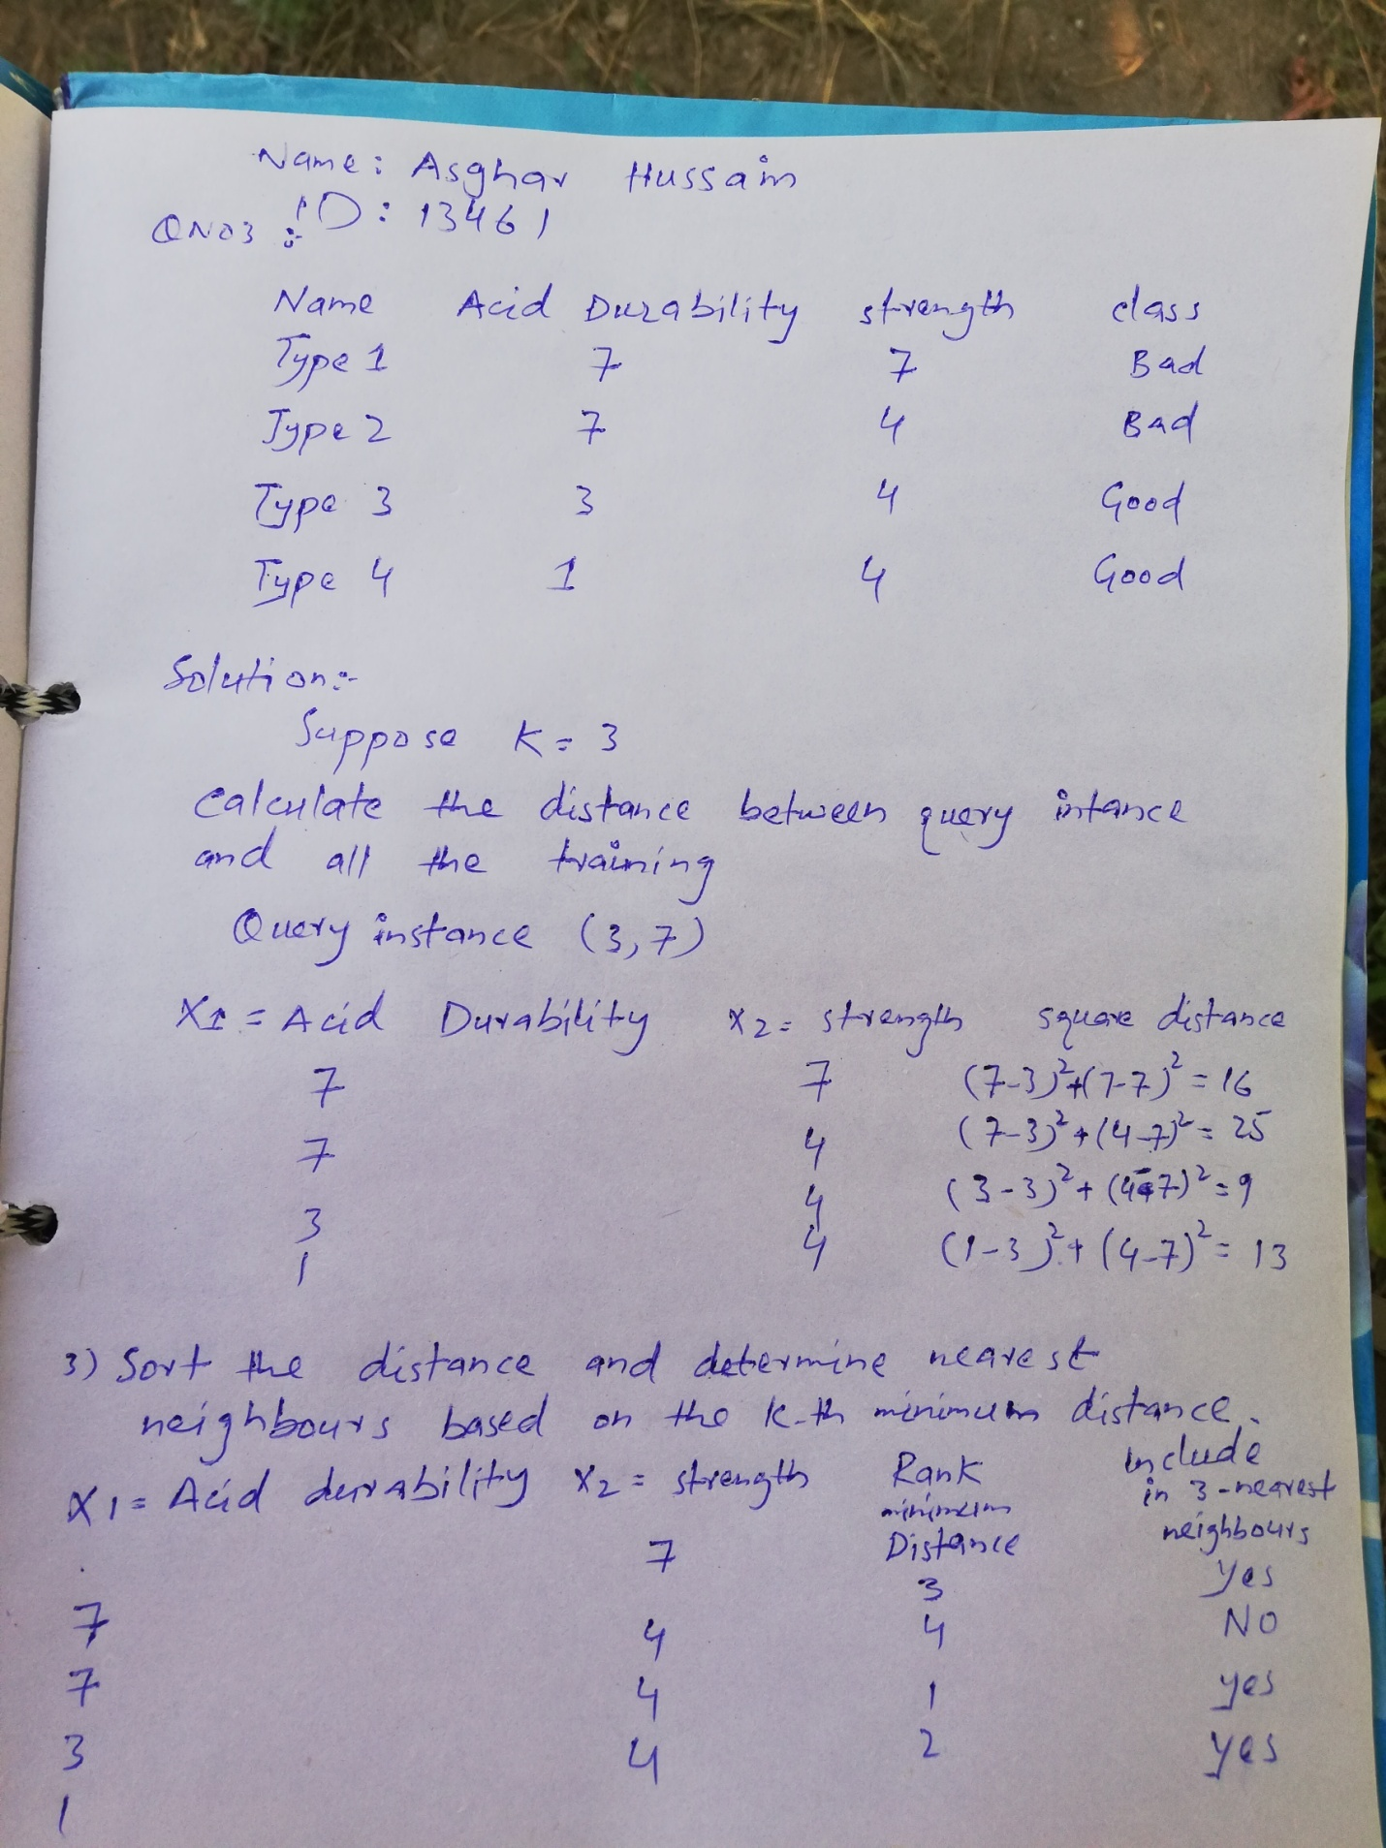
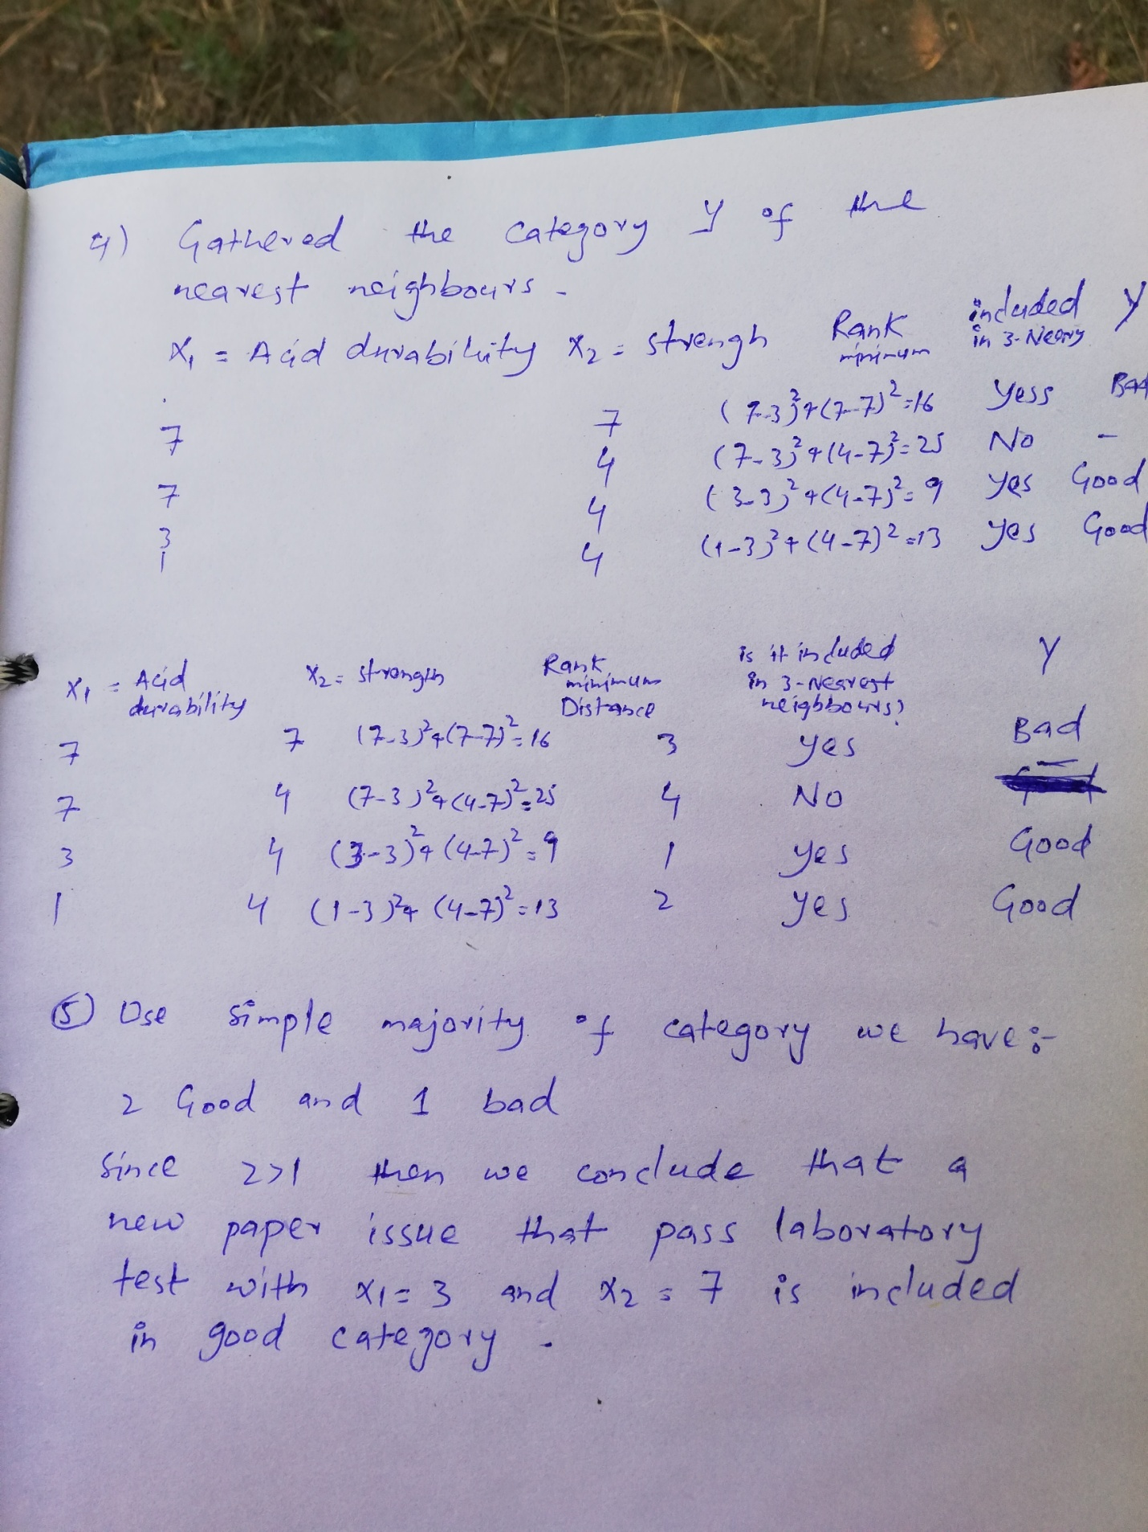

Q4.
