Name: Usman
ID : 14993
Paper: Dental Morphology
Teacher: Dr Salma Ishaq

Q1: Briefly explain the palatal aspect of maxillary 1st molar?
Ans: Palatal Aspects of maxillary 1st molar:
- Outlines reversed from the buccal aspect, still trapezoidal.
- Mesiopalatal largest cusps.
- Distolateral smallest cusp, almost spheroidal.
- Has a palatal pit at the end of the distopalatal groove.
- There may be a cusp on the palatal surface of the mesiopalatal cusp.
- This is a fifth cusp called the cusp of carabelli, which is visible in addition to the four cusps on the occlusal surface.
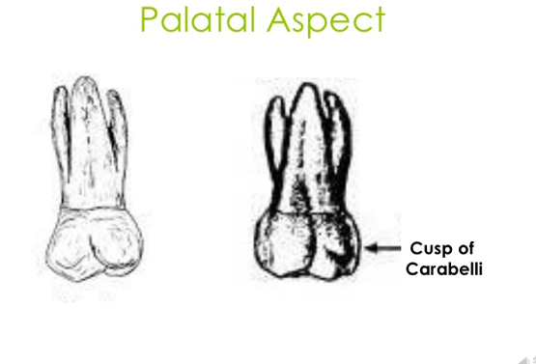

Q2: Specify the function of permanent maxillary canine and 1st pre-molar?
Ans: Function of maxillary canine:
The location of the canines reflects their dual function as they complement both the premolars and incisors during mastication, commonly known as chewing. Nonetheless, the most common action of the canines is tearing of food.

Function of maxillary 1st pre molar:
Eruption:
Enamel completed 6-7 years Eruption 10-12 years Root completed 13-15 years.
Function:
This tooth supplements the maxillary first premolar in function of tearing and grinding food

Q3: What is the chronology of mandibular central incisor?
Ans: Mandibular central incisors:
The mandibular central incisor is the tooth located on the jaw, adjacent to the midline of the face. It is mesial (toward the midline of the face) from both mandibular lateral incisors. ... The mandibular central incisors are usually the first teeth to appear in the mouth, typically around the age of 6-8 months.

Chronology:
First evidence of calcification 3-4 months.
Crown completion 4-5 years
Eruption 6-8 years
Root completion 10 years
Average Dimensions in millimeters:
Crown length | Root Length | Mesiodistal Diameter at Contact area | Mesiodistal Diameter at Cervical line | Labiolingual Diameter at crest of curvature | Labiolingual Diameter at Cervical line | Curvature of Cervical line  M D
9.0 | 12.5 | 5.0 | 3.5 | 6.0 | 5.3 | 3.0 2.0

Q4: Simplify the geometrical outline of occlusal aspect of mandibular 2nd pre molar?
Ans: Mandibular of 2nd pre molar:
Occlusal Aspects:

- Square profile.
- Mesial and Lingual profiles are parallel
- More than half of buccal surface is visible
- Buccal ridge is less prominent than that of mandibular 1st premolar
- Mesial and distal marginal ridges are equal in length.

Occlusal View:
- 3 cusps (“Y” outline)
- 2 cusps (“H” outline)
- 2 cusps (“U” outline)
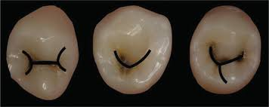

Q5: Why we have molars?
Ans: The sharper teeth can tear food into smaller pieces and the flatter teeth grind food down. Wisdom teeth are the flatter kind of teeth, called molars. Molars are all the way in the back of your mouth
Wisdom teeth are believed to be "evolutionary relics," and were helpful to our distant ancestors who ate diets that consisted of rougher foods like sticks and reed plants. As teeth wore down or fell out, wisdom teeth provided replacements. Nowadays, with modern advancements in oral hygiene and softer diets, we don’t need these replacement teeth, but they still grow in. Essentially, our mouths can hold 28 teeth, but including wisdom teeth, we have about 32 teeth all vying for space. Wisdom teeth symptoms such as overcrowding, bone and nerve damage, infection, etc. can all result.

Wisdom Teeth Symptoms:

- Pain at the back of the mouth, behind the molars. This pain will gradually increase with time as the wisdom teeth continue to grow in misaligned or sideways, pressing on nerves and bone, and crowding surrounding teeth.
- Other wisdom teeth symptoms include pain, redness, tenderness and/or swelling around the site. As wisdom teeth begin to erupt through the surface of the gums, this allows bacteria to enter through open tissue, which can result in infection. Oral infections have been shown to affect your overall health as well.

