Iqra National University
Name: Pir Shafqat Ullah Shah
ID : 14614
BBA
Course Title: Microeconomics
Instructor: Ms. Wajiha Amin
Date:21/8/2020

Q1: (a) Discuss briefly the concept of opportunity cost in Economics.

ANS: Definition – Opportunity cost is the next best alternative foregone.

Since resources are limited, every time you make a choice about how to use them, you are also choosing to forego other options. Economists use the term opportunity cost to indicate what must be given up to obtain something that’s desired. A fundamental principle of economics is that every choice has an opportunity cost. If you sleep through your economics class (not recommended, by the way), the opportunity cost is the learning you miss. If you spend your income on video games, you cannot spend it on movies. If you choose to marry one person, you give up the opportunity to marry anyone else. In short, opportunity cost is all around us.

- Studying for your exam
It is not potentially an opportunity cost because studying for an exam will give you better benefit.

- Spending 2 hrs. playing computer games instead of doing exercise
It is a potential opportunity cost because playing a computer games is a waste of time, other then that exercise will give you a better health.

- Going to a university instead of staying at home
It is not a potential opportunity cost because staying at home will give you nothing in contrast going to university will prepare you for the future and at the end you will get a proper job.

- You decide to spend $80 on some great shoes and do not pay your electric bill.
It is a potential opportunity cost because the other option is way much better to spend that earning. In future you may face electricity cut out.

b) Differentiate between positive and normative economics and identify each of the following statement as positive or normative.

Positive and Normative economics are two standard branches of modern economics. Positive economics describes and explains various economic phenomena, while normative economics focuses on the value of economic fairness or what the economy should be.
To put it simply, positive economics is called the "what is" branch of economics. Normative economics, on the other hand, is considered the branch of economics that tries to determine people's desirability to different economic programs and conditions by asking what "should" be or what "ought" to be.
- There is an inverse relationship between wealth and demand for inferior goods. (positive)
- Wealth tax should be implemented to reduce the disproportionate distribution of wealth. (Normative)
- Adopting protectionist policies results in shrinkage of the total global gross domestic product. (Positive)
- An increase in tax rate ultimately decreases total tax revenue. (Positive)
- Tariffs should be increased on imports from countries with poor human rights record. (Normative)
- Developing countries should adopt democracy as a system only when they population is educated and emancipated. (Normative)

Q2;
(a)
1;
  - The joined axes at the right present the plotting area.
  - The horizontal axis measure qualities the number of rides on the roller coaster . This ranges 0 to 8.
  - The vertical axis measure total utility in utile from 0 to 8.
  - The carve begins at the origin . II Edger does not ride then he receives no utility.
  - The total utility carve is something shape like a hill .it increases from the first 6 rides, then decrease from 7 to 8.in general Elgar utility increases when he consume a large quality.
  - The total utility crave peaks of 36 utils at 6 rides. This is the number of rides that maximize Eder utility

2:
Marginal utility is also related to the elasticity of demand. If demand is inelastic, then the quantity demanded drops off slowly as the price increases, indicating that the marginal utility of the product or service is high; with elastic demand, demand quantity drops off sharply, indicating a low marginal utility for the product, so the consumer is not willing to pay a higher price.

(b) What the concept of diminishing marginal rate of substitution is all about?
Ans: Diminishing marginal rate of substitution:
This behavior showing falling MRS of good X
For good Y and yet to remain at the same level of satisfaction is known as Diminishing marginal rate of substitution.
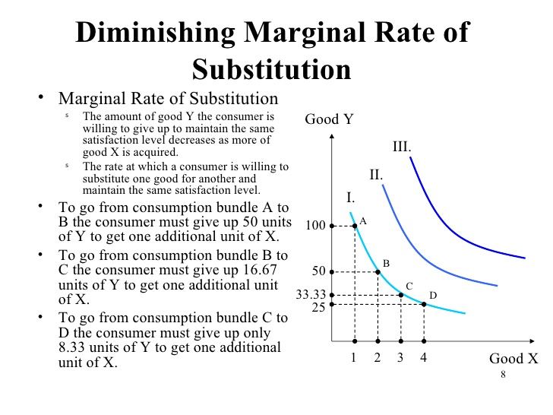

(C) What are the characteristics of an IC?

Ans: Characteristics of Indifference Curves

The indifference curves have a number
of attributes and interesting properties which have come to be known as characteristic features or properties of indifference curves. The following are some of the important features.
- Indifference curves slop downward to the right
This is an important and obvious feature of indifference curves. The sloping down indifference curve indicates that when the amount of one commodity in the combination is increased, the amount of the other commodity is reduced. This must be so if the level of satisfaction is to remain constant on the same indifference curve.

Let us consider the logical inferences or conclusions if the indifference curve does not slope downwards from left to right. If it not like that, it should be either parallel to X axis or vertical or it should be an upward sloping curve as shown in the Figure 1.
If the indifference curve is horizontal to X axis, the various points on the curve A,B,C,D denoting various combinations of x commodity and y commodity may not have equal significance. At point B, the consumer gets more of x than at point A and at point C, the consumer gets still more of x while the quantity of y remains constant.
As the consumer moves along the indifference curve he is getting a fixed quantity of y but increasing quantities of x. So the consumer cannot be indifferent, as having rational behavior, he would prefer D more than C, C more than B and B more than A and the level of satisfaction is not the same. Each succeeding combination is better than the previous one. Therefore an indifference curve cannot be horizontal since different combinations on the curve differ in significance.
Similarly, an indifference curve cannot be vertical as shown in the figure, as in point D, the consumer gets more of y commodity than at point C, B or A while the x commodity remains constant; so the consumer cannot be indifferent to various combinations as they denote different satisfactions.
In the upward sloping curve too, the different points on the curve differ in significance because as he moves from point A to B, he gets more of x and more of y commodities. So, he cannot be indifferent to the combinations. Similarly point C is better than point B and D is better than point C as the combinations differ giving the consumer greater satisfaction.
Only in a downward sloping curve the loss in one is compensated by the gain in another commodity so that the different points on the curve will be of equal significance and satisfaction to the consumer and he may be indifferent to the various combinations. So, a horizontal or vertical or sloping up curve is not possible.

2:Every indifference curve to the right represents a higher level of satisfaction

Every indifference curve to the right of the preceding curve indicates higher level of satisfaction and the curve to the left shows lesser satisfaction. This means that the indifference curve at a higher level from the axes shows greater satisfaction than an indifference curve at a lower level. This can be illustrated by having two indifference curves as given in Figure 2.
In the indifference curve IC1 at point P the consumer is having OM quantity of Bananas and ON quantity of Biscuits. At point Q in the IC2, the consumer though having the same quantity of Biscuits, the quantity of Bananas has increased from OM to OM1, i.e., at point Q the consumer gets larger quantities than at point P and naturally position Q is preferred by the consumer than position P as in the former he gets larger satisfaction due to larger commodities.
An indifference curve on the right is preferred than the indifference curve on the left. The consumer will always try to move up in the indifference map so that he can occupy as much as possible the topmost curve, as higher curves give larger satisfaction in the difference map.

Q3: (a)
Differentiate between cardinal and ordinal approach?

Ans: Cardinal Approach:
In this approach the consumer satisfaction/utility are expressed
in the term of unit or we can say that it is measurable.
According to Marshall the utility is measurement scale is ”money”.

Ordinal approach:
In this approach the consumer satisfaction/utility are not expressed in
the term of unit it will compared only.

Marginal Utility :
Increase in total utility by consuming one additional unit of a commodity is called marginal.

- Marginal Utility nth =Total utility n – Total utility n-1
MU n = TU n =TU n-1

Total utility :
Total utility is the sum total of utility derived from the consumption of all the Units of a commodity.

OR

Total utility is the addition of marginal utility is obtained from various units of consumption.

Formula -TU={MU

Cost :

An amount that has to be paid or spend to buy or obtained something.

Types of Cost :;

Fixed Cost :
Fixed Cost is the cost that do not vary with the level of output in the short term.

Variable Cost:
Variable Cost varies in direct proportion with the level of output.

Direct Cost,

Total Cost,
Indirect Cost,

Benefit:
An advantage or profit gain by something.

Example:

The profit you gain from the insurance company after the accident of your car is known as benefit.

(B): What does the budget line show ?In which case it shift forward or backward?

Ans :
Budget line :

Budget line shows all combination of two goods which the consumer can
Buy spending his income on the two goods at their given price.
The knowledge of the concept of budget line is essential for understanding the theory of consumer’s equilibrium. A higher indifference curve shows a higher level of satisfaction than a lower one. Therefore, a consumer in his attempt to maximise his satisfaction will try to reach the highest possible indifference curve.

But in his pursuit of buying more and more goods and thus obtaining more and more satisfaction he has to work under two constraints; first, he has to pay the prices for the goods and, secondly, he has a limited money income with which to purchase the goods. Thus, how far he would go in for his purchases depends upon the prices of the goods and the money income which he has to spend on the goods.

Now in order to explain consumer’s equilibrium there is also the need for introducing into the indifference diagram the budget line which represents the prices of the goods and consumer’s money income.

Shift of Budget line Forward or Backward:
Similarly a consumer can purchase a combination of two goods with a fixed amount of money. A fall in the price of both goods or a raise in the consumers disposable income mean that the Budget line will shift outward as purchasing power has increased in relation to the previous line.

