NAME: FATIMA KHALID

ID #: 16916n

MID TERM ASSIGNMENT

IQRA NATIONAL UNIVERSITY
DEPARTMENT OF ALLIED HEALTH SCIENCES
Mid-term Assignment (spring– 2020), HND 2nd

Course title: Macronutrients in Human Nutrition
Course instructor: Prof. Dr. Jehangir Khan Kahlil
Department: Human Nutrition and Dietetics
Time allowed: 48 Hours
Date: 13/04/2020 Marks: 30
Name: Fatima khalid
ID #:16916______________________________________________________________
Note: Attempt all questions from the section.. All questions carry equal marks
Questions: 1 (10)
What are Carbohydrates? What is their role in our body.

Answer:

CARBOHYDRATES:

Carbohydrates which are also known as saccharides are polyhydric or polyhydroxy alcohols (OH),they are further classified into aldehyde or keto group.So a carbohydrate may belong to aldehyde or keto group.

EXPLANATION:

Basically carbohydrates are starches are sugars that are found in daily products(milk) ,fruits(banana) ,vegetables(potatoes) and grains(wheat).
They are composed of oxygen and hydrogen chemically, hence they are called carbohydrates and are one of the three macronutrients.

CLASSIFICATION OF CARBOHYDRATES:

Carbohydrates are divided into 5 major categories which are classified on the basis of number of sugar residues present in it.
They are classified into:
- Monosaccharides
- Disaccharides
- Oligosaccharides
- Polysaccharides
- Nucleotides

MONOSACCHARIDES:
- Monosaccharides are simple sugars.
- They cannot be further broken down cause they are already in their simplest form.
- All monosaccharides are reducing sugars.
- Examples of monosaccharides are glucose,galactose,and fructose.

DISACCHARIDES:
- Disaccharides can produce two monosaccharides by glycosidic linkage to
form disaccharides.
- Two monosaccharides by glycosidic linkage form disaccharides.
- Examples are sucrose, lactose and maltose.

OLIGOSACCHARIDES:
- Oligosaccharides contain a small number of monosaccharides and are known as saccharide polymers.
- When they are hydrolyzed these produce three to ten monosaccharide units.
- They have functions such as cell recognition and cell binding.
- Examples are sucrose,lactose and maltose.

POLYSACCHARIDES:
- Polysaccharides are long chains of carbohydrates molecules.
- When hydrolysed they produce more than ten monosaccharide units.
- They are non-reducing carbohydrates.
- They are of two types i.e homosaccharides and heterosaccharides.

NUCLEOTIDES:
- Compound consisting of nucleoside and phosphate group and known as nucleotides.
- They are basic building blocks of DNA and RNA .
- Examples of nucleotides are adenine,thyamine,guanine,cytosine etc.

ROLE OF CARBOHYDRATES IN HUMAN BODY:
The four primay functions of carbohydrates are:

PROVIDING ENERGY:
When you intake carbohydrates, they are broken down into simple sugars by your body, then inturn they are absorbed into th blood stream and if you are healthy then carbohydrates are converted into glucose which are then used by the body for energy.

STORING ENERGY:
Energy from glucose is stored as glycogen ,with majority of it in the muscle and liver.Carbohydrates energy stored in muscles are and efficient soure is of energy that fuel muscle contractions ,carbohydrates are then further broken down into smaller units of sugar which can be used as energy for immediate tasks. If any of the glucose is left over and not used then it will be converted into glycogen and will be stored in muscles and liver for use in the future.

BUILDING MACROMOLECULES:
Most of the glucose that is absorbed into the human body is used to make energy after that glucose will inturn be converted into ribose and deoxyribose which are commonly known as DNA and RNA. Macromolecules are essential pillars/building blocks that are used in DNA and RNA. Macromolecules are classified into three types i.e monosaccharides,disaccharides and polysaccharides. Carbohydrates build macromolecules and spare protein and fat for other uses.

BREAK DOWN OF FATTY ACIDS:
Carbohydrate play a vital role in the breakdown of fatty acids in the human body the first line of defence to maintain energy in the human body is to be able to break down carbohydrates or glycogen and simplify them into smaller glucose molecules this process as whole is known as glycogenolysis. After this the human body breaks fats into glycerol and fatty acids in a process called lyposis.

RECOVERY OF THE IMMUNE SYSTEM:
Carbohydrates play a role in the recovery of the immune system of human body .
Example: The injestion of carbohydrates during vigorous exercises tend to help in immune system recovery. Because sugar levels are maintained by carbohydrates, it is known that stable blood sugar levels reduce the bodies stress response.

CARBOHYDRATES AND CELLS:
Carbohydrates supplu energy to cells and keep them active and running. Some cells take glucose as energy while some take fatty acids as a source of energy. Red blood cells on the other hand are only able to produce cellular energy from glucose.

Question: 2 (10)
What are the impacts of deficit and excess intakes of carbohydrates?

Answer:

CARBOHYDRATES:
Carbohydrates are the sugar,starch and fibres found in fruit,grains, vegetables and dairy products. It is one of the basic food groups. They are important for a healthy diet and maintainence of a healthy life style.

CLASSIFICATION OF CARBOHYDRATES:

Carbohydrates are divided into 5 major categories which are classified on the basis of number of sugar residues present in it.
They are classified into:
- Monosaccharides
- Disaccharides
- Oligosaccharides
- Polysaccharides
- Nucleotides

IMPACTS OF DEFICIT INTAKE OF CARBOHYDRATES:
The impacts of less amount intake of carbohydrates are the following:

Weightloss:
One of the things that deficit intake of carbohydrates leads to is weightloss. Low carbohydrate diets often cause weightloss because they restrict kilojoules or energy. When the body does not get the required amount of carbohydrates then it begins to use the glucose stored in the body to replace the need of carbohydrates. Once all of the stored carbohydrates are used then the body starts relying on other sources of fuel such as fats, which leads to the development of ketones and inturn makes the body acidic. That acidity leads to metabolic changes which can be dangerous for ome people.
This may lead to nausea,constipation,lethargy, dehydration etc

Diharrea:
Low intake of carbohydrates also leads to diharrea. And often may lead to constipation ass well.

Ketosis:
The deficiency of carbohydrates leads to ketosis which is a disease. Ketosis comes with certain symptoms such as constant, dry mouth and a fruity small to the breath. It may also lead to excessive breakdown of protein fatigue and a decreased energy level.

Lightheadedness:
Frequent light headedness is a that your carbs intake level is dangerously low.you may feel fatigued and sluggish.

IMPACTS OF EXCESS INTAKE OF CARBOHYDRATES:

Effect on the heart:
Carbohydrates are said to be really bad for heart health. They tend to be more damaging than fats. Researchers state that carbohydrates have a advese effect of cardiovascular factors

Type -2-diabetes:
It has been said that type two diabetes may also be caused by over consumption of refined carbohydrates such as pasta, bread and many other packaged and confectionarized goods. Such carbohydrates tend to digest quickly which inturn causes glucose rush in the blood, hence the bodies need for insulin is then increased. The higher the demand on insulin gets within short intervals of time the lower the production of insulin cells from the pancreas becomes which leads to the generation of type-2-diabetes.

Obesity:
Carbohydrates are refined fibres are in rich in fats , they are the main cause of excess body fat because they tend to cause fluctuations in blood sugar which leads to inscreased appetite. When the blood sugar increases it also causes insulin seceretion due to which sugar drives into the cells. Whatever is not burned or used as energy or stored in the muscles and liver changes into fat through a process known as lipogenesis.

Blood triglycerides:
Carbohydrates tend to increase ones blood triglycerides and this also has an affect on ones cholesterol which intead leads to heart problems obesity etc.

Question: 3 (10)
What are the important functions of proteins in our body? Illustrate the chemical structure of protein.

Answer :

PROTEINS:
Protein are large biomolecules, of any class of nitrogenous compounds which have large molecules. These large molecules are composed of one or more than one long chain of amino acids.

SOURCES OF PROTEINS:
- Animal sources
- Plant sources

EXPLANATION:
- Proteins are known as amino acids because an amino group and an acid group.
- Amino acids are the building blocks of protein.
- The contain a side chain which determines functions and charachteristics of amino acids.
- More than 300 amino acids have been described but only 20 have been found.
- They are present in mammalian tissues and take part in synthesis.

FUNCTION OF PROTEINS IN HUMAN BODY:
Following are the functions of proteins:
- They are important constituents of protoplasm.
- All enzymes are proteins which play a part in chemical reactions.
- Simple proteins combine with nucleic acid tofrom nucleoproteins ,which carry heredity material from one generation to the next.
- Proteins help in muscle contraction. (actin and myosin)
- Some hormones are proteins such as insulin,glucagon;parathyroid etc, which
coordinate the activity of different body systems
- Proteins perform the function of a carrier in the body e.g it carries oxygen and haemoglobin.
- Proteins help in the cogulation of blood.
- Proteins provide defence to the body.
- They provide energy to the body.
- Proteins are present in all viruses and are important for their pathogenicity.
- Proteins provide nourishment in early development of embryo and the seedling.
- Help in digestion by catabolizing nutrients into monomeric units.
- Its protects the body from pathogens.

CHEMICAL STRUCTURE OF PROTEINS:

Primary structure and tertiary:
- ---------On page below--------
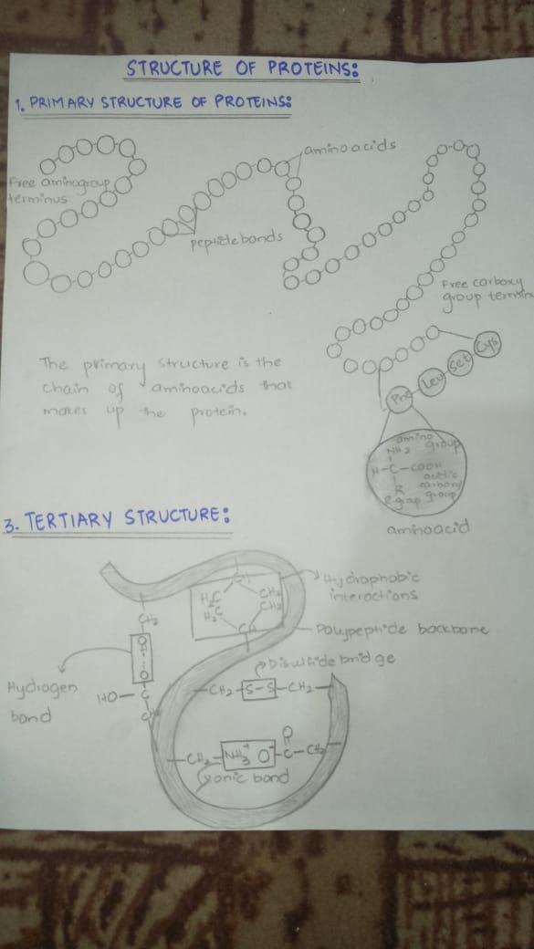

Secondary structure:

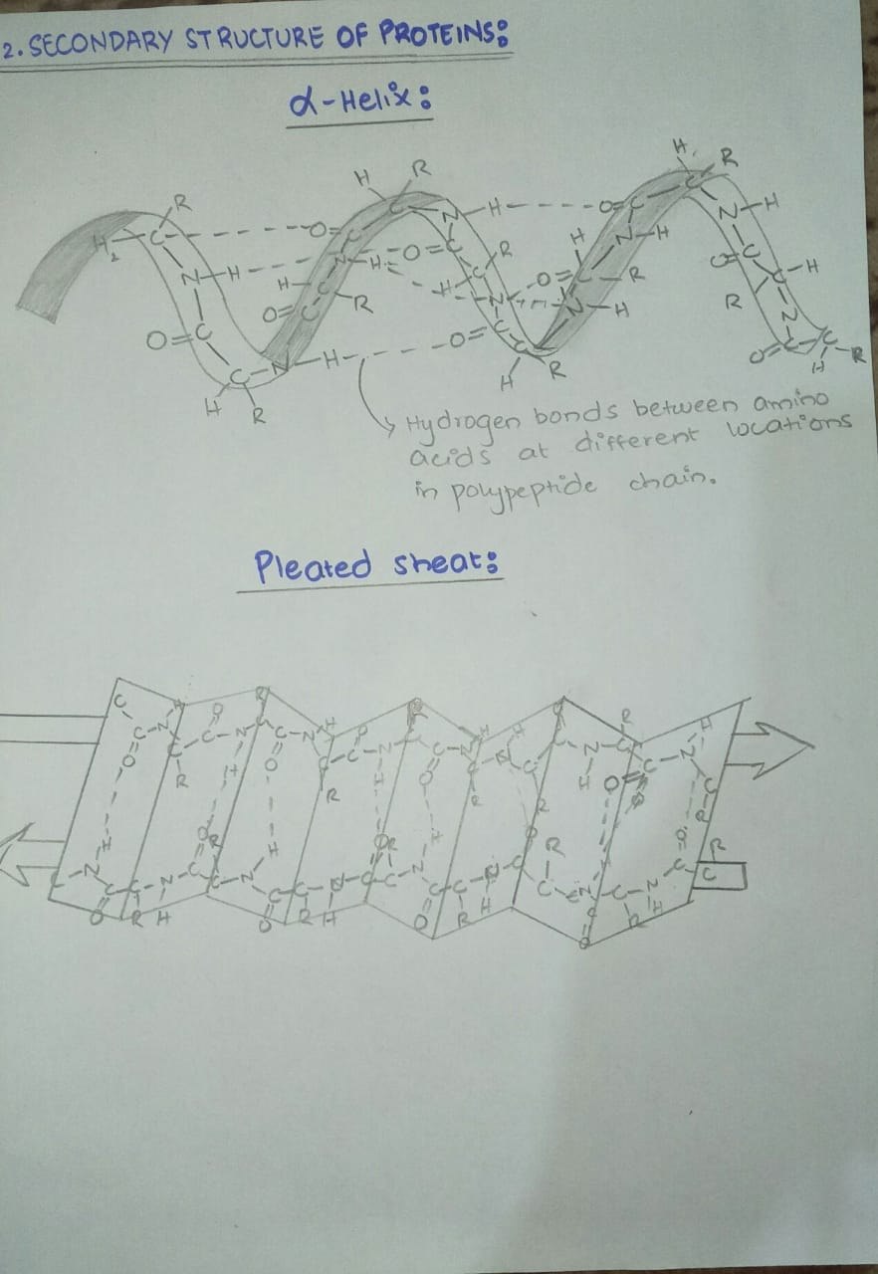

Quarternary structure:
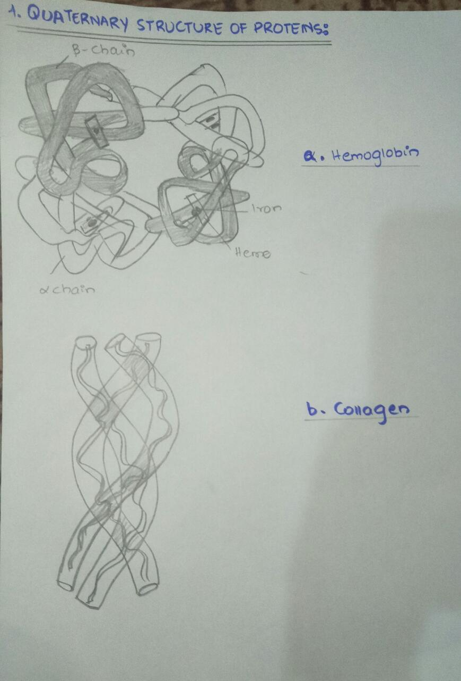

CHEMICAL COMPOSITION OF PROTEIN:
Proteins are made up of 20 different amino acids. Each one of the amino acids consists of a central carbon. The central carbon is binded to an amine group ,a carboxyl group, a hydrogen atom and an R group.

