Subject : Anatomy-IV
Submitted by : Noor Razzaq
Student ID: 15187
DPT 4th Semseter

SELECT THE BEST POSSIBLE ANSWER
- A
- B
- C
- C
- A
- B
- A
- C
- D
- A
- . 2. Cell body
3. satellite glial cells
4.schwann cells
7. Node of Ranvier
8. Neuromuscular Junction

Answer the following Questions.
ANSWERS:
- Due to injury on the right orbital side usama vision is impaired in his left eye effecting his visual field in the retina . The visual field which is connected to brain via optic chiasm divided upwards into right ad left side of the brain. Thus an injury to the right side of brain result in the trauma of his left eye vision.

- SPINAL NERVES VS CRANIAL NERVES
SPINAL NERVES:
- Spinal nerves comprised of 31 pairs .
- They originate from nerve roots of spinal cord.
- They are classified of thoracic, cervical , lumber , sacral and coccygeal nerve pair.
- Spinal nerve are composed of both sensory and motor neurons.
- Spinal nerve involved in sensation and sweat.

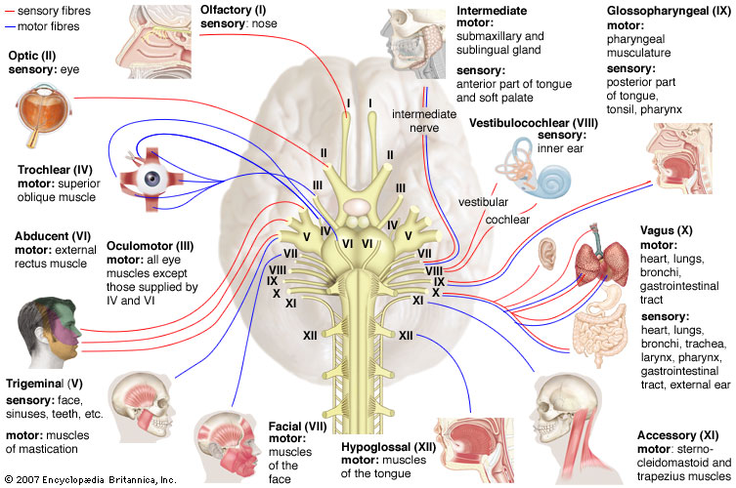

CRANIAL NERVES:
- Cranial nerve Comprised of 12 pairs
- They arise directly from brain
- They are number from I to XII
- These contain sensory motor or mixed neurons
- they are involved in hearing smell and sensation of visions etc
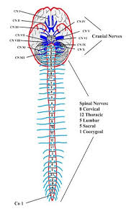
- The Reticular formation of Spinal cord :
The reticular formation helps in regulation of concousiness and arousal. It consists of interconnected networks in the tegmentum of brain stem, lateral hypothalmic area and medial, intra laminar and reticular nuclei of the thalamus . it is composed of almost 100 brain cells and contains many projections into forebrain cerebullem and brainstream among other areas.
Traditionally reticular nuclei divided into three columns:
- In median column – the raphe nuclei
- In medial column – gigantocellular nuclei (because of larger size of the cells)
- In lateral column – parvocellular nuclei (because of smaller size of the cells)
The varied funtions of reticular formation are :
- Somatic motor control
- Cardiovascular control
- Pain modulation
- Sleep and conciousness
- Habituation
The reticulospinal tracts provide a pathway by which the hypothalamus can control sympathetic thoracolumbar outflow and parasympathic sacral outflow.
