Course Title: Biochemistry I
Micro 2nd Lab Assignment
Student Name: Shah jehan
Student ID: 16492

Note: Avoid copy paste material as it may deduct your marks.

Q1. Discuss the Watson and Crick Model of DNA.
Q2. Draw the structure of following saccharides:
  - Fructose
  - Maltose
  - Table sugar
  - Stachyose
  - Milk sugar
  - Glyceraldehyde

Name_m yaseen
Id_16705
Dep_ microbiology 2nd semester.

QNO1_discuss the watson and crick model os DNA.
ANS.
The Watson-Crick Model of DNA (1953)

Deoxyribonucleic Acid (DNA) is a double-stranded, helical molecule. It consists of two sugar-phosphate backbones on the outside, held together by hydrogen bonds between pairs of nitrogenous bases on the inside. The bases are of four types (A, C, G, & T): pairing always occurs between A & T, and C & G. James Watson (1928 - ) and Francis Crick (1916 - 2004) realized that these pairing rules meant that either strand contained all the information necessary to make a new copy of the entire molecule, and that the aperiodic order of bases might provide a "genetic code".

Watson and Crick shared the Nobel Prize in 1962 for their discovery, along with Maurice Wilkins (1916 - 2004), who had continued research to provide a large body of crystallographic data supporting the model. Working in the same lab, Rosalind Franklin (1920 - 1958) had earlier produced the first clear crystallographic evidence for a helical structure. Crick went on to do fundamental work in molecular biology and neurobiology. Watson become Director of the Cold Spring Harbor Laboratory, and headed up the Human Genome Project in the 1990s

QNO,2
Fructose
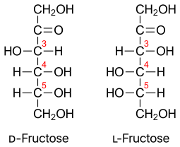

3_ Stachyose.
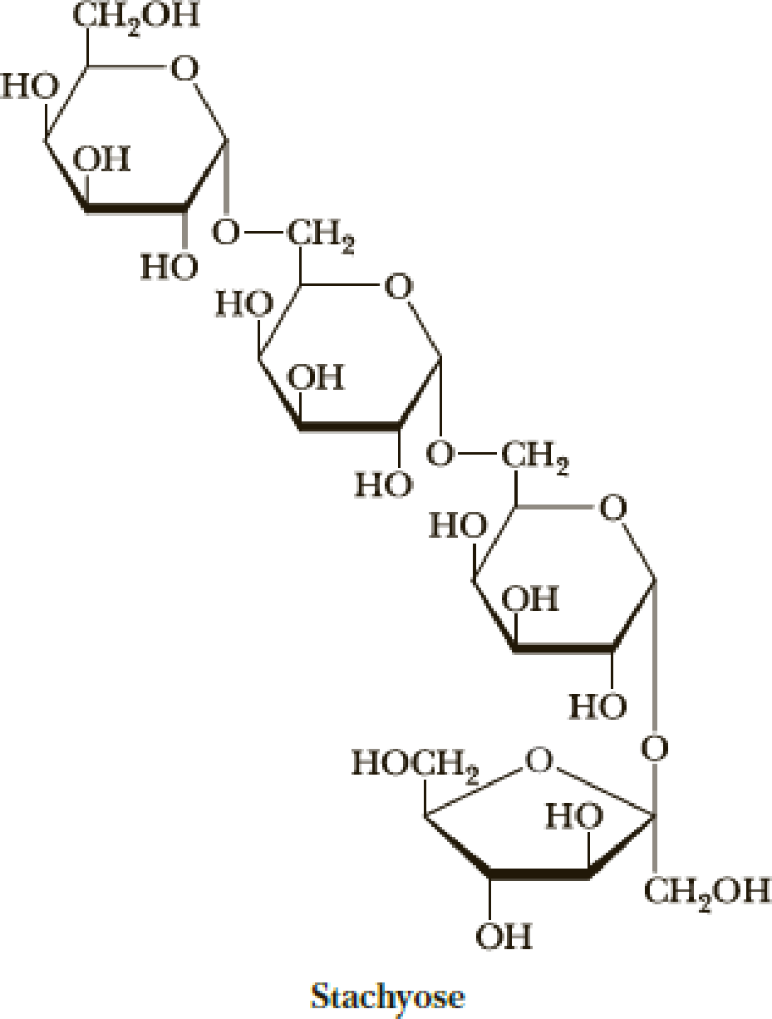

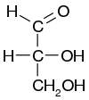

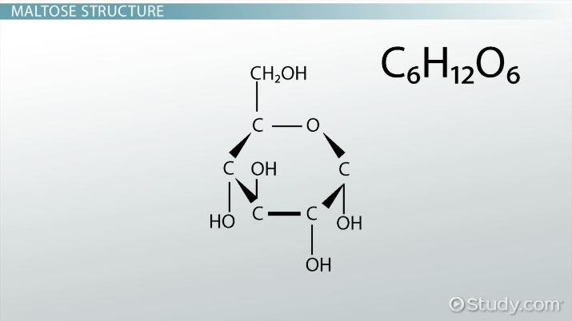
3_maltose structure.

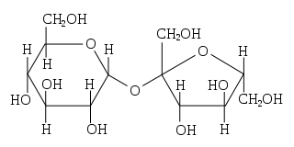
4_table sugar structure.

5_ milk sugar structure.
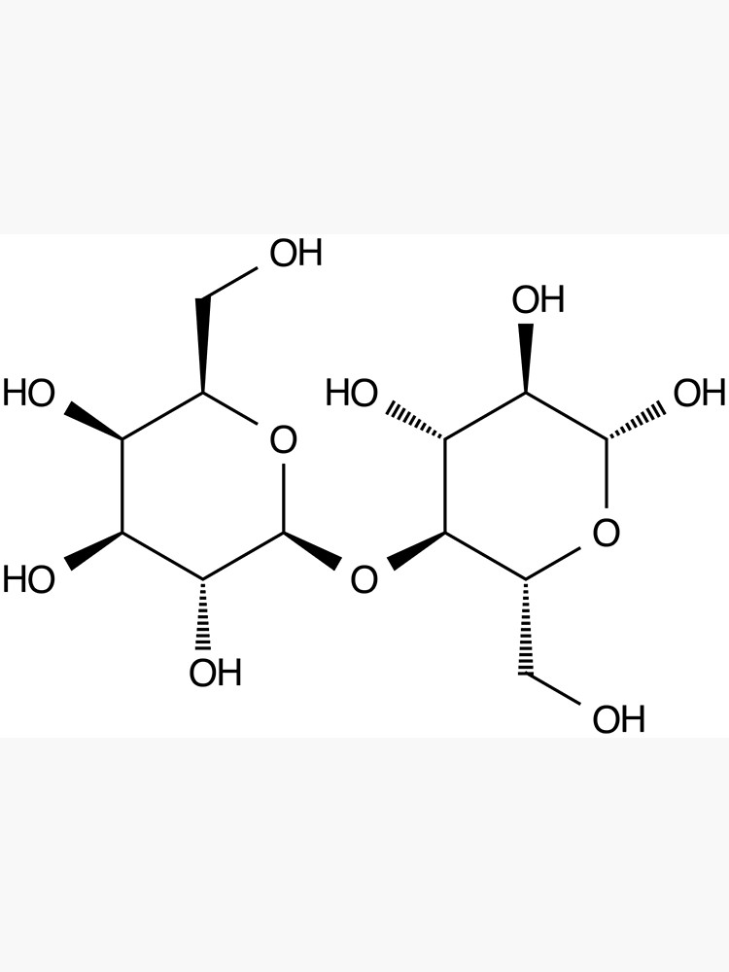

6_ glyceraldehyde

